Title: Card Game Project Writeup

Name: Gabriel Donnan

Number

Contents

Analysis 4

Identification 4

Computational Approach 4

Research 5

Stakeholders 8

Interviews 8

Hardware Spec 9

Software Spec 10

Requirements 10

Limitations 11

Design 12

Design of required features. 12

1) Card Buying System 12

2) Having different types of cards with different effects 15

3) Cards which trigger effects at different intervals 18

4) Placing limitations on the size of the players’ boards, hands, mana and currency 27

5) Tutorial Section 34

6) Ability to end the game when an end condition is reached 36

7) Ability to combine cards to make them more powerful 39

8) Implementation of local multiplayer against another human player 42

Design of Screen layouts 44

Main Board 44

Main Menu 48

Implementation 51

Game Loop 51

First Iteration 51

Intermediate Iteration (Iteration 1.5) 56

Player Class 58

First Iteration 58

Intermediate Iteration (Iteration 1.5) 63

Card class 64

First iteration 64

Second Iteration 66

Intermediate Iteration (Iteration 2.5) 68

STUFF TO ORGANISE 68

Testing 75

Shop Testing 75

Card Class Testing 78

Card Effect Testing 80

On Death Effect and Card Destruction Testing 80

On Play Effect and Card Playing Testing 90

On Attack Effect and Card Attacking Testing 95

On End of Turn Effect and Ending Turn Testing 101

Player Hand Testing 108

Tutorial Section Testing 110

Game Ending Testing 119

Evaluation 119

# Analysis

## Identification

Currently I believe the market for digital card games is relatively bare, with only two main games dominating the market. I believe this leaves room for the creation of a new digital card game, using the simple combat mechanics employed by many card games in the past but using the digital medium to allow for more complicated effects and mechanics that are not amenable to the physical medium, specifically pseudo-random effects such as random generation. As such I believe that creating a game to fill this role would be beneficial to those who may believe the current game market to be stale as it could revitalize an interest in games of this type.

## Computational Approach

The problem of making this is, I believe, best solved by computational methods. This is for a variety of reasons, firstly the game is easily broken down into consecutive logical operations, which is exactly how computers operate, following instructions linearly. For example when a card is played this can easily be broken down into some function calls that can be made, firstly any effect the card might have on play must be enacted so a function called playedFunct() can be called to do this, then the card must be removed from the list of cards in your hand then added to the list of cards on the board, this can be done via a simple function call or even a single line statement which can pop and append the card (though one-liners like this can be disadvantageous when debugging as they can often seem more logically complex than they actually are). And finally the card has to be rendered on the board so a function renderCard(card,position) can be called, allowing the card to become visible on the board. Every facet of the gameplay can be broken down logically as such, as can the menus outside of the game.

The AI which will be playing the game is not only best suited to computers as it can interact linearly with the game, it is impossible to make without them as you would need some other device capable of intelligent decision-making to be playing the game, which is limited to only humans and computers. Using a human here would defeat the purpose of having an AI opponent as the game is meant to be playable by yourself. The AI’s algorithm makes use of iterative decision making (iteration being one of the most important components of computational reasoning), performing mathematical and logical operations to achieve pseudo-intelligent decisionamking at a speed not physically achievable by non-computational methods. The AI operates on a basic level by taking data from the current game state and calculating the optimal cards to buy, play and combine from the amount of currency and mana it has alongside deciding the best attacks to make based on the attack and health values of the cards on the board using preset “if” statements.

The game will be made in an object-oriented manner as I find this to be the best method to create the game whilst maintaining an intelligible, logical, code flow. Each card for each player can be instantiated as an object of the class “Card” which allows the cards to have their own unique properties (such as a name, cosmetic text, health, cost, attack, etc.) and were I not using an object oriented structure like this it would be much more difficult to logically allow the game to function. This process can be shown to be effective when using the example of playing a card again as using objects the cards themselves can have a .play() function, which is important as if it was necessary to use a global function the player number would need to be specified as each player has cards and the syntax within this function would be much more complicated, requiring many IF statements to determine which player is playing and what card they’re playing. Once the card played is determined when using objects any effects the cards may have on other cards can be easily enacted as they can directly adjust the properties of the other cards, but when not using an object oriented approach there are no individual card properties to edit, and as such everything would have to be kept in lists and adjusted this way, resulting in much more unreadable code, greater difficulty in adding more cards and inefficient code.

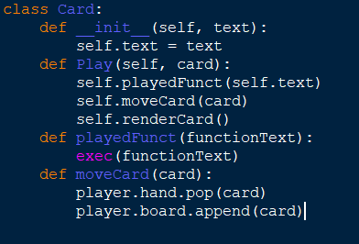 *Below is a mock-up of the Card class structure needed to play a card:*

## Research

When looking into creating a game such as this I must first look at other similar games to see what inspiration I can derive from them but also more importantly what I can improve on comparatively to them. As part of my research I played and looked at the features of the two most popular online card games (Hearthstone and Magic: The Gathering, Arena) and the recently released DOTA Underlords, which is not a card game but uses an interesting unit buying system which I feel can help solve the problem of card drawing randomness which often negated some amount of the skill involved in gameplay for the first two games I looked into.

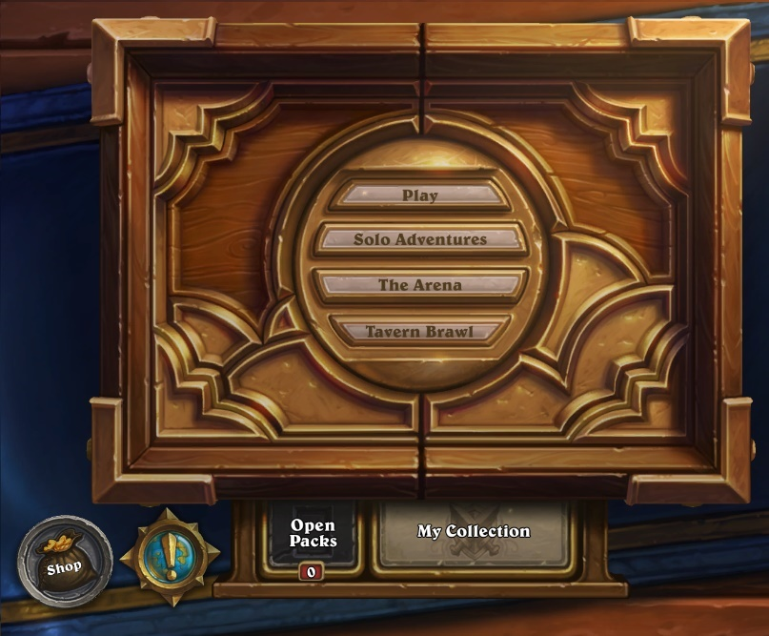 Firstly I looked at Hearthstone, which is a game which is designed to look as smooth and user-friendly as possible, meaning it is an automatic attractor for those newer to the card game community or those who appreciate the polish put in to it.

*The Hearthstone main menu screen*

Hearthstone’s simple user interface is extremely appealing and as such I have decided to use a more simplified visual main menu structure rather than using text or any more complicated layouts which I feel needlessly confuse the user. The game has a pack opening system and an overarching card “collection” which indicates the cards which you do and do not own, and therefore the cards which you can and can not put into decks. I feel this is unfair to the end user and instead have opted to allow each user to have access to all the cards in the game.

The game’s concept is relatively simple, you draw 3 or 4 cards at the start of the game (dependant on whether you go first or second), you start at 1 mana crystal, gaining one per turn until you have 10. Mana crystals can be spent by playing cards and will refresh at the start of each player’s turn. There are two main card types, minions and spells. Minions are creatures which are summoned on to the board which can fight for you, either attacking your opponent or their minions. Spells are instant effects which do not necessarily summon creatures but can affect them or either player’s character. When the first player reaches 0 health the game ends.

I have decided to simplify cards into one type instead of using minions and spells. Cards will always summon a creature and can have effects similar to those of hearthstone’s spell cards attached to them, thus meaning the game is more easily understood. I have also opted to use a similar combat style, however unlike in hearthstone, you must always attack the creatures on the board before attacking the opposing player, allowing the game to last for longer and for creature on creature combat to be a larger facet of the game.

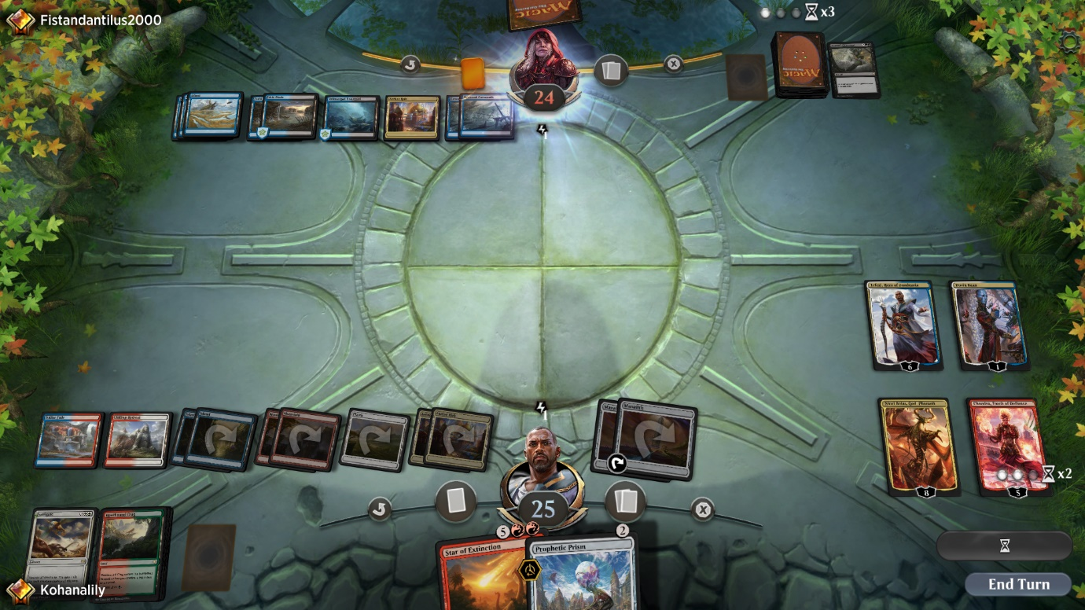

*A standard board state in Magic: The Gathering, Arena*

The second game I researched was Magic: The Gathering, Arena. Magic: The Gathering is one of the longest standing card games ever made and its advent into the market of digital card games has given me an opportunity to see what works and what doesn’t comparatively to Hearthstone.

The game functions slightly differently to hearthstone in that instead of mana crystals you gain as the turns advance you have the ability to play “land” cards which allow you to play other cards by spending them each turn. It is also different in the fact that your opponent gets to dictate the path on which your attacking creatures attack, meaning the game is also reliant on bluffs and not knowing your opponent’s decision-making.

I believe that whilst this does promote the skillful aspect of the game that my stakeholders want, bluffing and strategies such as this are almost impossible against an AI opponent as it does not make decisions in the exact same way humans do and as such I am allowing the player full control of their creatures’ attacks. In Magic: The Gathering damage inflicted to creatures is not permanent due to the game originating in physical form so it was nearly impossible to keep track of damage inflicted to so many things. Since my game will be digital the damage inflicted to creatures will last between rounds as computers can keep track of this very easily.

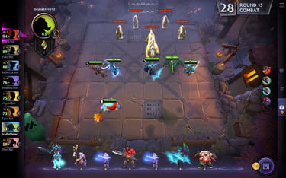 One feature of Magic: The Gathering that I wish to implement if I have time is the ability to be able to stack like units on top of one another to remove clutter on the board and allow the game to look more visually appealing, which I believe is a key factor in player accruement.

*A standard board state in DOTA: Underlords, with purchased units displayed at the bottom*

The final game at which I looked for my research was DOTA: Underlords, a recently released game based on the popular mod DOTA: Autochess. This was the only game I researched that was not a card game, but rather just a strategy game in a more broad sense to see if I could incorporate any features currently unused by digital card games but applicable to strategy games in general to allow mine to stand out.

One particular feature that stood out to me while researching this game is the unit purchasing system in which each round you are offered a selection of units which you can buy with gold you collect over the course of the game, when applied to a card game instead of drawing a card each turn I feel that this would be extremely beneficial to the skill requirement of the game and thus the long term enjoyment levels that can be achieved. Adding this feature also removes the need for deckbuilding, which becomes simply a game of statistics instead of an interesting facet of the game with which to play due to the easily analysable gameplay of card games.

## Stakeholders

When looking into stakeholders for my game a number of my peers expressed interest in such a game given certain features they wanted were implemented. One particular interested party is a friend of mine named Vishaan who has a background in games that involve longer term strategy so as such a card game was a natural attractor for him. The game perfectly suits his desire for strategizing as there are nigh on infinite possible iterations of the game and its state so a good understanding of strategic thinking is rewarded.

He also enjoys games with a high degree of customization as evidenced by his investment in RPGs with character customization in the past, so the deck customization that is possible appeals to him as well. He hopes that in the way the game is coded it will be easy to add new cards to allow the game to feel fresher as new cards can rejuvenate a game to ensure it’s long term enjoyability. He also enjoys games in which he can play by himself in his free time so the AI implemented will allow him to do this without relying on anyone else to play with him.

Another potential interested party is my younger brother Micah as he has enjoyed digital card games in the past but feels like the current available market for them is too bare for his liking, as such he wants a game with different gameplay to the other two major online card games of Hearthstone and Magic: The Gathering, Arena. In order to achieve high enough difference from these games he feels that the game I am making should have mechanics with more choice to replace the classic method of drawing cards implemented by other games which can lead to a high amount of luck being involved in gameplay as opposed to pure skill so as such I have decided to instead opt for a turn based card buying system instead which, whilst it still has some variance, rewards skill over luck a greater proportion of the time. He has also requested that the game have a screen that will scale to any screen size automatically so it does not take any additional effort to use it on different devices and as such the game will be able to be enjoyed by a wider range of device owners who can now use any device without the game looking any different between them.

The third stakeholder I have identified is another friend of mine who very much enjoys gaming but is not currently very involved in card games or strategy games in general and as a result of this lack of current investment into games of this type he has said he would enjoy it if the game were to have an explanation of the rules included within it to make his learning process easier. In order to fulfill this request I have decided that I will add a basics tutorial section to the game accessible via the main game menu so that the game can be picked up by new players with greater ease.

### Interviews

I conducted short interviews with my stakeholders in order to identify what exactly they wanted to see from the finished product of the game:

My first interviewee was Vishaan, below is a record of the interview that was conducted:

Me: What, for you, makes a game enjoyable?

Vishaan: Well, in my opinion as long as the game is of a type that I like it just has to not be completely reliant on luck but have enough variation so it doesn’t feel stale

Me: How do you think one could tackle the problem of luck versus variance in a card game?

Vishaan: Im not 100% sure, but if I had to guess I would say I would want not to have to build a deck of cards so the games I play don’t always feel the same for each deck

Me: Alright, and what do you feel, if anything, that current card games are doing wrong that I could improve on?

Vishaan: Yeah there is one thing that annoys me about card games right now, most games do this actually and its really offputting. Its that their AIs for enemies don’t feel like they’re actually a challenge and I think if they seemed more human then I could look at them as more of a valid opponent

## Hardware Spec

The game will not be extremely hardware intensive as all the AI’s training will be done on my computer beforehand so the intense training process is not necessary to carry out on the end user’s machine. If someone were to attempt re-training it or training an entirely new neural network to use instead of mine (this can be done relatively easily and would normally be done to adjust the difficulty level of the AI opponent as less training would mean more difficulty and vice versa up to a point) I would recommend a system using:

* Dedicated GPU with no less than 4GB of VRAM
  + GB+ of VRAM would be recommended but can be very expensive
  + A more powerful GPU is more impactful on training performance than a more powerful CPU
* CPU with at least 4 cores with a clock speed of 3GHz
  + Improving the CPU will increase the performance of training with more cores being more impactful than higher clock speed but an upgrade of CPU will almost always be worse than an upgrade of GPU

These hardware specs are important in the event of a retraining in order to attempt to train it in a practical amount of time (i.e. less than a week). The only real requirement when you are not retraining is that the hardware is able to support all the necessary software at a basic level for the computer to run it which, according to Intel (<https://software.intel.com/en-us/distribution-for-python/system-requirements>), Is at least one gigabyte of secondary storage (SSD or HDD are both acceptable as the read/write speed will not affect the performance very much) for the base python and an additional 2 to 3 gigabytes for the rest of the libraries that need to be imported such as pytorch.

The system should also have:

* A processor at least as powerful as a single core 1.6GHz processor
  + This is normally the power level of the lowest price point ARM or Intel Atom processors
* Standard peripheral devices required for computers to function normally
  + At least one monitor on which to see the gameplay
  + A keyboard (even 80% size keyboards still work)
  + A mouse

## Software Spec

There are relatively few pieces of required software for the game:

* A python version of 3.0 or more recent
  1. Syntax changes heavily in some common statements like print or input from 2.7 to 3.0 and as such the code would not be able to run on any older versions of python
* The most recent versions of the python libraries I use
  1. Pygame
  2. Pytorch
  3. Random
  4. Math
* An operating system which supports all the libraries I have listed (i.e. the standard operating systems of Windows, most Linux distributions or Mac OS)

## Requirements

The game, upon completion, should have:

* Necessary Features for the game to function:
  1. Card buying system
  2. Background for game to be played on
  3. Indication as to when the current player changes
  4. Buttons the user can press to perform different actions
  5. At least 10 different card types
  6. Cards which trigger effects on:
     + Death
     + Play
     + Attack
     + End of turn
  7. Ability to play cards from your hand onto the board
  8. A limit on the space on your board and in your hand
  9. Tutorial section
  10. Ability to attack using your played cards to damage the opposing player
  11. AI implementation of the second player
  12. Ability to win or lose the game given certain criteria have been fulfilled
  13. Ability to combine cards to make them more powerful
  14. Local multiplayer versus another human player
* Important features the game should have but are not necessary for it to function:
  1. A menu with which to navigate, at the very least containing the ability to:
     + Play a game
     + Adjust your settings
     + View the tutorial
  2. Ability to adjust the position of cards on your board
  3. Tooltip boxes which appear when items are hovered over
  4. Ability to combine multiple of the same card into a single more powerful version of themselves
  5. Ability to pause the game
  6. Menu of all the cards and their combinations
     + Given enough time this could also be an interactable visual menu, though this is more of a stretch feature
* Features that would be nice to have but less likely to be finished:
  1. The ability to retrain the AI from within the game menu
  2. Different game modes to the standard mode of play
  3. In-game custom card creation feature
  4. Ability to save the game state and return to it later
  5. Animations for actions such as playing cards
  6. Passive effects for played cards
  7. Stacking alike units

## Limitations

Whilst the game will be feature-rich and strategically in-depth as I can make it, there will of course be limitations to the things that I will have been able to complete or add to the game within the time frame I have to make it.

Such limitations include:

* No sound
* No custom animations for different effects
* No online or LAN multiplayer
  1. I might possibly implement local multiplayer, however online or LAN multiplayer is much too complicated to do within such a time frame
* Only English language support

# Design

## Design of required features.

### Card Buying System

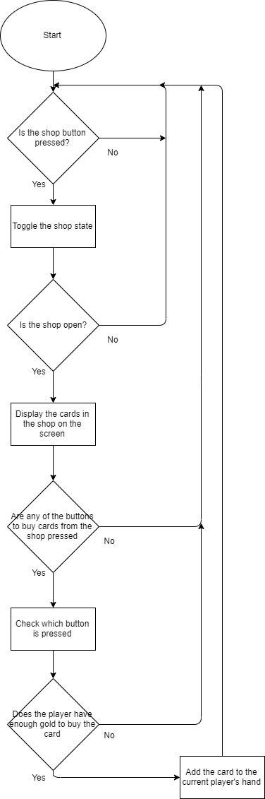This is a system to allow the current player to buy cards from the shop via clicking buttons associated with them in order to be played later.

If mouse.collide(button) and mouse.clicked() then

Shop.open = True // toggles Boolean value

If Shop.open == True then

Cards.display() //Displays cards in the shop

Cards.displayButtons() // Displays the buttons associated with the cards in the shop

For button in Cards.buttons:

If button.get_pressed() == True and PlayerCurrency > button.card.currency then

Player.buyCard(button.card) // Buys the card which the button is linked to

PlayerCurrency -= button.card.cost // Deducts the cost of the card from the players gold count

Else

DisplayError(“You don’t have enough currency to buy that”)

##### Test Plan

|  |  |  |  |
| --- | --- | --- | --- |
| Number | Item | Purpose | Expected Result |
| 1 | Clicking shop button | Check that button functions as required to toggle the shop | The shop goes from not being displayed to being displayed when the button is pressed |
| 2 | Clicking on the card itself when shop is open | Check that clicking on the card in the shop does not buy it, play it if an instance is in your hand or any other such possible bugs | Clicking on the card itself should not do anything, as the buttons associated with the cards are what are used for buying them |
| 3 | Clicking on the buy buttons associated with the cards when you have enough currency to buy them | Check that when you have enough currency to buy the card it can be added to your hand and removed from the shop | The card is removed from the shop and added to your hand, deducting the amount of gold it costs from your balance |
| 4 | Clicking on the buy buttons associated with the cards when you do not have enough currency to buy them | Check that when you do not have enough currency to buy the card it does not get purchased from the shop and an error message is displayed | The card remains in the shop and a copy of it is not added to your hand, an error message is displayed telling you that you do not have enough gold to purchase that card right now |
| 5 | Clicking in the locations in which the buy buttons would be located when the shop is not being displayed | Check that the buttons cannot be interacted with if the shop is invisible | Nothing will happen, the cards in the shop at that location will not be bought |

### 2) Having different types of cards with different effects

This is managed using a class as a blueprint for cards, allowing them to have effects which trigger at different times, variables common to each card but also functions exclusive to each.

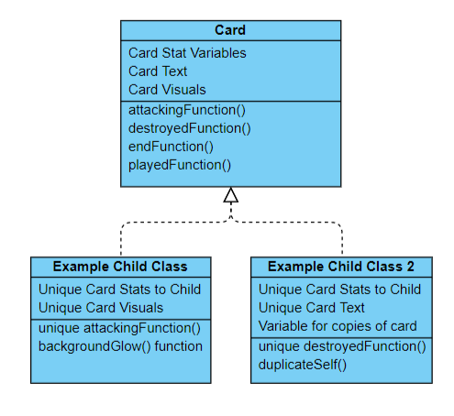Class Card:

Initialise(health, attack, cost, text, picture):

Card.health = health // Declares class variables

Card.attack = attack

Card.cost = cost

Card.text = text

Card.picture = load(picture, size) // Loads the picture as an image

attackingFunction()

Null // The function does nothing and the child classes will modify these via polymorphism to make them do things specific to their needs

destroyedFunction()

Null

endFunction()

Null

playedFunction()

Null

Class ExampleChild(Card):

Initialise(health, attack, cost, text, picture):

Card.initialise(health,attack,cost,text,picture) // Initialises child class using parent class

ExampleChild.IsDuplicated = False // Adds an additional variable which does not exist in the parent class

DuplicateSelf()

ExampleChild.isDuplicated = True

ExmpleChild(x,y,z,a,b,c) // Creates a duplicated instance of the same class

endFunction()

ExampleChild.health += 1 // Changes the inherited endFunction to do something different from the default of doing nothing

##### Test Plan

|  |  |  |  |
| --- | --- | --- | --- |
| Number | Item | Purpose | Expected Result |
| 1 | Create an object from the parent card class | See if objects can be created and used as cards even when they are not declared as the unique card child classes | A template card is created that can be used as a card functionally but it will not be able to have any differing methods from normal |
| 2 | Create an object from a child card class with every function changed and call each | Make sure that changing each function via polymorphism for a child class works as intended | A card is created with changed played, destroyed, attacking and end functions, when each one is called the intended effect is enacted in the correct manner |
| 3 | Create an object from a child card class with every class variable changed | Make sure that changing each class variable works as intended for the card | A card is created with the default functions but different variables (i.e. different picture, different health values, etc.) |
| 4 | Create an object from a child card class with additional functions such as duplicating themselves | Making sure that adding additional functionality outside of the basic four functions that cards come with works as intended | A card is created with default stats and the default functions other than the newly added function. This function, when called, will perform its task as intended and no error will occur |
| 5 | Create an object from a child card class which costs 0 mana to play | Making sure that the correct icon is displayed for the mana cost and that it deducts the correct amount of mana for this edge case | A card is created where it’s mana cost is 0, when played the card deducts no mana from the current player and it’s mana cost is displayed as a blue 0 in the top right corner of the card |
| 6 | Create an object from a child card class which costs 0 currency to buy from the shop | Making sure that the correct icon is displayed for the shop cost at this edge case and the correct cost is deducted from the current amount of currency | A card is created where it’s shop cost is 0, which should be displayed as a gilded 0 in the top left corner of the card and should not deduct any currency from the current player when bought |

### 3) Cards which trigger effects at different intervals

#### 1) On Death

This simultaneously checks whether destroyed cards need to be removed from the board and, if so, triggers their effect by calling a class function that all cards have but is changed via polymorphism to the specific card.

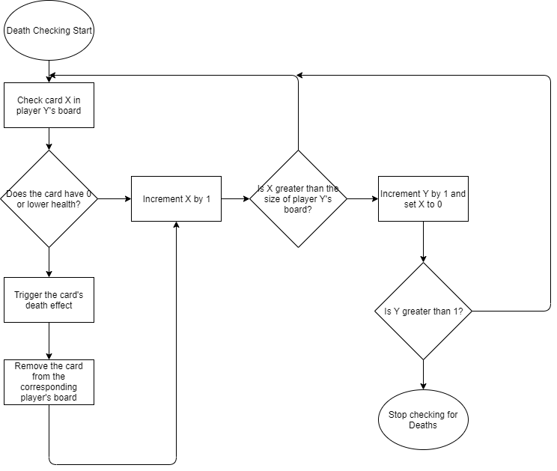

For card X in playerBoard[Y]:

If X.health < 1: // Checks if the card is dead

X.onDeath() // Triggers the card’s death effect

playerBoard[Y].remove(X)

if index(X) > length(playerBoard[Y]) // Checks if it is checking outside the range of the current player’s board

Y++

X = 0

##### Test Plan

|  |  |  |  |
| --- | --- | --- | --- |
| Number | Item | Purpose | Expected Result |
| 1 | Checking an empty board | To check if the program tries to remove cards despite lack of any or if there’s an index range error where the max index is 0 | No error will occur, i.e. no cards will erroneously try to be removed and the indices will not exceed their limits |
| 2 | Checking a full board of living cards | To test the edge case where both players’ boards are full, i.e. that no index range error occurs and no cards are removed | No cards are removed as they all are alive (i.e. have health values greater than 0)  No index out of range error occurs. |
| 3 | Checking a full board of dead cards | To test whether the program can effectively remove multiple cards at a time from multiple boards | All cards are removed from both players’ boards |
| 4 | Checking a board with some living and some dead cards | To test whether the program can differentiate between living and dead cards interchangeably | The dead cards are removed from the correct players’ boards and the living cards are ignored |
| 5 | Checking a board with some living and some dead cards of the same name | To test whether the program can differentiate between living and dead instances of the same card and does not remove the living ones erroneously | The living instances of the cards remain untouched and the dead ones are removed, the death effects are triggered only for the cards that died |
| 6 | Checking the on death effects of each card | To check whether the functions assigned to each card with an ability that activates on its destruction function properly | The cards will all function identically to how the text of the card describes their effect when destroyed, with no extra effects or less effects than stated. |
| 7 | Checking a board with intermediate numbers of cards on both players side with some living and some dead | To make sure the program functions outside of purely edge cases | All dead cards are removed and all living cards are ignored |

#### 2)On Play

This checks whether the current player is able to play their card and, if so, triggers the On Play effect unique to that card

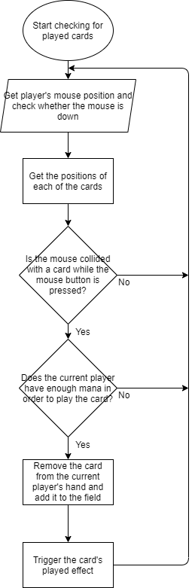

For card in playerHand[currentPlayer]:

Position = card.getPosition() // Gets the position of each card

If mouse.touching(Position) and playerMoney > card.cost and mouse.isDown() == True: // Checks if cursor is touching the card and whether the mouse is down. Then subsequently whether the player can afford the card

card.play()

card.playedEffect()

##### Test Plan

|  |  |  |  |
| --- | --- | --- | --- |
| Number | Item | Purpose | Expected Result |
| 1 | Attempting to play a card with insufficient mana | Make sure that the mana cost of the card is enforced | The card will not be played and no mana will be deducted. |
| 2 | Playing a card with sufficient mana | Make sure that the correct number of mana is deducted and the card enters the battlefield while triggering its played effect | The corresponding amount of mana to the card’s cost is deducted from the current player, the card is moved from the current player’s hand to the battlefield and its played effect is triggered. |
| 3 | Playing a card with a played effect that affects the board when other cards are populating the board | Make sure the played effect interacts as intended with the other cards on the board | The played effect will activate on all of the cards on the board as intended (i.e. one that deals damage to all cards on the board will deduct X amount of health from all the other cards once) |
| 4 | Playing a card with a played effect that affects the board when no other cards are populating the board | Make sure that the played effect does not break when there is nothing to interact with | The played effect will change nothing (i.e. one that deals damage to all other cards will not change anything or crash the program as there are no other cards to deal damage to) |
| 5 | Attempting to play a card when the current player’s board is full | Make sure nothing changed when this is attempted | The card will remain in the current player’s hand, will not trigger its played effect and will not end up on the current player’s board. |

#### 3)On Attack

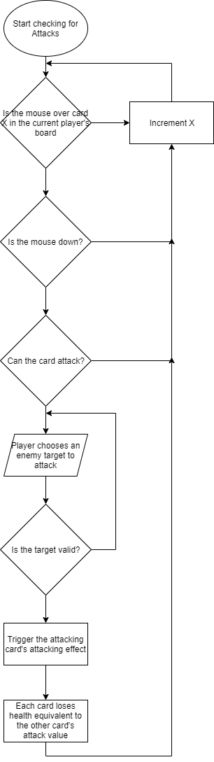Checks whether a card can attack and whether its target is valid and if it can it triggers its attacking effect.

For card X in playerBoard[currentPlayer]:

If mouse touching X and X can attack and mouse down: // Checks if the player is attempting to attack with the card

Attacker = X

For card Y in playerBoard[opposingPlayer]:

If mouse touching Y and Y.isAlive() and mouse down: // Checks whether the targeted card is valid to attack

Attacker.attackEffect() // Triggers the attacking effect of the attacking card

Attacker.attack(Attacker,Y) //Deducts the attack of each card from each other’s healths and inverts X’s canAttack value to false

##### Test Plan

|  |  |  |  |
| --- | --- | --- | --- |
| Number | Item | Purpose | Expected Result |
| 1 | Attempt to attack with a card which cannot attack | Make sure that the condition that the card be able to attack for it to be able to trigger its attacking effect be enforced | The card does not attack any other card, the attack effect does not trigger and no health is deducted from either card |
| 2 | Attempt to attack a friendly card with a card that can attack | Make sure the card cannot attack friendly cards | The card does not attack the friendly card, the attack effect does not trigger and no health is deducted from either card |
| 3 | Attack an opposing card with a card that can attack when both survive | Make sure that the health values are correctly reduced for each card and that the correct effects trigger | The health values for each card are reduced by each other’s attack value and the attacking card triggers its on attack effect |
| 4 | Attack an opposing card with a card that can attack and at least one card is destroyed | Make sure that the destroyed cards are correctly removed from the board and only the correct cards are destroyed | The health values for each card are reduced by the attack values of the opposite cards, any cards with on attack effects trigger those effects and destroyed cards are removed from the board. |
| 5 | Attack an opposing card with a card that has an attacking effect that affects the board | Make sure the effect of the attacking card triggers before the attack occurs and it does not crash if the attacked card is removed pre-attack | The attacking card’s board affecting effect triggers before the actual attack itself, If the opposing card Is destroyed by the effect the attacking card does not have its health deducted. |

#### 4)On Turn End

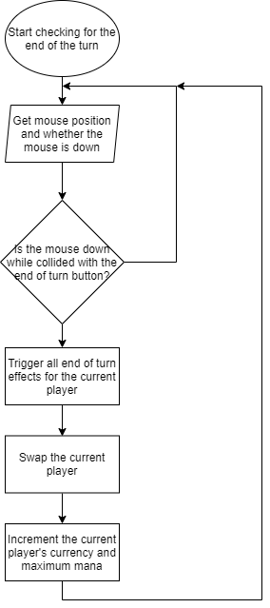Checks whether the player has ended the turn and, if so, triggers all end of turn effects for that player before swapping to the other player and incrementing some of their stats.

mouse.getPos()

If mouse down and mouse touching endTurnButton: //Checks if the endTurn button is pressed

For minion in currentPlayerBoard:

minion.endEffect() // Triggers the end of turn effect for each minion in the current player’s board before the player is swapped

currentPlayer.swap() // Swaps the current player

currentPlayerMana += 1

currentPlayerCurrency += 4

##### Test Plan

|  |  |  |  |
| --- | --- | --- | --- |
| Number | Item | Purpose | Expected Result |
| 1 | End the turn when the opposing player has the maximum amount of mana and currency | Make sure ending the turn, which would normally grant currency and mana, does not when these values are full | The opposing player, when the player is swapped, remains on the same amount of mana and currency and does not exceed the set maximum for each. |
| 2 | End the turn with a card in play which has an end of turn effect on the ending player’s board | Make sure the end of turn effect correctly triggers | The end of turn effect on the card would trigger for the ending player, subsequently swapping players |
| 3 | End the turn with multiple different cards in play with end of turn effects | Make sure each end of turn effect triggers as opposed to only one | The end of turn effect of each card in turn triggers once for each card |
| 4 | End the turn with multiple of the same card with end of turn effects | Make sure that the program can differentiate between multiple instances of the same card and still triggers the end of turn effect for each | The end of turn effect triggers for each instance of the card, not missing any out and not triggering more times than the number of instances of the card |
| 5 | End the turn when the opposing player has a card with an end of turn effect | Make sure that the opposing player’s end of turn effects do not trigger when the turn is ended | The end of turn effects of the opposing cards possessing end of turn effects do not trigger |

### 4) Placing limitations on the size of the players’ boards, hands, mana and currency

#### 1) Hand Size

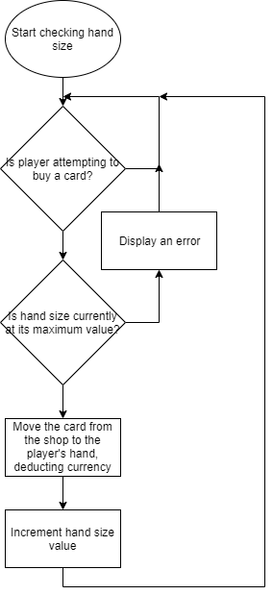Limits the player’s hand size so that it cannot reach values which would cause the cards to move off the screen display when playing and so that the player cannot infinitely hoard cards.

If player buying card and playerCurrency > cardCost: // Checks if the player Is attempting to buy a specific card and whether the player can actually afford it

If not handSize >= maxHandSize:

buyCard(card) // Removes the card from the shop and adds it to the player’s hand

handSize += 1 // Increments hand size so that buying more cards might be prevented if the hand size is too large

playerCurrency -= card.cost // Deducts the cost of the card from the current player’s currency balance

else:

errorDisplay(Your hand is too big for that right now)

##### Test Plan

|  |  |  |  |
| --- | --- | --- | --- |
| Number | Item | Purpose | Expected Result |
| 1 | Try to buy a card with a hand size less than maximum | Check if buying cards functions as normal when the hand size is in a normal value range | The card is removed from the shop and added to the current player’s hand, deducting the correct amount of currency from their balance |
| 2 | Try to buy a card with the maximum hand size | Check that the imposed hand size limit functions for cards in the hand | The card remains in the shop and is not added to the current player’s hand, no currency is deducted and an error is displayed |

#### 2) Board Size

Limits the players’ board sizes so that they cannot reach values that would cause cards to be displayed off the screen.

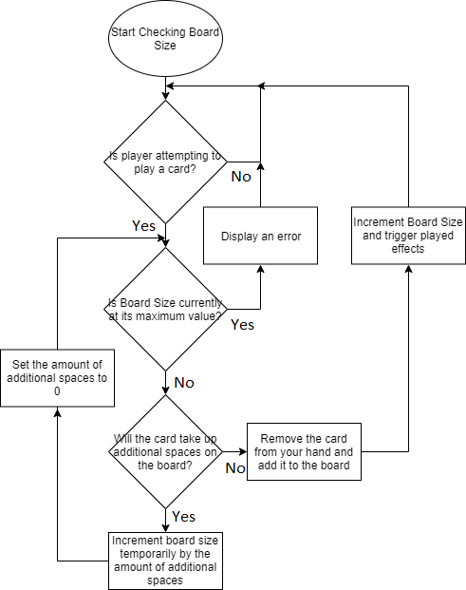

If player playing Card:

If boardSize >= maxBoardSize:

errorDisplay(“Oops looks like you cant do that right now”)

else:

if additionalSpaces > 0:

boardSize += additionalSpaces // Temporarily increments board size to check against maximum if the card would take up additional spaces

additionalSpaces = 0

if boardSize >= maxBoardSize:

errorDisplay(“Oops looks like you cant do that right now”)

boardSize = length(board) // Resets board length to the correct value from the temporary value assigned by the increase in board length

player not playing Card

else:

play(Card)

boardSize = length(board) // Updates the length of the board to the correct value after the card has been played

Card.playedEffect()

##### Test Plan

|  |  |  |  |
| --- | --- | --- | --- |
| Number | Item | Purpose | Expected Result |
| 1 | Attempt to play a card which does not take up more than one space with some remaining board space | Make sure standard playing of cards functions correctly. | The card is removed from the player’s hand and added to the board, the board size is incremented |
| 2 | Attempt to play a card which takes up more than one space when you have sufficient board space to hold all copies | Make sure copying cards can function as intended | The card is removed from the player’s hand and added to the board alongside the copies of the card |
| 3 | Attempt to play a card which takes up more than one space when you have exactly one board space open | Make sure that the card which takes up more than one space cannot enter the battlefield if the battlefield without summoning its duplicates | The card is not removed from the player’s hand, no mana is deducted and no on play effects are enacted. An error should be displayed |
| 4 | Attempt to play a card which does not take up more than one space when there is insufficient space on the board to play it | Make sure that the limitations of board space are still enforced for cards which do not take up more than one board space | The card is not removed from the player’s hand, no mana is deducted and no on play effects are enacted. An error should be displayed |

#### 3) Currency and Mana

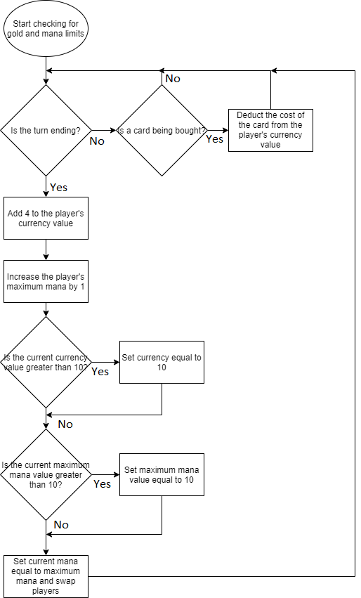Limits players’ currency and mana to 10 each so that the entire shop cannot be consistently bought out and the player cannot easily play an entire board worth of cards each turn.

If turn ending: // Checks if the player is attempting to tend the turn

playerCurrency += 4

playerMaxMana += 1

if playerCurrency > 10: // Checks that the updated currency value has not exceeded the set maximum of 10, and if it has it is then reduced to 10

playerCurrency = 10

if playerMaxMana > 10: // Checks that the updated mana value has not exceeded the set maximum of 10, and if it has it is then reduced to 10

playerMaxMana = 10

playerMana = playerMaxMana

player.swap() // Switches the current player as the turn has ended

elif card being bought:

playerCurrency -= card.cost

##### Test Plan

|  |  |  |  |
| --- | --- | --- | --- |
| Number | Item | Purpose | Expected Result |
| 1 | End the turn with 0 maximum mana and 0 currency | Make sure that standard incrementing of currency and maximum mana functions correctly | The currency of the player increases by 4, the maximum mana increases by 1 and the current mana is set equal to the maximum mana (i.e. 1) |
| 2 | End the turn on 10 maximum mana and 0 currency | Make sure that the mana limitation functions separately to the currency limitation | The currency of the player is increased by 4 but the maximum mana remains the same at 10, the current mana is set equal to this value, becoming 10 |
| 3 | End the turn on 10 currency and 0 maximum mana | Make sure that the mana limitation functions separately from the currency | The currency of the player remains at 10 and the maximum mana of the player is increased to 1, as is the current mana |
| 4 | End the turn on 10 currency and 10 maximum mana | Make sure that the mana limitation and currency limitation can work simultaneously | The currency of the player remains stagnant at 10 as does the maximum mana and current mana values |
| 5 | Buy a card with sufficient currency | Make sure that buying a card will deduct the correct amount of currency from your current amount | The currency of the player has the cost of the card deducted from it and the card is moved from the shop into the player’s hand |
| 6 | Buy a card with insufficient currency | Make sure that nothing happens if the player tries to buy a card without the sufficient currency | The currency of the player remains at its current value and does not go negative, the card remains in the shop and is not added to the current player’s hand |

### 5) Tutorial Section

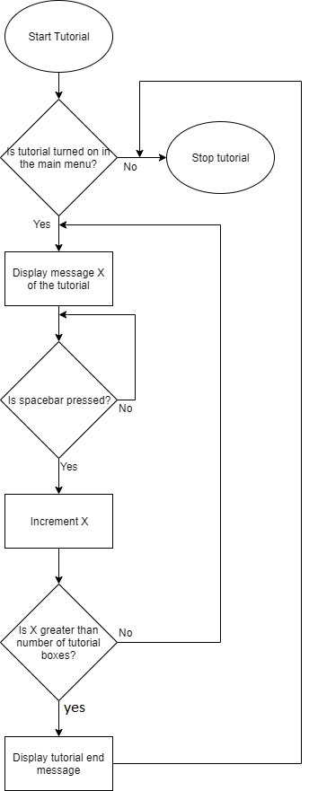

While tutorial:  
 display(TutorialMsg[x]) // Displays the current tutorial message

While spacebar not pressed:

Wait // Waits for the spacebar to be pressed to display the next tutorial message

x+=1

if x>length of TutorialMsg -1:

tutorial = False

display(endmessage) // Displays a message indicating that the tutorial has ended

end tutorial

##### Test Plan

|  |  |  |  |
| --- | --- | --- | --- |
| Number | Item | Purpose | Expected Result |
| 1 | Activate the tutorial in the main menu and hold down the spacebar | Make sure holding down the spacebar correctly moves through the tutorial messages as if it were pressed repeatedly | The tutorial displays all messages in the correct order in quick succession before closing and displaying the endmessage |
| 2 | Activate the tutorial in the main menu and attempt to play the game while it is open | Make sure the tutorial messageboxes do not impair the playing of the game and It can still fully function while the windows are open | The tutorial displays messages over the screen but the game still functions fully (i.e. you can buy, play and attack cards correctly regardless of the tutorial) |
| 3 | Activate the tutorial in the main menu and iterate through it by pressing the spacebar repeatedly | Make sure that the tutorial functions as intended when used regularly | The tutorial displays messages in the correct order, updating whenever the spacebar is pressed and finishing with an end message before closing |
| 4 | Disable the tutorial in the main menu and press the spacebar repeatedly | Make sure the tutorial does not have any functionality when disabled | No tutorial messages are displayed and when the spacebar is pressed enough times that the end message would normally be displayed it does not display |
| 5 | Disable the tutorial | Make sure that when the tutorial is disabled it does not display | No tutorial message is displayed |

### 6) Ability to end the game when an end condition is reached

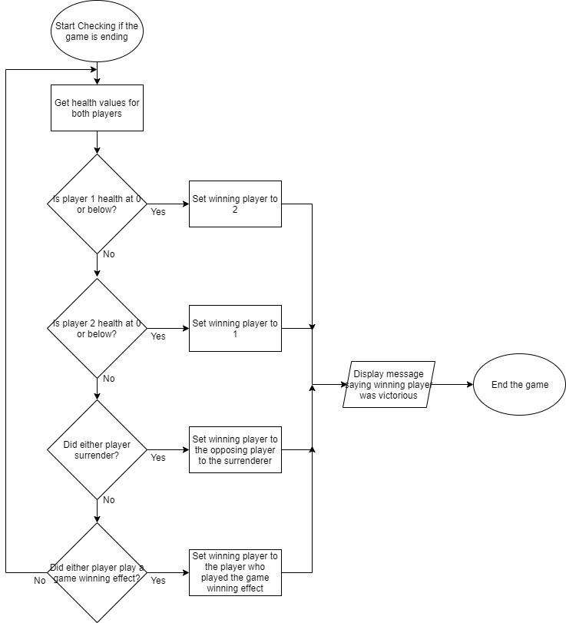Allows the game to be completed when either player is reduced below 0 health or potentially if any other end condition has been met (e.g. a player surrenders or a card which ends the game is played)

playerHealths = getPlayerHealths() // Gets the health values for each player

if playerHealths[0] < 1:

gameWon = True

winner = 1

if playerHealths[1] < 1:

gameWon = True

winner = 0

if surrendered[0]: // Checks if that player has surrendered

gameWon = True

winner = 1

if surrendered[1]:

gameWon = True

winner = 0

if winningEffect in playerBoard[0]: // Checks if that player has played a winning effect

gameWon = True

winner = 0

if winningEffect in playerBoard[1]:

gameWon = True

winner = 1

if gameWon: // Checks if either player has won the game to end it and display a winner message

display(“player ” + winner + “ won”)

game.end()

##### Test Plan

|  |  |  |  |
| --- | --- | --- | --- |
| Number | Item | Purpose | Expected Result |
| 1 | Reduce each player in turn below 1 health | Test that both situations will end the game and give the opposing player the victory | When player 1 is reduced below 1 health a message will appear stating that player 2 has won the game and the game will end, the same will happen for player 2 except reversed |
| 2 | Reduce both players simultaneously below 1 health | Test that the player who loses when reduced below 1 health is always consistent when they happen simultaneously | When both players are simultaneously reduced below 1 health a message will appear stating that player 1 has won the game regardless of whose turn it currently is and the game will end |
| 3 | Surrender the game with each player in turn | Test that both situations will end the game and give the opposing player the victory | When player 1 surrenders the game a message will appear stating that player 2 has won the game and the game will end, the opposite will happen if player 2 surrendered |
| 4 | Play a winning card with each player in turn | Test that both situations will end the game and give the player who played the card victory | When player 1 plays a winning effect a message will appear that they have won the game and the game will close, the same will happen but in reverse if player 2 were to play one of these cards |
| 5 | Attempt to interact with the game during the brief window in which the winning message is displayed over the board | Test that the game will not function in this window of time | When the user tries to click on cards behind the winning message nothing will happen, the cards will not be played, bought or combined, no effects will trigger nor will any animations. |

### 7) Ability to combine cards to make them more powerful

Allows the player to use extra copies of the cards that they have bought to turn them into much more powerful versions of them to affect the game in a larger way

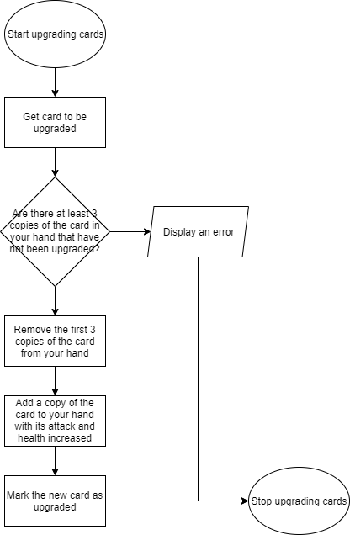

combineCard = getUpgrade()

For each card in playerHand:

If card == combineCard and card not upgraded: // Loops through each card in the combining player’s hand to check if the card is the same as the card to be upgraded

Count += 1 // Increments the number of combined cards by 1

removeList += card // Adds the card found to the removal list so it can be removed before being re-added in its upgraded form

if Count == 3:

break loop // Exits the loop if count is 3 so that no additional cards get removed past 3

If Count == 3: // Checks that a sufficient amount of cards have been removed

removeCards(removeList)

for each stat in removeList[0] // Doubles the attack and health of the card originally removed from the hand for it to be re-added as more powerful

stat = stat * 2

removeList[0].upgraded = True // Sets the card re-added as “upgraded” so that it cannot be used in combining cards in future as it has already been combined

playerHand += removeList[0]

else:

errorDisplay(“Oops, looks like you cant do that right now, you don’t have enough cards”)

##### Test Plan

|  |  |  |  |
| --- | --- | --- | --- |
| Number | Item | Purpose | Expected Outcome |
| 1 | Combine 3 cards of the same type | Test that the basic functionality of combining cards works as intended | The 3 cards are removed from the hand and are replaced by one copy of the card with double the attack and health which is marked as upgraded |
| 2 | Attempt to combine cards with only one of that card in your hand | Test that the combining does not function if you do not have sufficient cards to combine | The card is not removed from your hand, its stats are not doubled and it is not marked as upgraded. |
| 3 | Attempt to combine cards with 2 regular copies of that card and 1 upgraded copy in your hand | Test that combining normal copies of a card and upgraded copies does not function | The cards are not removed from your hand, none of their stats are doubled and the upgraded card remains upgraded whilst the other two remain not upgraded |
| 4 | Attempt to combine 3 upgraded copies of a card | Test that combining 3 identical upgraded copies of a card does not allow you to upgrade them again | The cards are not removed from your hand, no new cards are added to your hand, their stats are not modified, they all remain upgraded |
| 5 | Attempt to combine 3 non upgraded cards with differing stats (i.e. they are the same type but one costs 1 mana less or has 1 more attack from various ingame effects) | Test that combining cards works regardless of the stat changes that have occurred on the card throughout the course of the game | The cards are removed from your hand, the leftmost card in your hand is used as the card from which the stats are doubled. The card is re-added to your hand with the attack and health of the leftmost card in your hand doubled and it is marked as upgraded. |
| 6 | Attempt to combine a card when you have more than 3 copies of it in your hand | Make sure that only 3 copies of the card are consumed when upgrading cards | 3 of the cards are removed from your hand and one is re-added with its stats doubled and marked as upgraded. The rest of the cards in your hand remain untouched (i.e. they are not marked as upgraded, no stats on them are changed and they are not removed from your hand) |

### 8) Implementation of local multiplayer against another human player

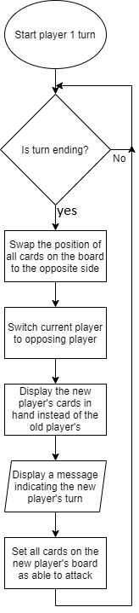Allows the game to switch between players and for the user to play as both player 1 and 2 so that local multiplayer can be achieved

If turn.ending:

For each card in playerBoard[currentPlayer]: // Loops through each card in the current player’s board and swaps it with the card in that position on the opposing player’s board, meaning that their positions visually swap when displayed on turn change

Card.swap()

currentPlayer = opposingPlayer // Switches the current player to the opposing player

display(playerHand[currentPlayer]) // Displays the new hand of the current player in place of the hand of the old player

display(“It is now player” + currentPlayer + “’s turn”) // Indicates that the current player has changed over

for each card in playerBoard[currentPlayer]:

card.canAttack = True // Makes each card in the new current player’s board able to attack

##### Test Plan

|  |  |  |  |
| --- | --- | --- | --- |
| Number | Item | Purpose | Expected Result |
| 1 | End the turn with no cards on the board | Test that ending the turn works correctly when there’re no items on the board | No cards will swap sides as there are no cards to swap, the rest of the ending of the turn functions as intended |
| 2 | End the turn with the full amount of cards in each player’s board | Test that no board size limits are exceeded when swapping full boards of cards | All cards will swap sides keeping their position on the board without exceeding board length limits or otherwise crashing the program. All other parts of the turn ending function as intended. |
| 3 | End the turn with a different amount of cards on each player’s board | Test that swapping a card with a blank space works as intended | All cards swap with the opposite position on the board, whether they be populated by a card or not. All other parts of the turn ending function as intended. |

## Design of Screen layouts

### Main Board

The basic screen of the game should look as follows, with a clear colour difference indicated on the board so players can tell themselves apart.

The colours red and blue were chosen as they contrast the best and are very clearly recognisable when they change positions.

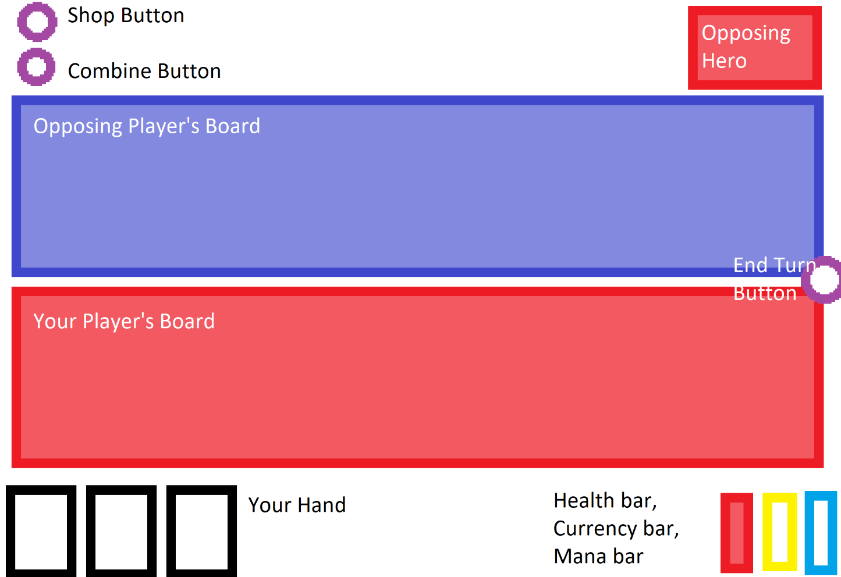

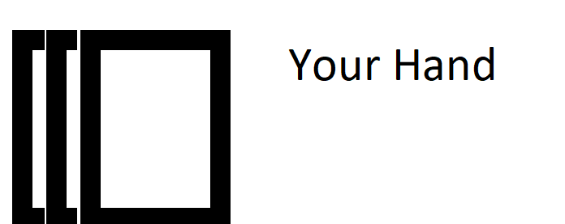The current player’s cards should be displayed at the bottom right of the screen and should fan out so they are easier to interact with when the mouse moves near, moving from close together as you would naturally hold them in your hand as shown below:

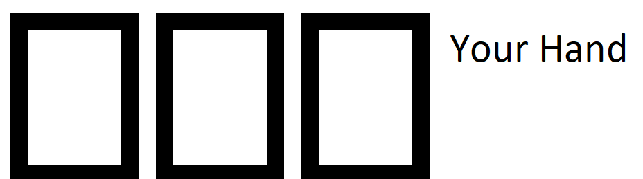To spread apart so that they can be more easily interacted with in a digital medium as such:

This is done so that cards will not initially clutter the screen and will feel more real as they respond to your mouse’s movement.

The current player’s health should be displayed at the bottom right alongside that player’s currency and mana values. This will switch whenever the current player switches. The colours of each side of the board will swap on turn end so that the current player can be known more easily as the image below shows:

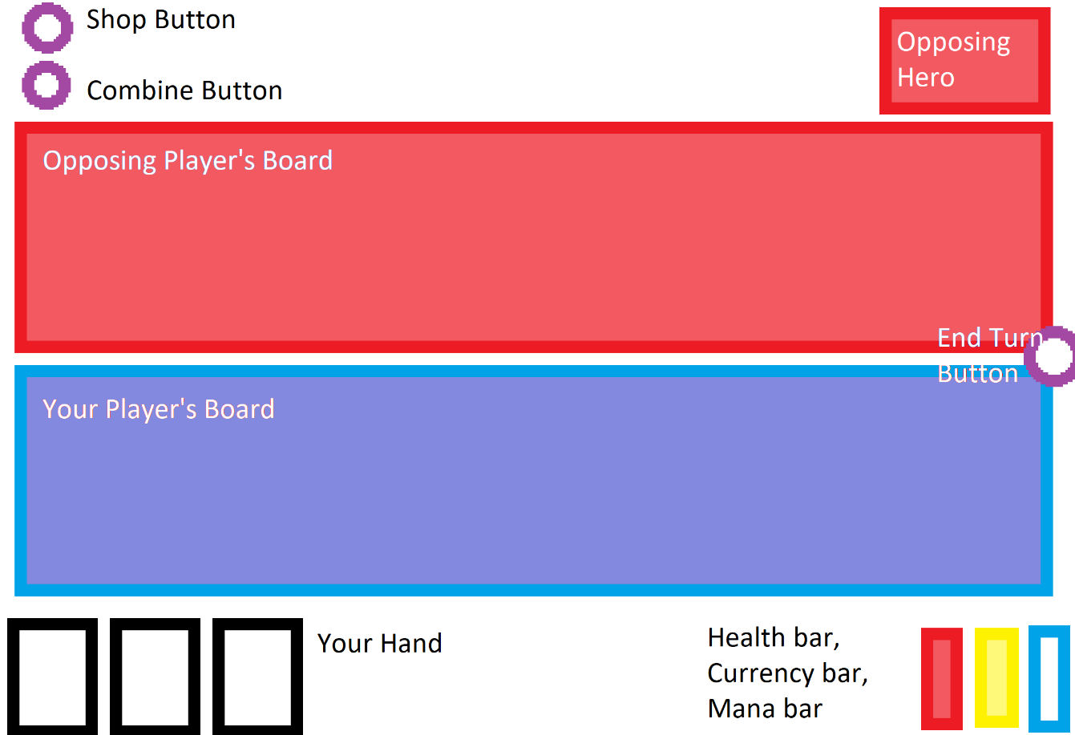

When the shop button (the top right button on the screen) is clicked the shop will be opened as follows

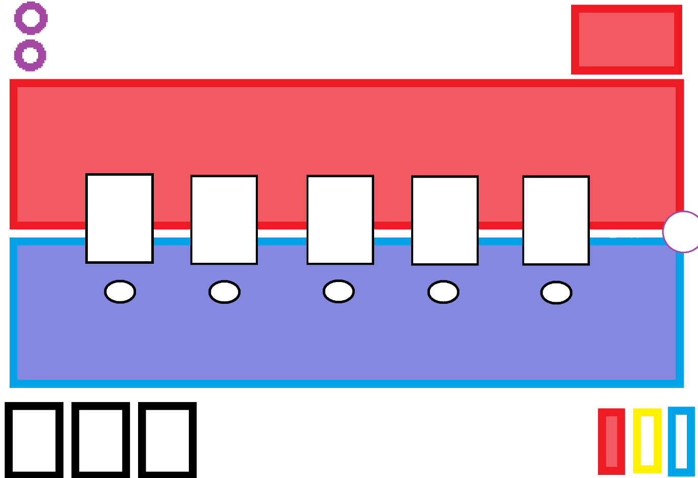Where the white rectangles in the middle of the board represent the cards that can be bought and the ovals underneath them represent buttons that can be used to buy them.

These cards that can be bought vary each turn for each player or a new button which appears next to the shop button can be clicked to refresh the items within the shop. This button is initially not there so as to prevent confusion for players as it will not display any visible change if it were to be pressed when the shop was closed as its only function is to change the cards currently available in the shop.

These buttons are separate from the cards themselves to make it clear to the player what the buttons will do instead of just having unlabelled cards hovering in the centre of the screen.

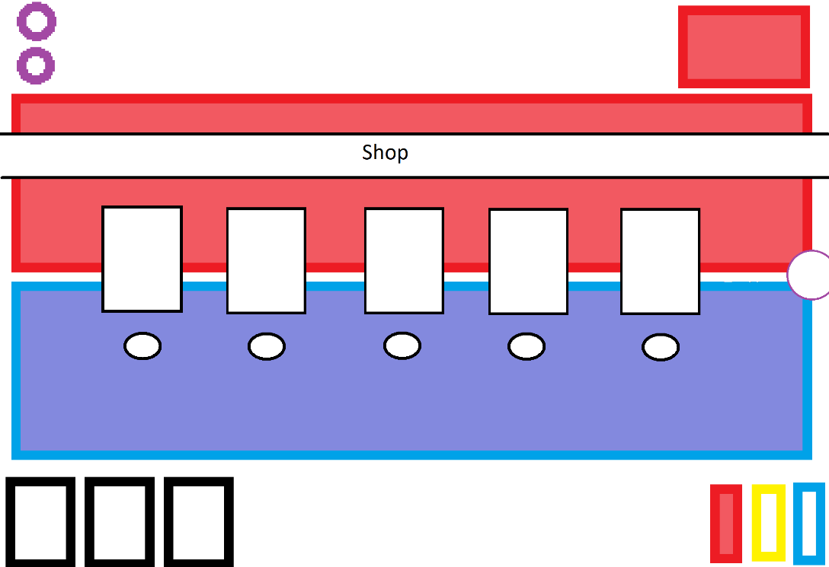The shop will be closeable with the same shop button in which case the board will look as it originally did before the shop was rendered. Another possible design is to have a banner stating that the shop is open above the shop as follows in order to be more obvious for the player:

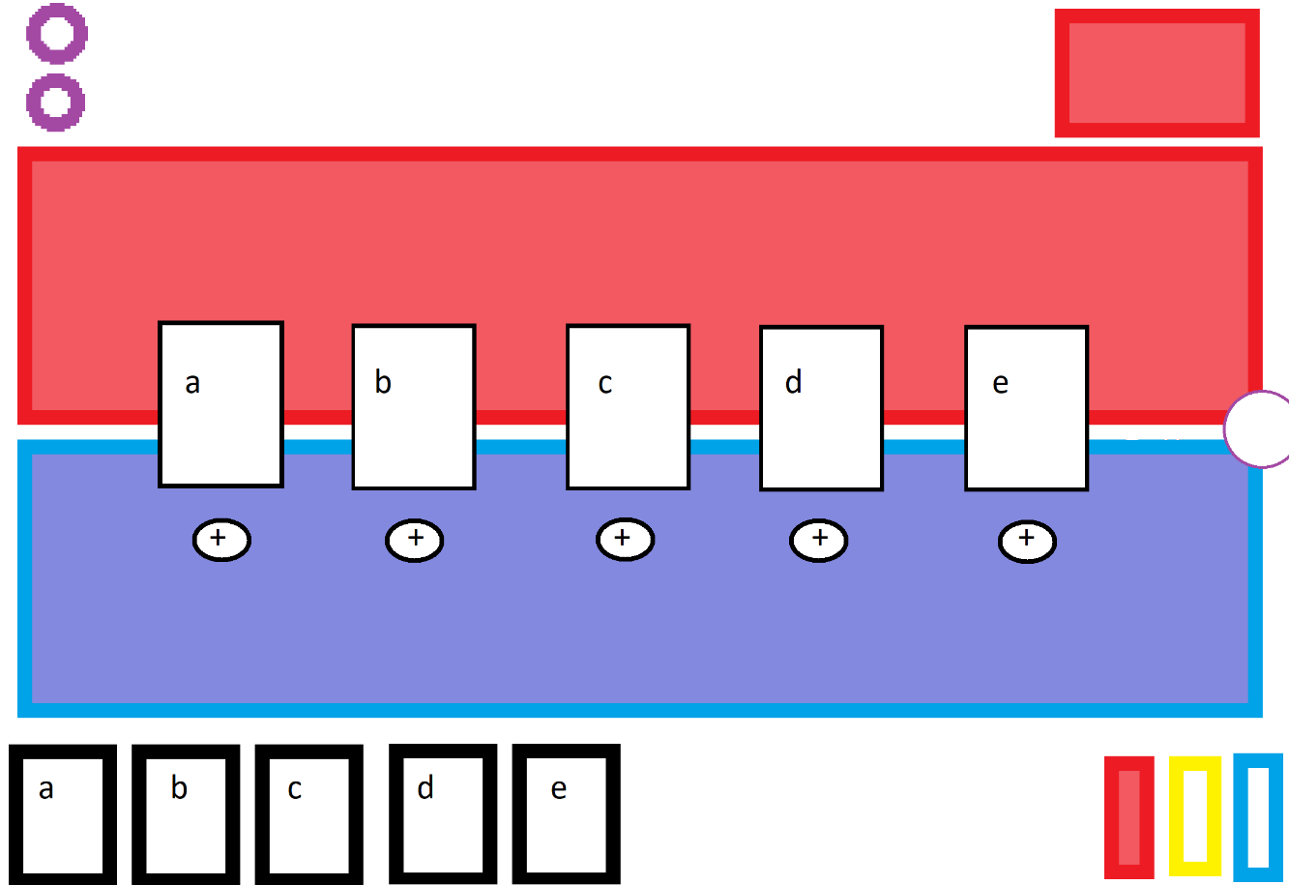When the combine button is pressed the combine screen will open. If the shop is currently open at that time the shop will close and the combine screen will open in its place. When opened it looks as follows:

Where the cards a, b, c, d and e in the player’s hand correspond to the cards a, b, c, d and e in the shop. The buttons labelled + underneath the cards are the buttons to combine their corresponding card (i.e. the card directly above them) and are done this way so that clicking on the cards in the combine screen does not have any unintended effects such as playing the copy of that card present in your hand. This also serves to make the buttons more distinct from the shop buttons and prevents unnecessary confusion on the side of the player.

### Main Menu

For the main menu only a few items are required so the screen should be fairly simple, with bright buttons to stand out from the background and no complex sub-menus to navigate within it so the user has no room for confusion.

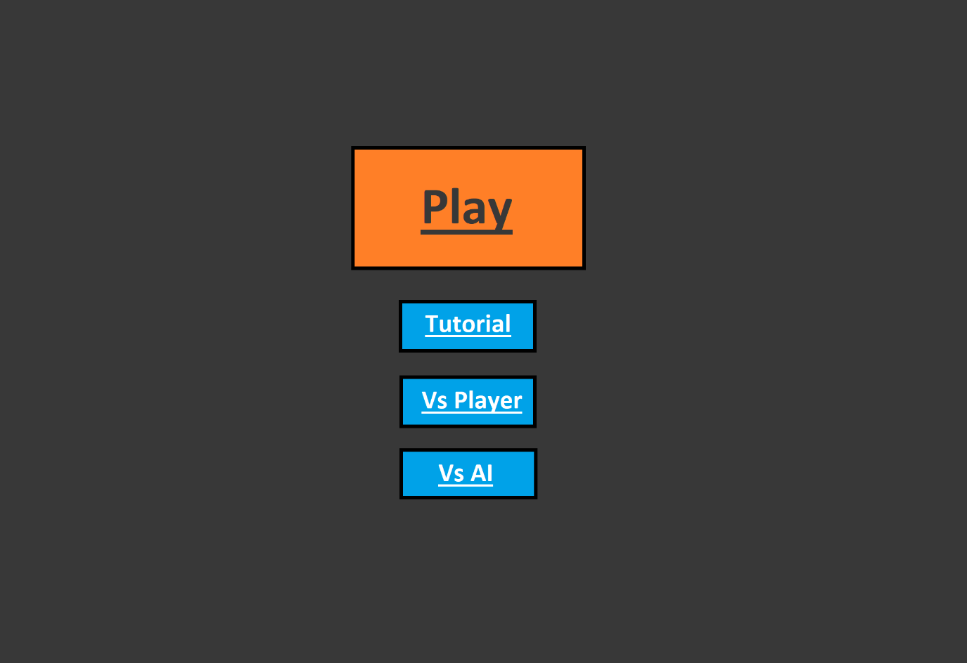

The tutorial button toggles the tutorial messages on and off (these are displayed when the game is launched on the top of the screen). When pressed its colour changes to indicate that it has been highlighted as follows:

The button starts un-highlighted with a black border and a dark blue background

The button’s background colour then brightens and its border becomes white instead of black



The reason that the background both brightens and the border changes colour is so that there is a clearer indication if it has been pressed on systems with lower brightness levels or to users with worse eyesight.

The “Vs Player” and “Vs AI” buttons are mutually exclusive (i.e. you cannot both be playing against another player and an artificial intelligence simultaneously) so when one is pressed the other is switched off and vice versa. The game cannot be played when neither has been highlighted so one button is selected as the default mode that will be considered pressed when the program is launched.

The “Play” button is the largest as it is the one that the user must press to launch the game itself, it is also a different colour from the other 3 buttons to allow it to stand out from them. When it is pressed a similar effect occurs, turning from orange with a black border like this:

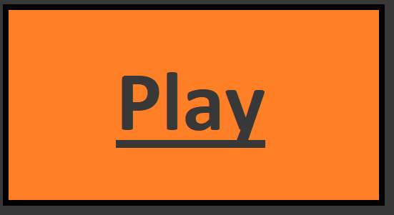

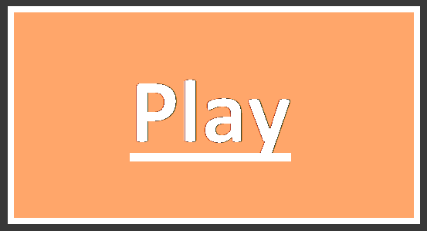To having a white border and text with a lighter background as shown below:

This is only displayed briefly as the game will launch immediately but it allows the user to rest assured they pressed the button and do not need to repeatedly press it in the event that it takes a second or so to launch.

Another possibility is to have, instead of a distinctive colour for the play button, a distinctive shape. This serves a similar purpose and makes for a more unique menu experience.

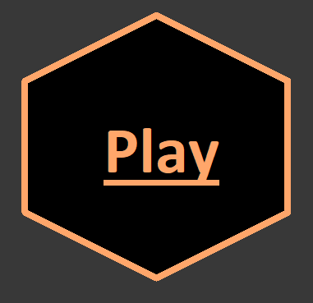For example a hexagonal play button would be ideal for differentiating it from the other buttons due to its distinctly different shape. This type of button may end up looking good in isolation but when combined with other shapes not end up looking as good as I would like.

# Implementation

When starting the implementation I initially made the game text based in order to test out functionality instead of jumping straight into a pygame based iteration.

## Game Loop

### First Iteration

1. **while** **not** done:
2. **print**("__________________________\nPlayer " + str(player.currentPlayer) + "'s Turn\n__________________________\nYou may:")
3. pprint.pprint(["1. Play a minion","2. View the shop", "3. Attack with a minion", "4. End your turn"])
4. choice = 0
5. **while** choice **not** **in** [1,2,3,4]:
6. choice = int(input("Please input your choice [1,2,3 or 4]: "))
7. **if** choice == 1:
8. counter = 0
9. **for** i **in** player.playerHand[player.currentPlayer-1]:
10. **print**(str(counter) + ". " + i.name)
11. counter += 1
12. **print**(str(counter) + ". Back")
13. playChoice = 999
14. **while** playChoice **not** **in** range(0,len(player.playerHand[player.currentPlayer-1])+1):
15. **try**:
16. playChoice = int(input("please input the card you would like to play: "))
17. **except**:
18. **print**("invalid choice")
19. #print(len(player.playerHand[player.currentPlayer-1]))
20. **if** playChoice != len(player.playerHand[player.currentPlayer-1]):
21. player.play(player.playerMana[player.currentPlayer-1],playChoice)

In the first iteration I created a basic game loop with 4 options, I used a heavily class based implementation, with variables and functions in the player class allowing cards to be played. The variable player.playerHand is a list which stores all the cards that are currently in each player’s hand which I used to choose a card to be played using the player.play() function. If the player chose “1” as their option the names of each card in the player’s hand would be displayed alongside an index and the player would be allowed to choose one of the cards displayed to attempt to play (or choose to go back and not play anything). Once the user selects a valid card to play the game will call the player.play() function which will verify whether the player has enough mana to play the card needed and if so then it will be moved from the player’s hand to the board.

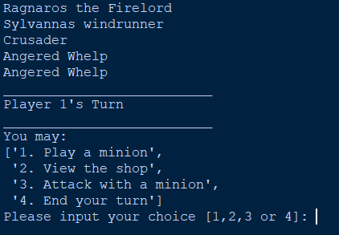

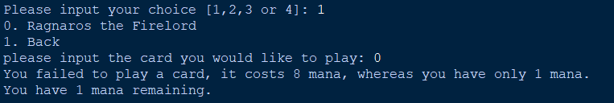

Upon testing out the code for playing cards like this I quickly realized that while in theory it should work correctly I had no way of gaining enough mana to play the cards I needed to play as my endTurn function in the player class had not yet had mana gain implemented.

1. **def** endTurn(self):
2. #Executes the end of turn functions of the cards in play
3. **for** card **in** playerBoard[0]:
4. card.executeFunction(card.endFunc, 1)
5. **for** card **in** playerBoard[1]:
6. card.executeFunction(card.endFunc, 2)
7. #Changes the current player
8. self.playerCurrency[0] += 3
9. self.playerCurrency[1] += 3
10. self.currentPlayer = (self.currentPlayer % 2)+1
11. self.genCards(5)

this was easily changed by simply adding in the lines

1. self.playerMana[0] += 1
2. self.playerMana[1] += 1

which, while not the desired end result for my mana gain mechanic allowed me to test the playing function thoroughly and confirm that it did in fact function correctly.

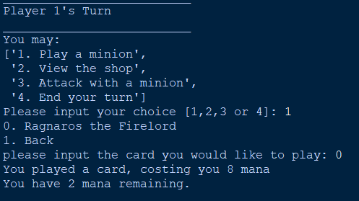

For the second section of the main game loop used very similar methods to the first, looping through each card in the shop to display them next to an index from and allowing you to choose which one you would like to purchase by typing in the index of the selection you would like. The try: except: statement in the validation is to make sure the program will not crash if the user inputs a string as it tries to convert the user’s input into an int, which cannot happen if it is not a number.

1. **elif** choice == 2:
2. counter = 0
3. **print**("The shop has:")
4. **for** i **in** player.forSale:
5. **print**(str(counter)+".",i.name)
6. counter += 1
7. **print**(str(counter) + ". Back")
8. purchaseChoice = 255
9. **while** purchaseChoice **not** **in** range(0,len(player.forSale)+1):
10. **try**:
11. purchaseChoice = int(input("please input the card you would like to buy: "))
12. **except**:
13. **print**("invalid choice")
14. **if** purchaseChoice != len(player.forSale):
15. player.buyCard(purchaseChoice)

This called a function player.buyCard which validated that the player had sufficient currency to buy the card rather than this validation occurring within the game loop in order to improve readability.

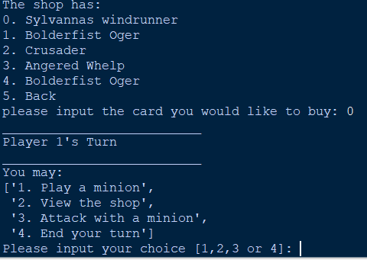

There was, however, an issue. Even though the card was bought there was no indication that anything at all had happened and so I updated the buyCard() function in the player class to include a method of showing what happened.

1. **def** buyCard(self, cardPos):
2. **if** self.playerCurrency[self.currentPlayer-1] >= self.forSale[cardPos].shopCost:
3. #Adds the purchased card to the purchasinc player's hand and removes it from the shop if they have enough currency to buy it
4. self.playerHand[self.currentPlayer-1].append(self.forSale.pop(cardPos))
5. **print**("You bought the card " + self.playerHand[player.currentPlayer-1][len(self.playerHand[player.currentPlayer-1])-1].name + " succesfully.")
6. **else**:
7. **print**("Oops, looks like you dont have enough gold to purchase that card right now!")

The added print statement displaying the name of the latest card in the player’s hand successfully managed to function in the way I intended, displaying the card purchased by the player.

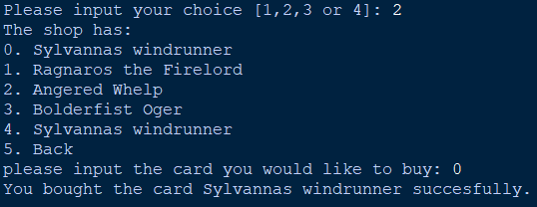

This addition, while not important to the fully pygame-based iteration later was extremely useful in debugging and the function of the first iteration as a useable product.

The third section of the initial game loop is slightly more complicated than the first two

1. **elif** choice == 3:
2. counter = 0
3. **print**("You have " + str(len(player.playerBoard[player.currentPlayer-1])) + " minions, of which:")
4. **for** i **in** player.playerBoard[player.currentPlayer-1]:
5. **if** i.canAttack:
6. **print**(i.name)
7. **print**("Can attack")
8. **for** i **in** player.playerBoard[player.currentPlayer-1]:
9. **print**(str(counter) + ". " + i.name)
10. counter += 1
11. **print**(str(counter) + ". Back")
12. attackChoice = 255
13. **while** attackChoice **not** **in** range(0,len(player.playerBoard[player.currentPlayer-1])+1):
14. **try**:
15. attackChoice = int(input("please input the card you would like to attack with: "))
16. **except**:
17. **print**("invalid choice")
18. enemyChoice = 255
19. **if** player.currentPlayer == 2:
20. playerSwap = 1
21. **else**:
22. playerSwap = 2
23. counter = 0
24. **for** i **in** player.playerBoard[playerSwap-1]:
25. **print**(str(counter) + ". " + i.name)
26. **while** enemyChoice **not** **in** range(0,len(player.playerBoard[playerSwap-1])+1):
27. **try**:
28. enemyChoice = int(input("please input the card you would like to attack: "))
29. **except**:
30. **print**("invalid choice")
31. **if** attackChoice != len(player.playerBoard[player.currentPlayer-1]):
32. player.attack(player.playerBoard[player.currentPlayer-1][attackChoice],player.playerBoard[playerSwap-1][enemyChoice])

This time almost all of the validation was done before the attack function was called as in this text based version higher numbered choices did different things, such as being the back button instead of a valid attack target. This meant that much more validation was needed and as two separate inputs were required, one for the attacking card and one for the card to be attacked, this simply cannot be done later in an efficient manner.

Firstly it loops through all cards for which “canAttack” is True in the current player’s board, displaying the name of each, the player then chooses which of the cards they want to attack with (or alternatively they can select “back” to cancel). When a valid selection has been made here the names of all possible enemy targets are printed and the player can then choose which of them they want to attack. Once this has been selected the player.attack() function is called to make the first selected card attack the second.

\\\\\\\\\\\\\\\\\\\\\\\\\\\\\\\\\\\\\\\\Add testing here\\\\\\\\\\\\\\\\\\\\\\\\\\\\\\\\\\

### Intermediate Iteration (Iteration 1.5)

1. cards = [
2. Ragnaros(),
3. Sylvannas(),
4. Thaurissan(),
5. Crusader(),
6. Whelp(),
7. Ogre()
8. ]
9. done = False
10. **while** **not** done:
11. #Start testing loop
12. mousepos = pygame.mouse.get_pos()
13. player.screen.fill((0,0,0))
14. #Fill background with black ^
15. player.drawCard(mousepos,cards[0])
16. player.drawCard((10,10),cards[1])
17. #Test drawing multiple cards ^
18. pygame.display.update()
19. #Update screen ^
20. pygame.event.pump()
21. #Handle events ^

In this iteration I transitioned between text based and visual gameplay so while doing so I arrived at an iteration in which I tested all the aspects of the visual medium without the restrictions of the game’s ruleset which is why I am not calling this iteration 2. The game was not functional during this iteration but rather this was paving the way so that making the game functional in the long term would be easier.

As such this iteration of the game loop is very short and simplistic, simply filling the background with black and getting the player’s mouse position followed by rendering 2 cards. The first card is rendered statically in the top left corner of the screen and the other is rendered at your mouse’s position on the screen to test out the movement of cards and see whether it operated smoothly.

The “pygame.event.pump()” line is necessary as I have no need for pygame’s events but the module operates in a way in which if your events are not handled the window will crash as it thinks that nothing is happening. This line informs pygame that the game is still running but the events are not needed.

This new testing iteration introduces many new functions to allow for the most efficient drawing of cards possible, paving the way for drawing the many that will be needed for the actual game itself.The first iteration of the drawCard function is extremely simplistic, only drawing a static image of the card in the desired location with a picture to distinguish them on top.

1. **def** __init__(self, cardList):
2. self.playerHealth[0] = 25
3. self.playerHealth[1] = 25
4. self.playerHand[0] = []
5. self.playerBoard[0] = []
6. self.playerBoard[1] = []
7. self.playerHand[1] = []
8. self.playerMaxMana[0] = 1
9. self.playerMaxMana[1] = 1
10. self.playerMana[0] = 1
11. self.playerMana[1] = 1
12. self.globalCardList = cardList
13. self.currentPlayer = 1
14. self.forSale = []
15. self.playerCurrency[0] = 0
16. self.playerCurrency[1] = 0
17. self.cardImage = pygame.image.load("C:\\Users\\Gabriel\\Documents\\GitHub\\Donnan-Project\\Images\\Card.png")
18. self.cardImage = pygame.transform.scale(self.cardImage, (148, 192))
19. #Player class function for drawing a specific card in a desired location
20. #Needs ability to draw text and stats on
21. **def** drawCard(self, location, card):
22. self.screen.blit(self.cardImage,location)
23. self.screen.blit(card.picture,(location[0]+17,location[1]+13))

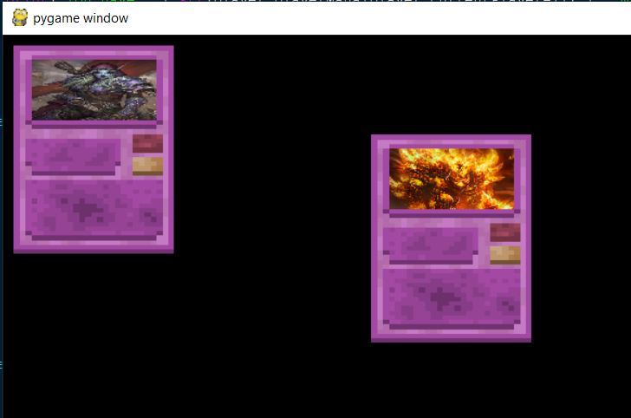

The cardImage variable stores the background card image used for all cards and as such it is stored In the player class but each card has their own picture to distinguish them which is stored within their subclass so that they can be easily separated out and new images can be added easily when a new card subclass is added.

The images for each card are stretched to fit the correct size regardless of the size or shape of the original image, meaning it will always fit but incorrectly shaped images (i.e. images with width to length ratios significantly different to the width to length ratio of the image section of the cards) will end up looking stretched, which is the compromise that has to be made to ensure consistency.

1. **class** CardBase:
2. **def** __init__(self,shopCost,name, mana, attack, health, picture):
3. #for all the func variables the input is a block of text which is passed into generic functions containing only an exec block, this saves me from having to write hundreds of new functions and allows for creations of new cards extremely quickly
4. #The function text defaults to a function that does nothing
5. self.canAttack = False
6. self.name = name
7. self.mana = mana
8. self.health = health
9. self.attack = attack
10. self.shopCost = shopCost
11. #Declare picture and transform it to the correct size so that it overlaps the correct section of the card background image
12. self.picture = pygame.image.load(picture)
13. self.picture = pygame.transform.scale(self.picture, (115, 56))

When images are the incorrect shape for cards they will look like this

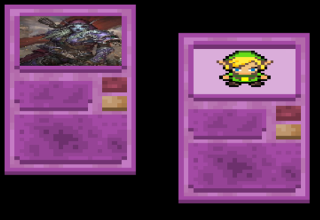

The second image is a perfect square and the first is taller than it is wide, leading to pixilation and horizontal stretching in each. It is possible to get vertical stretching as well if the card was significantly wider than it was tall however this is an unusual image shape.

### Iteration 2

1. **while** **not** done:
2. mousepos = pygame.mouse.get_pos()
3. #Draws the board
4. player.screen.blit(boardPicture,(0,0))
5. #Draws buttons so that they can be interacted with (they could still technically be clicked without being drawn but they would be invisible)
6. shopButton.draw()
7. endButton.draw()
8. closeButton.draw()
9. combineButton.draw()
10. mousepressed = pygame.mouse.get_pressed()[0]
11. **if** menu.tutorial:
12. textBox.draw()
13. **if** pygame.key.get_pressed()[pygame.K_SPACE]:
14. **try**:
15. tutorialCounter +=1
16. textBox = tutorialBoxes[tutorialCounter]
17. time.sleep(0.5)
18. **except**:
19. menu.tutorial = False
20. **if** shopButton.pressed:
21. rerollButton.draw()
22. **if** rerollButton.clickRect.collidepoint(mousepos):
23. player.hoverBox = TextBox("Rerolls the contents of the shop for 1 gold", 20, 8, mousepos)
24. **if** mousepressed:
25. rerollButton.press()
26. time.sleep(0.2)
27. #Checks if the health and attack values of each card have been changed, destroys them if their HP is below 1
28. **if** pygame.mouse.get_pressed()[2]:
29. player.attackHover = False
30. updateCards()
31. #Checks if mouse is collided with the button and is clicked, if so it activates the pressed functions of the buttons
32. **if** endButton.clickRect.collidepoint(mousepos):
33. player.hoverBox = TextBox("Ends the turn", 20, 8, (mousepos[0]-90,mousepos[1]))
34. **if** mousepressed:
35. endButton.press()
36. boardPicture = pygame.transform.flip(boardPicture, 1,1)
37. time.sleep(0.2)
38. **if** shopButton.clickRect.collidepoint(mousepos):
39. player.hoverBox = TextBox("Opens the shop", 20, 8, mousepos)
40. **if** mousepressed:
41. shopButton.press()
42. time.sleep(0.2)
43. **if** combineButton.clickRect.collidepoint(mousepos):
44. player.hoverBox = TextBox("Opens the combine screen", 20, 8, mousepos)
45. **if** mousepressed:
46. combineButton.press()
47. time.sleep(0.2)
48. **if** closeButton.clickRect.collidepoint(mousepos):
49. player.hoverBox = TextBox("Closes the game", 20, 8, (mousepos[0]-100,mousepos[1]))
50. **if** mousepressed:
51. closeButton.press()
52. time.sleep(0.2)
53. **if** shopButton.pressed:
54. shopButton.displayCards()
55. **for** i **in** shopButton.buttons:
56. #Defines the collision rects for each button generated by the shopButton
57. temprect = pygame.Rect(i.coords,(60,27))
58. **if** temprect.collidepoint(mousepos):
59. player.hoverBox = TextBox("Buys the above card", 20, 8, mousepos)
60. **if** mousepressed:
61. i.press()
62. time.sleep(0.1)
63. **elif** combineButton.pressed:
64. combineButton.displayCards()
65. **for** i **in** combineButton.buttons:
66. #Defines the collision rects for each button generated by the combineButton
67. temprect = pygame.Rect(i.coords,(60,27))
68. **if** temprect.collidepoint(mousepos):
69. player.hoverBox = TextBox("Combines the above card with like cards", 20, 8, mousepos)
70. **if** mousepressed:
71. i.press()
72. time.sleep(0.1)
73. #Displays everything on the board and in the hand of players
74. player.boardDisplay(mousepos)
75. **if** player.hoverBox:
76. player.hoverBox.draw()
77. player.hoverBox = None
78. **if** player.attackHover:
79. player.screen.blit(player.cross,(mousepos[0]-32,mousepos[1]-32))
80. #Updates the diplay
81. pygame.display.update()
82. #Checks if the window has been closed (this is essentially functionless for now but it manages events)
83. **if** player.playerHealth[1] < 1:
84. winningPlayer = 1
85. done = True
86. **elif** player.playerHealth[0] < 1:
87. winningPlayer = 2
88. done = True
89. **for** event **in** pygame.event.get():
90. **if** event.type == pygame.QUIT:
91. done = True
92. #player.boardDisplay()
93. endBox = TextBox("Player " + str(winningPlayer) + " wins!", 20, 8, (int(player.screen.get_width()/2),int(player.screen.get_height()/2)))
94. endBox.draw()
95. pygame.display.update()
96. time.sleep(5)
97. pygame.quit()

In this iteration of the game loop it has had to be extended significantly from the initial iteration, as it now has to manage the draw and trigger order of each item on the screen alongside the game’s played functionality.

The loop starts off with getting the player’s mouse position as this is required by many of the functions within the loop and repeatedly attempting to get this as was done in earlier stages of this iteration would be inefficient as it will not realistically change significantly enough to make any difference between the running of 3 lines of code so re-calling this function yields no possible benefit.

The loop then draws the board background and all the buttons are immediately drawn on top of it followed by checking if the player’s mouse is pressed. The reasoning for checking if the player’s mouse is pressed is much the same as the logic behind checking it’s position at the beginning of the loop.

The loop then manages the tutorial. If the tutorial is active the spacebar is then able to be used to increment the current index of the tutorial list and the text box at the current index is drawn on the screen.

After the tutorial has been managed the loop checks each button in turn and sees whether it is collided with the player’s mouse and, if so, whether the player’s mouse is down. If the player’s mouse is down in this situation the button is counted as pressed and the function of the pressed button is called.

If the shop button has been pressed the loop also reveals the cards in the shop, which are all rendered and underneath each a buy button is rendered, the clicking of which is also managed by the game loop.

After all these buttons have been rendered and checked for clicks the “boardDisplay” function is called to draw all the cards onto the player’s board (provided the shop and combination screen are closed)

Finally the loop checks whether either player is below 1 health. If this is the case then the other player is marked as victorious and the loop is bombed out of. The winning player is then displayed on the screen and the game closes itself.

#### Nice to have

I would like to have added the functionality that you can only press a button by clicking while the mouse is on top of the button rather than clicking anywhere and dragging the mouse on top of the button, as this would make the game more robust feeling, as it would be more realistic towards actual buttons.

## Player Class

### First Iteration

1. **class** Player:
2. playerHealth = [None,None]
3. playerHand = [None,None]
4. playerBoard = [None,None]
5. playerMana = [None,None]
6. playerCurrency = [None,None]
7. **def** __init__(self, cardList):
8. self.playerHealth[0] = 25
9. self.playerHealth[1] = 25
10. self.playerHand[0] = []
11. self.playerBoard[0] = []
12. self.playerBoard[1] = []
13. self.playerHand[1] = []
14. self.playerMana[0] = 10
15. self.playerMana[1] = 10
16. self.globalCardList = cardList
17. self.currentPlayer = 1
18. self.forSale = []
19. self.playerCurrency[0] = 20
20. self.playerCurrency[1] = 20

The player class is what manages most of the gameplay and as such is used many times in the game loop. It is initialized with a health value for each player, what is in each player’s hand and board, each player’s starting mana value and currency value alongside other things. The list “cardList” contained declared versions of each card object so they could be more easily generated by the genCards() function

1. **def** genCards(self, amount):
2. displaylist = []
3. #randomly generates (amount) cards from the globalCardList (list of all possible cards) and prints their name, will display them for purchase later and replace card drawing
4. **for** i **in** range(amount):
5. displaylist.append(random.choice(self.globalCardList))
6. self.forSale = displaylist
7. **for** i **in** self.forSale:
8. **print**(i.name)

This function randomly chooses (amount) times from the globalCardList class variable and appends them to a list “displayList” which replaces the items in the shop and then prints each item in it once completed.

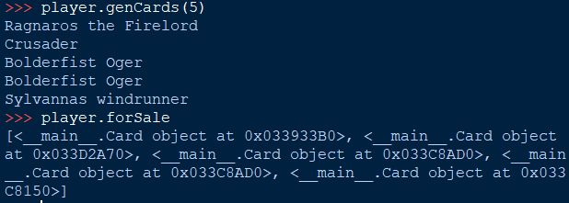

The items in the shop are Card objects as this makes moving them from the shop to your hand and from the hand to the board while acting as they should (i.e. calling played functions) extremely easy.

1. **def** buyCard(self, cardPos):
2. **if** self.playerCurrency[self.currentPlayer-1] >= self.forSale[cardPos].shopCost:
3. #Adds the purchased card to the purchasinc player's hand and removes it from the shop if they have enough currency to buy it
4. self.playerHand[self.currentPlayer-1].append(self.forSale.pop(cardPos))
5. **print**("You bought the card " + self.playerHand[player.currentPlayer-1][len(self.playerHand[player.currentPlayer-1])-1].name + " succesfully.")
6. **else**:
7. **print**("Oops, looks like you dont have enough gold to purchase that card right now!")

The buyCard() function follows on logically from the genCards() function, taking in a card position of the item you want to buy in the shop and checking if you have sufficient currency to buy it, if you do then the card is moved from the player.forSale[] list to the player.playerHand[] list for the current player, printing a message depending on whether you are able to successfully do it.

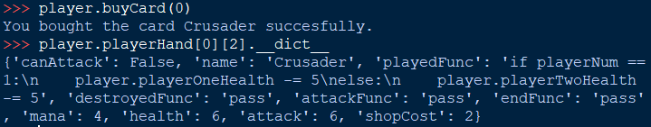

However upon testing I found that if you tried to buy a card larger than the maximum index of the hand an exception would occur (this most often happened when trying to buy the first card after everything had already been bought)

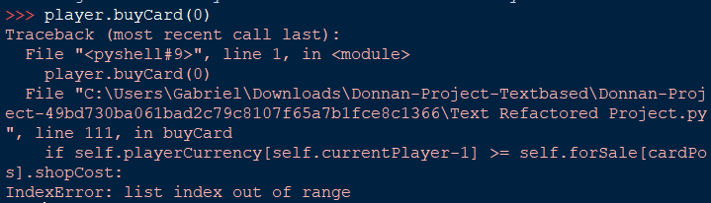

As such I edited the code to include the statement

**if** player.forSale[cardPos]:

at the beginning of the function to check whether the index exists in the forSale list to prevent crashes such as these

1. **def** boardDisplay(self):
2. #Update this with pygame stuff later, simple visualiser for logic for now
3. **print**("\n[][] Player One Board [][]")
4. **for** i **in** self.playerBoard[0]:
5. **print**("[] " + i.name + " []")
6. **print**("\n[][] Player Two Board [] []")
7. **for** i **in** self.playerBoard[1]:
8. **print**("[] " + i.name + " []")

The player.boardDisplay() function was relatively simple and was called after every change in the board state, displaying the names of the cards on each player’s board. It takes no inputs as it’s function is always the same

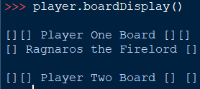

The attack function is significantly more complicated

1. **def** attack(self, card1, card2):
2. self.boardDisplay()
3. card1.executeFunction(card1.attackFunc, self.currentPlayer)
4. card2.health -= card1.attack
5. card1.health -= card2.attack
6. **if** self.currentPlayer == 1:
7. **if** card1.health <= 0:
8. self.destroy(card1, 1)
9. **if** card1.health <= 0:
10. self.destroy(card2, 2)
11. **else**:
12. **if** card1.health <= 0:
13. self.destroy(card1, 2)
14. **if** card1.health <= 0:
15. self.destroy(card2, 1)

It takes in the arguments “card1” and “card2”, where “card1” is the attacker and “card2” is defending. For the attacking card it calls the card.executeFunction() function on its attack function, effectively calling a function specific to each card that occurs when they attack affecting the board in different ways depending on their attackFunc variable.

The health of each card is reduced by the attack of the other card and each card’s health is checked after this to call player.destroy() on them if they have less than 1 health.

1. **def** destroy(self,card, player):
2. card.executeFunction(card.destroyedFunc, player)
3. **if** player == 1:
4. (self.playerBoard[0]).remove(card)
5. **else**:
6. (self.playerBoard[1]).remove(card)

Player.destroy() takes a card and player input to remove the card from a specified player’s board and calls card.executeFunction on the card’s destroyedFunc to perform a specific action to each card that happens when they die. The player input is taken so that the program knows which player’s board to remove the card from, in an earlier implementation I did not have this and as such it crashed whenever a friendly card was destroyed on your turn.

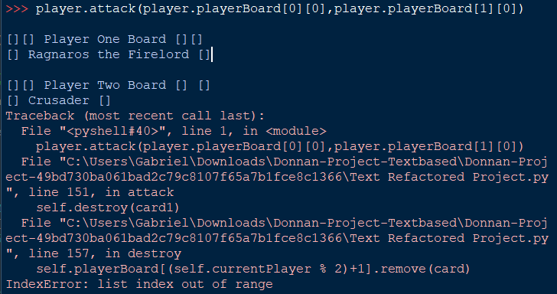

The player.endTurn() function is called at the end of each player’s turn to enact the changeover from one player to the other

1. **def** endTurn(self):
2. #Executes the end of turn functions of the cards in play
3. **for** card **in** self.playerBoard[0]:
4. card.executeFunction(card.endFunc, 1)
5. **for** card **in** self.playerBoard[1]:
6. card.executeFunction(card.endFunc, 2)
7. #Changes the current player
8. self.playerCurrency[0] += 3
9. self.playerCurrency[1] += 3
10. self.currentPlayer = (self.currentPlayer % 2)+1
11. 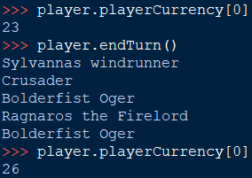    self.genCards(5)

This is done relatively simply by performing the modulus 2 on the self.currentPlayer variable and incrementing by one. It also triggers the endFunc for each card in each player’s board and increases the currency of each player by 3 and calls player.genCards() so that new cards may be bought each round. The function requires no inputs as it is the same in all situations in its functionality.

The final function in the first implementation of the player class was player.play()

1. **def** play(self, mana, cardPos):
2. card_played = self.playerHand[self.currentPlayer-1][cardPos]
3. #Checks if the card you're trying to play costs too much
4. **if** card_played.mana <= mana:
5. self.playerBoard[self.currentPlayer-1].append((self.playerHand[self.currentPlayer-1]).pop(cardPos))
6. card_played.executeFunction(card_played.playedFunc,1)
7. mana -= card_played.mana
8. **print**("You played a card, costing you " + str(card_played.mana) + " mana")
9. **else**:
10. **print**("You failed to play a card, it costs " + str(card_played.mana) + " mana, whereas you have only " + str(mana) + " mana.")
11. **print**("You have " + str(mana) + " mana remaining.")
12. **return** mana

This takes a mana and cardPos value as inputs and returns a mana value at the end after the card has either been played or the player has failed to play the card. The function uses the cardPos variable to find the position of the card the player wants to play within their hand, this makes playing cards easier when using text inputs as the user can simply input an index to play.

The function then checks the mana input against the mana cost of the card, if the mana input is higher than or equal to the cost of the card the card is popped from the player’s hand and appended to their board, triggering their playedFunc and producing a text output. The removal of the card from the player’s hand and adding it to the board are done in the same line, first popping the card from the player’s hand then immediately adding it to the board so that it is effectively instantaneous and to make sure that no logic can be programmed between these points as it would be one action in the real world.

### Intermediate Iteration (Iteration 1.5)

There are relatively few changes to the player class in this iteration, only adding a function to draw cards on the screen and a variable containing the background image of cards.

These have been covered in the game loop section as they tied in directly to the limited function of the testing as there is no more complicated logic required for the loop itself in this iteration.

Archaic functions in which text was output were removed so that the game can be completely visually based, these were replaced by placeholder functions which will later be developed into pygame based implementations of their previous functions.

One example of this which will later be made to draw all the cards on both player’s side of the board in bulk is:

1. #Placeholder, will be made to draw cards on board later
2. **def** drawScreen(self):
3. #Fills screen with solid colour and updates screen, cards should be done between these later
4. screen.fill((255,255,0))
5. pygame.display.update()

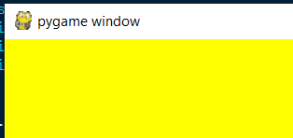

Currently all the function does is make the screen solid yellow.

The card drawing function in this iteration started as below, only drawing the card background and card image.

1. **def** drawCard(self, location, card):
2. self.screen.blit(self.cardImage,location)
3. self.screen.blit(card.picture,(location[0]+17,location[1]+13))

It was later modified to draw the attack and health values of the cards, the size of these does not need to be automatically scaled as they are never practically large enough numbers to fall off the edge of the card. The names of the cards are also drawn here but they cannot be too long or they will extend too far off the card

1. **def** drawCard(self, location, card):
2. #centres the image of the card instead of using the top left
3. location = (location[0]-74,location[1]-96)
4. self.screen.blit(self.cardImage,location)
5. self.screen.blit(card.picture,(location[0]+17,location[1]+13))
6. self.screen.blit(card.nameText,(location[0]+17,location[1]+86))
7. self.screen.blit(card.hpText,(location[0]+112,location[1]+79))
8. self.screen.blit(card.atkText,(location[0]+112,location[1]+100))

on line 3 the location value is changed so that it represents the centre of the card rather than the corner, meaning that placing the card on the screen in the correct location is easier and more intuitive.

### Iteration 2

In this iteration of the player class many functions change as the functionality of the game is implemented around the class, meaning many of the functions have had to have been edited to accommodate this.

1. **class** Player:
2. os.environ['SDL_VIDEO_WINDOW_POS'] = "0,0"
3. displayInfo = pygame.display.Info()
4. #For some reason you need to resize the image to 0.83 of the detected monitor resolution as it is too big otherwise
5. screen = pygame.display.set_mode((int(displayInfo.current_w*0.8), int(displayInfo.current_h*0.8)), pygame.NOFRAME)
6. coinIcon = [None]*15
7. manaIcon = [None]*11
8. moneyIcon = [None]*11
9. **def** __init__(self, cardList):
10. **for** i **in** range(0,11):
11. self.manaIcon[i] = pygame.transform.scale(pygame.image.load("Images\\Mana" + str(i) + ".png"),(90,120))
12. **for** i **in** range(0,11):
13. self.moneyIcon[i] = pygame.transform.scale(pygame.image.load("Images\\Money" + str(i) + ".png"),(90,120))
14. #Loads and scales all of the coin images
15. self.hoverBox = None
16. self.coinIcon[0] = pygame.transform.scale(pygame.image.load("Images\\Coin.png"),(45,45))
17. self.coinIcon[1] = pygame.transform.scale(pygame.image.load("Images\\Coin2.png"),(45,45))
18. self.coinIcon[2] = pygame.transform.scale(pygame.image.load("Images\\Coin3.png"),(45,45))
19. self.coinIcon[3] = pygame.transform.scale(pygame.image.load("Images\\Coin4.png"),(45,45))
20. self.coinIcon[4] = pygame.transform.scale(pygame.image.load("Images\\Coin5.png"),(45,45))
21. self.coinIcon[5] = pygame.transform.scale(pygame.image.load("Images\\ManaCoin0.png"),(45,45))
22. self.coinIcon[6] = pygame.transform.scale(pygame.image.load("Images\\ManaCoin.png"),(45,45))
23. self.coinIcon[7] = pygame.transform.scale(pygame.image.load("Images\\ManaCoin2.png"),(45,45))
24. self.coinIcon[8] = pygame.transform.scale(pygame.image.load("Images\\ManaCoin3.png"),(45,45))
25. self.coinIcon[9] = pygame.transform.scale(pygame.image.load("Images\\ManaCoin4.png"),(45,45))
26. self.coinIcon[10] = pygame.transform.scale(pygame.image.load("Images\\ManaCoin5.png"),(45,45))
27. self.coinIcon[11] = pygame.transform.scale(pygame.image.load("Images\\ManaCoin6.png"),(45,45))
28. self.coinIcon[12] = pygame.transform.scale(pygame.image.load("Images\\ManaCoin7.png"),(45,45))
29. self.coinIcon[13] = pygame.transform.scale(pygame.image.load("Images\\ManaCoin8.png"),(45,45))
30. self.coinIcon[14] = pygame.transform.scale(pygame.image.load("Images\\ManaCoin9.png"),(45,45))
31. self.cross = pygame.transform.scale(pygame.image.load("Images\\Cross.png"),(65,65))
32. self.heroPortrait = pygame.transform.scale(pygame.image.load("Images\\HeroPortrait.png"),(300,250))
33. self.heroPortraitHover = pygame.transform.scale(pygame.image.load("Images\\HeroPortraitHover.png"),(300,250))
34. #Initialises all class variables, can be improved in line efficiency
35. self.playerHealth = [25,25]
36. self.playerHand = [[],[]]
37. self.playerBoard = [[],[]]
38. self.playerMaxMana = [1,1]
39. self.playerMana = [1,1]
40. self.globalCardList = cardList
41. self.currentPlayer = 1
42. self.forSale = []
43. self.playerCurrency = [1,2]
44. self.attackHover = False
45. #Initialises and scales the card background images
46. self.cardImageHover = pygame.transform.scale(pygame.image.load("Images\\CardHover.png"), (148, 192))
47. self.cardAttackImage = pygame.transform.scale(pygame.image.load("Images\\CardAttacking.png"),(148,192))
48. self.cardImage = pygame.transform.scale(pygame.image.load("Images\\Card.png"), (148, 192))

The initialisation statement has increased in size significantly in this iteration as the mana and currency cost icons have to be initialised alongside the icons for the mana and currency bars for each possible value (0 to 10). These additions are simply additional declarations however, with little functionality provided to the class from them and are just needed for the game to be visually more appealing rather than for it to work.

1. **def** combineCards(self, card):
2. #Takes a card and removes all instances of it from your hand then calls upgradeCard on it
3. combinationCounter = 0
4. removed = []
5. **for** i **in** player.playerHand[player.currentPlayer-1]:
6. #Checks if the cards are all identical (i.e. you cannot combine an un-upgraded card and an upgraded one)
7. **if** i.name == card.name **and** combinationCounter < 3 **and** **not** i.upgraded **and** **not** card.upgraded:
8. removed.append(i)
9. combinationCounter += 1
10. #Checks if you have enough cards to combine
11. **if** len(removed) > 2:
12. **for** i **in** removed:
13. player.playerHand[player.currentPlayer-1].remove(i)
14. #Adds the upgraded card to the player's hand
15. player.playerHand[player.currentPlayer-1].append(player.upgradeCard(removed))

In this iteration of the player class the function to combine cards is added in, taking 3 copies of a card from the player’s hand and adding a copy of it back into the hand with the attack and health doubled with the cost reduced by one. The function checks if the cards have been upgraded before to make sure that they cannot be upgraded any further and that they can not be upgraded using 1 upgraded card and 2 non upgraded cards.

The function then calls a separate “upgrade” function when it has verified that there are enough cards in the player’s hand to combine into one:

1. **def** upgradeCard(self, cards):
2. #Scales the amount your card has been upgraded by the amount of cards used to upgrade it
3. cards[0].attack = cards[0].attack*2
4. cards[0].health = cards[0].health*2
5. cards[0].upgraded = True
6. **if** cards[0].mana > 0:
7. cards[0].mana -= 1
8. **return** cards[0]

This function simply takes the first of the card you have chosen in your and applies the stat changes, returning the card to the player’s hand afterwards.

The simple function “drawCoin” was added so that the coins for the mana and shop cost icons can be drawn on top of the cards when displayed.

1. **def** drawCoin(self, value, location):
2. location = (location[0]-22,location[1]-22)
3. self.screen.blit(self.coinIcon[value-1], location)

It simply takes the value of the coin to be drawn as well as a location and draws the coin at that specific value that has been input at the desired location.

In this iteration the “buyCard” function is updated to work with the pygame implementation of the game as opposed to the old text based implementation.

1. **def** buyCard(self, card):
2. #Checks if you can buy the card you want to buy (i.e. you have enough currency, your hand is not full)
3. **if** self.playerCurrency[self.currentPlayer-1] >= card.shopCost **and** len(player.playerHand[player.currentPlayer-1])<9:
4. self.playerCurrency[self.currentPlayer-1] -= card.shopCost
5. self.forSale.remove(card)
6. #Adds the purchased card to the purchasinc player's hand and removes it from the shop if they have enough currency to buy it
7. self.playerHand[self.currentPlayer-1].append(card)
8. **if** len(self.forSale) == 0:
9. shopButton.pressed = False

This means that instead of taking the index of the card in your hand and buying that it takes an input of the card object itself as this is much easier to implement when you can click on a visual buy button instead of giving the input of which card in the shop you want to buy. The function then simply checks the cost of the card input you wanted to buy against the current player’s current currency value and if it is enough then the cost is deducted and the card is added to the player’s hand.

The attack function was changed for this iteration as well as there can now be an indefinite amount of time between when the player decides that they want to attack and the time that the attack ends up going through and as such a class variable “attackHover” is required to indicate the user has initiated an attack.

1. **def** attack(self, card1, card2):
2. #Allows one card to attack another if it can attack
3. **if** card1.canAttack:
4. #Calls the "attacking" function of the card, triggering specific effects the card may enact when attacking
5. card1.attacking()
6. #Damages each card's health for the attack value of the other
7. card2.health -= card1.attack
8. card1.health -= card2.attack
9. card1.canAttack = False
10. self.attackHover = False
11. **else**:
12. self.attackHover = False

The function can only be called if the “attackHover” variable is true. If this is the case then 2 card inputs are taken, one of the attacker and one of the attacked card, if the attacker is able to attack then the attack goes through, disabling the “attackHover” variable, toggling the “canAttack” variable to false and reducing the health of each card by the attack of the other whilst calling the attacking function for the card that initiates the attack.

The “destroy” function of the player class has also been updated to be more concise and also to accommodate the card “dreadsteed” which is a special case as it cannot be destroyed.

1. **def** destroy(self,card, player):
2. #Enacts the "destroyed" function of a card and removes it from the board when it dies, this has some bugs when removing larger amounts of cards
3. #And as such I may have to allow it to take lists of cards to destroy
4. **if** card.name != "Dreadsteed":
5. card.destroyed()
6. (self.playerBoard[player]).remove(card)
7. **else**:
8. card.health = 1

It simply calls the destroyed effect of the card and removes it from the player’s board on which it has been destroyed.

The function to draw cards is now added in this iteration to render the cards generically in whatever location they need be rendered. This is used for every time cards are drawn, including rendering the shop, the player’s hand and the board.

1. **def** drawCard(self, location, card):
2. mousepos = pygame.mouse.get_pos()
3. #centres the image of the card instead of using the top left
4. location = (location[0]-74,location[1]-96)
5. #Checks if the mouse is colliding with the card
6. **if** (mousepos[0]>location[0] **and** mousepos[0]<location[0]+148)**and**(mousepos[1]>location[1] **and** mousepos[1]<location[1]+192):
7. **try**:
8. **if** self.attackHover **and** pygame.mouse.get_pressed()[0] **and** card **in** self.playerBoard[(self.currentPlayer % 2)]:
9. player.attack(self.attacker,card)
10. self.attackHover = False

The function takes the inputs of a location and a card to render. The card to render defines the stats (mana, health and attack), text and image of the card and the location defines where on the screen the card gets displayed. When the player’s mouse is hovering over the card instead a highlighted version of the background image is displayed to indicate to the user that they are in contact with the card and any valid interactions will register.

1. **except**:
2. **pass**
3. #Checks if the mouse is down and the card is in the player's hand so that the .play function can be called, will add the same but for .attack later
4. **if** pygame.mouse.get_pressed()[0] **and** card **in** self.playerHand[player.currentPlayer-1] **and** **not** shopButton.pressed **and** **not** combineButton.pressed:
5. #Plays card if you're hovering over it, click and have enough mana to play it (wierd to have it in this function but it works ok, dont judge me)
6. self.play(player.playerHand[player.currentPlayer-1].index(card))
7. #Rests for 0.2 seconds so that a brief click of the mouse will not rapidfire buy lots of cards
8. time.sleep(0.2)
9. self.attackHover = False
10. **if** pygame.mouse.get_pressed()[0] **and** card **in** self.playerBoard[self.currentPlayer-1] **and** card.canAttack:
11. self.attackHover = True
12. self.attacker = card
13. #add attack selector function
14. self.screen.blit(self.cardImageHover,location)
15. **elif** card.canAttack:
16. self.screen.blit(self.cardAttackImage,location)
17. **else**:
18. self.screen.blit(self.cardImage,location)
19. #Draws the text of all relevant attributes of the card in the correct locations on the card so that they can be changed dynamically and will not need to be "hard drawn"
20. self.screen.blit(card.picture,(location[0]+17,location[1]+13))
21. self.screen.blit(card.nameText,(location[0]+17,location[1]+86))
22. self.screen.blit(card.hpText,(location[0]+112,location[1]+79))
23. self.screen.blit(card.atkText,(location[0]+112,location[1]+100))
24. player.drawCoin(card.mana+6,(location[0]+138,location[1]+10))
25. addFactor = 125
26. #Places the scaled text in the correct location and renders it line by line so it does not stretch off the end of the card
27. **for** line **in** card.textDisplay:
28. self.screen.blit(line,(location[0]+17,location[1]+addFactor))
29. addFactor += 11

The second section of the function also contains the trigger for the card playing functions when the card is in your hand as well as the trigger for the “attackHover” variable which indicates that the user is preparing to attack with the card they have clicked.

The function will draw an image of the card with a green outline if it is on the board and can attack, indicating to the player which cards they are able to attack with that they have not yet used.

1. **def** endTurn(self):
2. self.attackHover = False
3. #Executes the end of turn functions of the cards in play
4. **for** card **in** self.playerBoard[self.currentPlayer-1]:
5. card.end()
6. #Changes the current player and gives both players currency
7. self.playerCurrency[player.currentPlayer-1] += 4
8. **if** self.playerCurrency[player.currentPlayer-1] > 10:
9. self.playerCurrency[player.currentPlayer-1] = 10
10. #Increments the maximum mana of each player if it is less than 10
11. **if** self.playerMaxMana[player.currentPlayer-1] < 10:
12. self.playerMaxMana[self.currentPlayer-1] += 1
13. self.playerMana[0] = self.playerMaxMana[0]
14. self.playerMana[1] = self.playerMaxMana[1]
15. #Sets all minions on the board to be able to attack
16. #Changes player
17. **for** i **in** self.playerBoard[player.currentPlayer-1]:
18. i.canAttack = False
19. self.currentPlayer = (self.currentPlayer % 2)+1
20. **for** i **in** self.playerBoard[player.currentPlayer-1]:
21. i.canAttack = True
22. self.genCards(5)

The endTurn function is largely the same as it’s previous iterations, taking no input as it’s function is static. In this iteration the possible amounts of mana and currency that each player can have is capped at 10 and the mana is refreshed each turn by making the playerMana variable equal to the playerMaxMana variable as opposed to being gained at a static rate as currency is, with 4 being added to the playerCurrency variable each time the player ends the turn.

In this iteration the end of turn effects of the cards for the current player are also called upon the turn ending, meaning that only the player who is ending the turn’s card effects will be triggered as opposed to both players. This also disables the attackHover variable, so that one player cannot accidentally attack using the others’ cards when the turn ends.

Very little changed from the first iteration of the “play” function to now, only removing the print statements to indicate whether the card has been played as they are useless in a pygame environment and moving from taking an input of mana, returning it after it has been spent to simply altering a class mana variable.

1. **def** play(self, cardPos):
2. card_played = self.playerHand[self.currentPlayer-1][cardPos]
3. #Checks if the card you're trying to play costs too much
4. **if** card_played.mana <= player.playerMana[player.currentPlayer-1] **and** len(player.playerBoard[player.currentPlayer-1])<8:
5. self.playerBoard[self.currentPlayer-1].append((self.playerHand[self.currentPlayer-1]).pop(cardPos))
6. card_played.played()
7. player.playerMana[player.currentPlayer-1] -= card_played.mana

This iteration of playing cards also checks against the board’s size limit which is important as if it did not do this some cards would end up off the screen when on the board meaning they cannot be interacted with.

During development of this function a card which summoned a copy of itself allowed this board limit to be surpassed and as such an unusable card was summoned. In order to remediate this an extra clause was added into the duplication function inside the card.

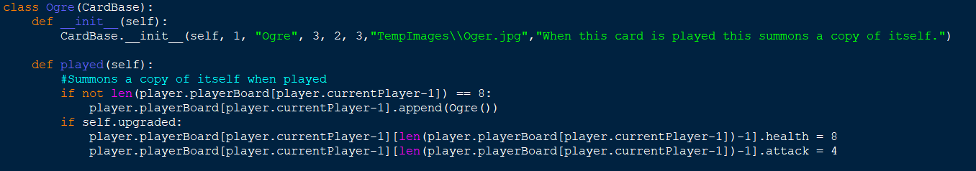

1. **def** boardDisplay(self,mousepos):
2. size = self.screen.get_size()
3. font = pygame.font.SysFont('arial', 16)
4. font.set_bold(True)
5. playerSwap = (self.currentPlayer % 2)+1
6. **if** self.playerCurrency[self.currentPlayer-1]>10:
7. coins = 10
8. **else**:
9. coins = self.playerCurrency[self.currentPlayer-1]
10. self.screen.blit(self.moneyIcon[coins],(size[0]-80,size[1]-130))
11. self.screen.blit(self.manaIcon[self.playerMana[self.currentPlayer-1]],(size[0]-130,size[1]-130))
12. #For drawing contents of hand
13. location = 115
14. **if** mousepos[1] > 550 **and** **not** shopButton.pressed **and** **not** combineButton.pressed:
15. #Moves the cards so they're farther apart if your mouse is further down the screen so they are easier to interact with but make minimal clutter otherwise
16. locFactor = 180
17. heightMod = 115
18. **else**:
19. locFactor = 56
20. heightMod = 25
21. **for** card **in** self.playerHand[self.currentPlayer-1]:
22. self.drawCard((location,size[1]-heightMod),card)
23. location += locFactor
24. #For drawing contents of board
25. **if** **not** shopButton.pressed **and** **not** combineButton.pressed:
26. location = 180
27. #Draws the cards in the board of the current player
28. **for** card **in** self.playerBoard[self.currentPlayer-1]:
29. self.drawCard((location,size[1]-320),card)
30. location += 180
31. location = 180
32. #Draws the cards in the board of the opposing player
33. **for** card **in** self.playerBoard[playerSwap-1]:
34. self.drawCard((location,size[1]-545),card)
35. location += 180
36. heroRect = self.screen.blit(self.heroPortrait,(self.screen.get_width()-375,0))
38. **if** heroRect.collidepoint(mousepos):
39. heroRect = self.screen.blit(self.heroPortraitHover,(self.screen.get_width()-375,0))
40. **if** self.attackHover **and** pygame.mouse.get_pressed()[0]:
41. self.attackHero(self.attacker)
42. **else**:
43. heroRect = self.screen.blit(self.heroPortrait,(player.screen.get_width()-375,0))
44. healthText = font.render(str(self.playerHealth[playerSwap-1]),True,(255,255,255))
45. self.screen.blit(healthText,(self.screen.get_width()-346,213))

The boardDisplay function has had to be completely reworked from the text based implementation of the game as it now must render all the cards the user can see as well as the portraits of both players, the currency and mana indicators for both players and implement the highlighting of all of the pertinent interactable objects that it renders.

It takes only an input of the player’s mouse position as it’s function is fairly static, simply acting as the main function to render each piece of the player’s board without implementing any functionality or requiring any additional information from other parts of the program.

The function manages the currency, making sure it cannot surpass it’s limit of 10. Once this has been managed it can then render the currency icon for the current player at the correct currency value.

The function then checks whether the player’s cursor is in the lower segment of the screen, if it is the cards in the player’s hand are drawn slightly higher on the screen, uniformly spaced so that the user can click on the correct one easily, if not the locFactor variable is reduced so the cards are drawn more closely grouped up in the bottom left side of the screen.

Finally it draws the hero portrait of the opponent’s hero and renders a text surface with their current health, drawing that in the underneath this portrait.

1. **def** attackHero(self, card):
2. playerSwap = (self.currentPlayer % 2)+1
3. card.attacking()
4. self.playerHealth[playerSwap-1] -= card.attack
5. card.canAttack = False
6. self.attackHover = False

Another separate attack function had to be added to cope with the fact that the user can attack both cards and the opposing player with the same action type. This makes the game significantly more intuitive to play as there is no need to differentiate between these types of attacks.

If this function was not used an instead the regular attack function were called the program would crash with the following error:

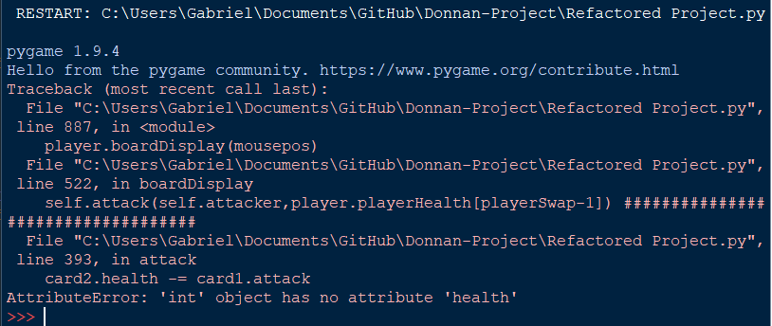

This occurs as the attack method takes in two card objects as an input but the players only exist insofar as their health totals and are not created as objects so if their health is passed in instead of an object it cannot function properly. Even if the players were externally declared as objects an error would occur when trying to call its attacking function as it would not have one.

#### Nice to have

There was insufficient time to add differing pictures to go within the frame for each player’s hero portrait within the boardDisplay function. This is not a required feature but in future iterations of the game adding this would be beneficial to differentiating between the two players when playing.

There is insufficient space on the player’s board to add a health indicator of sufficient size for the current player however if I were to redo the player’s hand spacing code in the future I could add one of these to make the game more welcoming for newer players as they would not need to memorise their health totals between turns.

## Card class

### First iteration

1. **class** Card:
2. **def** __init__(self,shopCost,name, mana, attack, health, playedFunc = "pass", destroyedFunc = "pass", attackFunc = "pass", endFunc = "pass"):
3. #for all the func variables the input is a block of text which is passed into generic functions containing only an exec block, this saves me from having to write hundreds of new functions and allows for creations of new cards extremely quickly
4. #The function text defaults to a function that does nothing
5. self.canAttack = False
6. self.name = name
7. self.playedFunc = playedFunc
8. self.destroyedFunc = destroyedFunc
9. self.attackFunc = attackFunc
10. self.endFunc = endFunc
11. self.mana = mana
12. self.health = health
13. self.attack = attack
14. self.shopCost = shopCost

The Card class is for creating objects out of each card so they can be played and interacted with meaningfully with outside of simply being variables. They are initially defined relatively simply, taking the inputs shopCost, name, mana, attack, health, playedFunc, destroyedFunc, attackFunc and endFunc and assigning each to a variable for the object. Each variable ending in Func was made so that no subclasses would have to be created for the cards, instead allowing specific functions to be passed in as text which was passed to an exec() block whenever they need to be called. Each of these was defaulted to “pass” as if they were called without a value the program would crash as it would try and execute an empty variable.

The function to execute the “func” variables is simply one line

1. **def** executeFunction(self,text, playerNum):
2. **exec**(text)

It takes in a variable “playerNum” alongside the text to be executed. This function may appear to do nothing but it actually is used in the cards’ “func” variables when run to determine what side of the board they are on.

The cards were declared as such

1. cards.append(Card(4,"Ragnaros the Firelord" ,8,2,8,playedFunc = """
2. for i in player.playerBoard[player.currentPlayer-1]:
3. i.health -= 8"""))
4. cards.append(Card(3,"Sylvannas windrunner",6,5,5, destroyedFunc = """if playerNum == 1 and player.playerBoard[1]:
5. (player.playerBoard[0]).append((player.playerBoard[1]).pop(random.randint(0,len(player.playerBoard[1])-1)))
6. elif player.playerBoard[0] and playerNum == 2:
7. player.playerBoard[1].append(random.choice(player.playerBoard[0]).pop)"""))

With the “func” variables written as if they were code within multi line strings so that they can be executed. This unfortunately made debugging much harder as if a bug were discovered within one of these variables the error text from the traceback would not be as informative as usual and as such during testing this proved to be a less efficient method of going about the card class.

### Second Iteration

In the second iteration the cards are implemented each as their own subclass of the overarching “CardBase” class and as such the initialization statements are much simpler

1. **class** CardBase:
2. **def** __init__(self,shopCost,name, mana, attack, health):
3. self.canAttack = False
4. self.name = name
5. self.mana = mana
6. self.health = health
7. self.attack = attack
8. self.shopCost = shopCost

This implementation eliminated all the “func” variables, meaning that significantly fewer variables had to be initialized and that all the functions would be much more easily debugged, however this did come with some side effects in terms of the length of my code, requiring significantly more lines per card declaration.

1. **def** played(self):
2. **pass**
4. **def** destroyed(self):
5. **pass**
7. **def** attacking(self):
8. **pass**
10. **def** end(self):
11. **pass**

In the “CardBase” superclass each possible function that the individual cards could have are declared with only “pass” as their code and through polymorphism the subclasses change this when initialized. The purpose of this is so that if a card were not to have a function that triggers when it is destroyed but the code tries to call it it could run the empty function with pass in it instead of crashing the program. For example for the card “Ragnaros” it has no “destroyed” function but the program will continue to run without crashing if this is called, not changing anything.

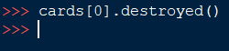

For the subclasses they each have one simple line in the __init__ function and the subclass nature mostly serves to allow the cards to have polymorphed versions of the CardBase class’s functions.

1. **class** Ragnaros(CardBase):
2. #All init statements for CardBase subclasses are extremely similar, merely passing in the values needed
3. **def** __init__(self):
4. CardBase.__init__(self, 5, "Ragnaros", 8, 2, 8)
6. **def** played(self):
7. #Deals 8 damage to all cards on the opposing side of the board
8. playerSwap = (player.currentPlayer % 2)+1
9. destroyed = []
10. **for** i **in** player.playerBoard[playerSwap-1]:
11. i.health -= 8

It is now much simpler to call the functions of the cards and most importantly proper tracebacks can be created if a bug is discovered in testing. 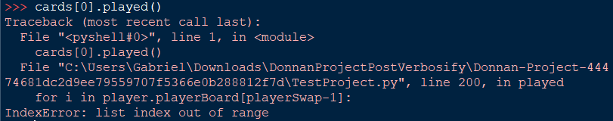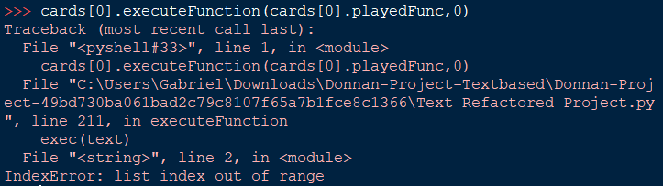

Whilst the exec implementation recognises that a list index is out of range it cannot point out where within the string the error ocurred, making debugging significantly more tedious.

Using the new class-subclass implementation also makes the initialisation statements for the cards significantly simpler.

1. cards = [
2. Ragnaros(),
3. Sylvannas(),
4. Thaurissan(),
5. Crusader(),
6. Whelp(),
7. Ogre()
8. ]

All the cards can be initialized to a list in a single statement with no parameters needing to be passed in to any of them whereas the func variable implementation required much messier, longer statements such as

1. cards.append(Card(2,"Emperor Thaurissan",6,5,5, endFunc = """if playerNum == 1:
2. for i in player.playerOneHand:
3. i.mana -= 1
4. else:
5. for i in player.playerTwoHand:
6. i.mana -= 1"""))

which were extremely difficult to read and understand.

### Intermediate Iteration (Iteration 2.5)

This iteration’s changes are very minor, only adding images for each card

1. self.picture = pygame.image.load(picture)
2. self.picture = pygame.transform.scale(self.picture, (115, 56))

These images are all scaled regardless of size to 115 pixels by 56 pixels so that they fit correctly with the card background image stored in the player class.

The card text whilst still stored in the card subclasses is only displayed later in this iteration as the player class’s drawing function only includes this later.

### Third Iteration

1. **class** CardBase:
2. **def** __init__(self,shopCost,name, mana, attack, health, picture, text):
3. self.canAttack = False
4. self.name = name
5. self.mana = mana
6. self.health = health
7. self.attack = attack
8. self.shopCost = shopCost
9. self.picture = pygame.image.load(picture)
10. self.picture = pygame.transform.scale(self.picture, (115, 56))
11. #Initialises the font for most card text
12. self.font = pygame.font.SysFont('arial', 16)
13. self.font.set_bold(True)
14. self.nameText = self.font.render(name, True, (255,255,255))
15. self.hpText = self.font.render(str(self.health), True, (255,255,255))
16. self.atkText = self.font.render(str(self.attack), True, (255,255,255))
17. #Initialises the font scaled for the text of each card
18. self.font2 = pygame.font.SysFont('arial', int((180/len(text.split(" ")))))
19. self.text = text
20. textSplit = [[]]
21. wordLen = 0
22. count = 0
23. self.upgraded = False
24. #Splits the text automatically into lines based on how long it is using the custom scaled font
25. **for** word **in** self.text.split(" "):
26. wordLen += len(word)
27. textSplit[count].append(word)
28. **if** wordLen > 12 **and** ("." **not** **in** word):
29. count += 1
30. wordLen = 0
31. textSplit.append([])
32. count = 0
33. self.textDisplay = []
34. **for** line **in** textSplit:
35. #Transforms the split text into font form for rendering on the card in a more legible way
36. self.textDisplay.append(self.font2.render(" ".join(line), True, (255,255,255)))

In this iteration of the card class the changes were mostly made to allow for the visual representation of the cards in pygame rather than changing how the class actually functioned with regards to the actual gameplay of the game.

For the “__init__” function additional attributes were added to store the rendered surface objects from generated from the text inputs in order to draw them on the screen when required. Additionally a list of these surfaces are generated so that they would have similar lengths when rendered so that they would fit within the designated text area on the card image.

These cards are not drawn within the card class but rather by a method within the player class so the objects simply have to store rendered surfaces of the card’s image and text lines so that they can be drawn externally.

Within this class I encountered in which all instances of a card created were considered the same card, meaning that damaging one instance or in any way altering its attributes would apply the same effect to all instances of the card wherever they were.

An example of this in practice:

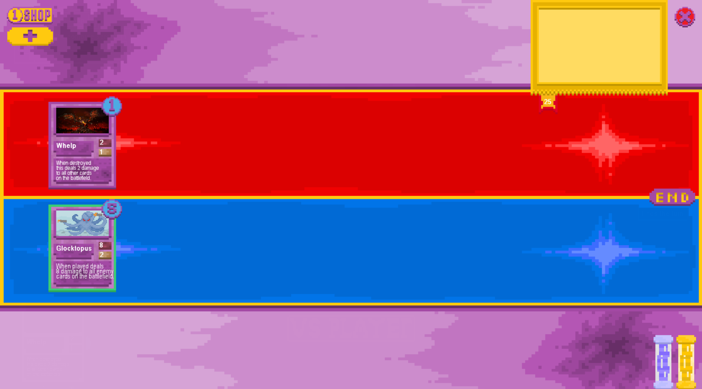

After attacking with the glocktopus the whelp is destroyed and the glocktopus is reduced to 5 health:

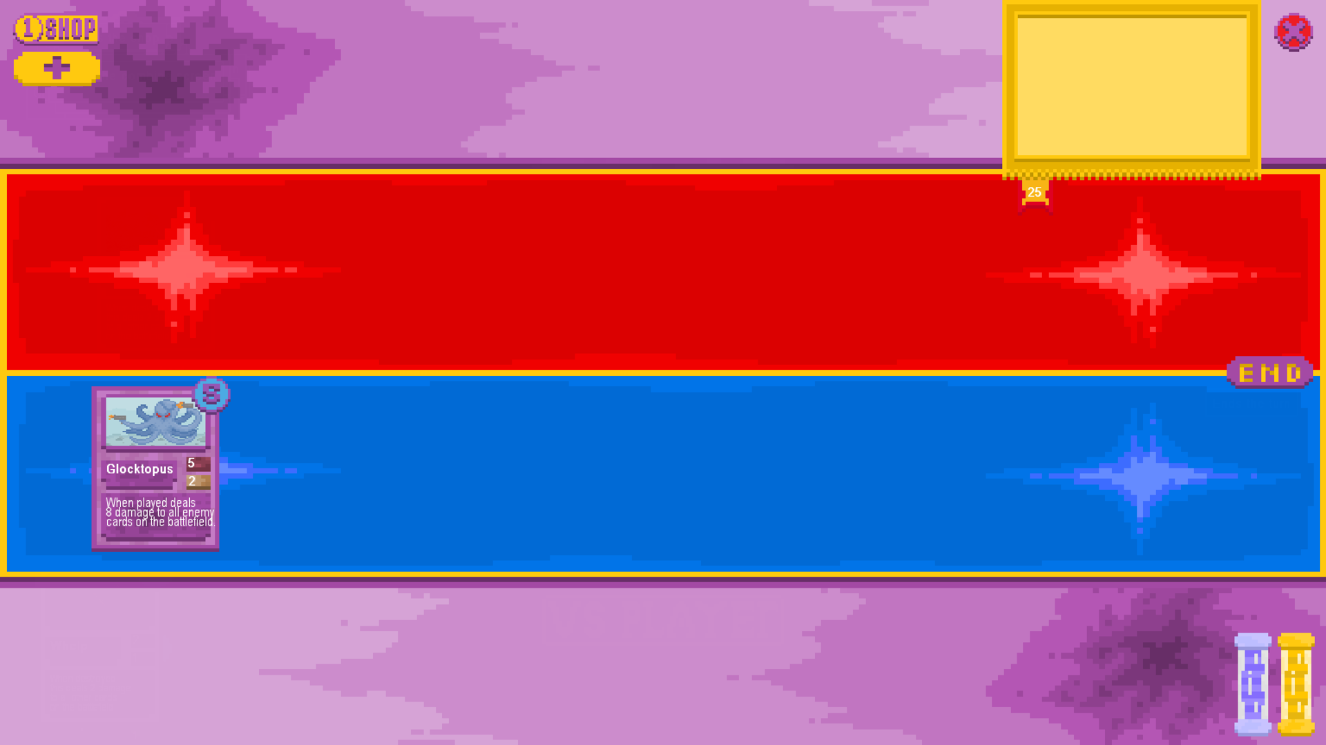

In the shop later when attempting to purchase a glocktopus it’s health will be 5:

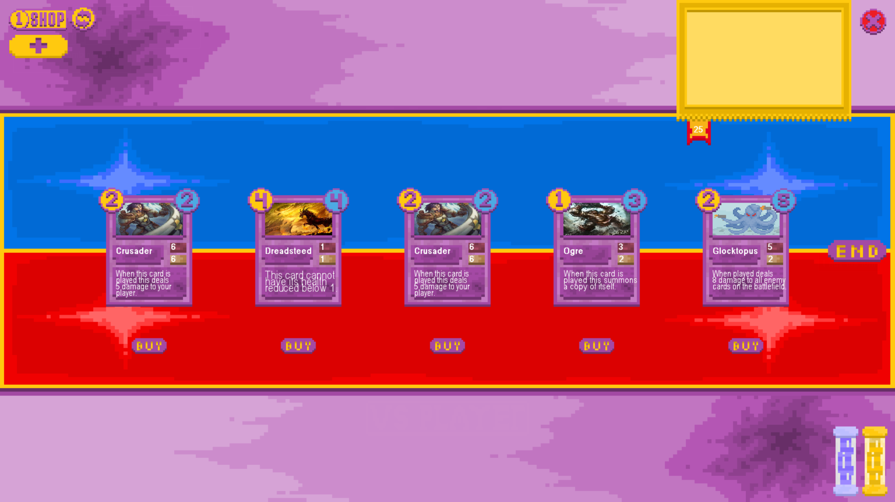

In order to remediate this I now add the card objects to two separate lists. One with the card objects instantiated to render the cards so that they do not need to be repeatedly be redeclared to render in static situations such as the shop, and the other with the references to the classes with which to initiate new copies of the cards in future for each time the cards are bought.

1. #This list stores the references to the classes in order that new objects can be created instead of duplicating old ones, meaning that specific instances of objects can be changed
2. cards = [
3. Glocktopus,
4. Sylvannas,
5. Thaurissan,
6. Crusader,
7. Whelp,
8. Ogre,
9. Dreadsteed,
10. Implings,
11. Armoursmith,
12. Meteor
13. ]
15. #This list is to help speed up graphical things as it will not have to repeatedly declare the objects to render
16. declaredCards = [
17. Glocktopus(),
18. Sylvannas(),
19. Thaurissan(),
20. Crusader(),
21. Whelp(),
22. Ogre(),
23. Dreadsteed(),
24. Implings(),
25. Armoursmith(),
26. Meteor()
27. ]

This now means that card combat and combination can function as intended as demonstrated in the testing section.

The individual subclasses for each card have not changed in any significant way other than adding in the additional inputs that the base card class requires such as an input of the card’s image.

1. **class** Meteor(CardBase):
2. **def** __init__(self):
3. CardBase.__init__(self, 3, "Meteor", 4, 6, 3, "Images\\Meteor.png", "Whenever this card attacks it also deals 2 damage to up to 2 random enemy cards.")
5. **def** attacking(self):
6. playerSwap = (player.currentPlayer % 2)+1
7. **for** i **in** range(2):
8. **try**: # Attempts to deal 2 damage to up to 2 enemies on the enemy player's board
9. random.choice(player.playerBoard[playerSwap-1]).health -= 2
10. **except**: # If this fails as the card has died already this except acts as a catch for that situation
11. **pass**

## Scaling Box Class

1. **class** TextBox:
2. **def** __init__(self, text, maxCharWidth, bufferSize, location):
3. self.location = location
4. self.text = text
5. self.maxCharWidth = maxCharWidth
6. self.bufferSize = bufferSize #A padding for the edges of the box
7. self.font = pygame.font.SysFont('arial', 16) #Creates the font to draw the text in
8. self.font.set_bold(True)
9. wordLen=0
10. count = 0
11. textSplit = [[]]
12. **for** word **in** self.text.split(" "):
13. wordLen += len(word) #Adds to the word length to judge when to go onto the next line of text
14. textSplit[count].append(word) #Adds the current word to the current line of text to be rendered
15. **if** wordLen > maxCharWidth: #If there are enough characters in the line the program moves onto the next line
16. count += 1
17. wordLen = 0
18. textSplit.append([])
19. count = 0
20. self.textDisplay = []
21. **for** line **in** textSplit:
22. self.textDisplay.append(self.font.render(" ".join(line), True, (255,255,255))) #Renders each of the text lines as a text surface
24. **def** draw(self):
25. addFactor = 0
26. provisionalW = 0
27. **for** i **in** self.textDisplay:
28. **if** i.get_width() > provisionalW:
29. provisionalW = i.get_width() #sets the provisional width of the box to the width of the current line if it's longer than the previous provisional width
30. pygame.draw.rect(player.screen,(0,0,0),(self.location,(provisionalW + 2*self.bufferSize,len(self.textDisplay)*16 + 2*self.bufferSize)),0) #draws the black background of the box with the width of the provisional width + the buffer
31. pygame.draw.rect(player.screen,(255,255,255),(self.location,(provisionalW + 2*self.bufferSize,len(self.textDisplay)*16 + 2*self.bufferSize)),2) #draws the white border of the box with the same dimensions as the black box
32. **for** line **in** self.textDisplay:
33. player.screen.blit(line,(self.location[0]+self.bufferSize,self.location[1]+self.bufferSize+addFactor)) #Draws the lines of text on the box

The TextBox class is designed to draw an automatically scaling box on which text is displayed so that information can be effectively communicated to the user. They are declared with a text input, a maximum amount of characters that the box can have in it’s width (i.e. 10 letters wide), a buffer size to pad out the box so it looks appealing and a location to find the place on which the box should be drawn.

The text input is split into lines so that the box can be rendered with a more readable formatting. As pygame’s rendering of text only allows for single line statements normally this needs to be built in as a list of many separately rendered single lines of text. The length of these lines is defined by the maximum character width input and the final width of the box is defined by the width of the longest line when rendered in the predefined font added to the buffer size. When the box object has been created it’s draw method can be called which will render the box in the desired location which is defined upon the object’s declaration rather than when the draw function is called to make rendering the tutorial easier.

These boxes are used in many places throughout the game so it is beneficial to have a class for declaring objects of them in order to act as indicators for certain actions or for the game’s built in tutorial which can be stored as a list of TextBox objects as shown below:

1. tutorialBoxes = [
2. TextBox("Welcome to the game, here's a brief overview of the game's mechanics. --PRESS SPACE TO CONTINUE--", 20, 8, (120,3)),
3. TextBox("Each turn you gain a set amount of gold which you can spend at the shop to buy cards. In order to open the shop press the shop button in the top left corner of the screen. --PRESS SPACE TO CONTINUE--", 20, 8, (120,3)),
4. TextBox("If the cards in the shop are not to your liking or you have already bought everything in it you can spend 1 gold in order to refresh its contents using the reroll button which appears next to the shop button when the shop is open. --PRESS SPACE TO CONTINUE--", 20, 8, (120,3)),
5. TextBox("When you have 3 of the same card you can choose to combine them to make a more powerful card using the combine button. --PRESS SPACE TO CONTINUE--", 20, 8, (120,3)),
6. TextBox("You start the game with 1 maximum mana, this increases by 1 for each of your turn up to a maximum of 10. At the start of each turn your mana refreshes up to your maximum mana value. --PRESS SPACE TO CONTINUE--", 20, 8, (120,3)),
7. TextBox("Each card has a mana cost associated with it, playing the cards (by clicking the cards when they're in your hand) will expend that much mana if it can, if it cannot you will not be able to play the card. --PRESS SPACE TO CONTINUE--", 20, 8, (120,3)),
8. TextBox("Your cards will not normally be able to attack immediately when played, you will have to wait until your next turn. In order to attack with a card you click on a card with a green outline on the board and its desired target, whether that be your opponent or their cards on the board --PRESS SPACE TO CONTINUE--", 25, 8, (120,3)),
9. TextBox("In order to win the game you must reduce the health of your opponent's hero down to 0 and having your health reduced to 0 or below will result in you losing the game. --PRESS SPACE TO CONTINUE--", 20, 8, (120,3)),
10. TextBox("That concludes the tutorial, have fun playing the game! --PRESS SPACE TO CLOSE--", 20, 8, (120,3))
11. ]

This list of objects can be iterated through in the game loop, rendering the current index if the tutorial is enabled.

Most of the debugging for this function involved getting the text within the text boxes not to overlap when the boxes rendered, Initially with a higher font size the text would overlap with each other or there would be no gap between lines.

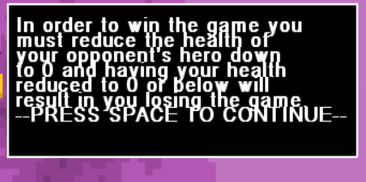

I also encountered a bug in which the text would all render on the same line as opposed to moving onto the next line as the add factor variable in the draw function was being incremented but not actually used.

1. **def** draw(self):
2. addFactor = 0
3. provisionalW = 0
4. **for** i **in** self.textDisplay:
5. **if** i.get_width() > provisionalW:
6. provisionalW = i.get_width()
7. pygame.draw.rect(player.screen,(0,0,0),(self.location,(provisionalW + 2*self.bufferSize,len(self.textDisplay)*16 + 2*self.bufferSize)),0) #draws the background of the box
8. pygame.draw.rect(player.screen,(255,255,255),(self.location,(provisionalW + 2*self.bufferSize,len(self.textDisplay)*16 + 2*self.bufferSize)),2) #draws the white border of the box with the same dimensions as the black box
9. **for** line **in** self.textDisplay:
10. player.screen.blit(line,(self.location[0]+self.bufferSize,self.location[1]+self.bufferSize)) #Draws the lines of text on the box
11. addFactor += 14

This caused boxes such as the tutorial to render completely nonsensically as shown below:

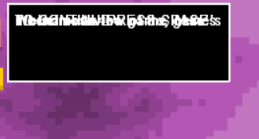

### Nice to have

This class was added relatively late in the game’s development and as such has only one iteration. In the future it would be possibly beneficial to have text boxes of different colours or shapes for different purposes

This would require additional subclasses or different attributes to be passed into the main init function for object declaration which given time pressure was simply not worth implementing in the time frame given over other features.

# STUFF TO ORGANISE

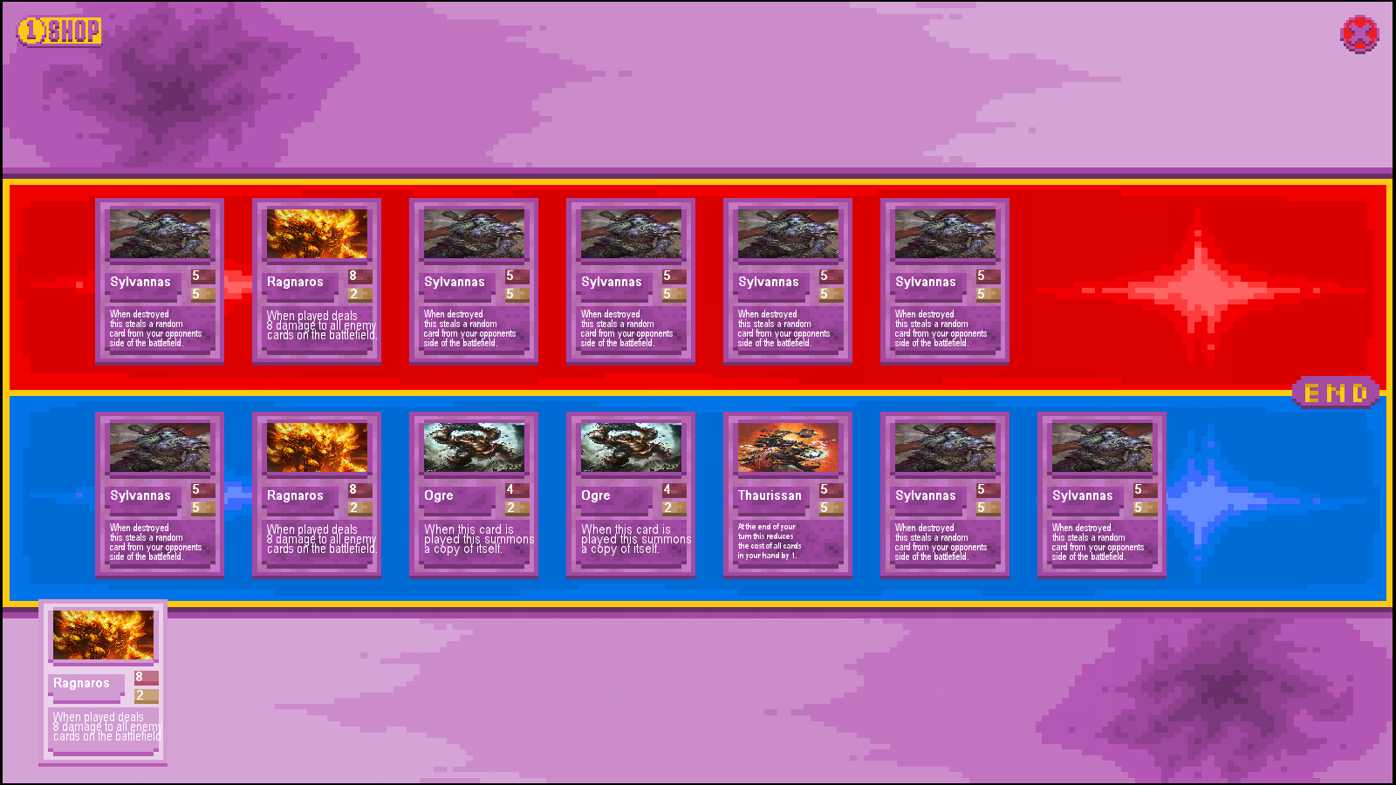

In certain situations with in which the card “Ragnaros” was played while sufficient amounts of the card “sylvannas” populated each side of the board the game would be caused to crash due to the “on play” effect of ragnaros no longer being able to find the cards it is looking for as they had already swapped sides of the board and would result in a lengthy error message of: 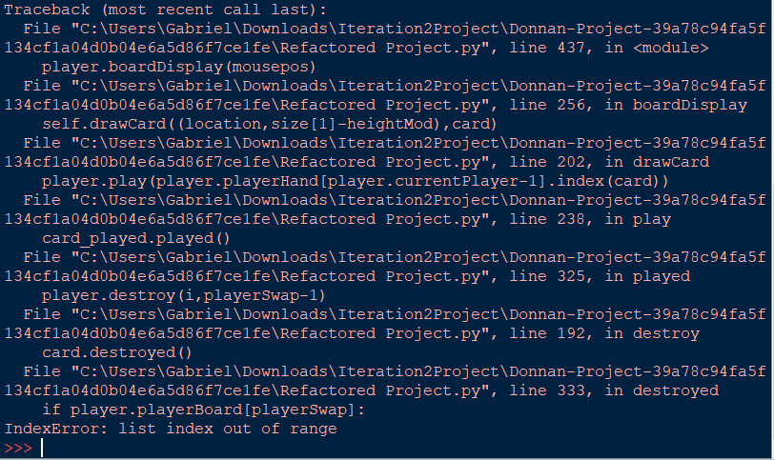

Which proved extremely difficult to debug as the issue is with the trigger order of the death effect and played effect coinciding meaning that both could not activate correctly and either it would be impossible to steal a card from the opposing side or it would be impossible to deal damage to a card that has already been stolen, effectively leading to the layering of two possible errors.

I debated removing the problematic cards from the game so that the error could not occur but I decided against it as the underlying issues causing the errors would still remain, meaning that the cards I wanted to add in the future may encounter similar game breaking bugs which would mean I had to resolve this regardless.

I added a relatively primitive game loop, enabling the purchasing and playing of cards as well as ending the turn.

1. **while** **not** done:
2. #player.screen.blit(cards[0].picture,(10,110))
3. mousepos = pygame.mouse.get_pos()
4. player.screen.blit(boardPicture,(0,0))
5. shopButton.draw()
6. endButton.draw()
7. closeButton.draw()
8. #player.drawCard(mousepos,declaredCards[0])
9. **if** endButton.clickRect.collidepoint(mousepos) **and** pygame.mouse.get_pressed()[0]:
10. endButton.press()
11. time.sleep(0.1)
12. **if** shopButton.clickRect.collidepoint(mousepos) **and** pygame.mouse.get_pressed()[0]:
13. shopButton.press()
14. time.sleep(0.1)
15. **if** closeButton.clickRect.collidepoint(mousepos) **and** pygame.mouse.get_pressed()[0]:
16. closeButton.press()
17. time.sleep(0.1)
18. **if** shopButton.pressed:
19. shopButton.displayCards()
20. **for** i **in** shopButton.buttons:
21. temprect = pygame.Rect(i.coords,(60,27))
22. **if** temprect.collidepoint(mousepos) **and** pygame.mouse.get_pressed()[0]:
23. i.press()
24. time.sleep(0.1)
25. #player.drawCard((10,10),cards[1])
26. player.boardDisplay(mousepos)
27. pygame.display.update()
28. **for** event **in** pygame.event.get():
29. **if** event.type == pygame.QUIT:
30. done = True

The loop simply draws the board background image on the screen at the beginning of every loop, meaning that all other drawn effects will be on top of it. It then draws each button which the player can interact with in its respective spot, followed by checking for each button whether the player is clicking on it.

Here I use “pygame.mouse.get_pressed()[0]” for each individual if statement, which is very inefficient as it means that the function will have to be called multiple times with each loop through the game loop even though it only has to be called once as the player’s mouse position will not change that significantly in between checking each button and as such it can be stored as a variable and used that way. This is used in a later implementation.

This game loop supports the opening of the shop which draws additional buttons onto the screen. As such the if statement which checks each of the individual shop buttons is nested within the if statement checking if the shop is opened, meaning that they cannot be accidentally clicked whilst the shop is closed. The rects for each of these buttons is assigned based on the amount of cards in the shop every loop rather than being set on the opening of the shop meaning that the shop will automatically take up as little space as possible as purchased cards will no longer take up any space and their button will be removed rather than staying in the same place and having to re close and open the shop to update the positions.

1. #This list stores the references to the classes in order that new objects can be created instead of duplicating old ones, meaning that specific instances of objects can be changed
2. cards = [
3. Ragnaros,
4. Sylvannas,
5. Thaurissan,
6. Crusader,
7. Whelp,
8. Ogre
9. ]
11. #This list is to help speed up graphical things as it will not have to repeatedly declare the objects to render
12. declaredCards = [
13. Ragnaros(),
14. Sylvannas(),
15. Thaurissan(),
16. Crusader(),
17. Whelp(),
18. Ogre()
19. ]
21. player = Player(cards)
22. #Gives the second player a small headstart as they are naturally at a disadvantage due to how turn based games work
23. player.playerCurrency[1] += 2

26. #For any variable "player" or "playerNum" within a function this refers to the player *in control* of the thing making the effect, not necessarily the player being affected
28. ##______________ MAIN GAME LOOP _________________##
29. player.playerHand[0].append(cards[0]())
30. player.playerHand[0].append(cards[1]())
31. player.genCards(5)
32. player.playerMana[0] = 100
33. player.playerMana[1] = 100
34. player.playerMaxMana[0] = 100
35. player.playerMaxMana[1] = 100
36. player.playerCurrency[0] += 100000000
37. player.playerCurrency[1] += 10
38. done = False
39. shopButton = ShowShop()
40. closeButton = CloseGame()
41. endButton = EndTurn()
42. boardPicture = pygame.image.load("C:\\Users\\Gabriel\\Documents\\GitHub\\Donnan-Project\\Images\\Board.png")
43. boardPicture = pygame.transform.scale(boardPicture, (player.screen.get_width(), player.screen.get_height()))

In order for the game loop to function many variables have to be set before it, the lists “cards” and “declaredCards” for example may appear to be identical in function but they are declared this way in order to fix a bug in which all cards purchased from the shop were treated as the same instance and so whenever one was destroyed all other copies of it were also. This is circumvented by the shops using the “declaredCards” list to display them and then if a card were bought the regular “cards” list counterpart was subsequently declared and added to the player’s hand so a brand new instance is created. The “declaredCards” list is used instead of the “cards” list for all displaying though as creating new instances of cards for each card loop becomes extremely quickly memory inefficient.

If these lists were not declared none of the main loop’s displaying would function for any card as the cards would only exist as classes but would never be instantiated.

1. **def** boardDisplay(self,mousepos):
2. size = self.screen.get_size()
3. #For drawing contents of hand
4. location = 115
5. **if** mousepos[1] > 550 **and** **not** shopButton.pressed:
6. locFactor = 180
7. heightMod = 115
8. **else**:
9. locFactor = 56
10. heightMod = 25
11. **for** card **in** self.playerHand[self.currentPlayer-1]:
12. self.drawCard((location,size[1]-heightMod),card)
13. location += locFactor
14. #For drawing contents of board
15. **if** **not** shopButton.pressed:
16. location = 180
17. **for** card **in** self.playerBoard[self.currentPlayer-1]:
18. self.drawCard((location,size[1]-330),card)
19. location += 180
20. location = 180
21. playerSwap = (player.currentPlayer % 2)+1
22. **for** card **in** self.playerBoard[playerSwap-1]:
23. self.drawCard((location,size[1]-575),card)
24. location += 180

In order to replace the old text based display formatting a new function had to be created in order to draw all of the items on the board at once. It does this by getting the size of the screen on which the game is being displayed then scaling all positions to a percentage of this size so that they remain in the correct locations if the game were scaled to a screen of a different size (such as 1440p vs standard 1080p). The first if statement detects whether the mouse is in the lower half of the screen so that if so the cards can be spread out while displayed so that they are more easily interacted with, this is done by increasing the “locFactor” which scales the distance between the cards.

This will now only happen if the shop is closed so that there is no overlap between the cards in the shop and the cards in your hand (which happened when the shop being closed was not a condition) which is confusing for the user and provides no additional functionality as playing cards while the shop is open is not possible so additional spacing between them is useless.

1. **def** play(self, cardPos):
2. card_played = self.playerHand[self.currentPlayer-1][cardPos]
3. #Checks if the card you're trying to play costs too much
4. **if** card_played.mana <= player.playerMana[player.currentPlayer-1] **and** len(player.playerBoard[player.currentPlayer-1])<8:
5. self.playerBoard[self.currentPlayer-1].append((self.playerHand[self.currentPlayer-1]).pop(cardPos))
6. card_played.played()
7. player.playerMana[player.currentPlayer-1] -= card_played.mana

The played function remains largely similar to its previous iteration with the key difference that the input for mana is no longer required, the function will instead use the class variable player.playerMana[current player] as the initial value to check whether the card is playable. If it is then this value can be updated directly by the function instead of returning a mana value which could then be used to update the player’s total. This makes the program’s logic easier to follow as the mana will always be updated within this function rather than have to have extra statements written outside of it whenever it is called for the mana to be updated.

1. **def** attack(self, card1, card2):
2. **if** card1.canAttack:
3. card1.attacking()
4. card2.health -= card1.attack
5. card1.health -= card2.attack
6. card1.canAttack = False
7. **if** self.currentPlayer == 1:
8. **if** card1.health <= 0:
9. self.destroy(card1, 1)
10. **if** card1.health <= 0:
11. self.destroy(card2, 2)
12. **else**:
13. **if** card1.health <= 0:
14. self.destroy(card1, 2)
15. **if** card1.health <= 0:
16. self.destroy(card2, 1)
17. **else**:
18. **print**("That minion cannot attack right now")

In this iteration attacking is programmatically implemented such that cards can be made to attack each other via code inputs, however this is not yet functional ingame. The reason for this is that in order for the game to be completely visually based new functions will need to be written in order to indicate whether a card can attack, if the card is currently attacking and to display a new cursor to show that the player can target the card’s attack to whatever card the mouse is currently pointing at. This is necessary as visuals are not as instantaneous as text and as such there is a time between the player selecting the first card to attack with and the second card which they desire to attack so this cannot directly be input to one function such as this with a “card1” and “card2” input all at once.

1. **def** combineCards(self, card):
2. combinationCounter = 0
3. removed = []
4. **for** i **in** player.playerHand[player.currentPlayer-1]:
5. **if** i.name == card.name **and** i.mana == card.mana **and** i.attack == card.attack **and** i.health == card.health:
6. removed.append(i)
7. combinationCounter += 1
8. **if** len(removed) < 3:
9. **print**("Error, you do not have enough of these cards to combine")
10. **else**:
11. **for** i **in** removed:
12. player.playerHand[player.currentPlayer-1].remove(i)
13. player.playerHand[player.currentPlayer-1].append(player.upgradeCard(removed))

The “combineCards” function is similarly programmatically functional to the attack function in this iteration, however it does not yet have it’s visual implementation as that requires some infrastructure to be built around it. It will require a section with a corresponding button similar to the shop in which all the cards in your hand are displayed centrally to the screen to indicate that they can be upgraded. These will need buttons beneath them to be pressed to confirm that the user wants to upgrade that specific card and as such it is once again not as simple as the text based implementation as the function will need to be called by a button tied to a card rather than the user typing in the command themselves. As such the function has been updated to accommodate for this, now taking a card object as an input rather than an index so that once the infrastructure has been created it will be easy and intuitive to call the function.

######## ITERATION 1. 5 ########

1. **class** Button:
2. **def** __init__(self, coords, size, picture):
3. self.coords = coords
4. self.picture = pygame.image.load(picture)
5. self.picture = pygame.transform.scale(self.picture, size)
7. **def** press(self):
8. **pass**

The button class is relatively simple as a base class, taking in a coordinate, size and picture. It loads the image passed into it into a format representable by pygame and transforms it so it is the size passed in. The class has an empty “press()” function which is changed by the subclasses via polymorphism to do what each subclass of Button needs for their purposes. In this iteration there is no implementation of actually drawing the buttons as I planned to implement other functionality of the game before putting in pressable buttons that the user can see.

1. **class** EndTurn(Button):
2. **def** __init__(self):
3. Button.__init__(self, (10,10),(10,15),"C:\\Users\\Gabriel\\Documents\\GitHub\\Donnan-Project\\Images\\EndTurn.png")
5. **def** press(self):
6. player.endTurn()

An example of a subclass of button is EndTurn, this subclass will always be in the same place, be of the same size and have the same image so the constructor simply initialises the superclass with set values for each of these. The press function is changed so that instead of doing nothing it calls the function “player.endTurn()” to swap the current player so that the other player can have their turn.

##### ITERATION 2 #####

1. **class** Button:
2. **def** __init__(self, coords, size, picture, hoverPicture = ""):
3. **if** hoverPicture == "":
4. hoverPicture = picture
5. self.clickRect = pygame.Rect(coords,size)
6. self.coords = coords
7. self.hoverPicture = pygame.image.load(hoverPicture)
8. self.hoverPicture = pygame.transform.scale(self.hoverPicture, size)
9. self.picture = pygame.image.load(picture)
10. self.picture = pygame.transform.scale(self.picture, size)
12. **def** press(self):
13. **pass**
15. **def** draw(self):
16. mousepos = pygame.mouse.get_pos()
17. **if** self.clickRect.collidepoint(mousepos):
18. player.screen.blit(self.hoverPicture,self.coords)
19. **else**:
20. player.screen.blit(self.picture,self.coords)

This iteration of the Button class is a little more complex than the initial iteration. It takes in coordinates, a size, a picture and optionally a “hoverPicture”. A hoverPicture in this case is supposed to be a slightly lighter version of the initial picture to indicate to the user that they are hovering over it but this is optional as it is not integral to the button’s function, it is simply a visual quality of life feature to make the game look more interactive. If no hoverPicture is passed in the function will then default it so that the hoverPicture variable is the same as the picture variable so no difference will be seen whether the button has been hovered over or not though it will technically be loading the same image from a different location when hovered.

This iteration of the button class has also added a “clickRect” class variable which defines the area in which the player’s mouse has to be located for the button to be pressed. This is checked against the mouse position within the game loop as having a function to check this would be mostly redundant.

When moving from using pure fullscreen to borderless initially I encountered a bug where the window would not align itself with the top left of the screen correctly, instead the top corner would end up moved into the centre of the screen.

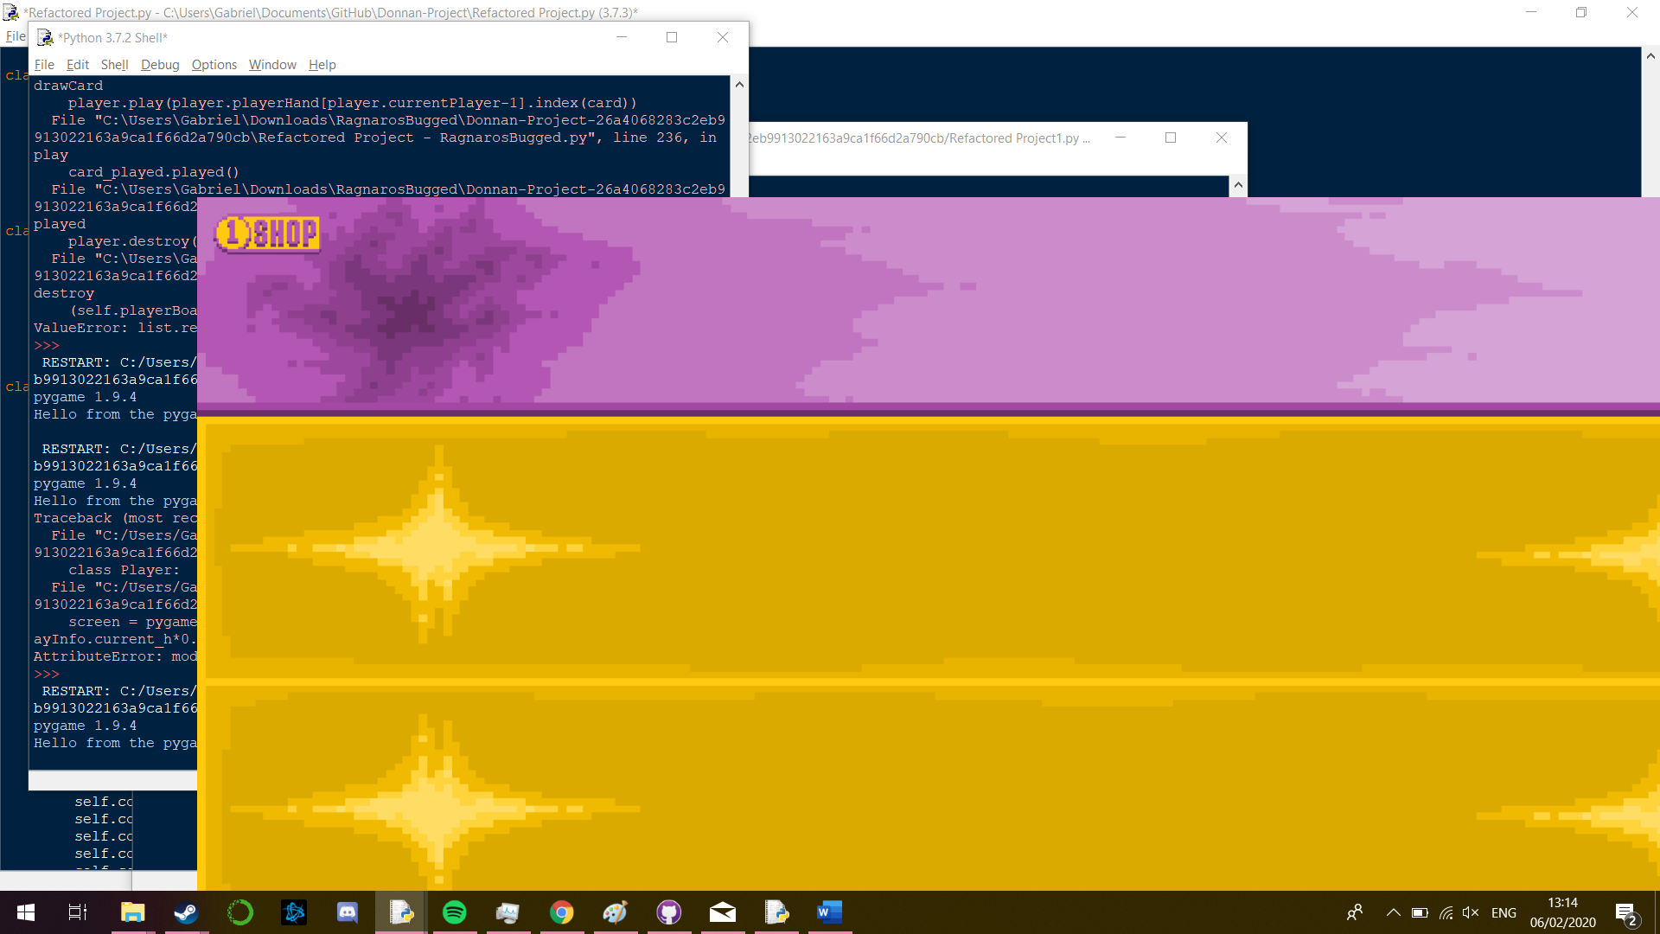

As such I added the line “os.environ['SDL_VIDEO_WINDOW_POS'] = "0,0"” to fix this. This changes the operating system variable SDL_VIDEO_WINDOW_POS to 0,0. Meaning that any windows that the program opened would start at 0,0 instead of closer to the centre of the screen.

# Testing

## Basics Testing

1. Test that the main menu loads

Before running the game:

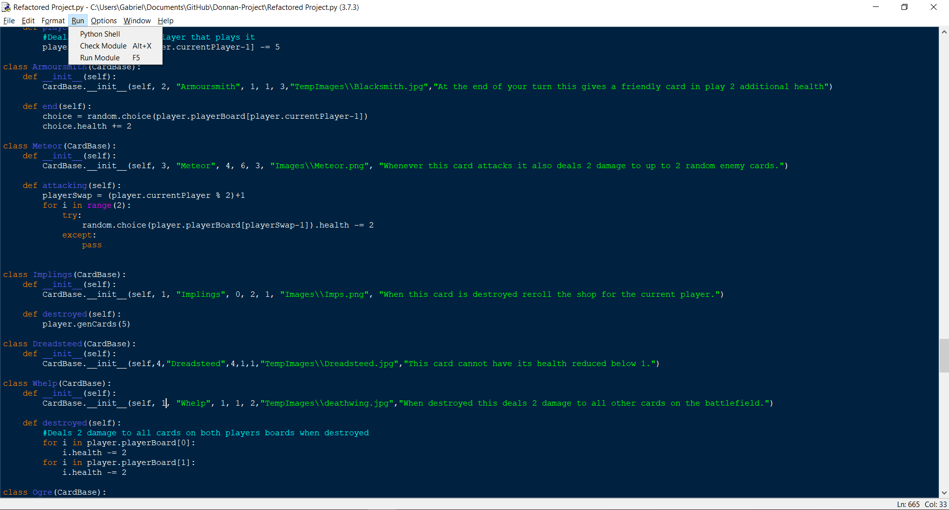

After running the game:

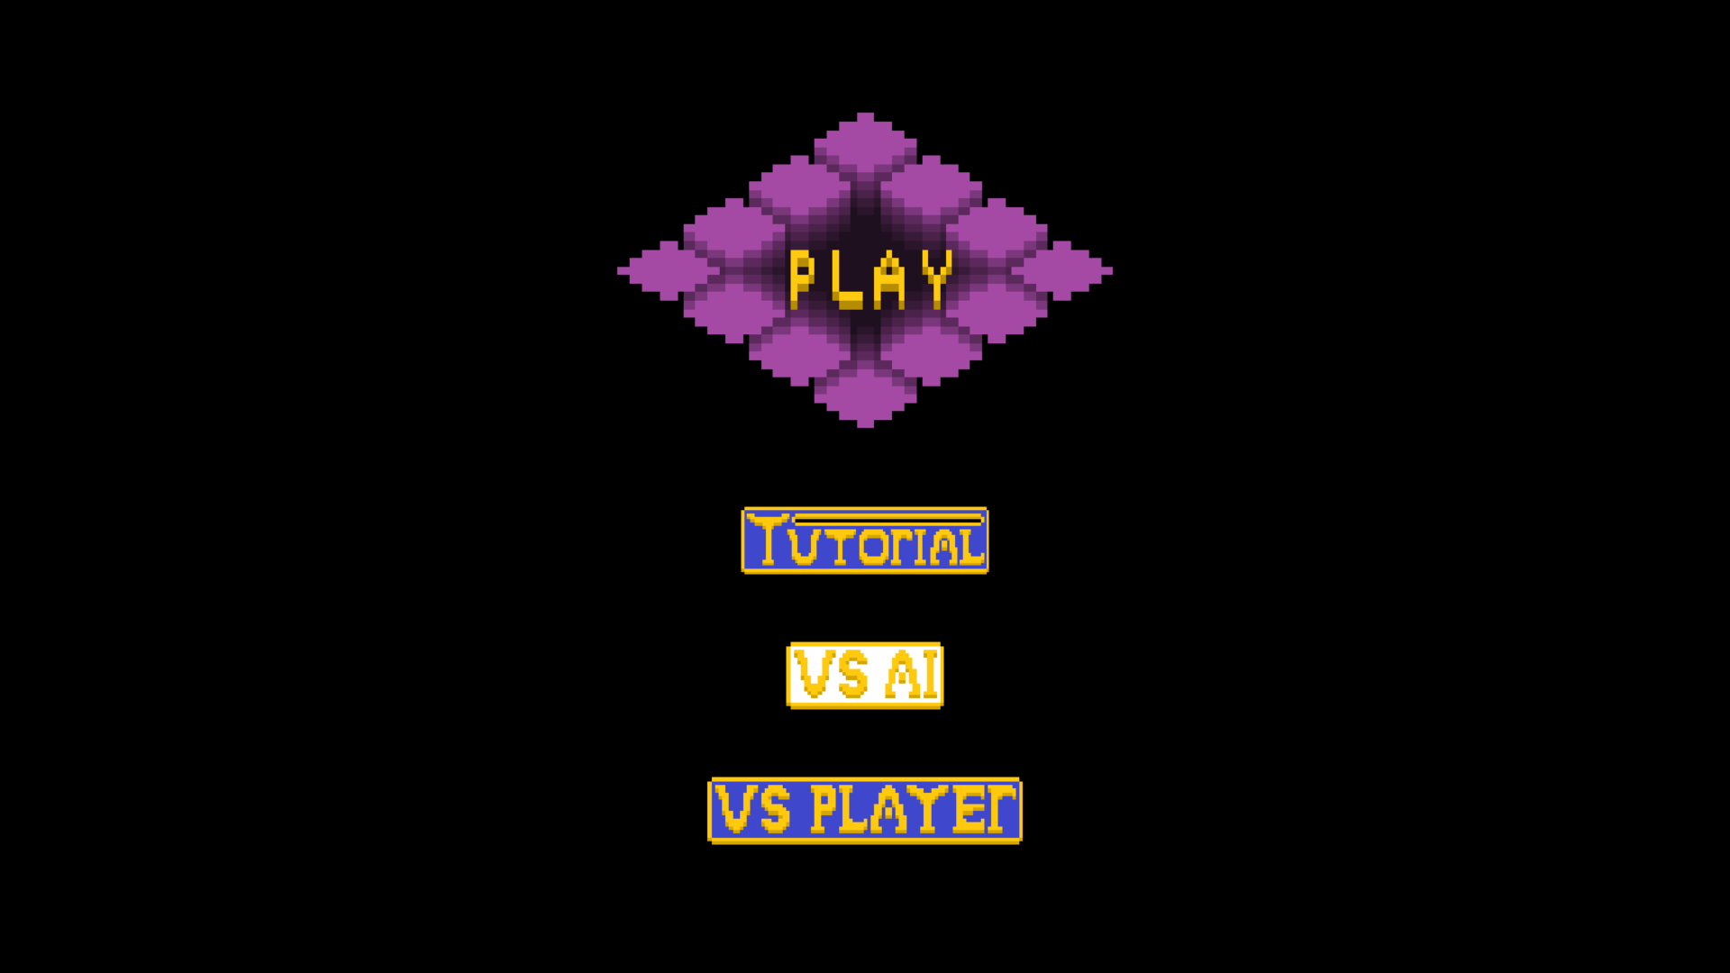

The test was a success as when launched the game loaded directly into the main menu

1. Test that pressing play on the main menu loads the game

Before pressing play:

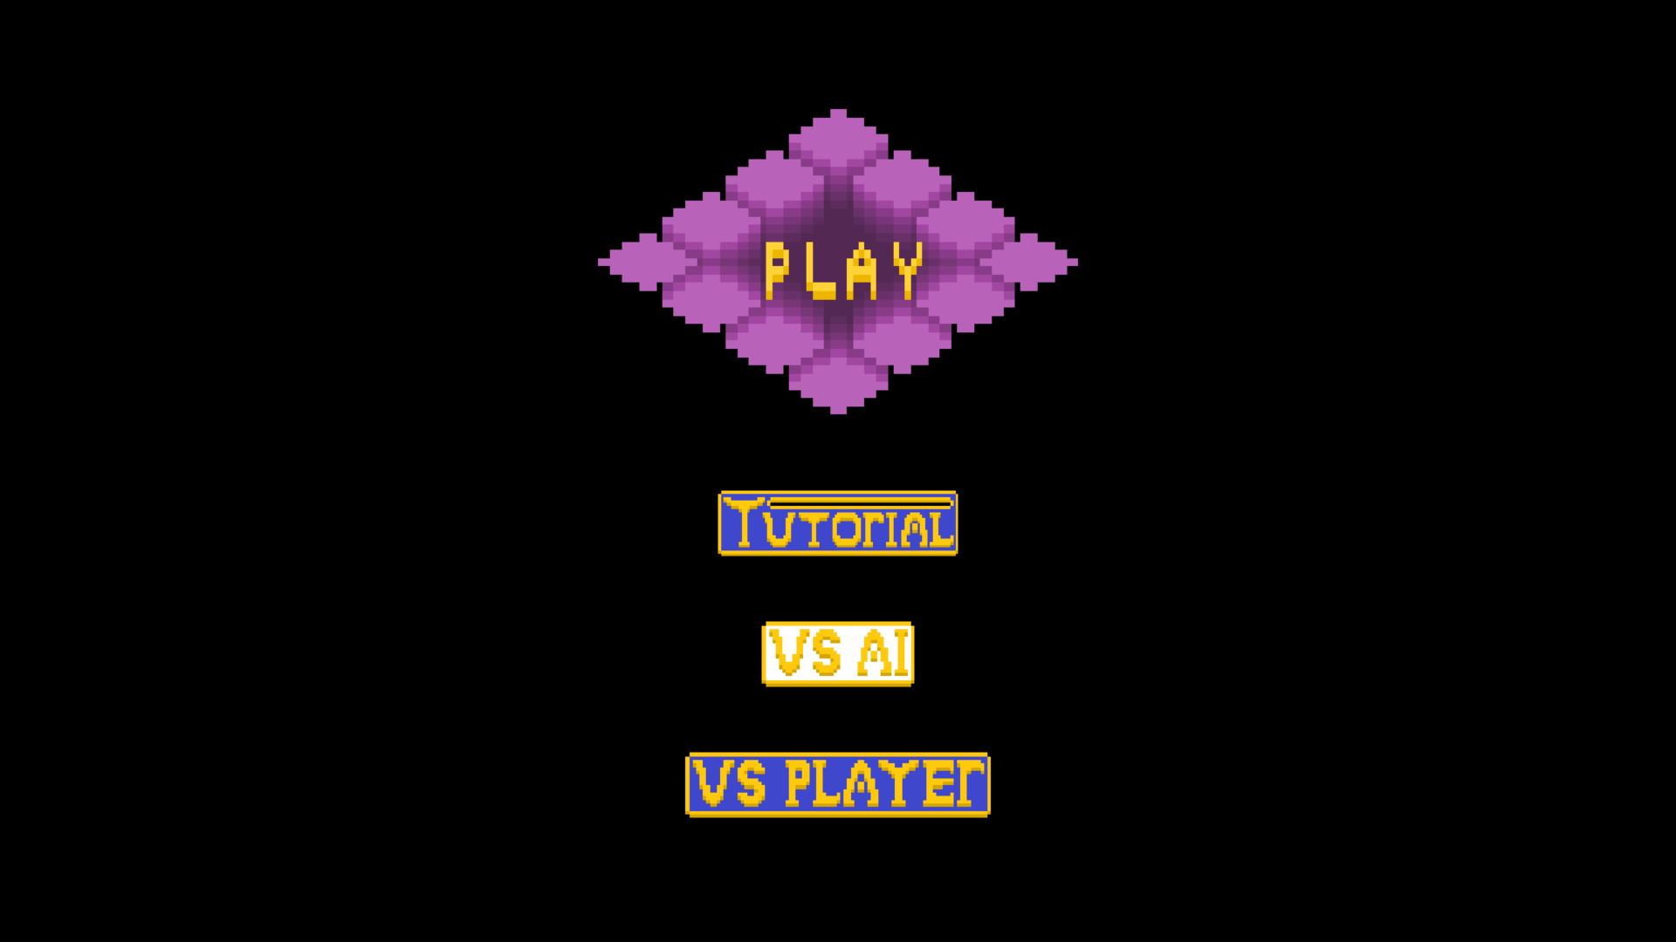

After pressing play:

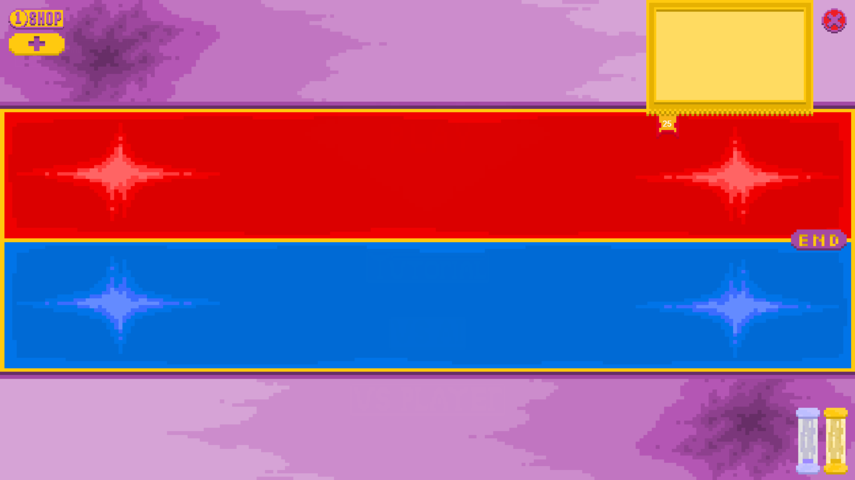

The test was a success as the play button caused the player to load into the game starting with player 1’s turn

1. Test that pressing the close button ends the game

Before pressing close button:



After pressing the close button:

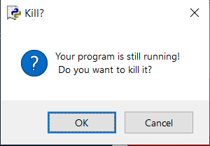

The test was a success as it ended the game by both closing the pygame window and prompting the user to terminate the python program as a whole once the button was pressed.

1. Test that each button in the main menu can be correctly toggled on and off

Tutorial Button:

Before being pressed:

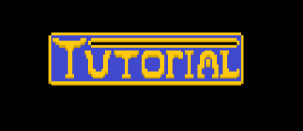

After being pressed:

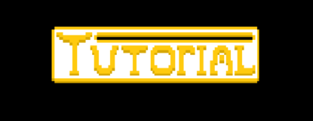

Vs AI button and Vs Player button (These toggle each other):

Ai button active:

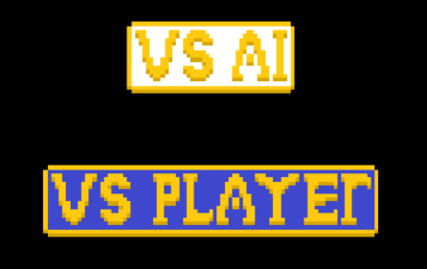

Player Button active:

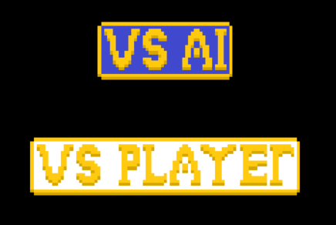

The test was a success as each button was able to be correctly toggled on when it’s condition was met (i.e. it was clicked or its corresponding button was clicked in the case of the Vs AI and Vs Player buttons)

1. Test that opening the shop causes the reroll button to appear and closing the shop causes it to disappear again

Before pressing the shop button:

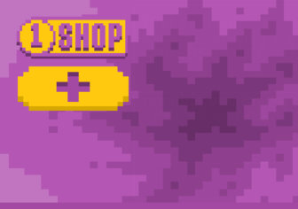

After pressing the shop button:  
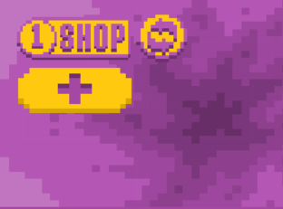

After pressing the shop button again:

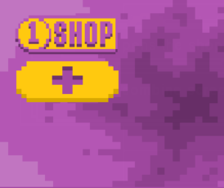

The test was a success as the reroll button appeared when the shop was opened and disappeared when the shop was closed again

1. Test that ending the turn swaps the colour of the board of each player

Board Before:

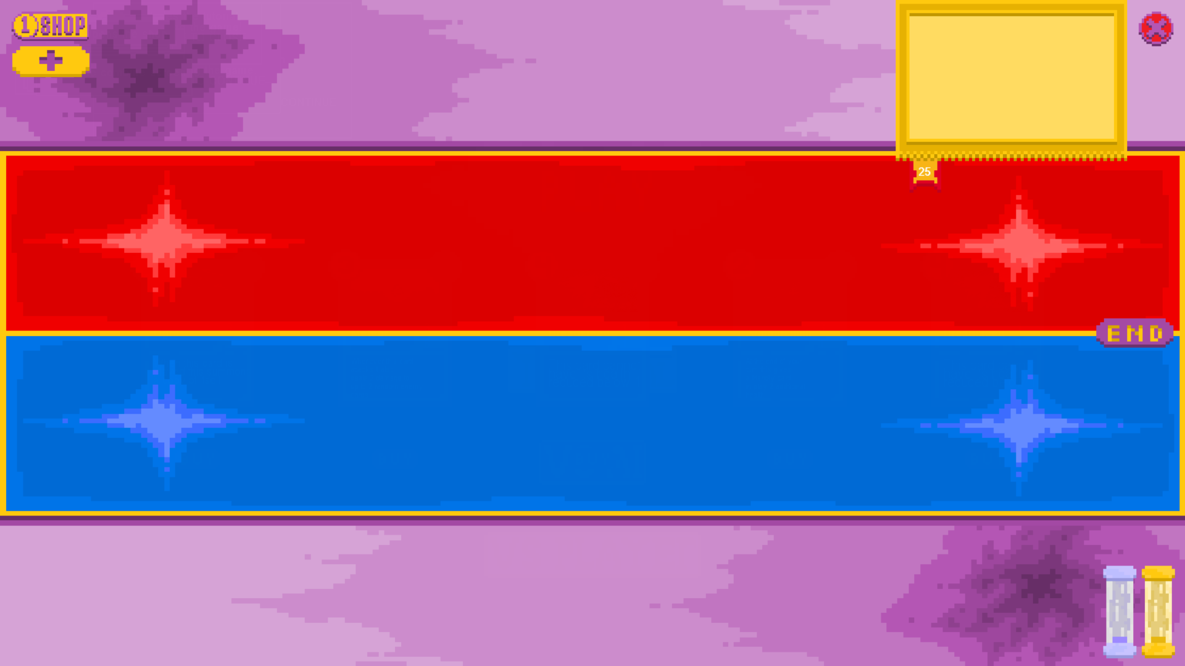

Board After:

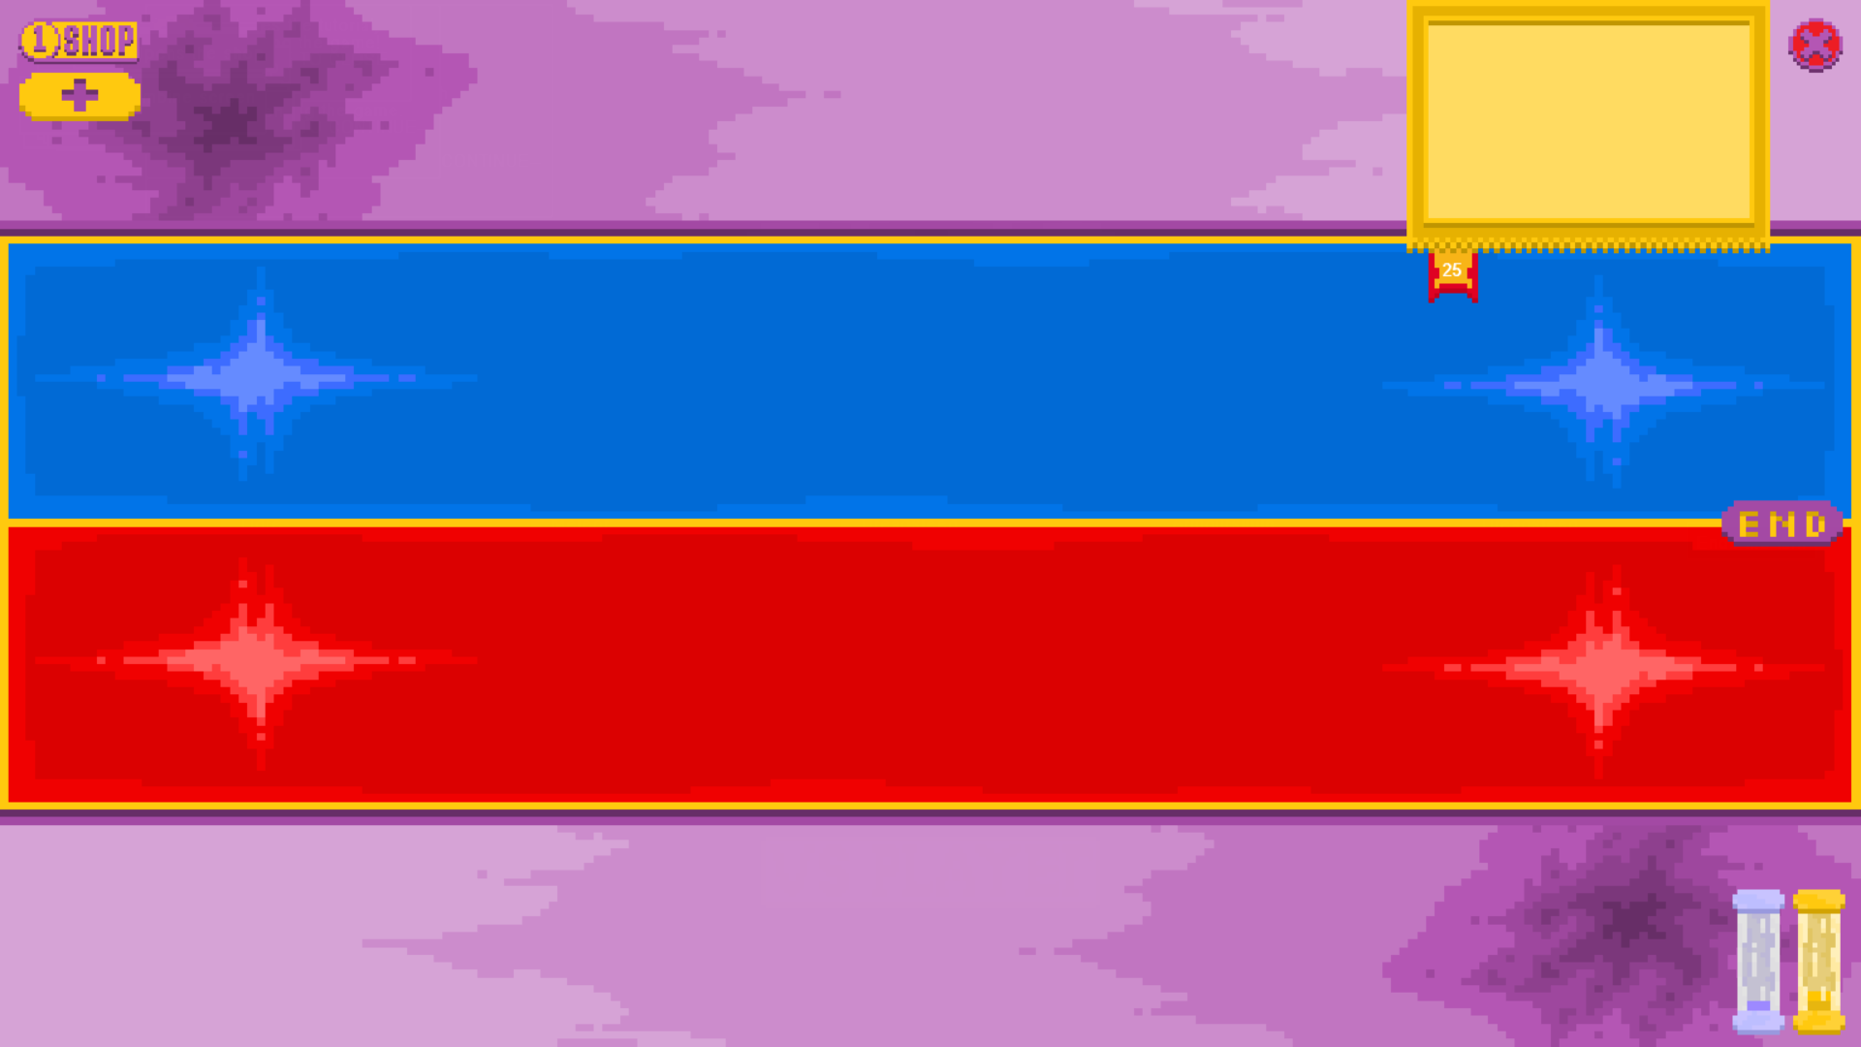

The test was a success as the board’s colour flipped when the end turn button was pressed.

## Shop Testing

1. 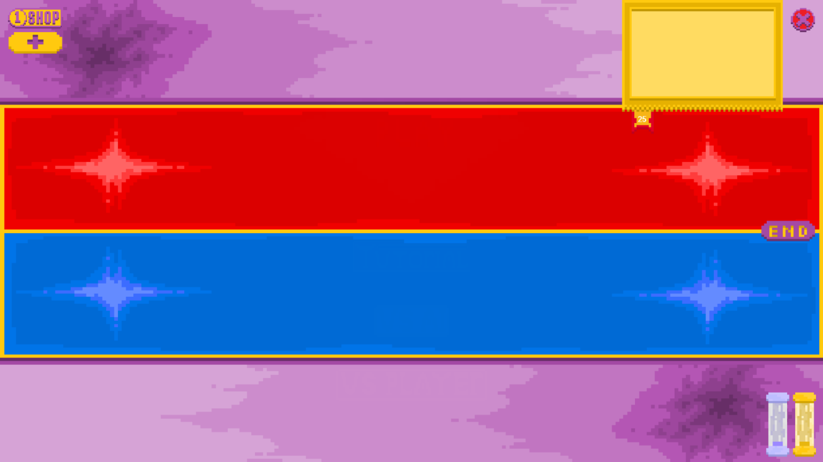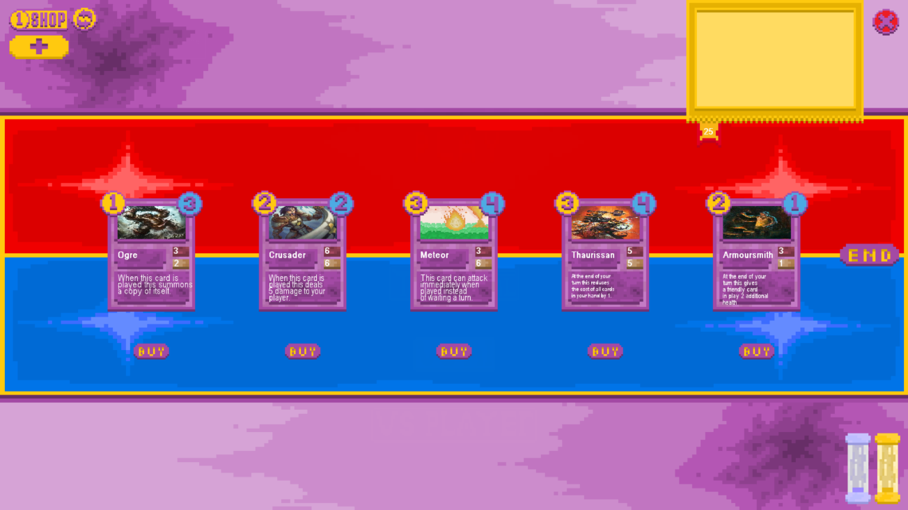Check that the shop can be opened by pressing the shop button

The test was successful as when the shop button was pressed the cards currently for sale in the shop appeared in the centre of the screen with corresponding buy buttons beneath them. The reroll button also successfully appears beside the shop button as the shop is open so it can be used.

1. Check that clicking on the card itself will not buy the card when the shop is open

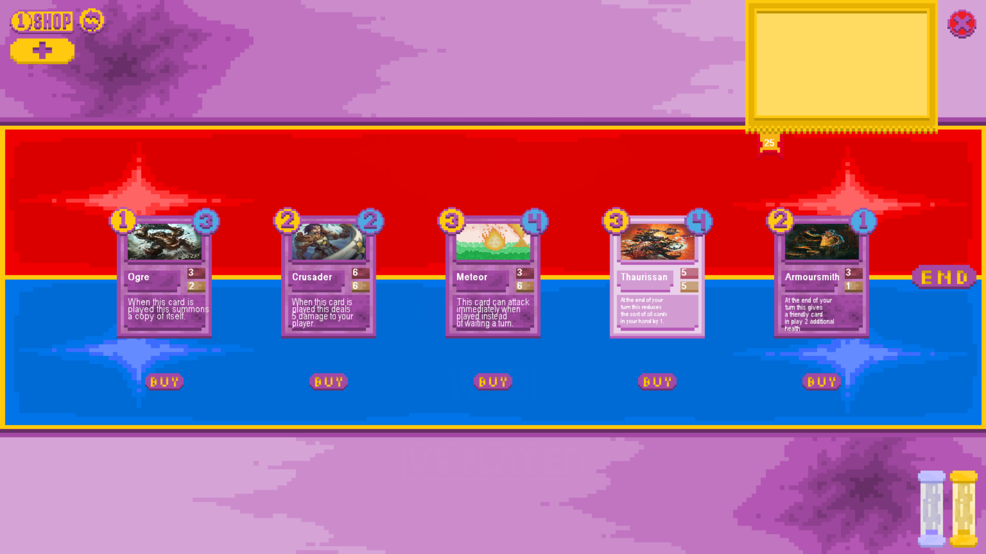

The test was successful as when the card (The second from the right card which is highlighted) was clicked nothing happened, it simply highlighted and was not added to the player’s hand, removed from the shop or played onto the battlefield.

1. Check that you can buy a card when you have enough currency

Shop Before: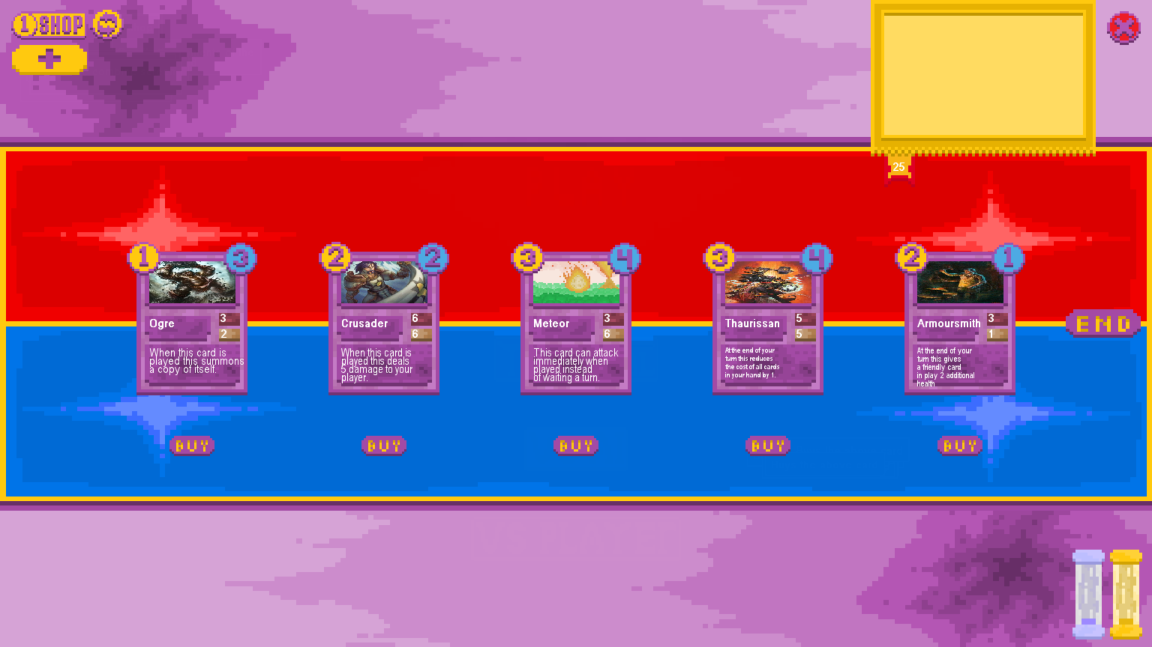

Shop After:

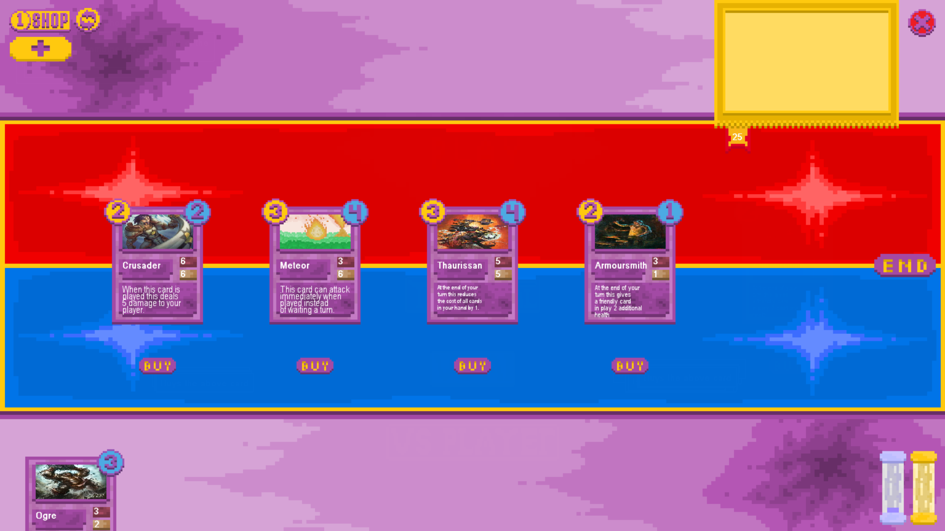

The test was successful, as the card was removed as an option from the shop, added to the player’s hand and the currency of the current player was reduced by the correct amount as you can see by the currency indicator at the bottom right of the screen

1. Check that you cannot buy cards with insufficient currency



# ADD RED CIRCLE AROUND CARD #

The test was successful as when trying to buy a card which cost more than the amount of currency the player currently possessed the card was not removed from the shop, added to the player’s hand or played onto the battlefield.

1. 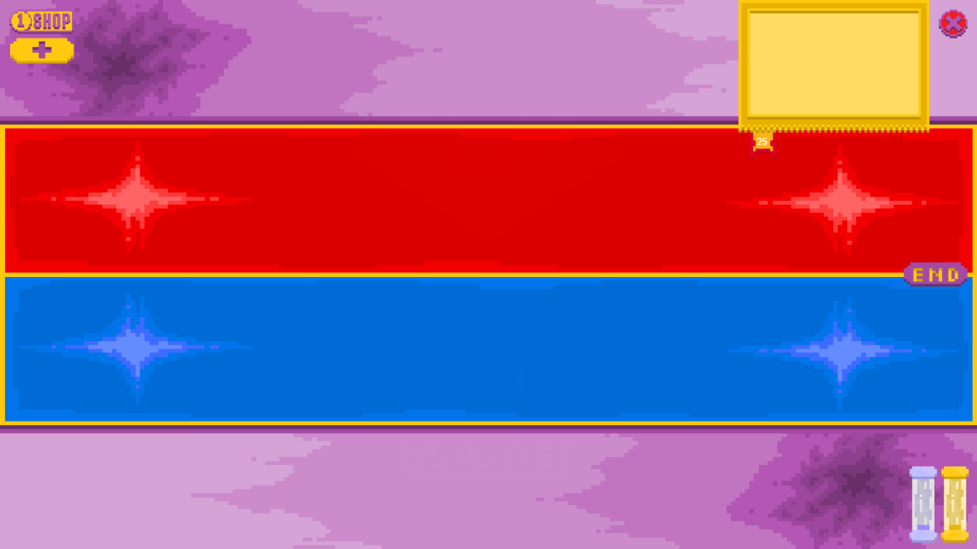Check that you cannot buy a card by clicking the location in which the shop button would be

#ADD CIRCLE AROUND POINT WHERE BUY BUTTON SHOULD BE#

The test was successful as when the buy buttons were not visible the player could not interact with them so no cards could be bought, removed from the shop or added to the player’s hand as a result of clicking an invisible button.

## Card Class Testing

1. Create a test card object from the base card class



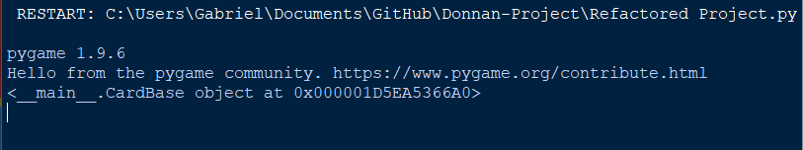

The test was successful as an object was successfully created using the base card class and the object was able to be printed to show that it existed within the program.

1. Create a card subclass with all methods changed and call them all

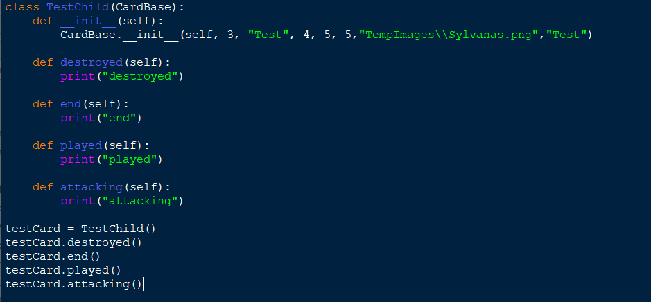

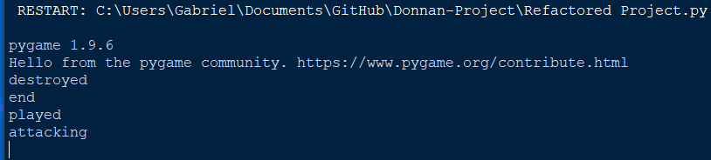

The test was successful as an object was able to be created of the subclass “TestChild” which inherited the superclass CardBase and the re-declared functions all were able to be called with the new effects instead of the superclass’ effects, printing each line in the correct order of calling.

1. Create a card subclass with all attributes changed

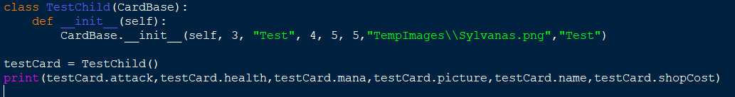

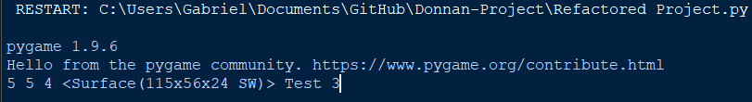

The test was successful as an object was successfully created of the class TestChild which was a subclass of the superclass CardBase and all of the attributes which could be changed were changed and individually printed. The image passed in was correctly formatted into a surface object as desired.

1. Create an object with an additional function as a child class of the CardBase class

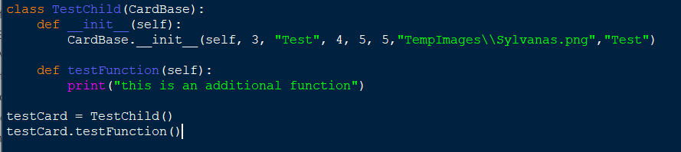

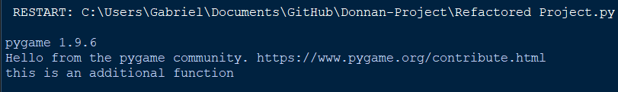

The test was a success as an object of the subclass TestChild was created which inherited from the superclass CardBase and an additional function called testFunction was added to it which was then called and the correct effect of the function was executed.

1. Create a card with a mana cost of 0 as a child of the CardBase class and play it

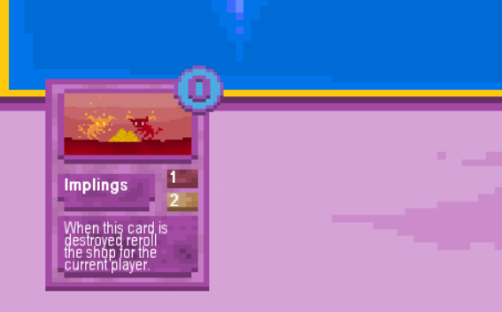

Mana Before playing the card:



Mana After playing the card:



This test was a success as the card did not reduce the current mana total of the player as it cost 0 and the correct symbol was displayed for the cost of the card in the top right corner.

1. Create a card with a shop cost of 0 currency as a child of the CardBase class and buy it

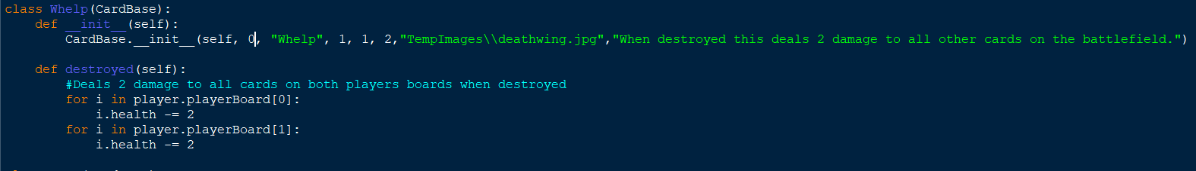Code for the card subclass which costs 0 currency (The first item in the initialisation statement is it’s shop cost):

Card in the shop (Central Card):

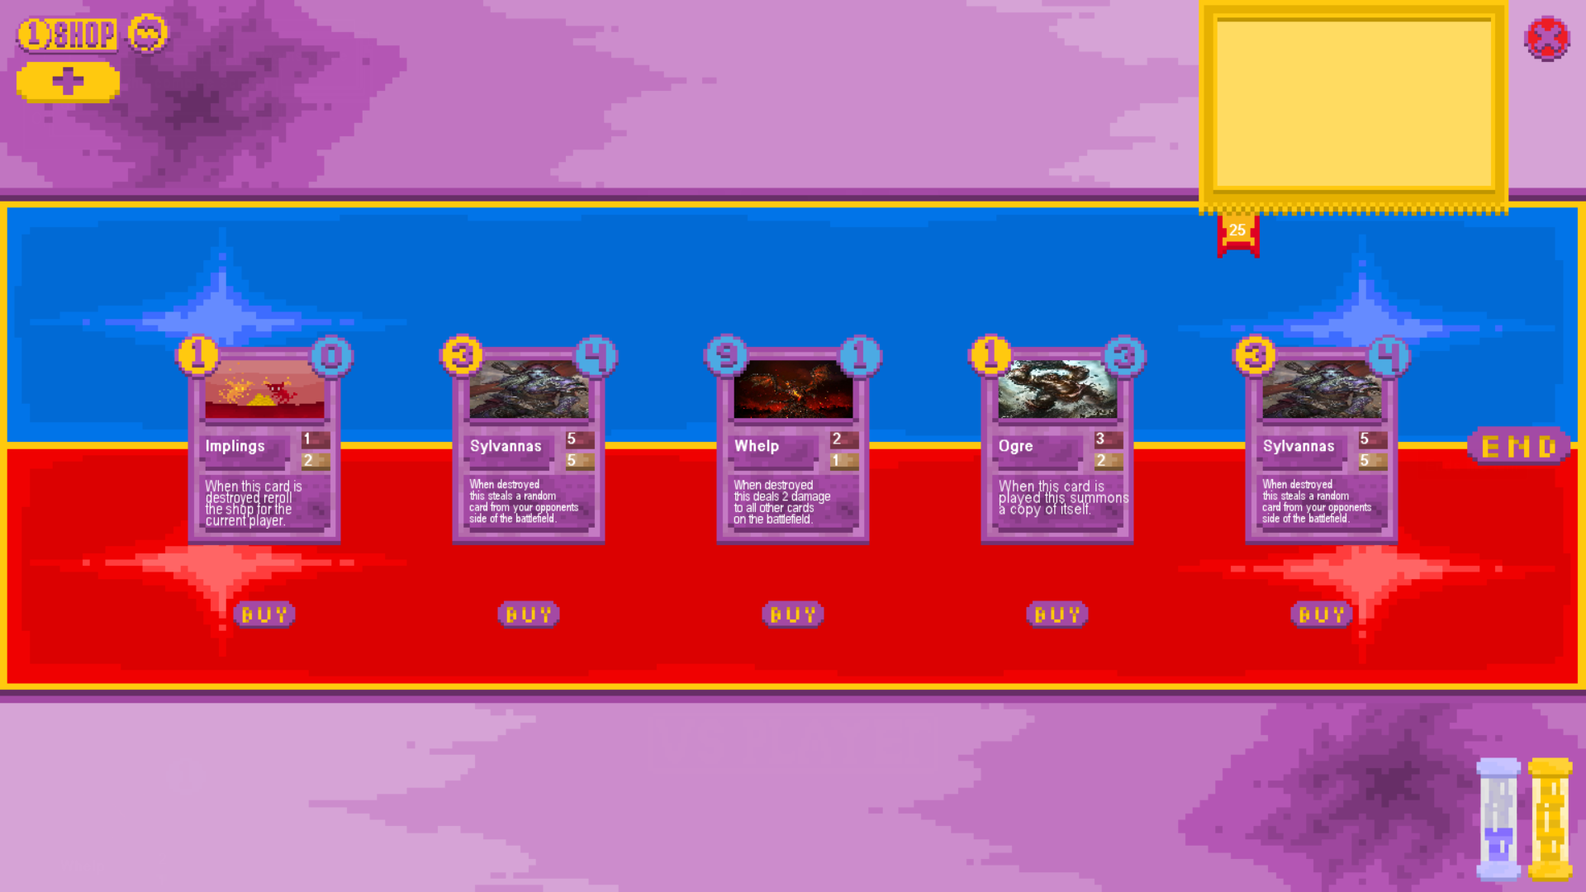

This test is immediately a failure as the shop cost is displayed as if it were a mana cost and the incorrect value is displayed in the shop as is visible from the blue nine in the top left corner of the centremost card whereas every other card has the correct cost in gold in that position.

Board After:

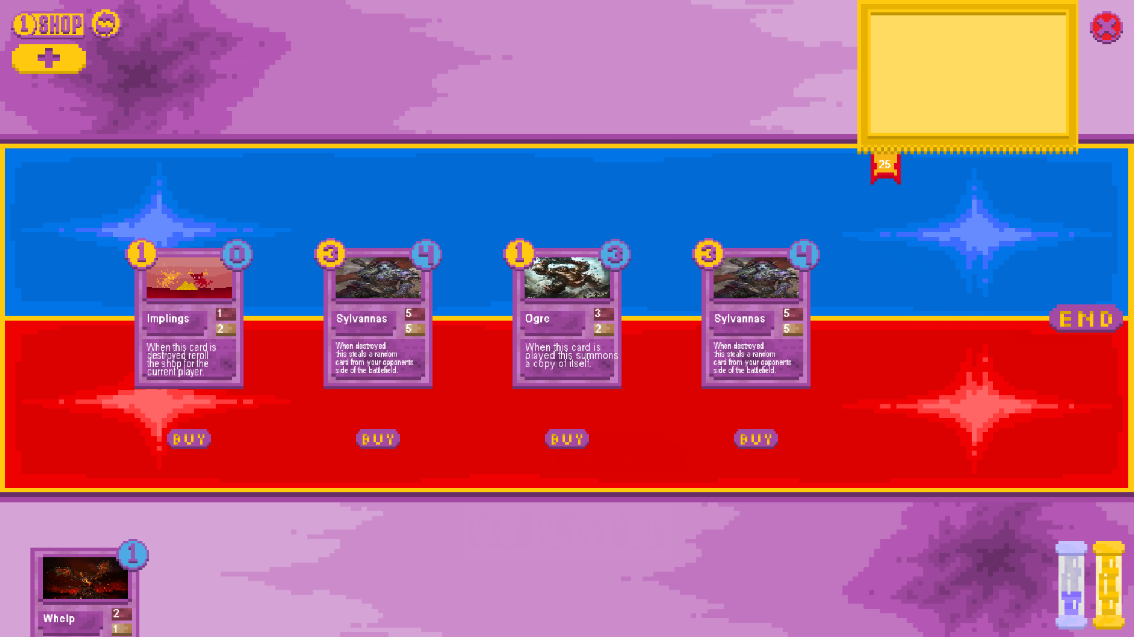

However the test was partially successful as, correctly, no currency was deducted from the current player’s total.

## Card Effect Testing

### On Death Effect and Card Destruction Testing

* 1. 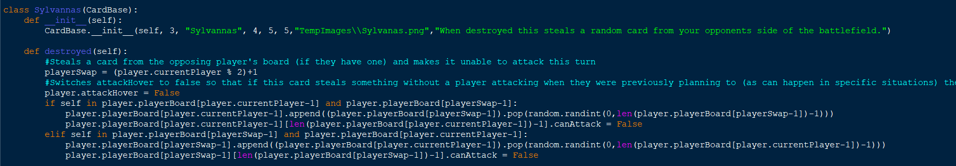Check if on death effects can cause the program to try and remove cards from the opponent’s empty board

The function of the Sylvannas card subclass tries to remove a card from the opponent’s board and add it to the current player’s board instead when the card is destroyed.

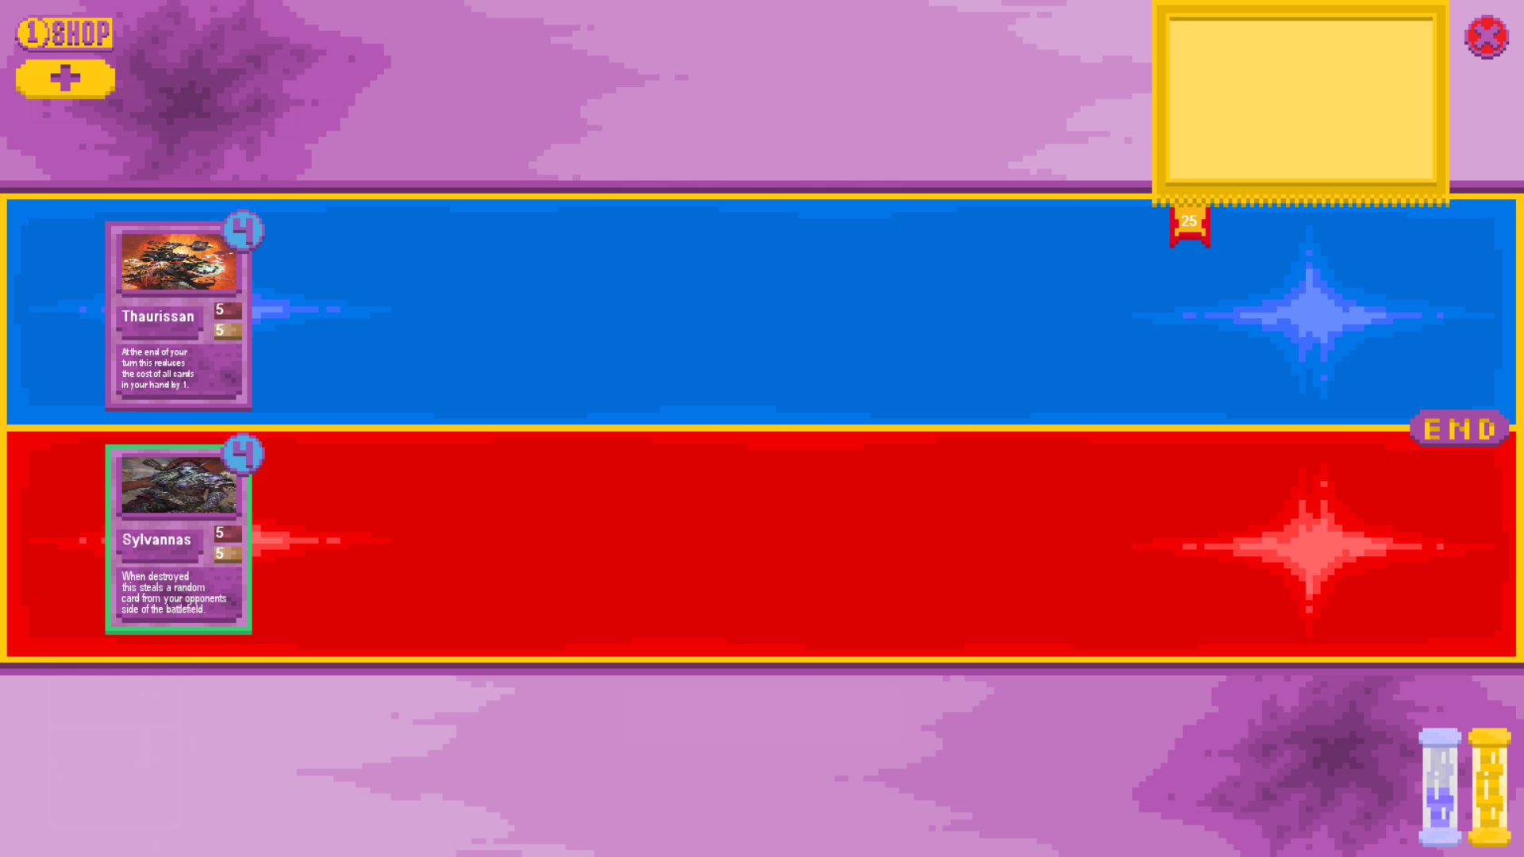

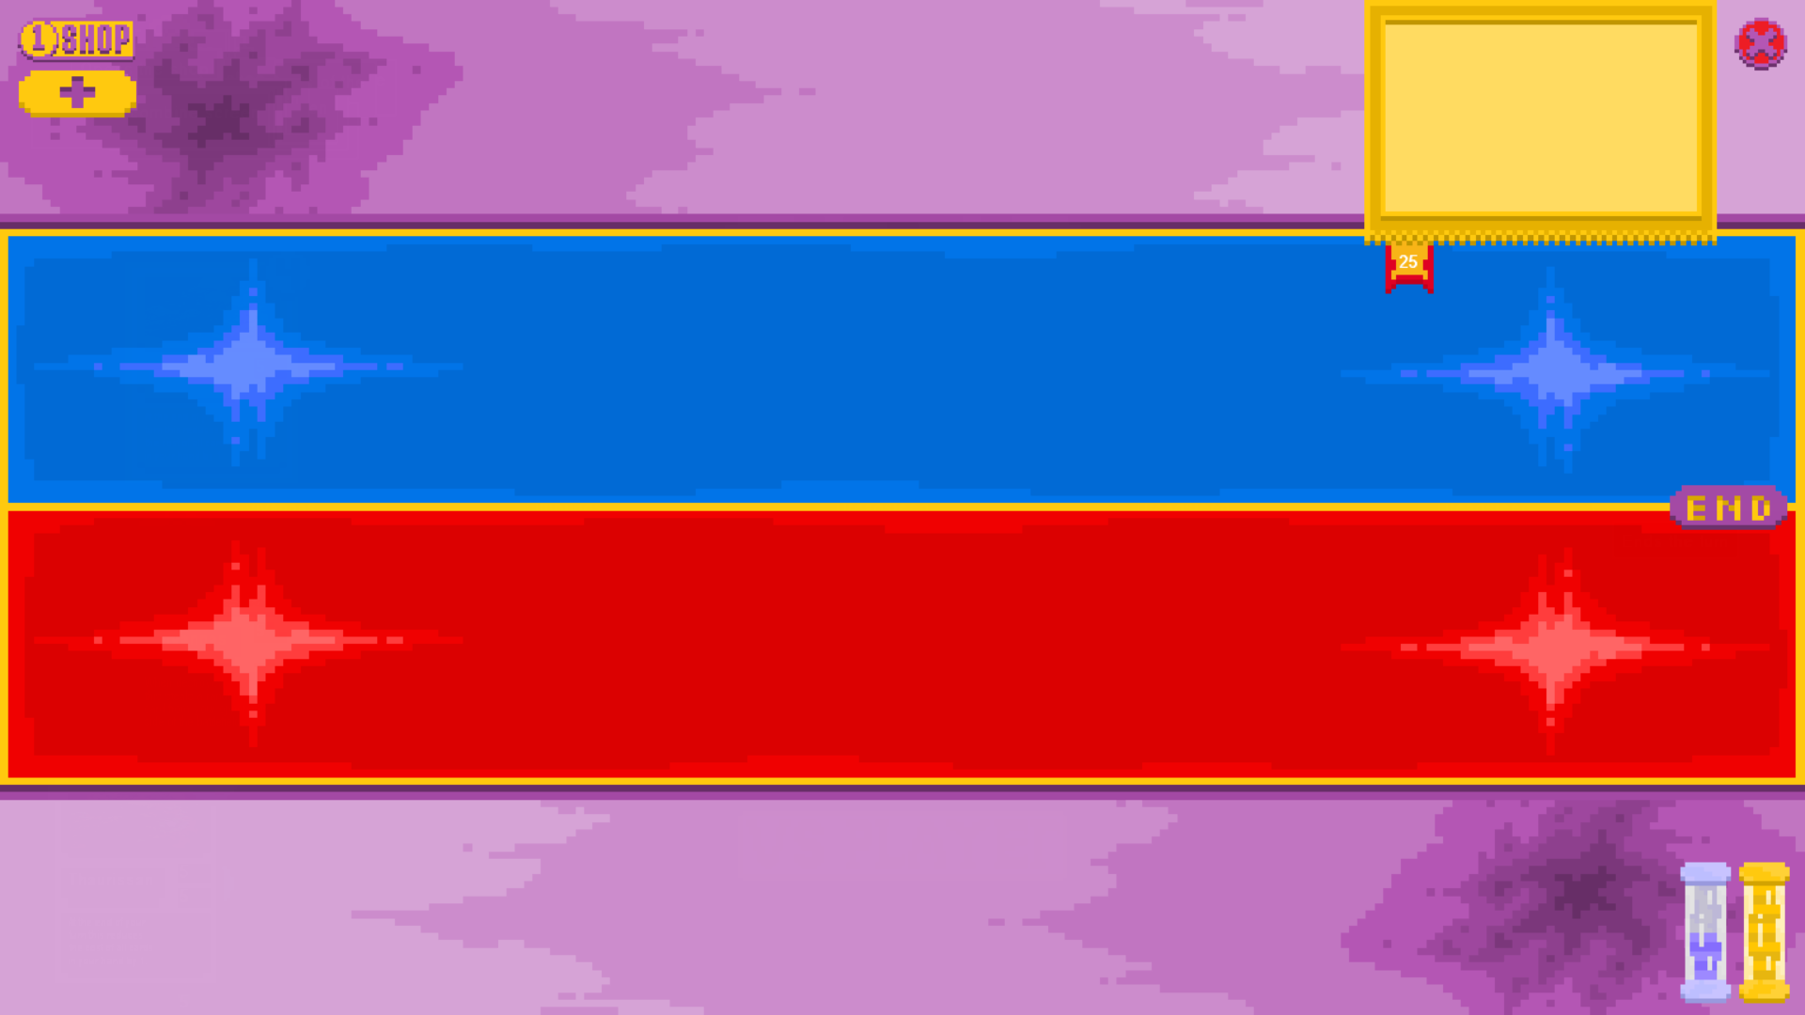

The test was a success as the player attacked with the sylvannas card into the opposing player’s Thaurissan. This destroyed both cards meaning that sylvannas’ on death effect would be unable to trigger but instead of crashing the program continued running as if the on death effect had not happened.

* 1. Check full boards

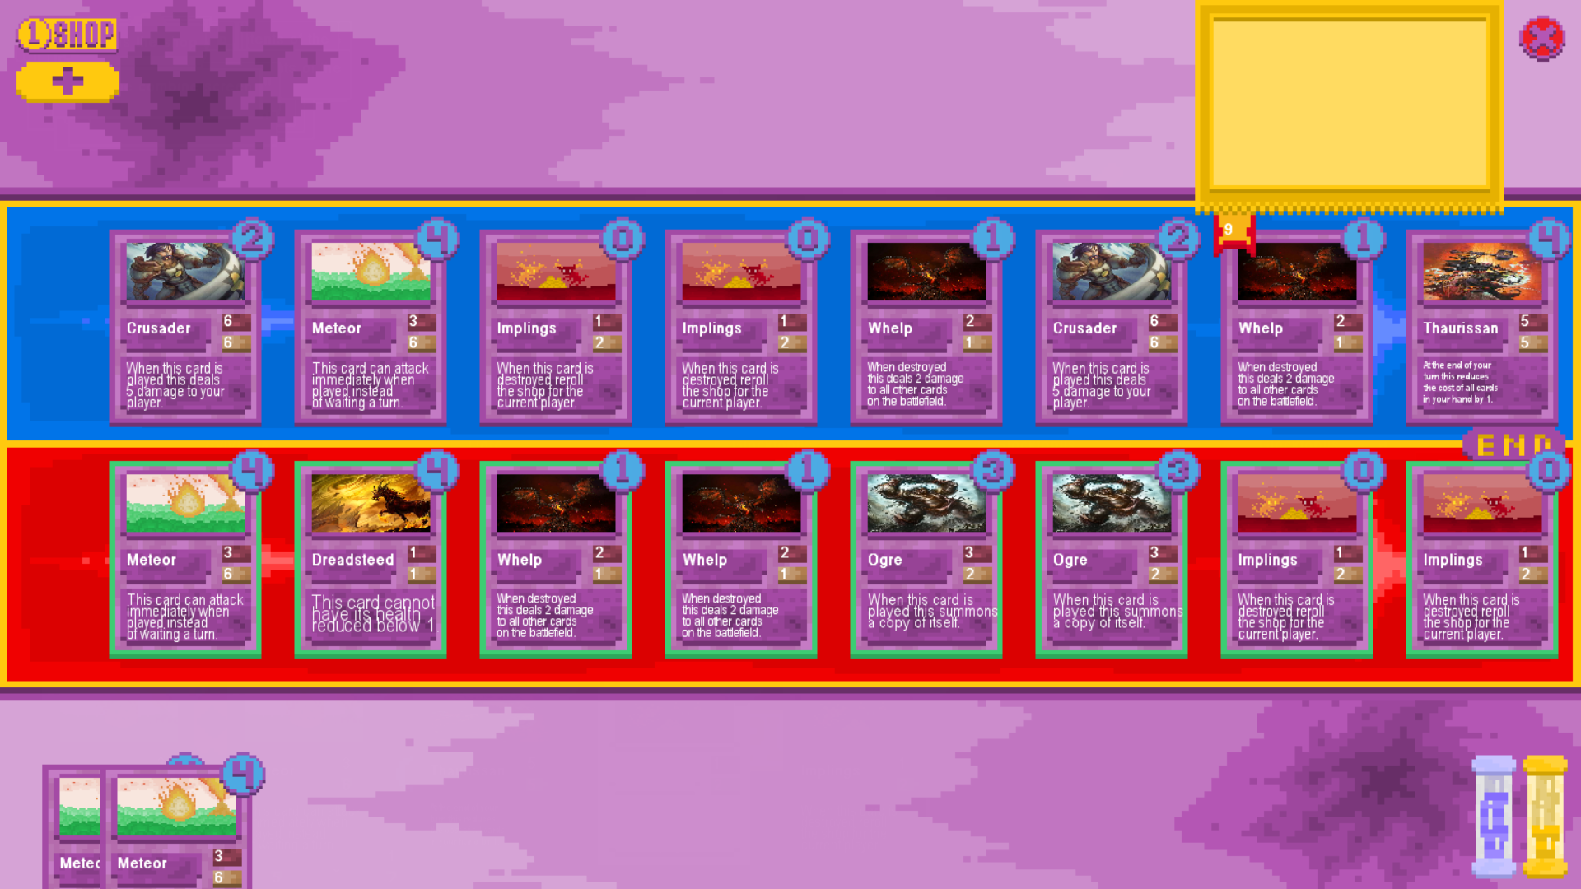

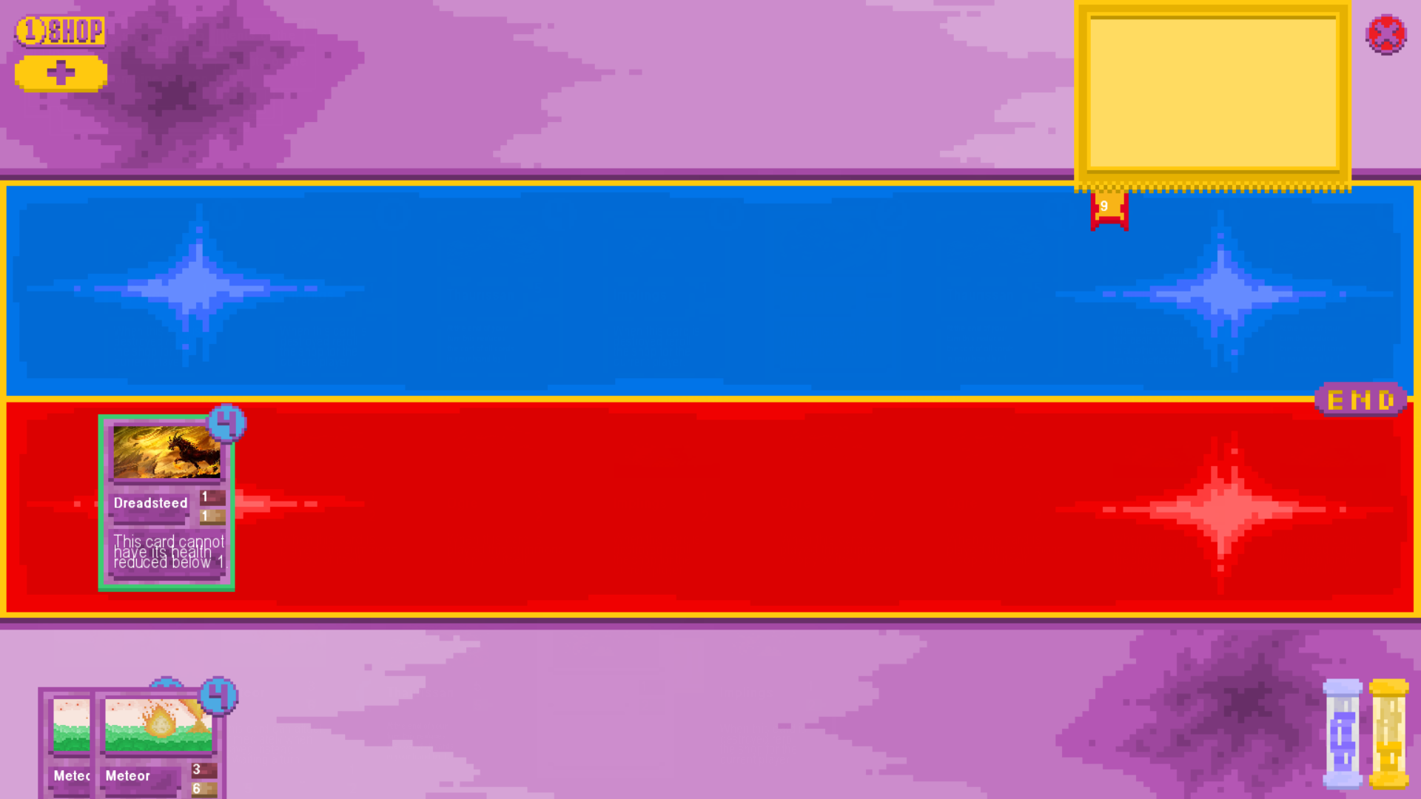

The test was a success as an ogre card on the current player’s attacked a whelp card on the opposing player’s board, triggering the on death effect of the whelp which destroyed all other whelps, triggering their on death effects and destroying all minions on the board. (except for the dreadsteed which cannot die). The game was able to handle all these minions dying at once from a full board without crashing.

* 1. Check full boards of dead minions

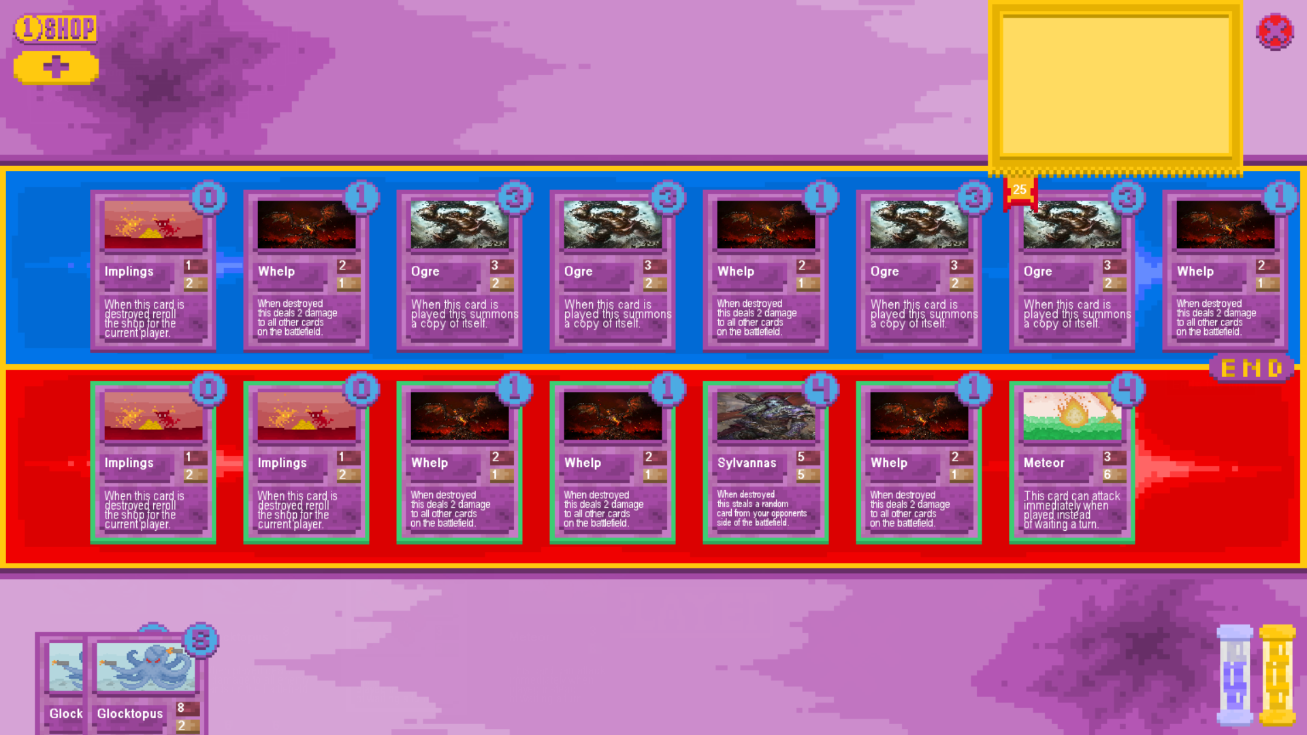

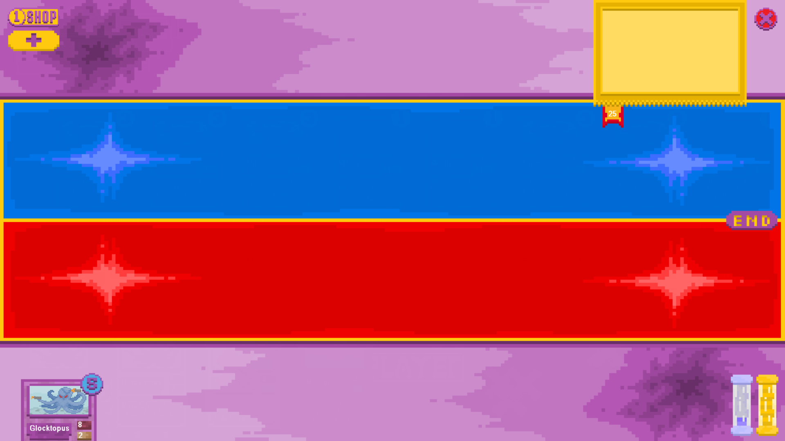

The test was successful as the card glocktopus was played, dealing 8 damage to all cards on the opposing side of the board which subsequently killed the whelps, dealing damage to all cards when destroyed, resulting in the board being completely full of dead minions. The card sylvannas which was killed normally will attempt to steal a card from the opposing side of the board when killed and if it had attempted to steal a dead card the limit of the board size would have been exceeded, causing the program to crash. This did not happen.

* 1. Check boards with mixed dead and living minions

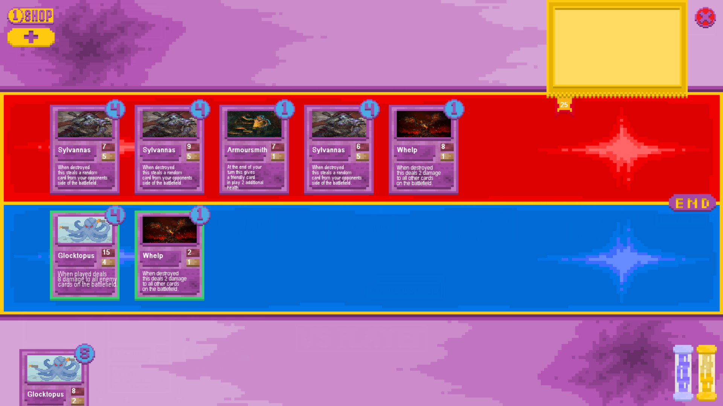

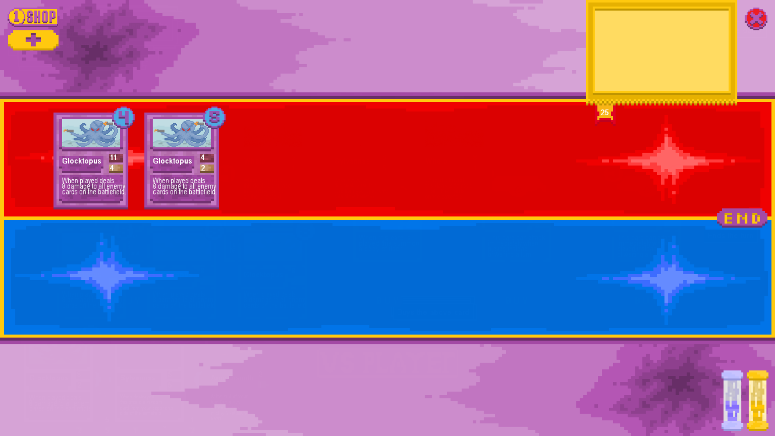

The test was successful. When the “glocktopus” card was played it resulted in all cards being destroyed other than the two instances of the glocktopus card, including the whelp card on the current player’s side of the board. The two glocktopus cards were stolen by the on death effects of the opposing sylvannas cards but the destroyed instance of the whelp card was not stolen by the third sylvannas’s on death effect, meaning the test was a success.

* 1. Check board with living and dead cards of the same name

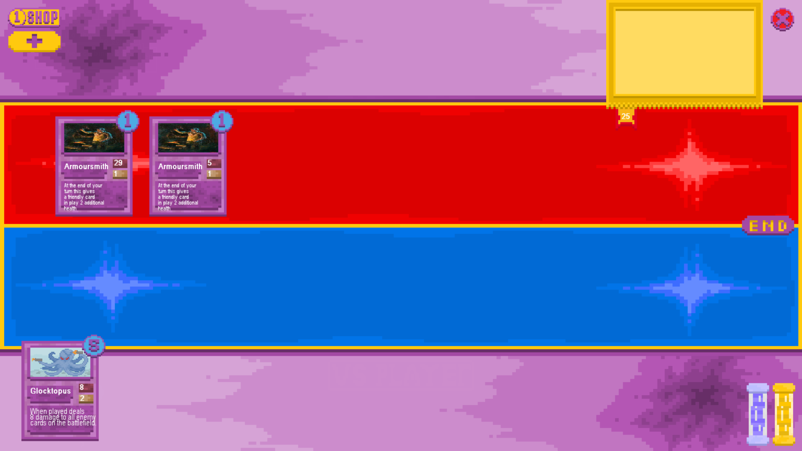

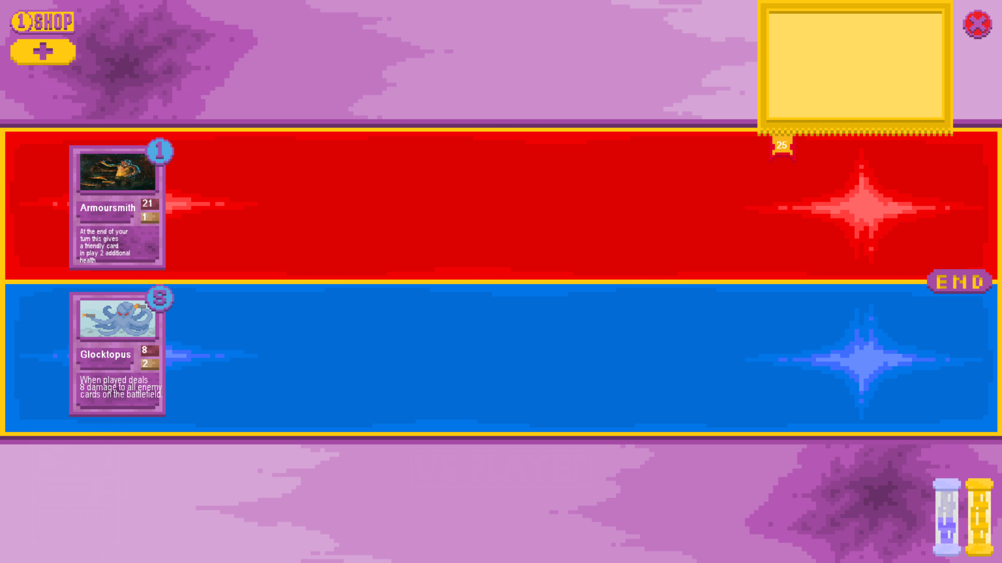

The test was a success as when the glocktopus card was played it killed the opposing armoursmith with lower health and the other instance of armoursmith didn’t get destroyed as would have happened if the game were unable to distinguish between instances of cards with the same name.

* 1. Check the on death effects of each card with a function that triggers on its destruction

1. Whelp

Board Before:

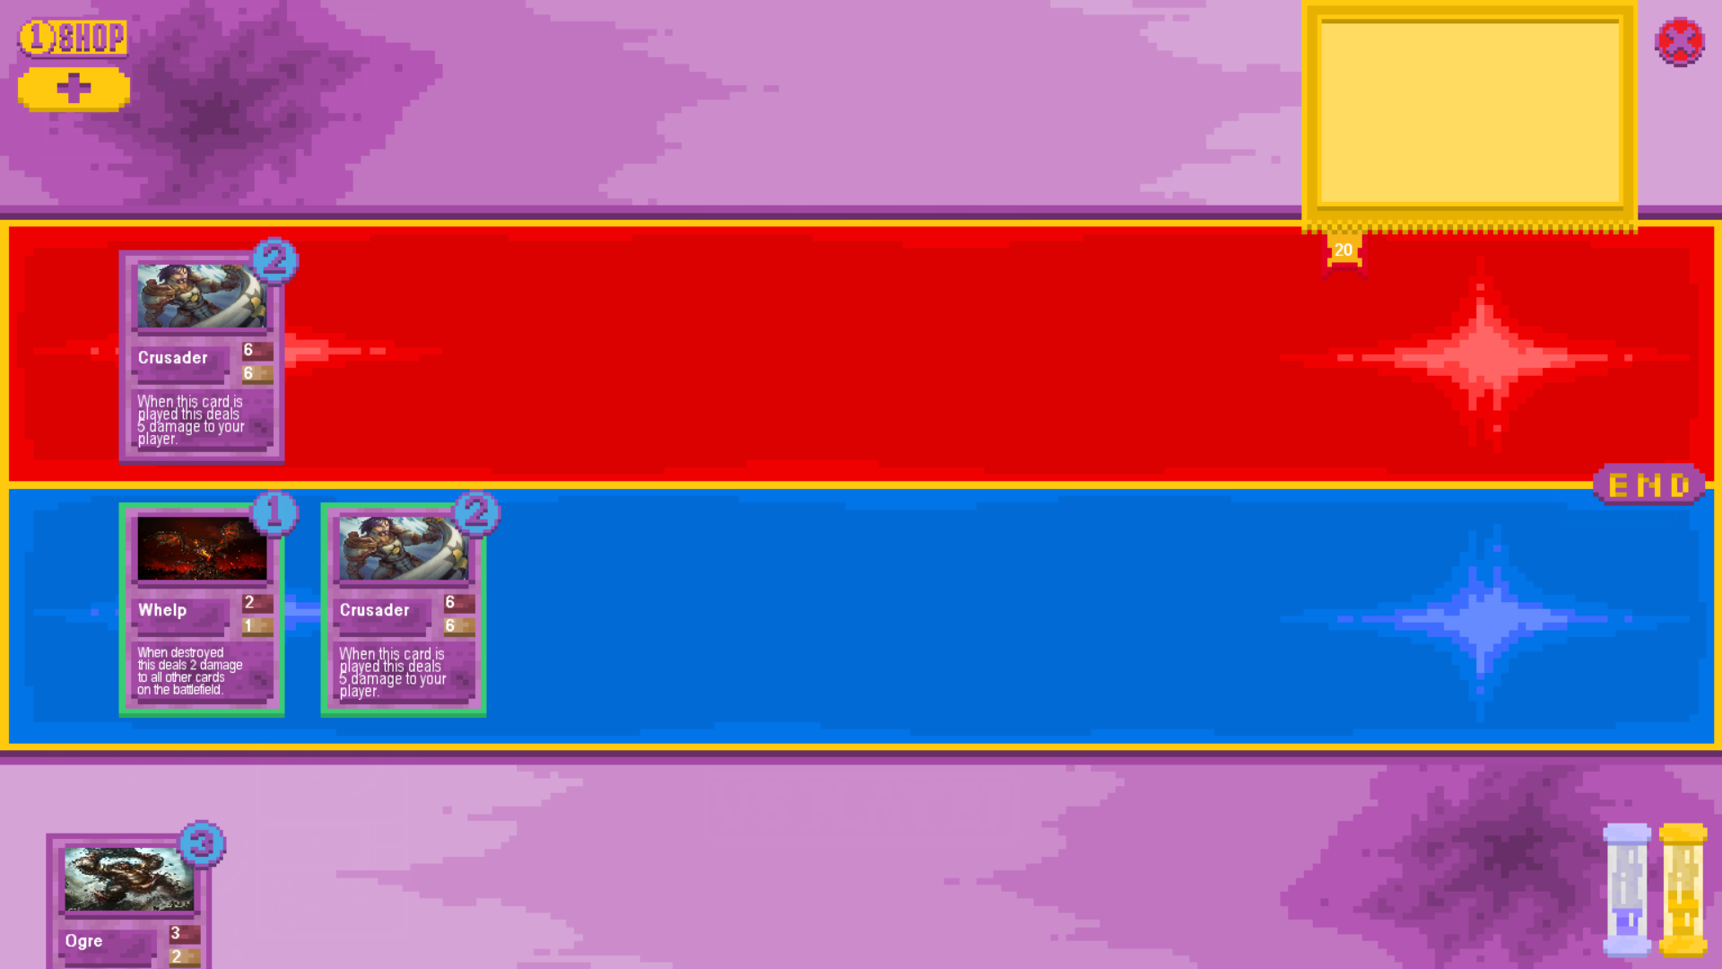

Board After:

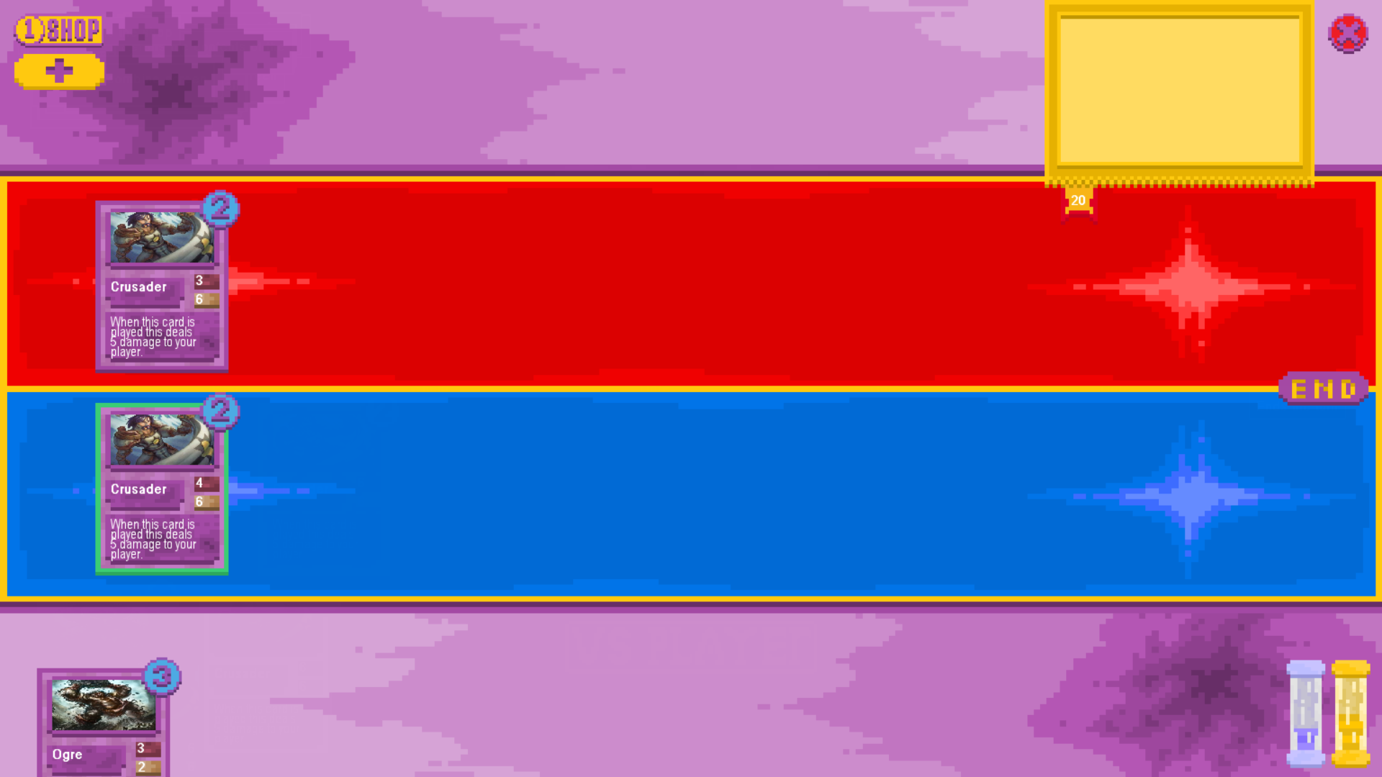

1. Sylvannas

Board Before:

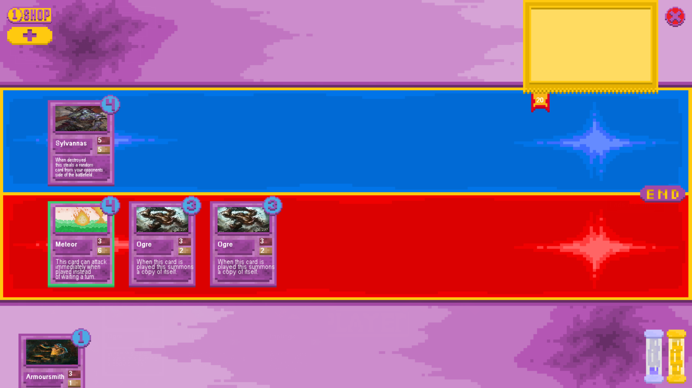

Board After:

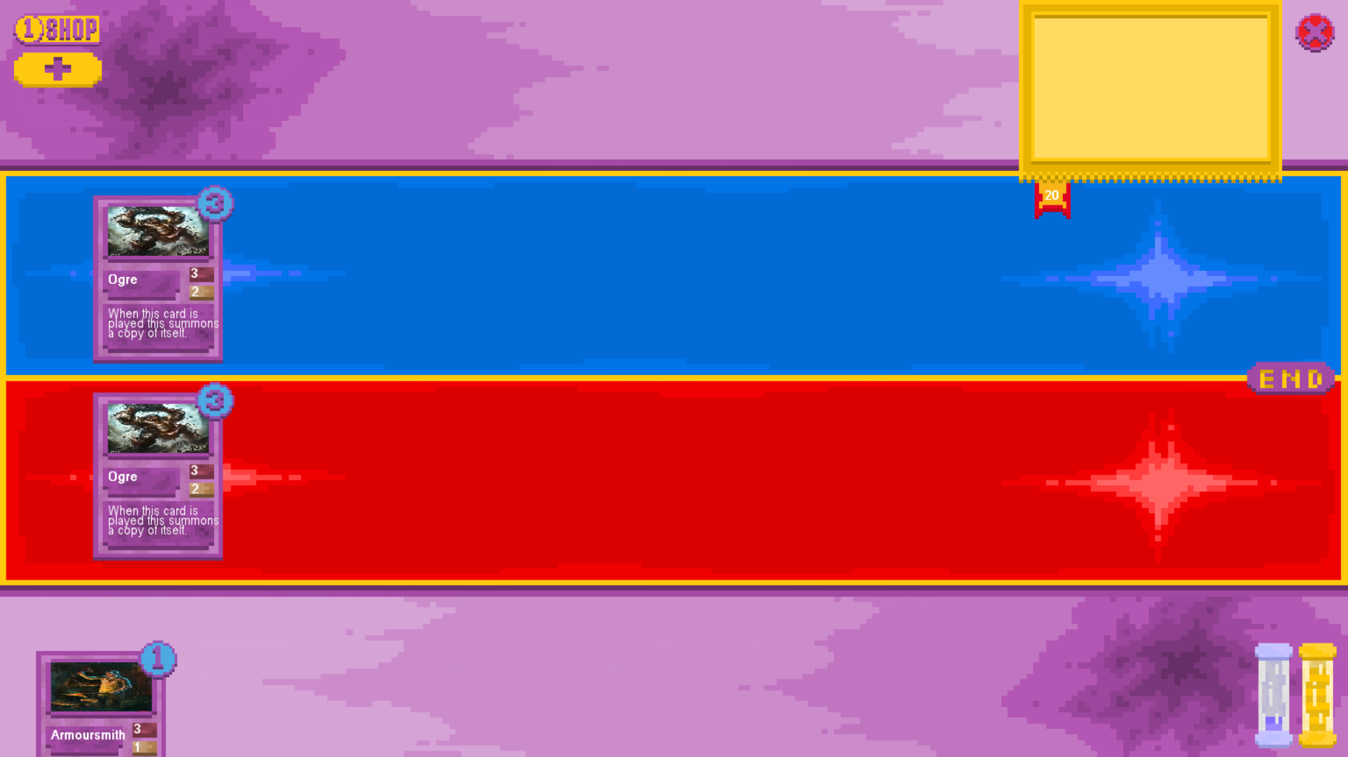

1. Implings

Board before:

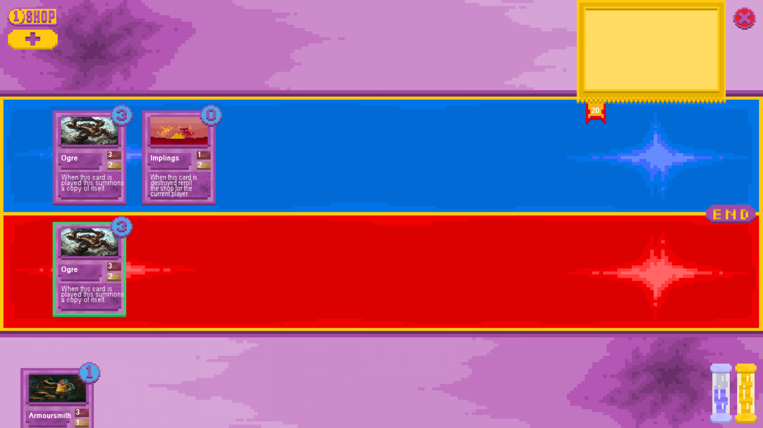

Shop Before:

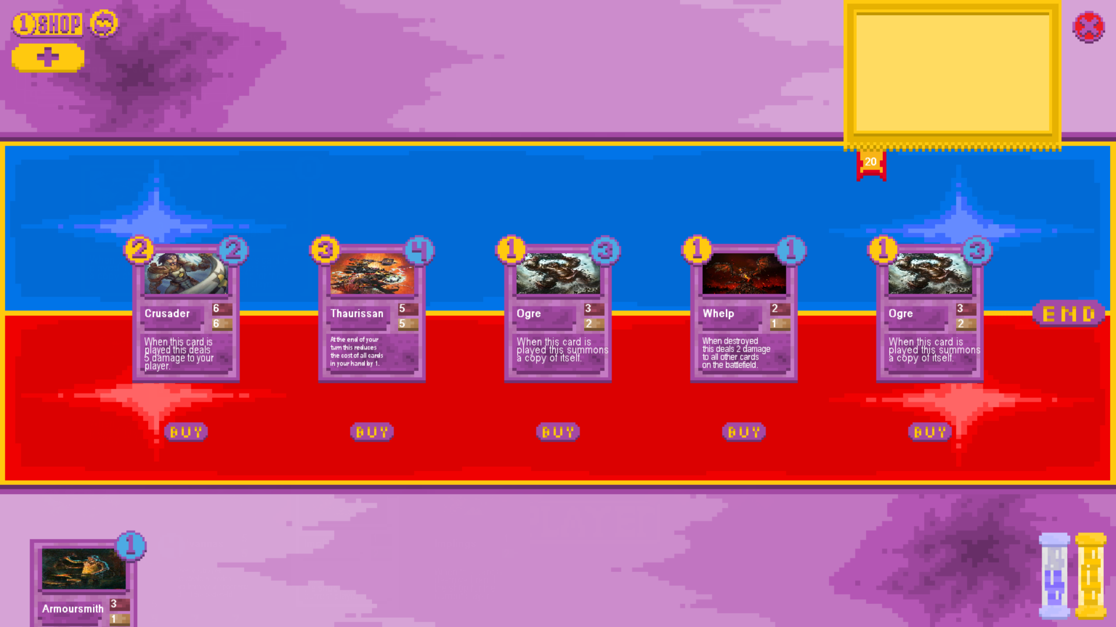

Board After:

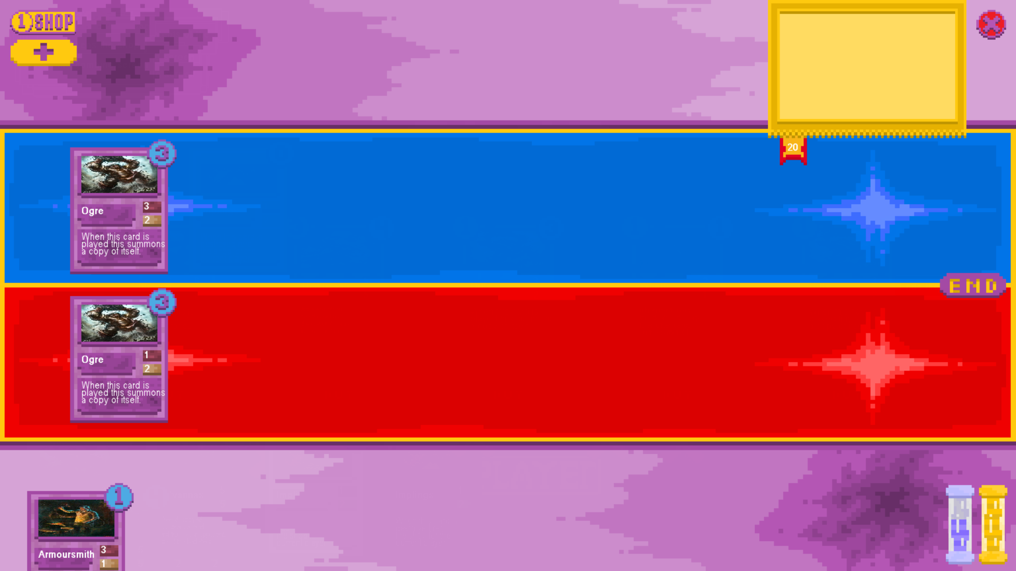

Shop After:

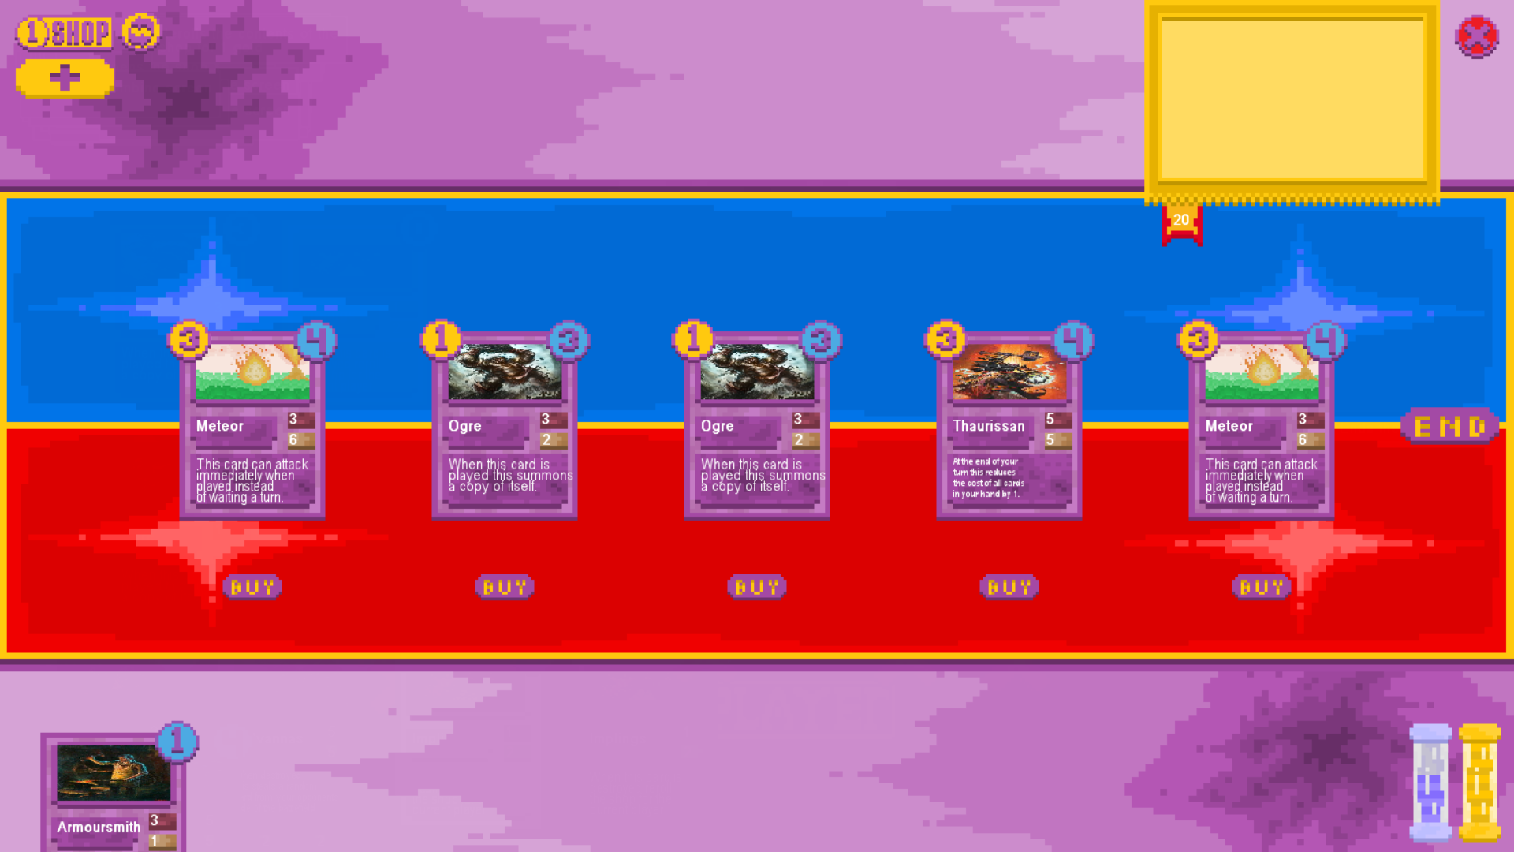

These tests were each a success. The whelp dealt 2 damage to cards on both sides of the board when destroyed as intended and stated on the card’s text.

Sylvannas when destroyed removed a card from the opposing player’s board and added it to the controller of sylvannas’ instead without changing anything else about the card.

Implings when destroyed rerolled the contents of the shop into a complete set of different cards to be purchased.

These are all the effects that are stated on the cards in their text and as such the test was successful.

### On Play Effect and Card Playing Testing

* + 1. Playing card with sufficient mana

Board Before:

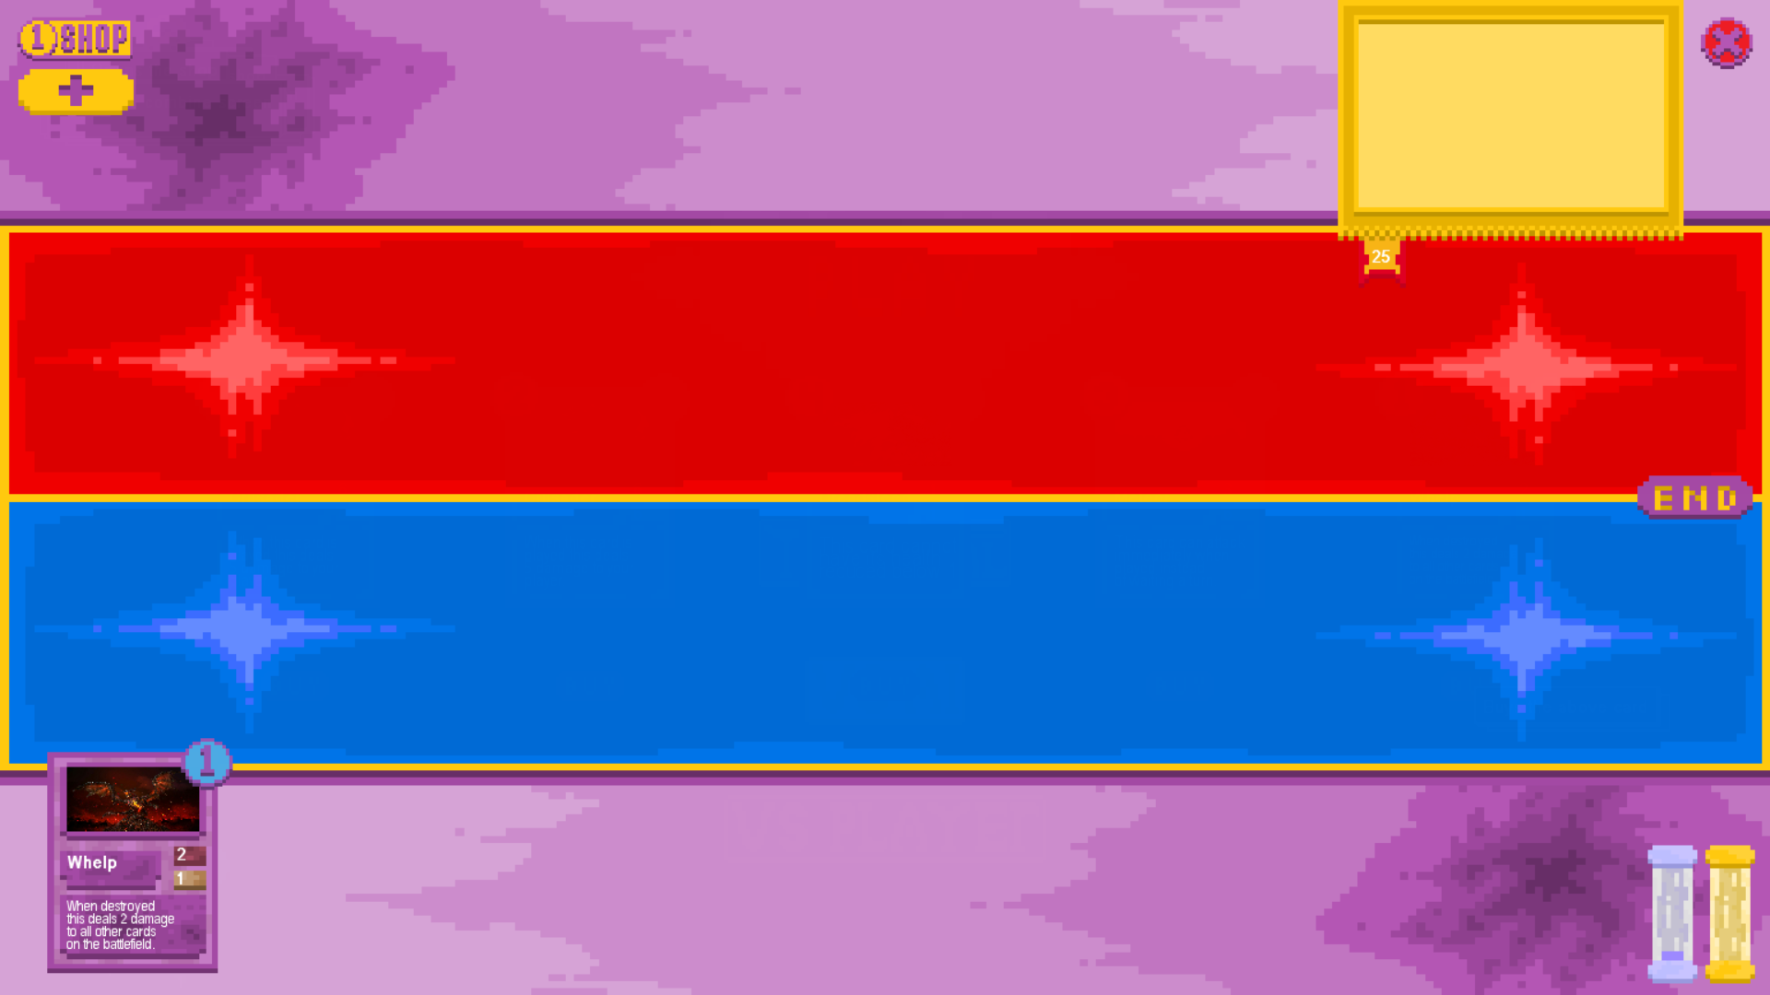

Board After:

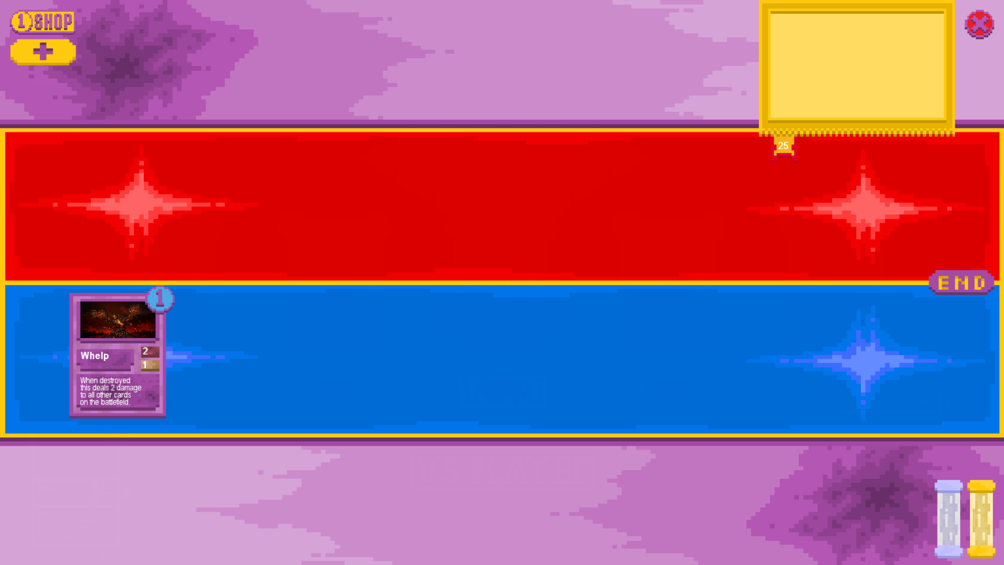

The test was successful as when the player had sufficient mana to play the card upon clicking on it the card was removed from the player’s hand and placed on the battlefield, deducting the correct mana cost.

* + 1. Attempting to play card with insufficient mana

Board Before:

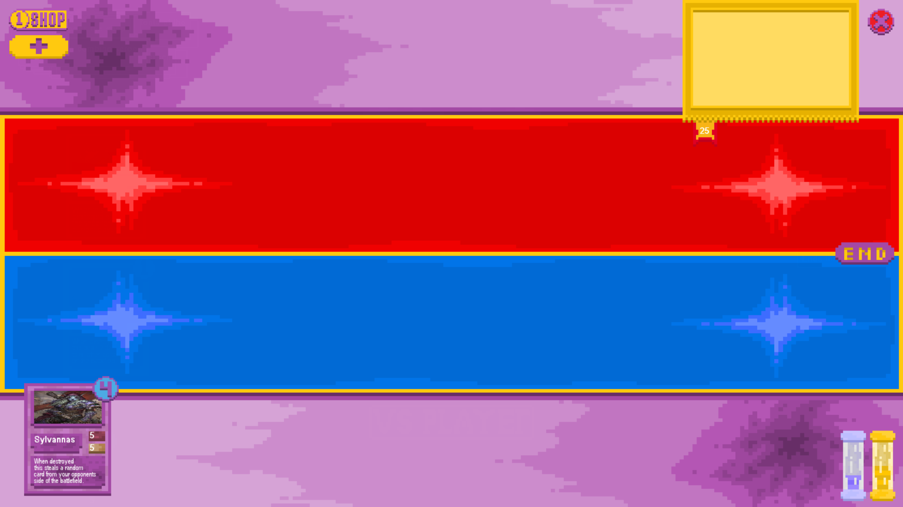

Board After:



The test was successful as when the player had only 3 mana when the card required 4 mana to play upon clicking on the card nothing happened. The card was not played, no effects were triggered and no mana was deducted from the player.

* + 1. Playing card with played effect that affects the board with other cards populating the board

Board Before:

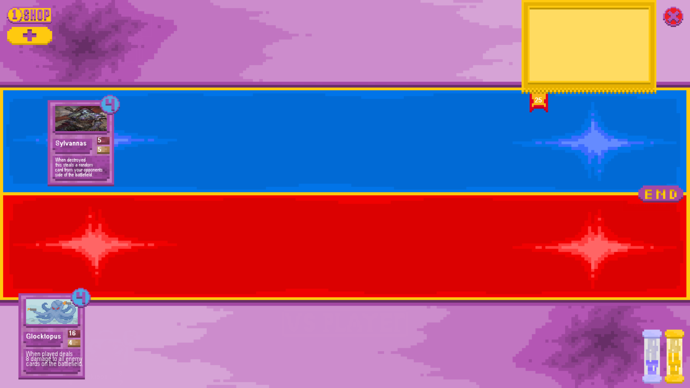

Board After:

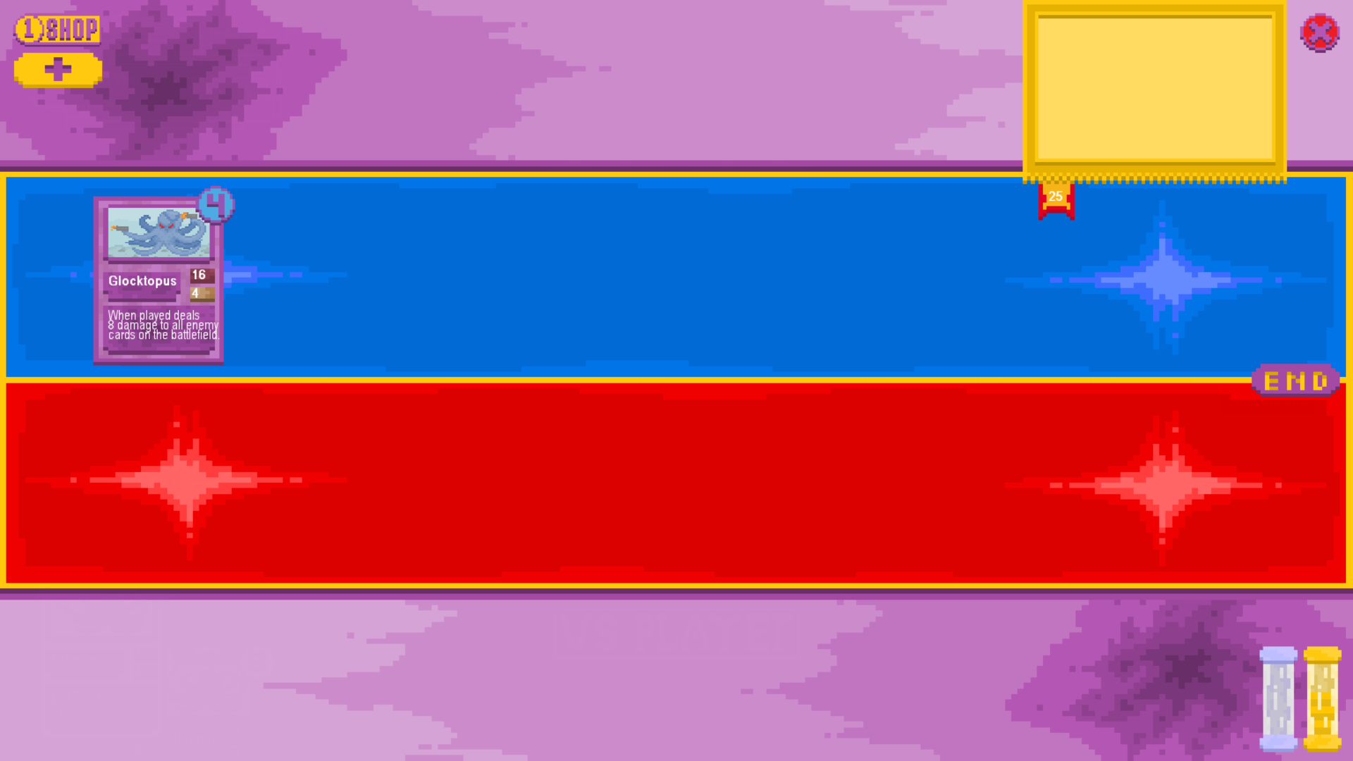

The test was successful as when the card was played its effect (in this case dealing 8 damage to all cards on the opposing side of the board) was enacted correctly upon the other cards in play.

* + 1. Playing card with played effect that affects the board without other cards populating the board

Board Before:

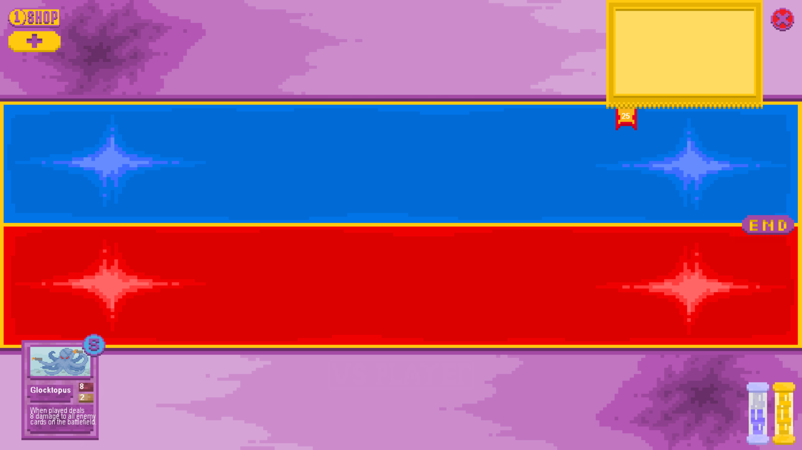

Board After:

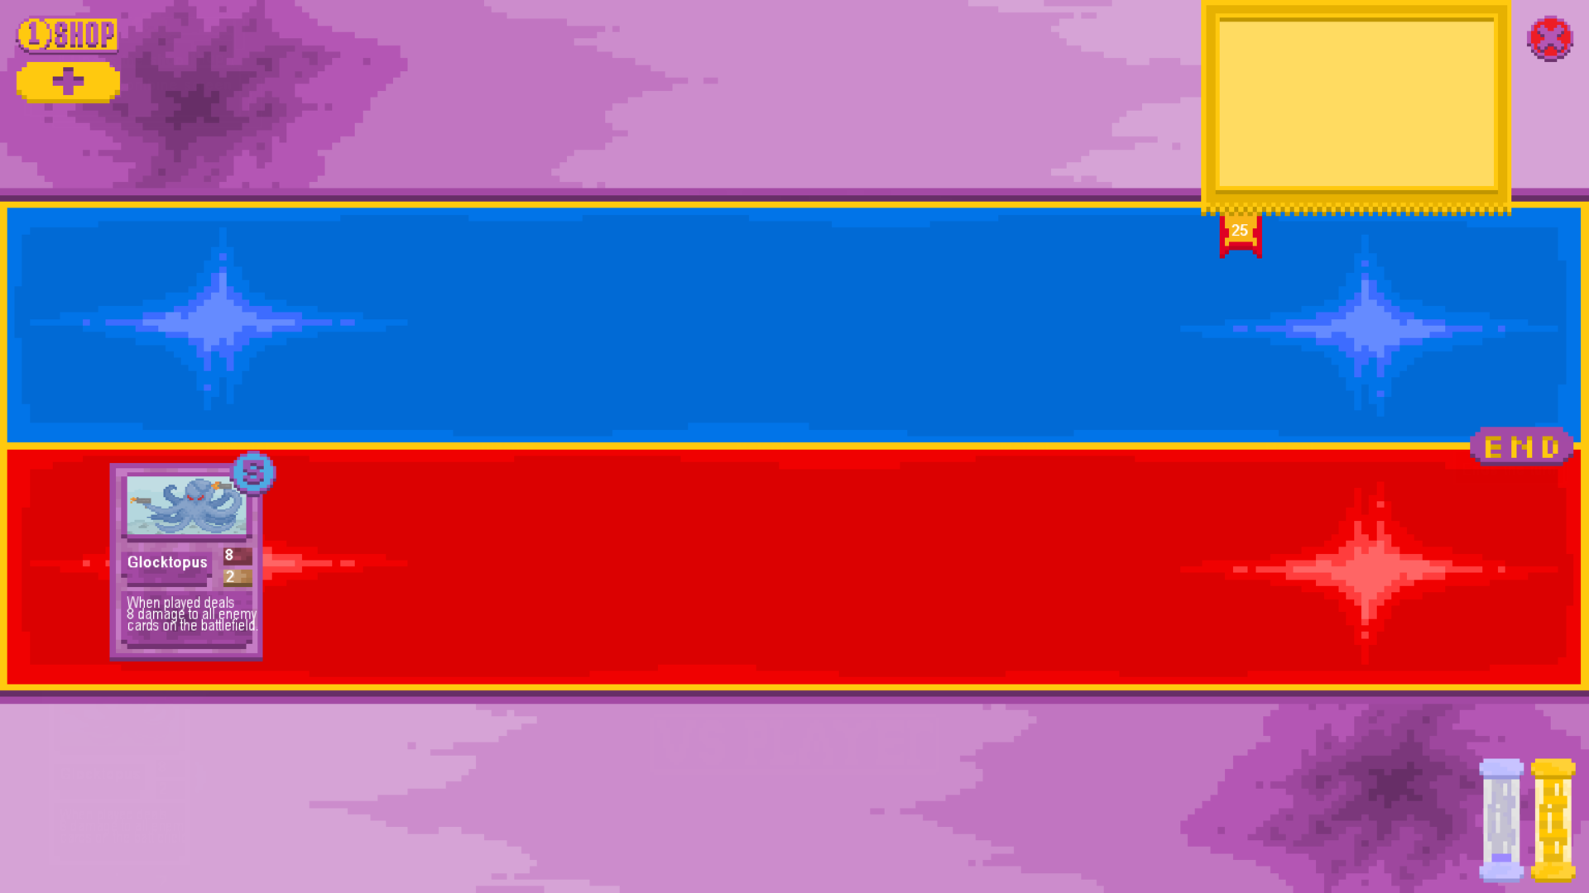

The test was a success as while the card would normally have an effect on the opposing player’s board, when there is no board it can still be played as a normal card instead of crashing due to lack of targets.

* + 1. Attempting to play a card when the current player’s board is full

Board Before:

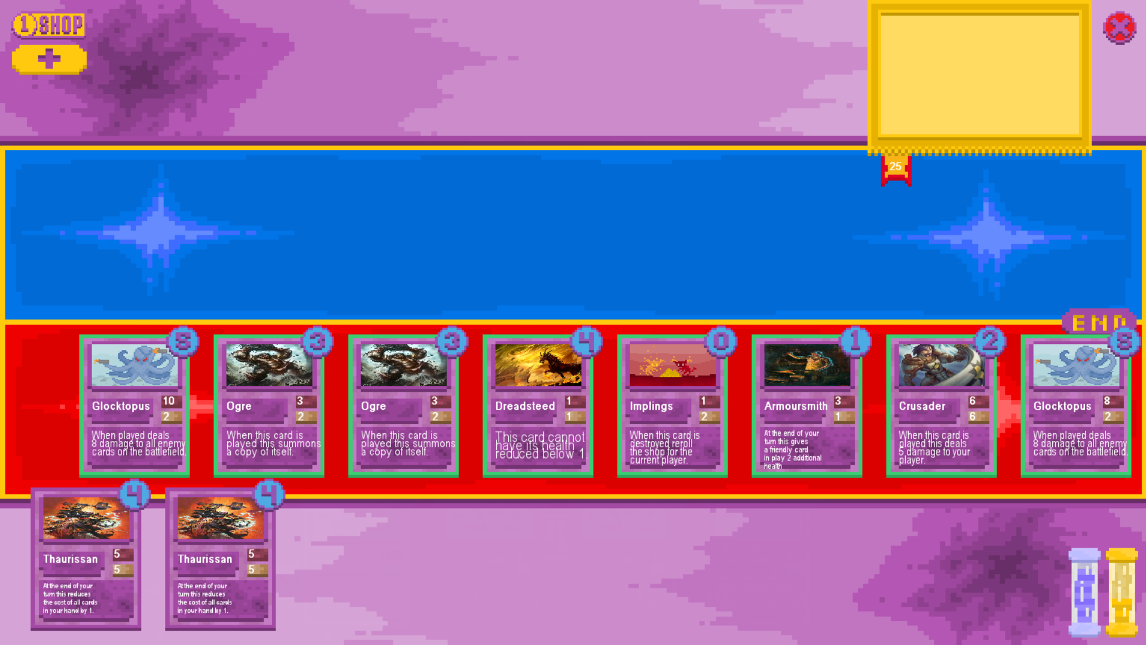

Board After:



The test was a success as when attempting to play a card with the board full the board’s size limit was respected, the card was not removed from the player’s hand or added to the board and it’s mana cost was not deducted from the total.

### On Attack Effect and Card Attacking Testing

* + - 1. Attempt to attack with a card that cannot attack

Board Before:

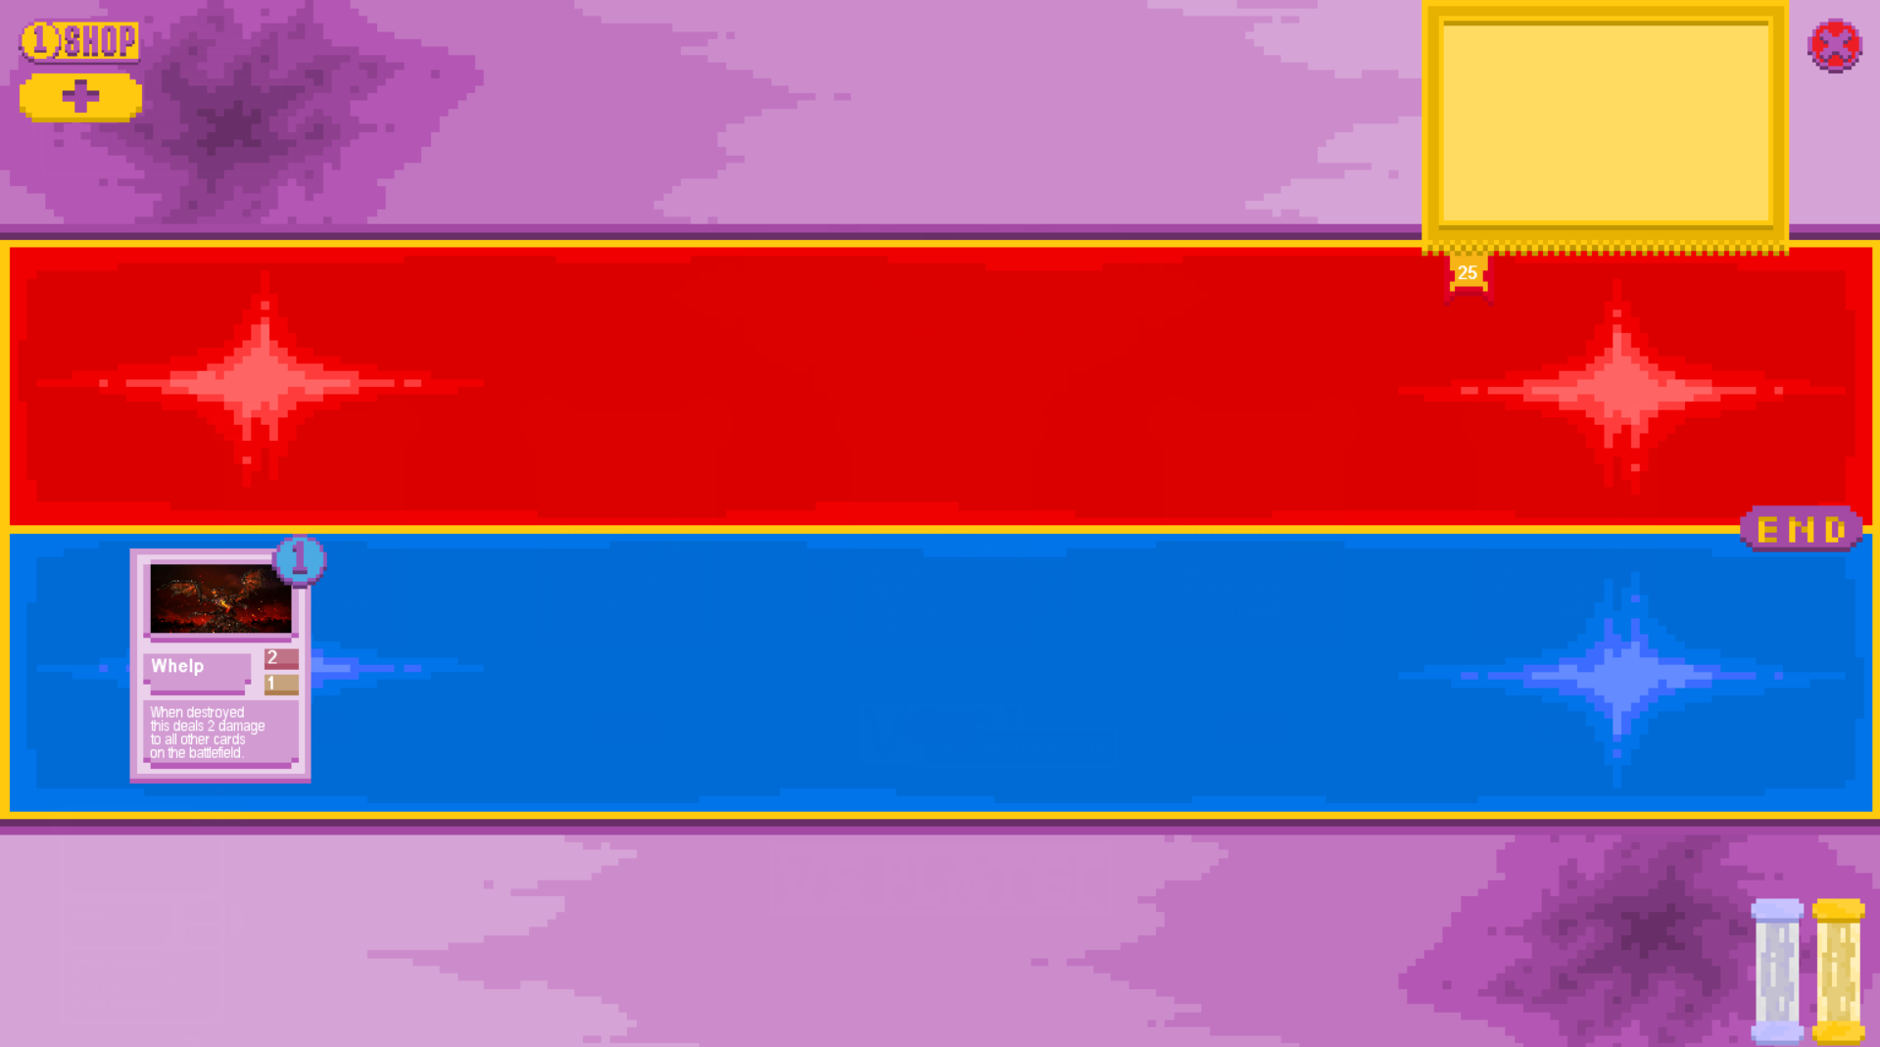

Board After:

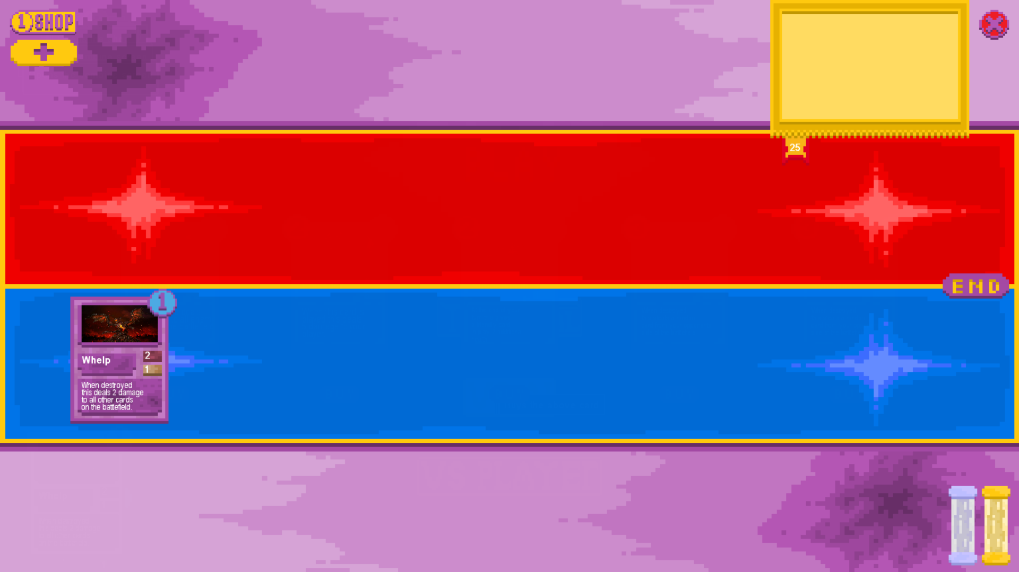

This test was successful as the card was unable to attack with it’s CanAttack Boolean set to false, it also did not display with the green border that a card that was able to attack would normally have.

* + - 1. Attempt to attack a friendly card with a card that can attack

Board Before:

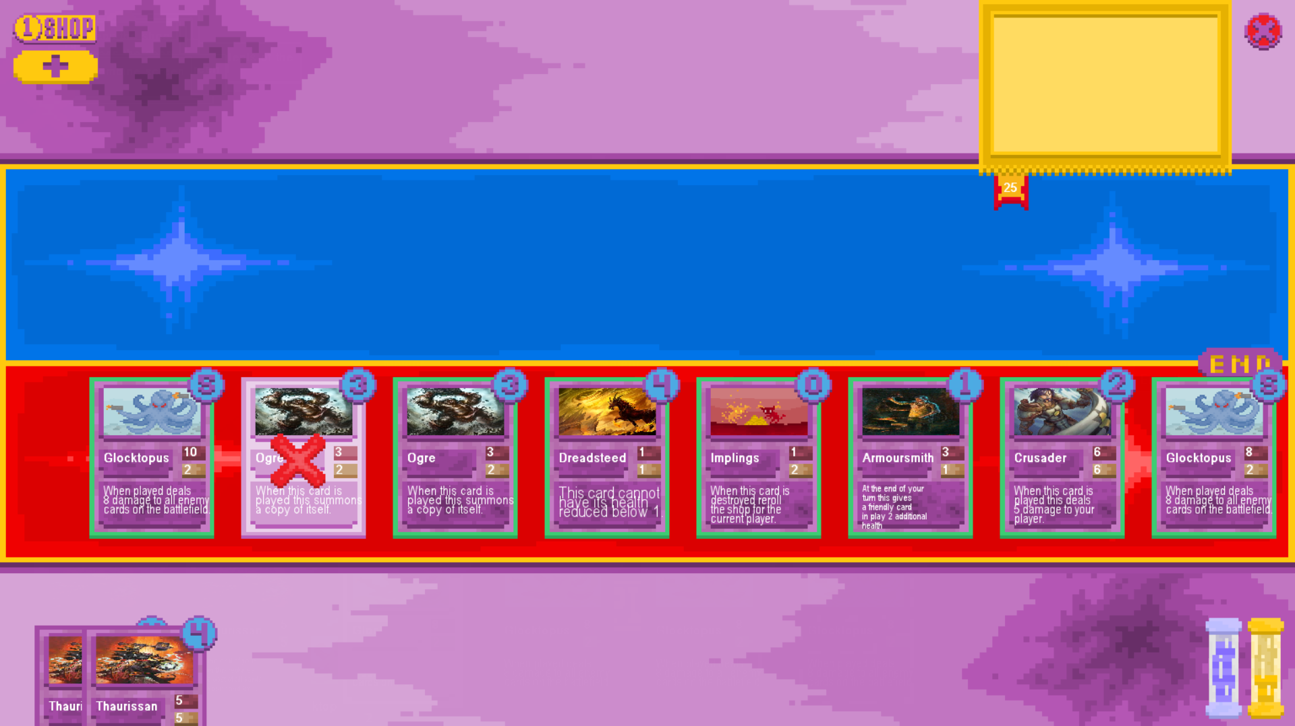

Board After:

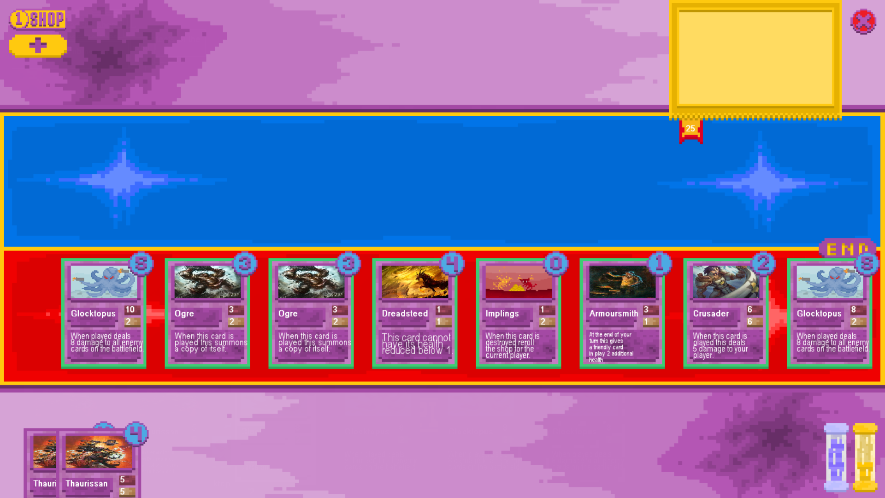

The test was a success as the card’s attack was not allowed to go through on a friendly card, the program did not crash as a result of attempting to target a friendly card and neither cards had their healths reduced or ability to attack removed.

* + - 1. Attack an opposing card with a card that can attack when both cards survive

Board Before:

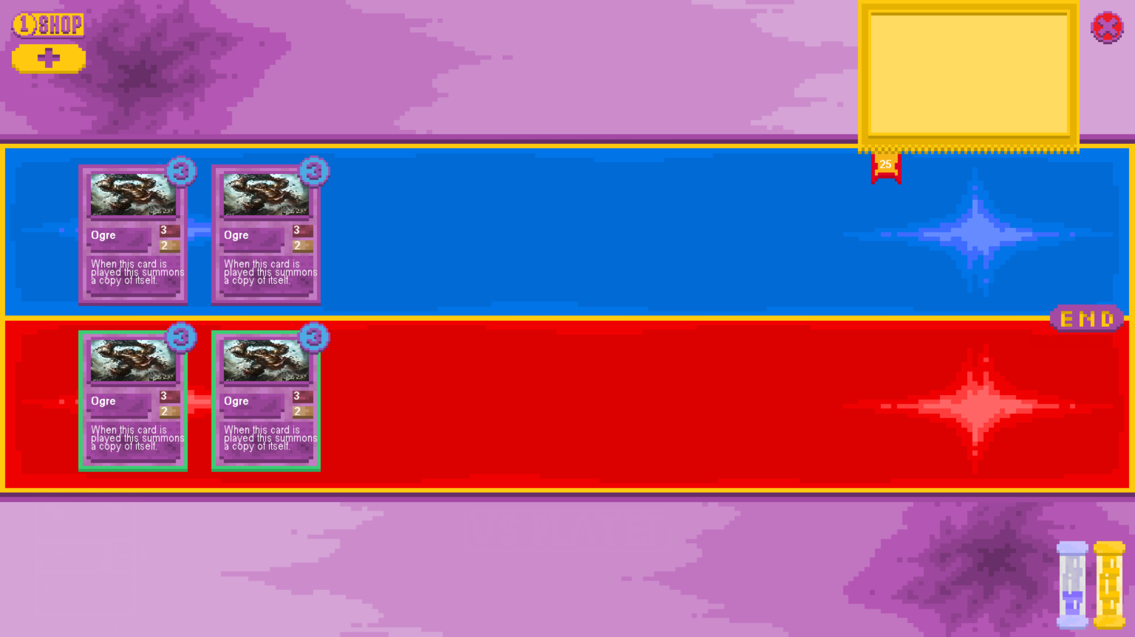

Board After:

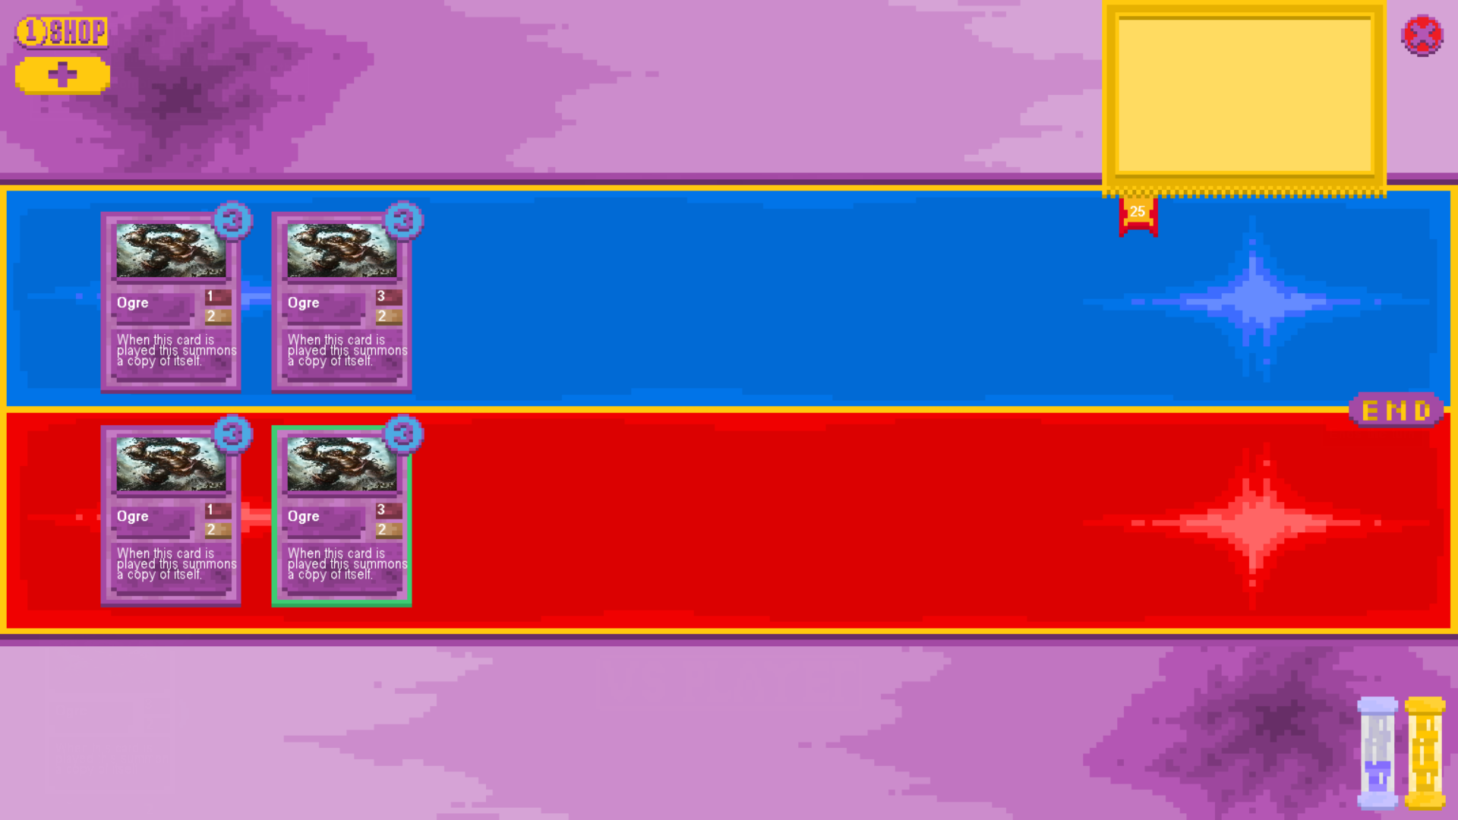

The test was a success as the health values of both the card that attacked (the left ogre on the friendly side of the board) and the card that was attacked (the left ogre on the enemy side of the board) were reduced by the correct values, neither card was destroyed as the values of the damage they took were lower than their health values.

* + - 1. Attack an opposing card with a card when at least one is destroyed

Board Before:



Board After:

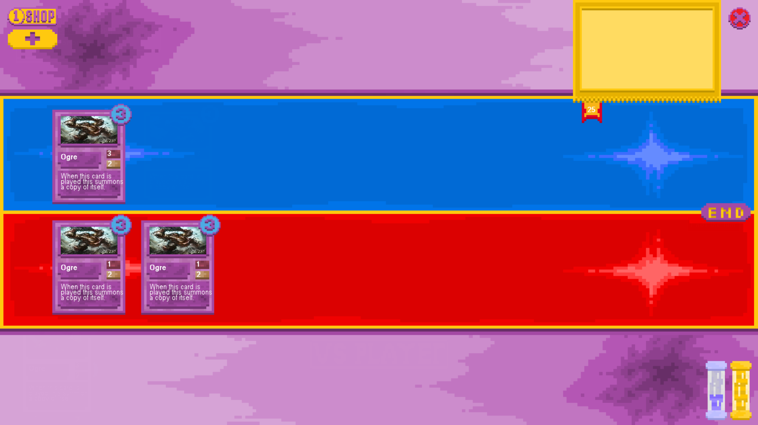

The test was a success as the health values for both the card that attacked and the card that was attacked were correctly reduced. The card that was attacked had it’s health value reduced below 1 so it was removed from the board and the other card populating it’s side of the board correctly was repositioned so that it took the place of the destroyed card.

* + - 1. Attack with a card that has an “on attack” effect

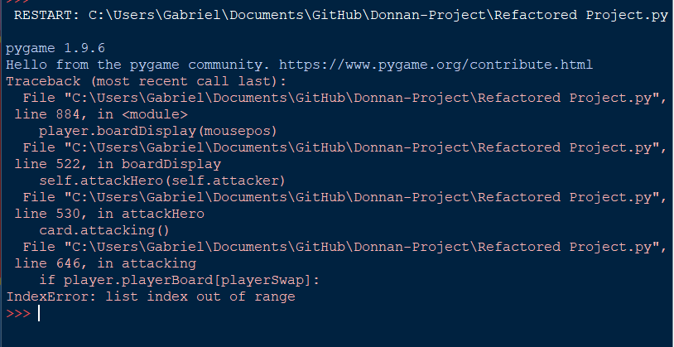

Initially the test was unsuccessful as there was an error in the logic of one “attacking” subroutine in which it tried to access a non-existent player’s board when the card was attacking an enemy.

Board Before:

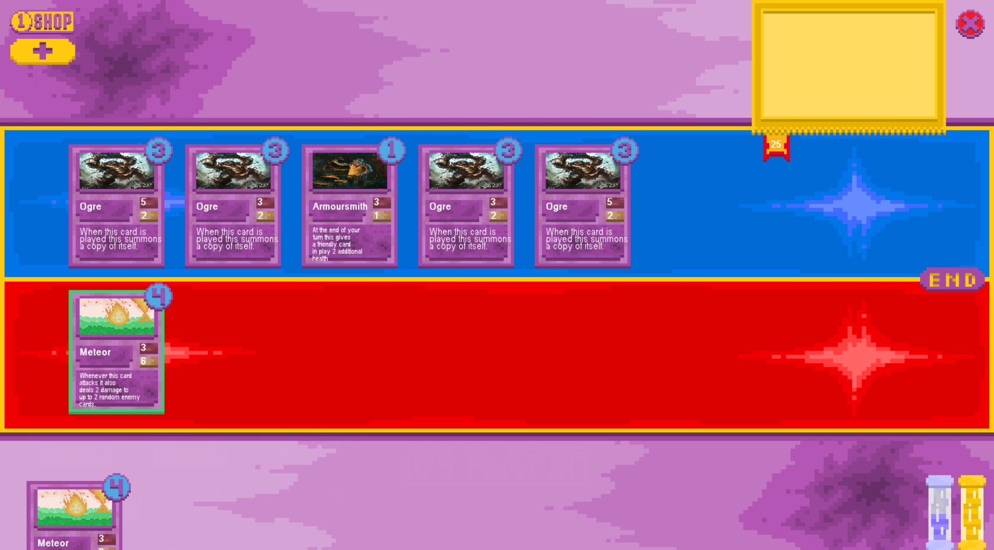

Board After:

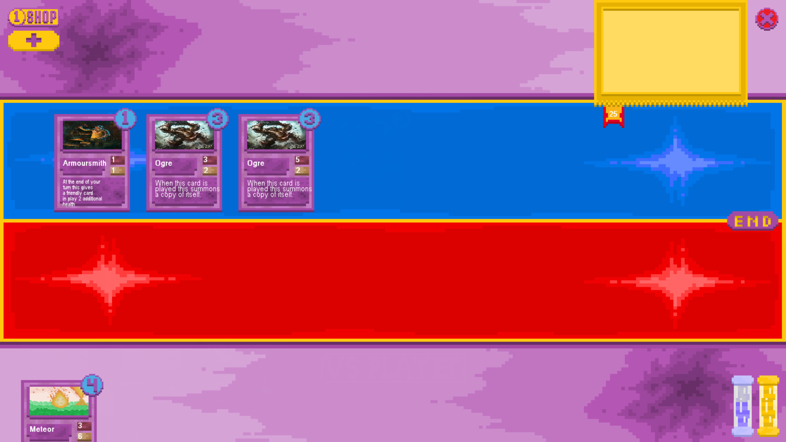

After this initial error was fixed the test was successful, with the meteor card attacking a card on the opposing side of the board and dealing an additional 2 damage to the opposing armoursmith card. The other 2 damage that the card does were applied to the card that was attacked which was already dead, but this is as intended as when attacking cards with higher health it is necessary to sometimes hit the same card the player is attacking.

### On End of Turn Effect and Ending Turn Testing

* + - * 1. End the turn when the opposing player has the maximum amount of mana

Opponent’s Mana Before Ending Turn:



Opponent’s Mana After Ending Turn:



Opponent’s Mana after playing card that cost 4 mana:



This test was a success as the opposing player’s mana remained at 10 mana after a turn without being used on maximum mana instead of exceeding it. We know it did not exceed 10 as when a card that cost 4 was played the player was left with 6 mana as opposed to having more if there was any overflow.

* + - * 1. End the turn when the opposing player has the maximum amount of currency

Opponent’s Currency before ending the turn:



Opponent’s Currency after ending the turn:



Opponent’s Currency after buying an item costing 3 gold:



This test was a success as the player’s currency did not exceed the maximum limit, which has been demonstrated by buying a card which costs 3 currency, leaving the player with 7 which would not be the case if they had more than 10 currency at that time.

* + - * 1. End the turn with an end of turn effect in play on the current player’s board

Board Before:

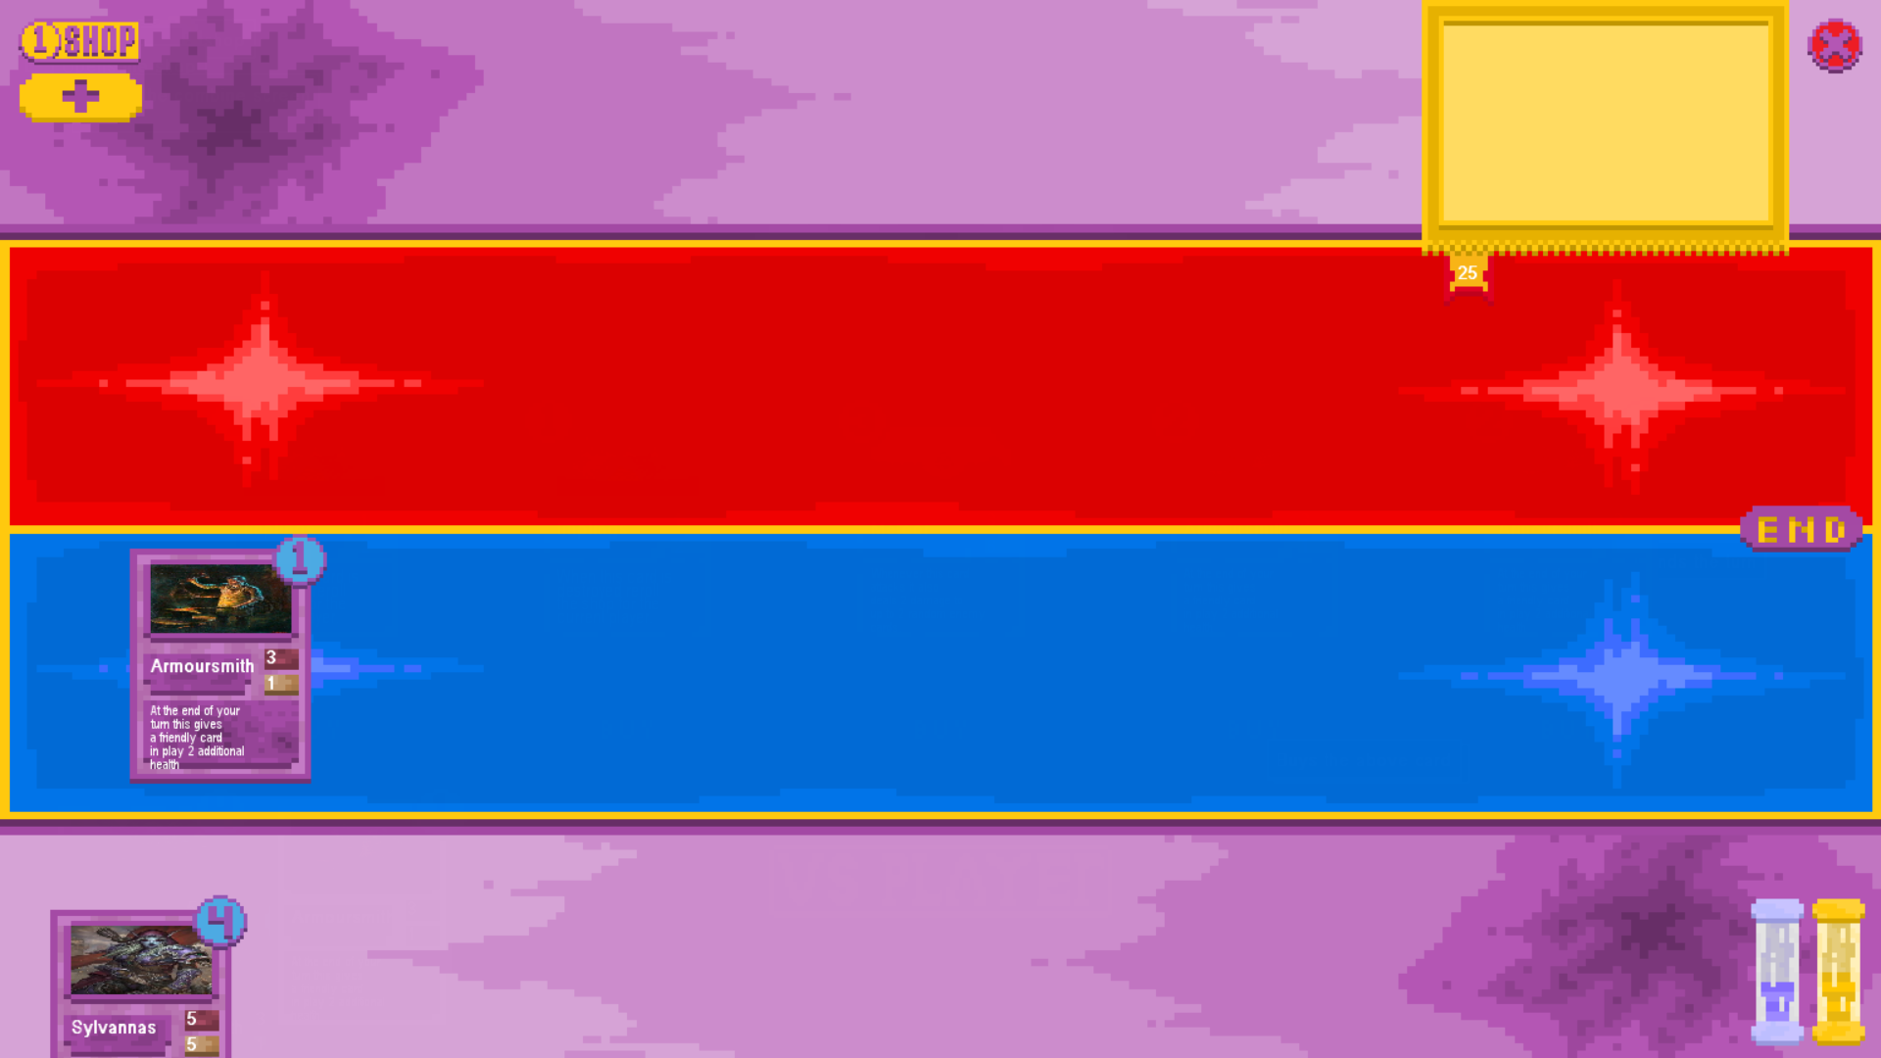

Board After:

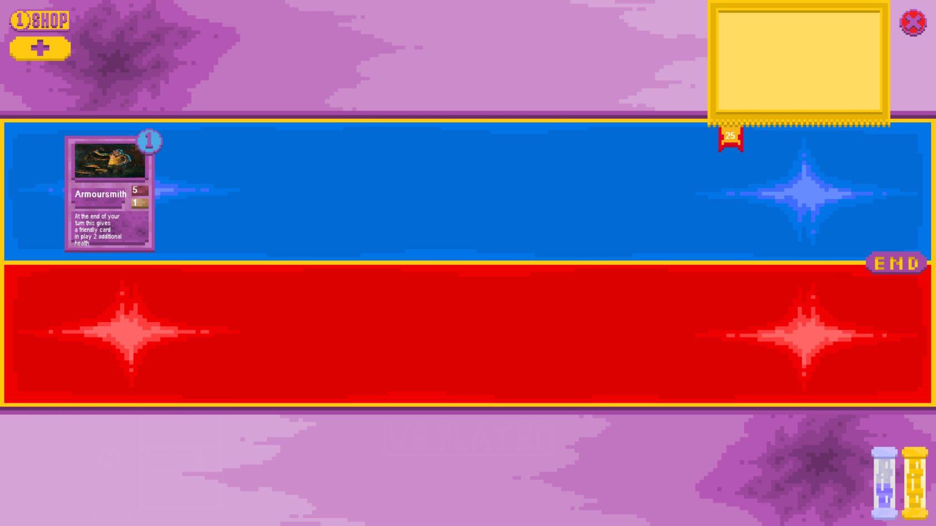

This test was a success as the card which has an effect of increasing a random friendly card’s health by 2 on turn end started with 3 health initially and upon the turn’s end now has 5 health meaning the effect triggered and worked correctly on itself.

* + - * 1. End the turn with multiple different end of turn effects in play on the current player’s board

Board Before:

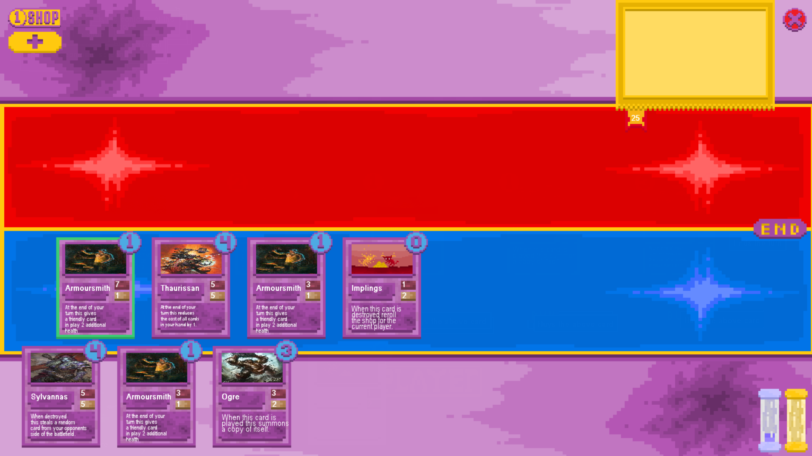

Board After:

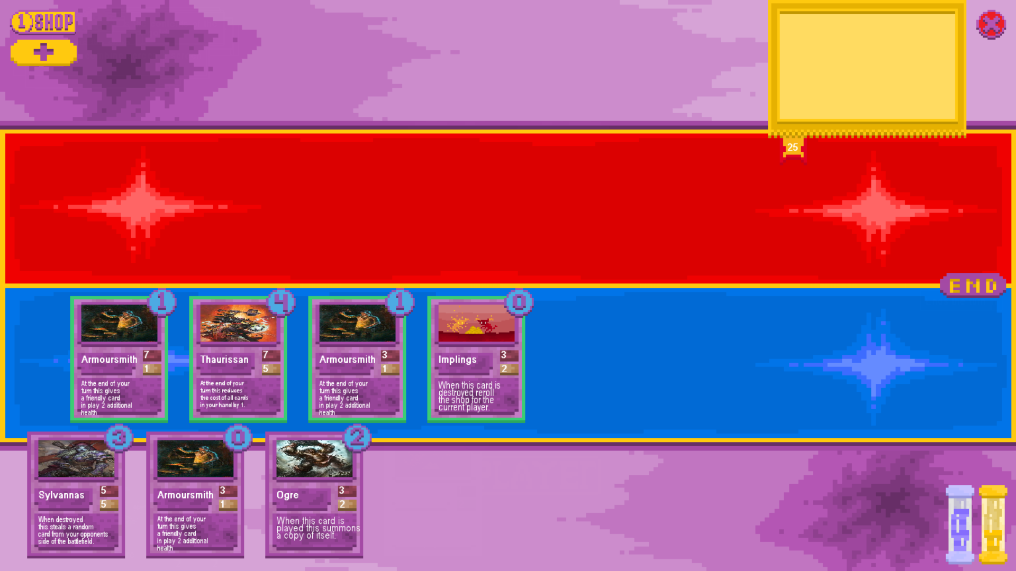

The test was a success as the end of turn effects of each card triggered, each armoursmith gave a random friendly minion 2 health and the Thaurissan reduced the costs of all cards in the current player’s hand. Each end of turn effect triggered the correct amount of times for the correct amount of cards.

* + - * 1. End the turn with multiple of the same end of turn effects in play on the current player’s board

Board Before:

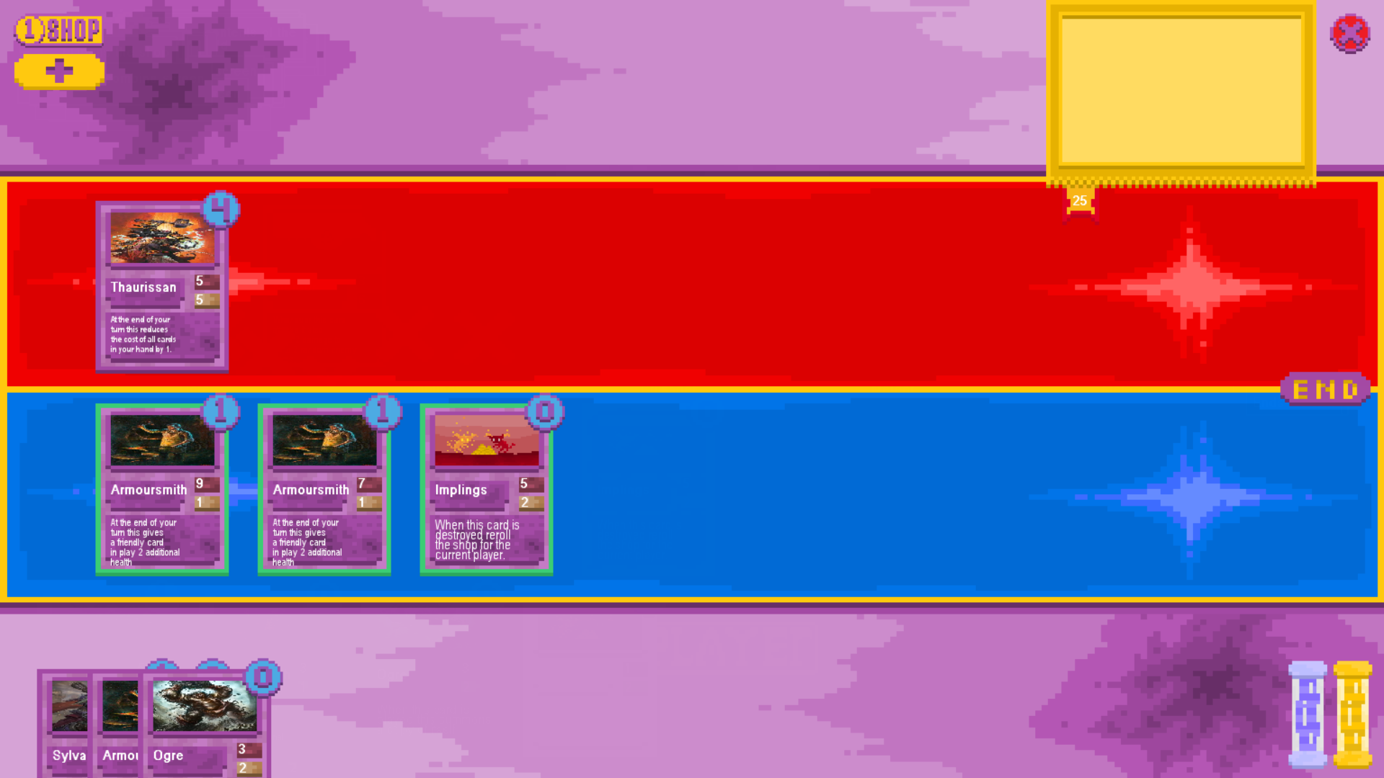

Board After:

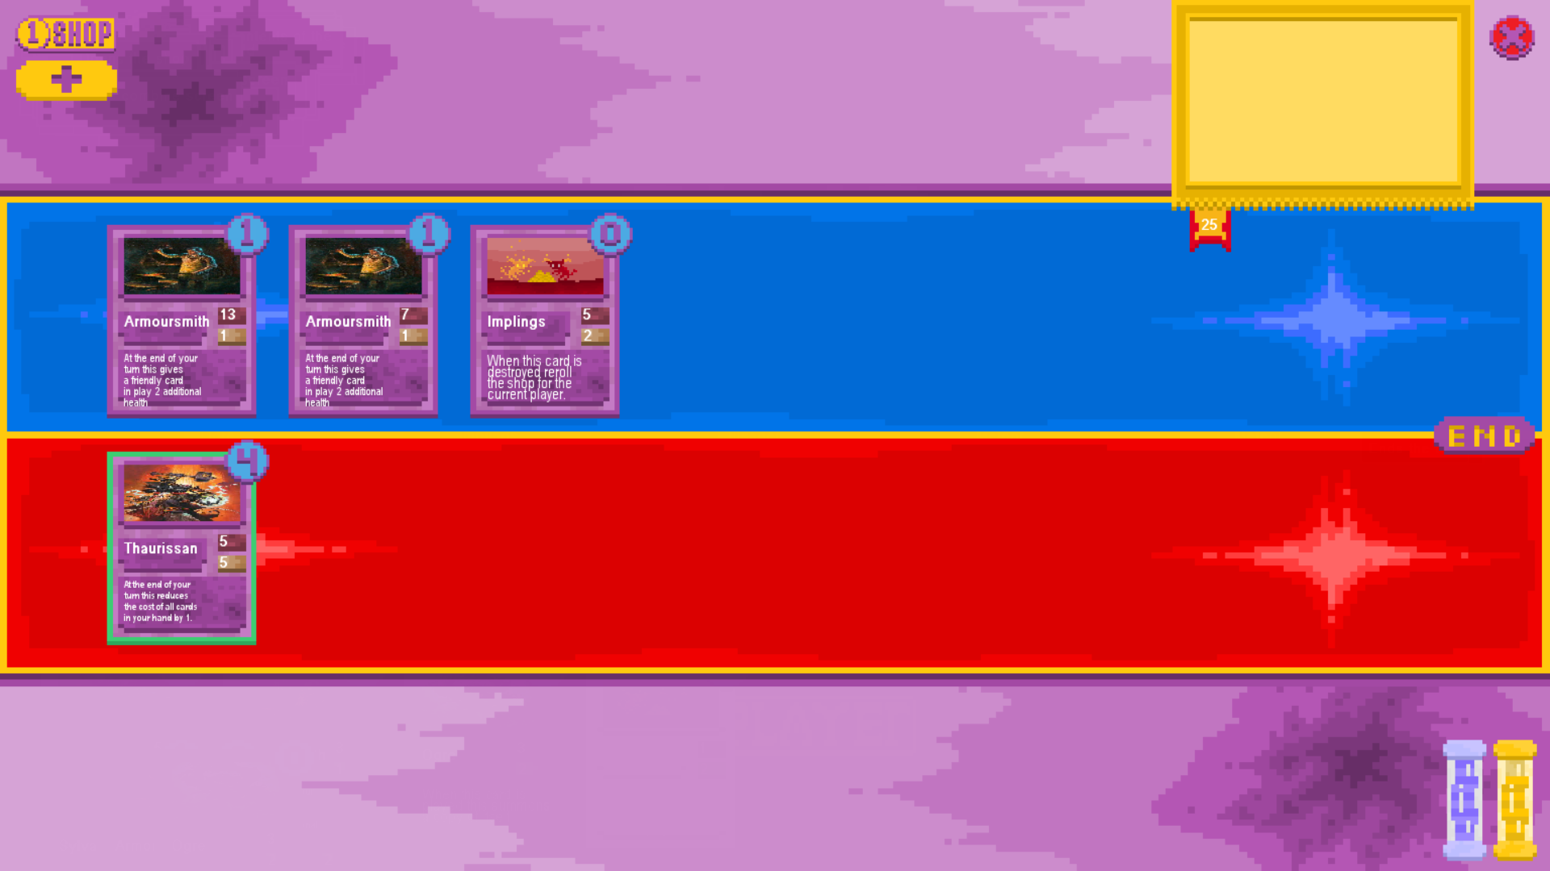

The test was successful as upon ending the turn each armoursmith gave a random friendly character 2 additional HP, with neither being cancelled due to the other and no additional triggers occurring due to multiple instances of friendly cards of the same type.

* + - * 1. End the turn when the opposing player has an end of turn effect in play

Board Before:



Board After:

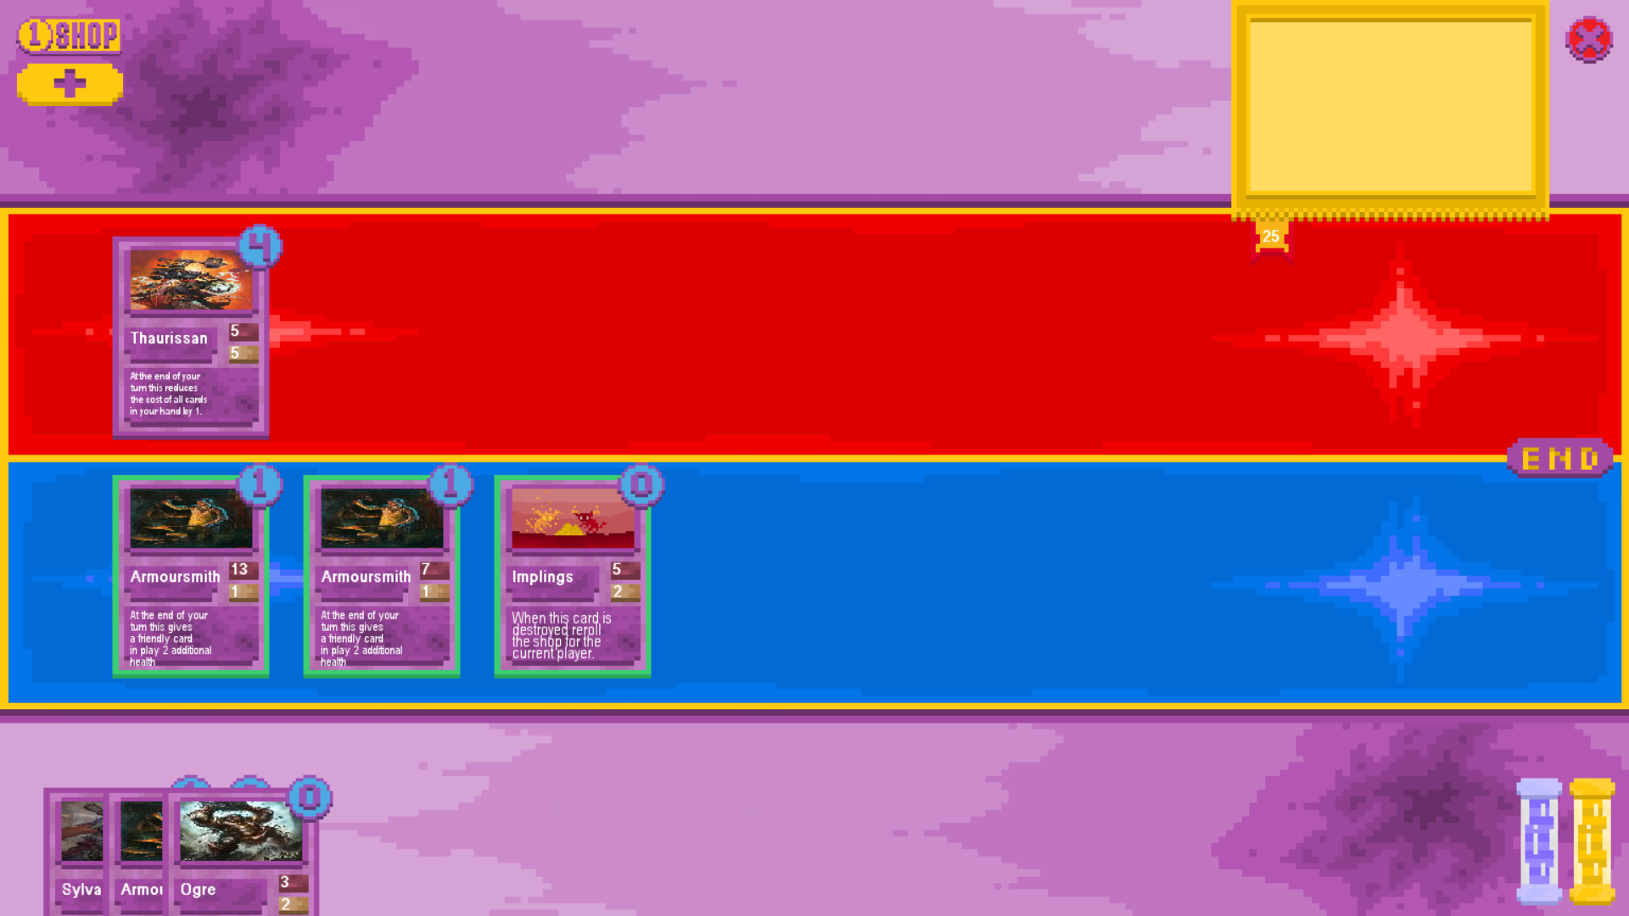

The test was a success as no additional health was added to friendly cards by the armoursmith cards that the opposing player possessed as end of turn effects only activate on ending the turn of the player that controls the card so ending the turn here did not trigger their effects, which is correct.

## Player Hand Testing

Try to buy a card with a hand size less than maximum

Board Before:

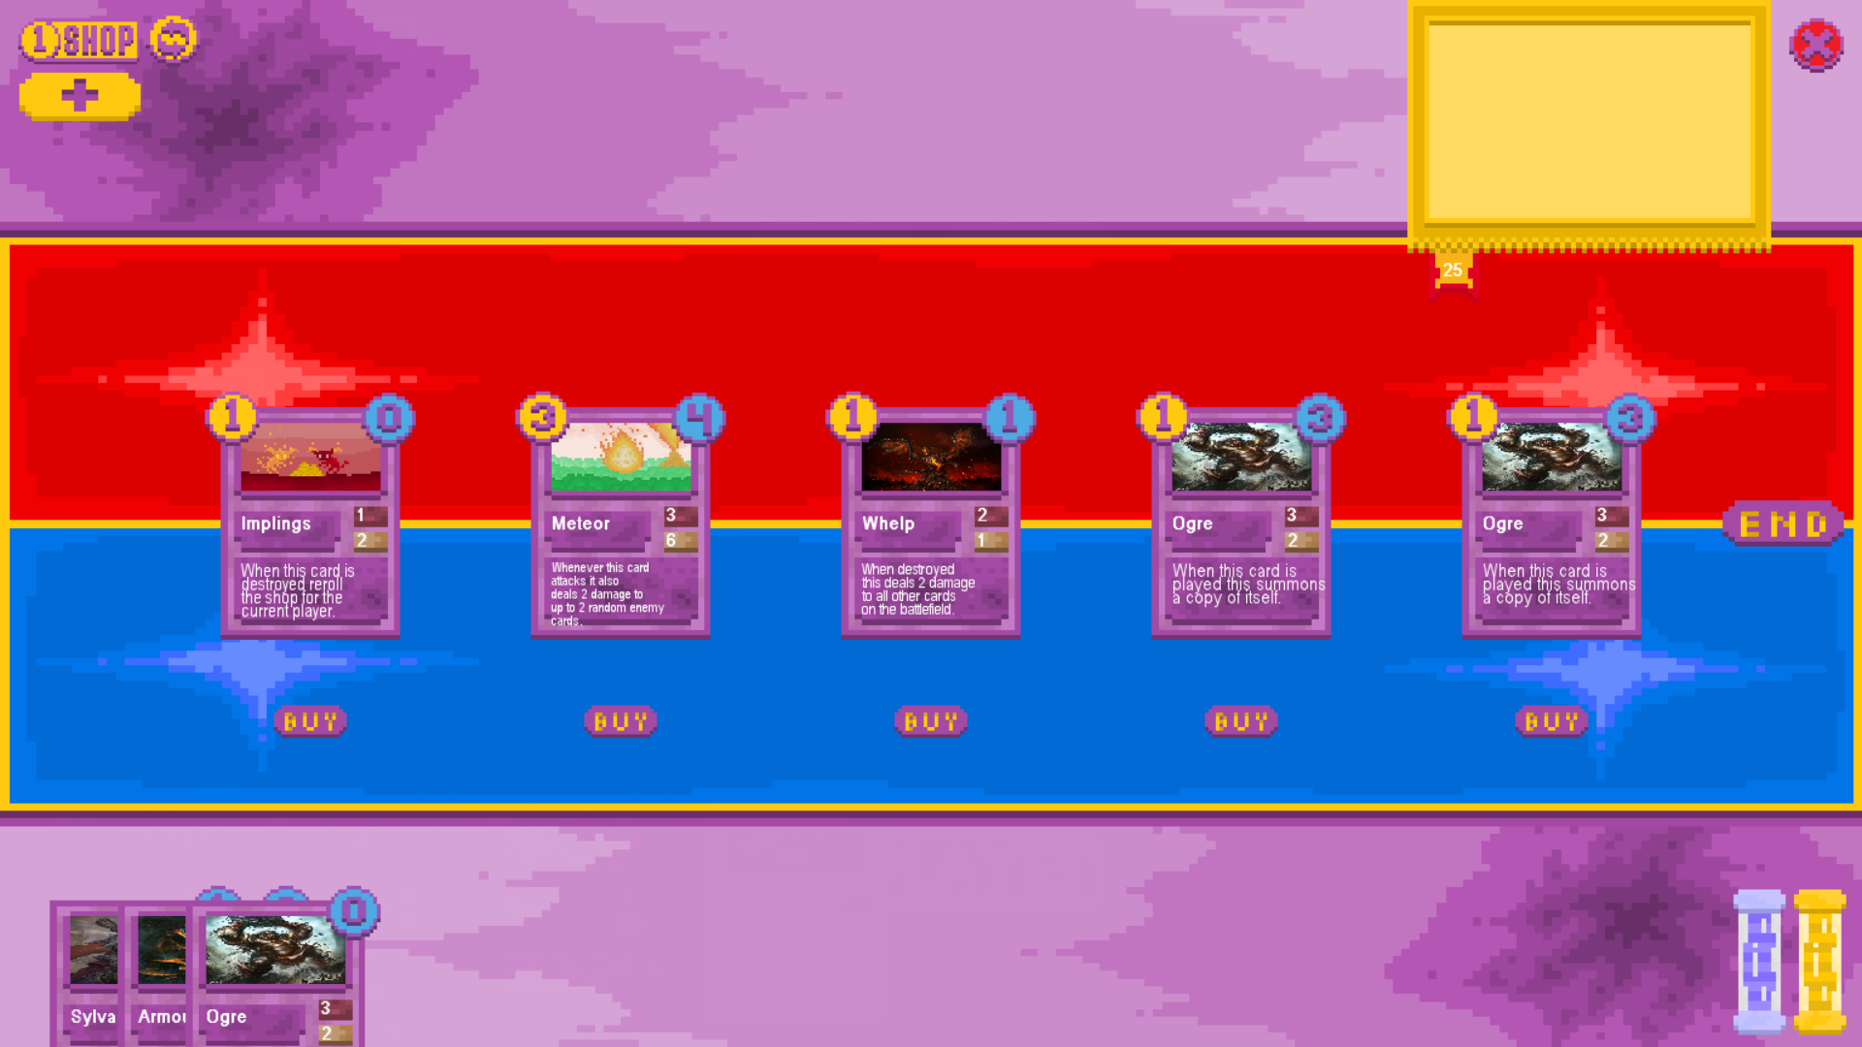

Board After:

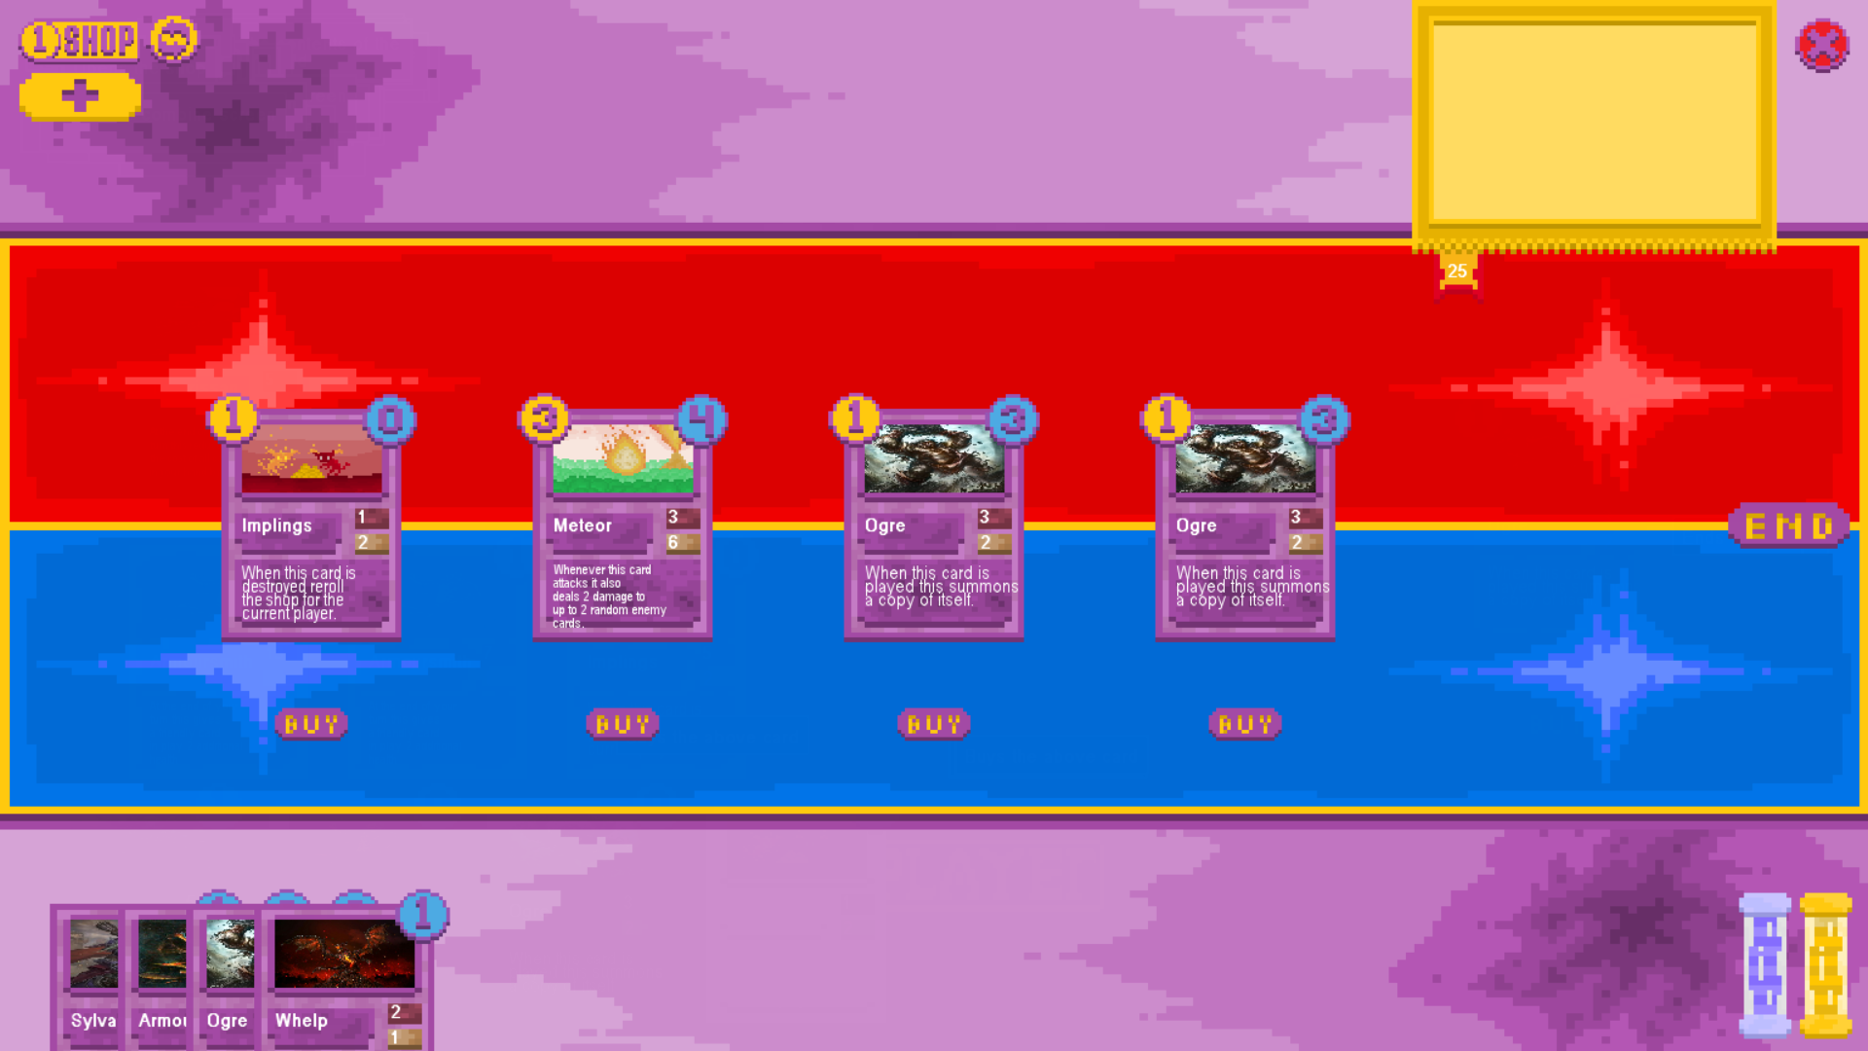

The test was a success as the whelp card that the player bought was correctly removed from the shop and added to the right hand side of the player’s hand, shifting the cards in the shop to the right of it to the left to take its place.

Try to buy a card with maximum hand size

Board Before: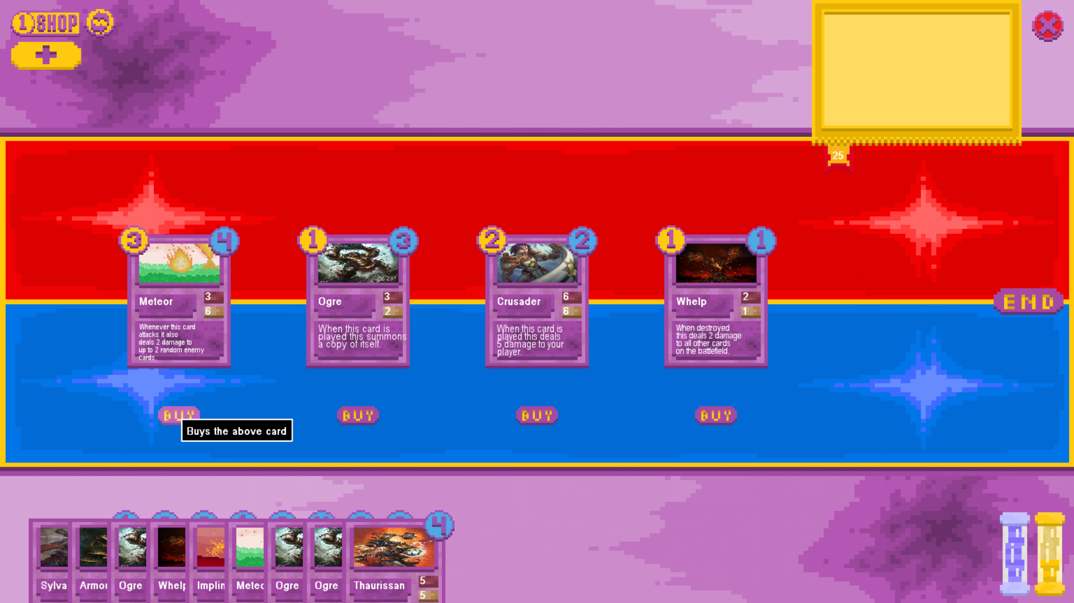

Board After:



The test was successful as the player was unable to buy the meteor card despite having sufficient currency as the hand size of the player was at a maxmum. No currency was unduly deducted from the player and the card correctly remained in the shop without being added to the player’s hand.

## Tutorial Section Testing

Activate the tutorial in the main menu

Main Menu Before:

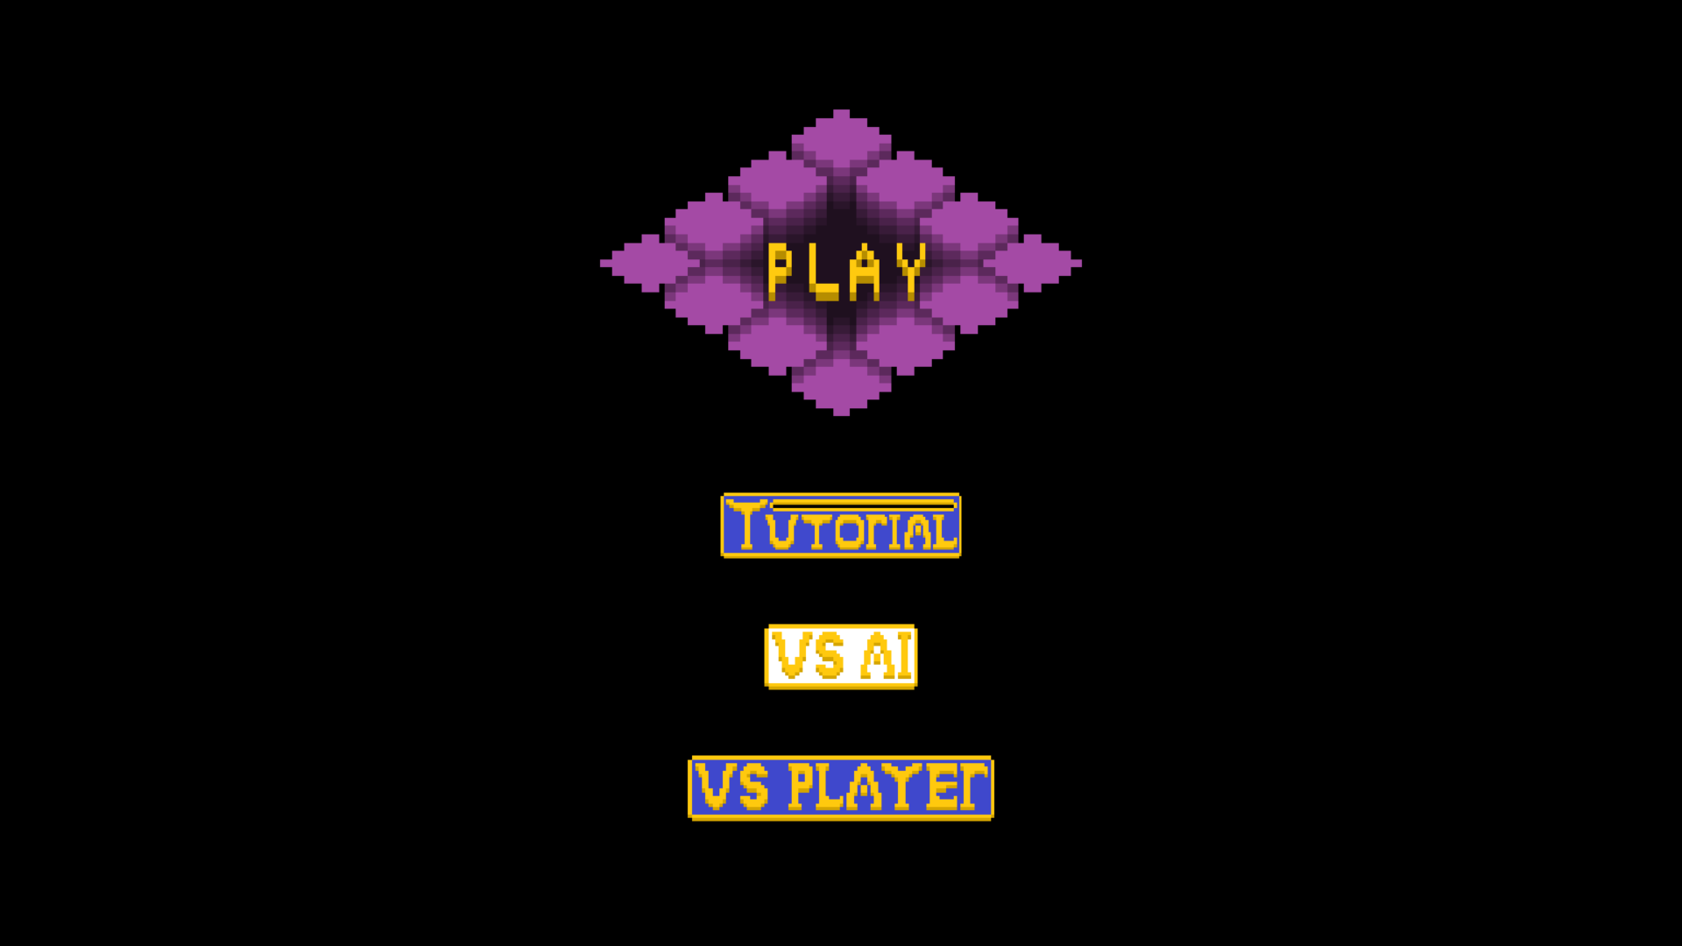

Main Menu After:

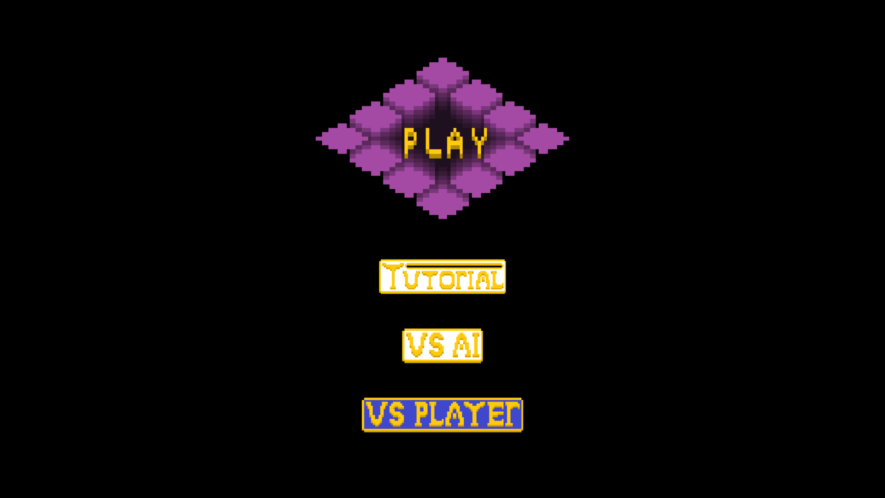

In game after pressing play:

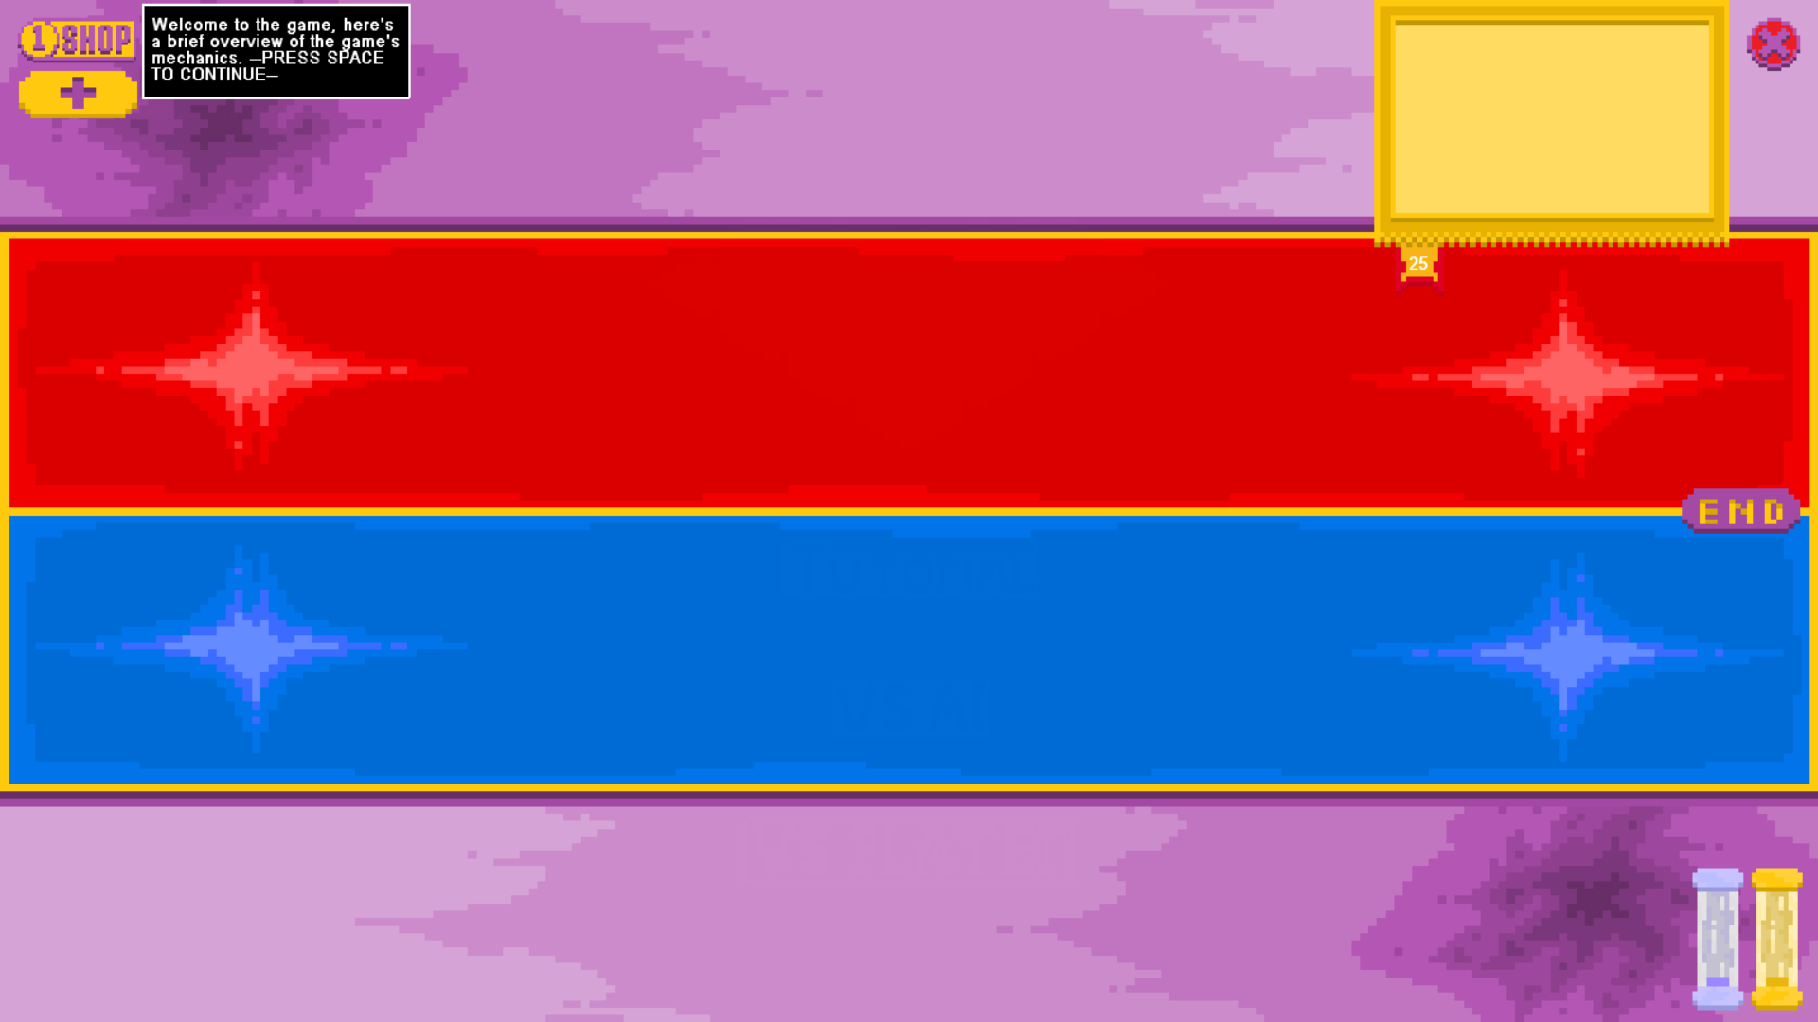

The test was successful as when the tutorial was toggled on in the main menu it appeared in the top left corner of the screen upon pressing play.

With the tutorial active hold down the spacebar

Board Before:



Board After:

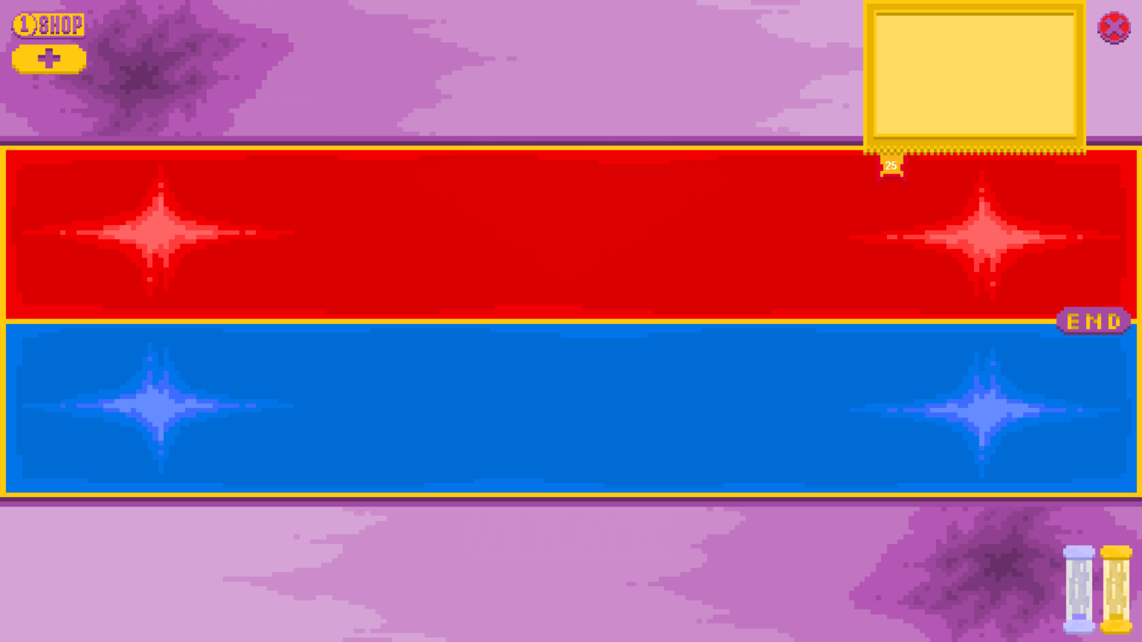

The test was a success as when holding down the spacebar the tutorial still correctly iterated through the tutorial options in the correct order followed by closing once finished. (I have not included screenshots of the tutorials being cycled through as screenshotting would require stopping holding down the spacebar to take them)

With the tutorial active repeatedly press the spacebar

Tutorial Part 1:

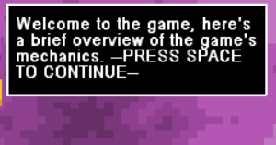

Tutorial Part 2:

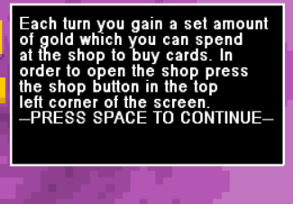

Tutorial Part 3:

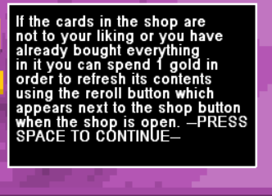

Tutorial Part 4:

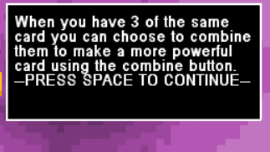

Tutorial Part 5:

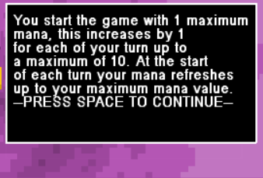

Tutorial Part 6:

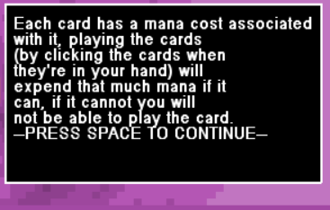

Tutorial Part 7:

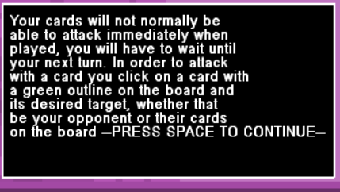

Tutorial Part 8:

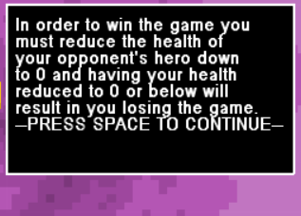

Tutorial Part 9:

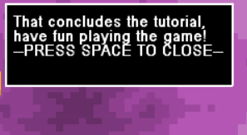

Tutorial Closed:



The test was successful as each time the spacebar was pressed the tutorial advanced exactly 1 step as intended and upon reaching the last tutorial message pressing the spacebar turned off the tutorial.

Disable the tutorial

Main menu with tutorial disabled:



Game after pressing play:



The test was a success as with the tutorial disabled it did not appear in the top left corner of the screen as it would were it enabled.

Attempt to iterate through the tutorial while it is disabled

Board Before:



Board After:



The test was a success as regardless of whether I tried to press the spacebar to iterate through the tutorial the tutorial box did not show up at any point, which is as intended.

In an earlier iteration of testing if I had pressed the spacebar with the tutorial disabled the window would show up as below:

Board Before:  


Board After:

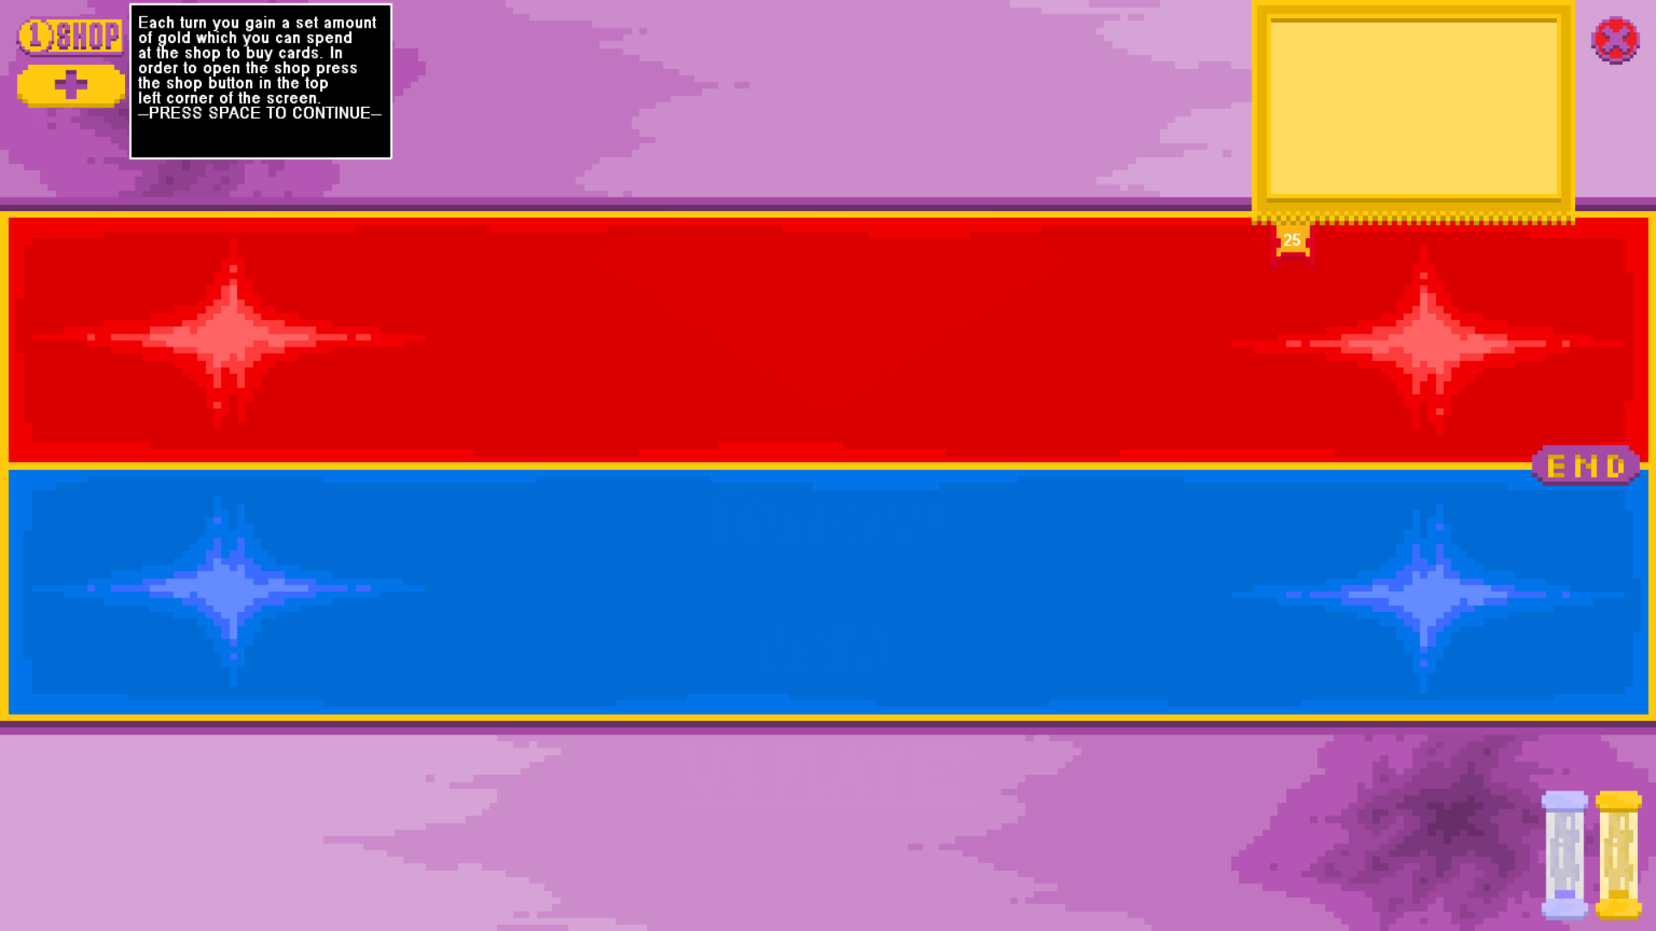

This effectively resulted in disabling the tutorial not working as it could just be activated by pressing space which was not intentional.

## Game Ending Testing

Reducing the health of each player in turn below 1

Board after reducing player 2 below 1 health:

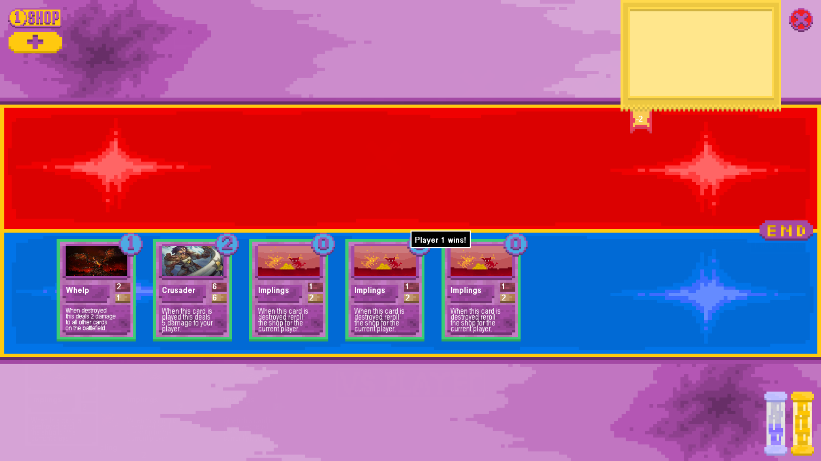

Board after reducing player 1 below 1 health:

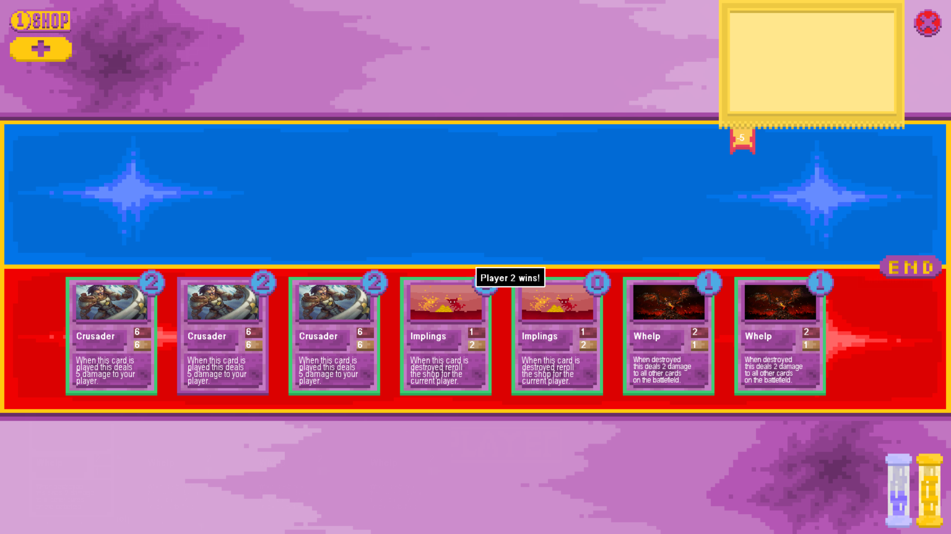

Reducing the health of each player below 1 simultaneously

It is currently impossible to reduce both players simultaneously below 1 health so I created an additional card to test this to ensure robustness of code, however this should not ever happen in game.

Board Before:

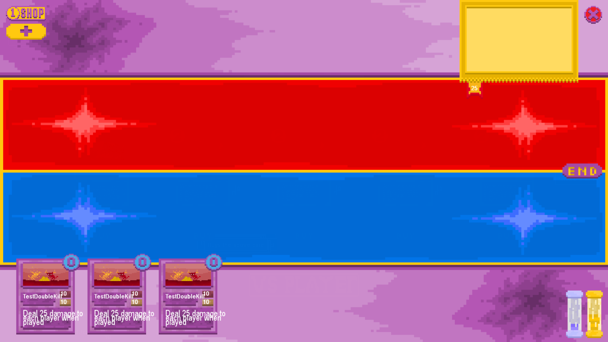

Board After:

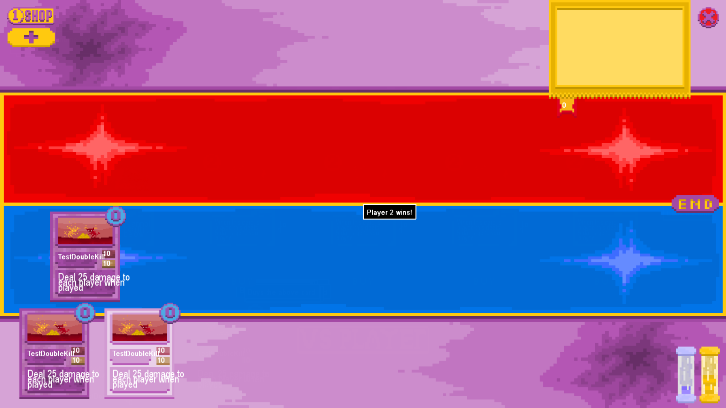

This test failed initially as it defaulted to player 2 winning instead of player 1 so I swapped around the trigger order of setting the winning player and the test subsequently succeeded, defaulting to player 1 winning

Board After Changes:

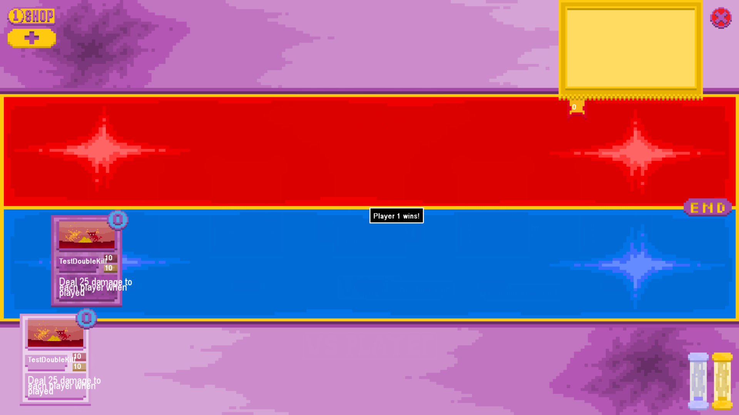

Screenshot of test class code:

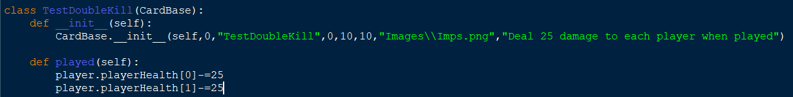

Surrendering on each player in turn

## NOT YET IMPLEMENTED ##

Playing a game ending effect for each player in turn

## NOT YET IMPLEMENTED ##

Test whether the game can be interacted with in the small window when the victory message is displayed

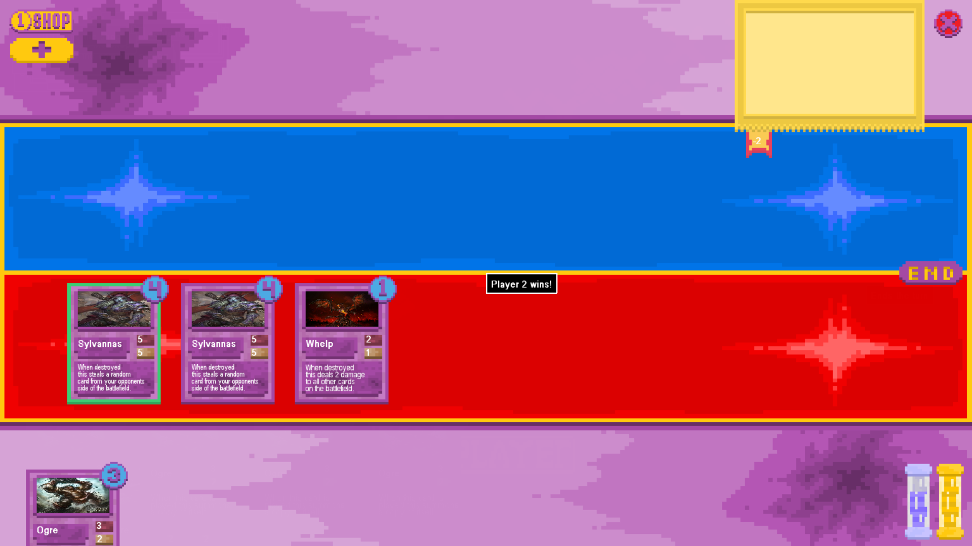

The test was a success as while attempting both to attack with a minion then subsequently play the card in my hand neither action was registered, which is correct as the game had finished.

## Card Combination Testing

Combining 3 cards of the same type

Combining Screen before combining 3 of the same card (Glocktopus):

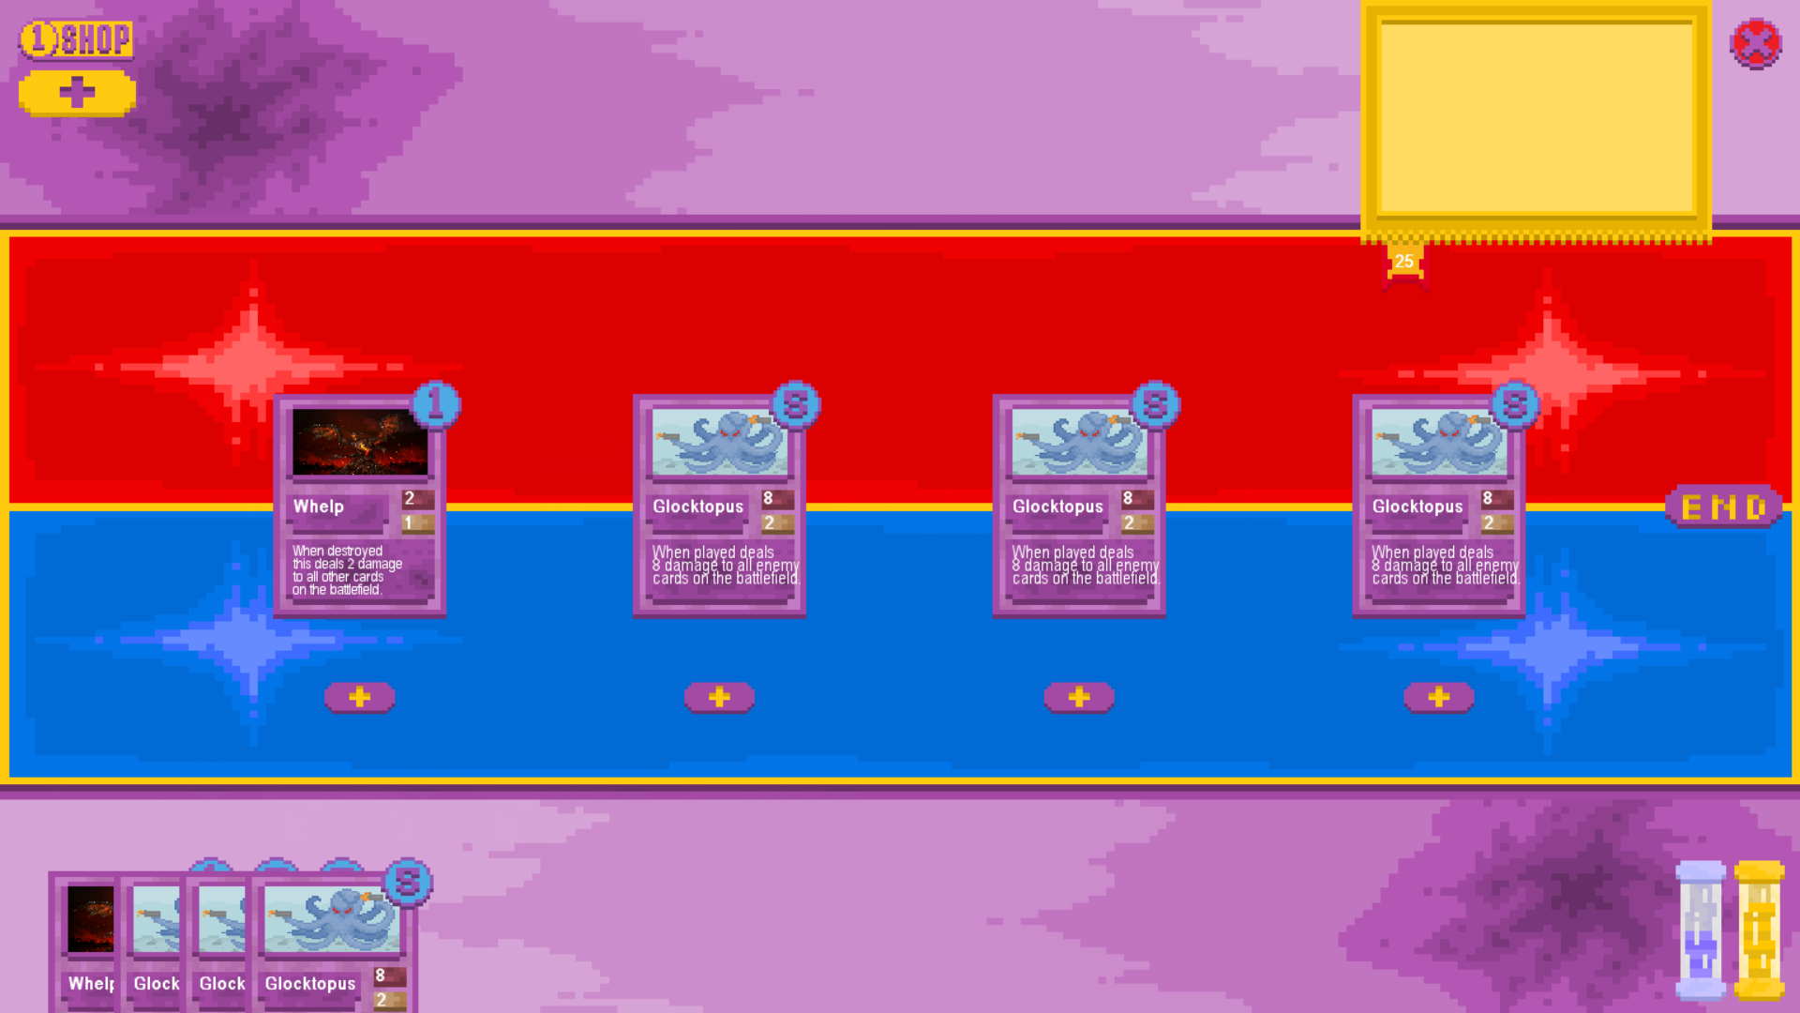

Combining Screen after combining the 3 cards:

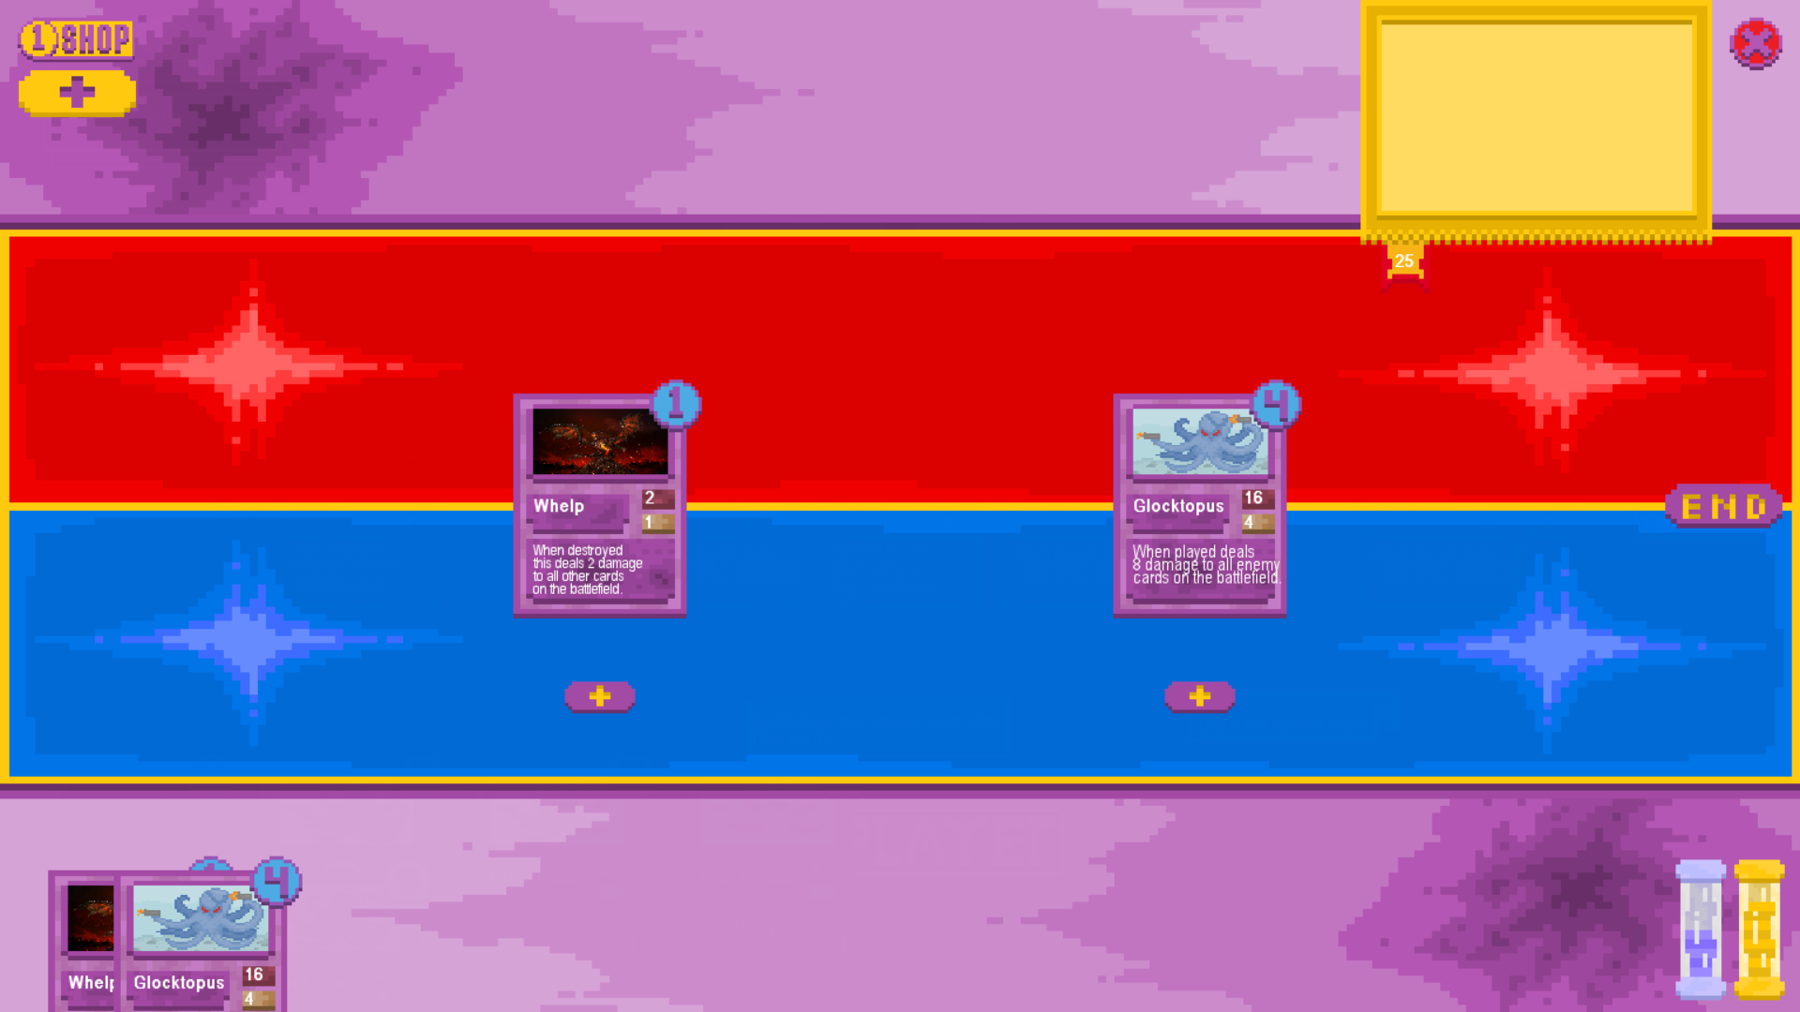

The test was a success as the 3 cards were condensed into one card which has double the attack and health as the original card with a cost of one less than the original.

Attempting to combine cards with less than 3 of that type of card in your hand

Combining Screen before attempting to combine fewer than 3 cards:

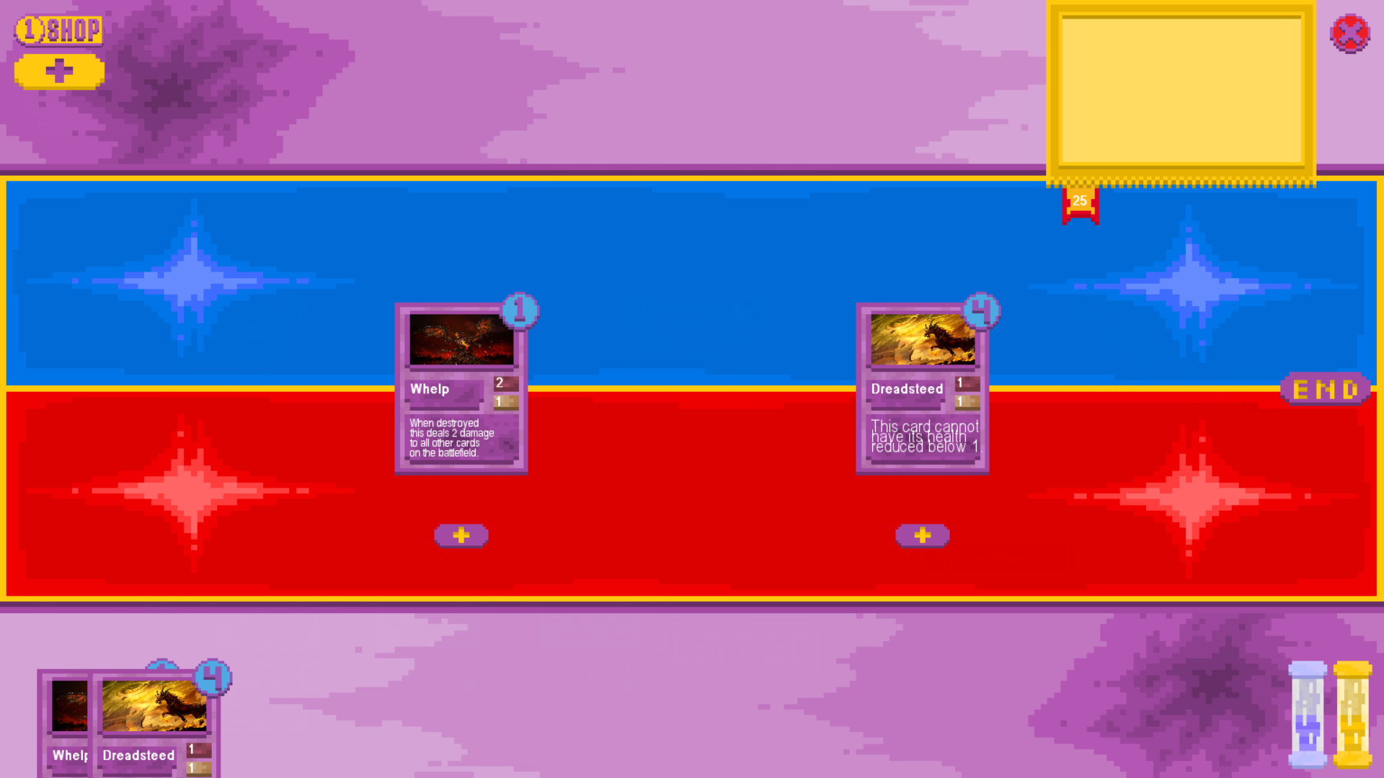

Combining Screen after attempting to combine fewer than 3 cards:



The test was a success as since there were fewer than 3 of the card the player tried to copy in the player’s hand nothing changed when attempting to copy either, their stats were not doubled, they were not marked as upgraded and their costs were not reduced.

Attempting to combine cards with 2 un-upgraded copies of the card and one upgraded card in your hand

Combining Screen before attempting to combine cards:

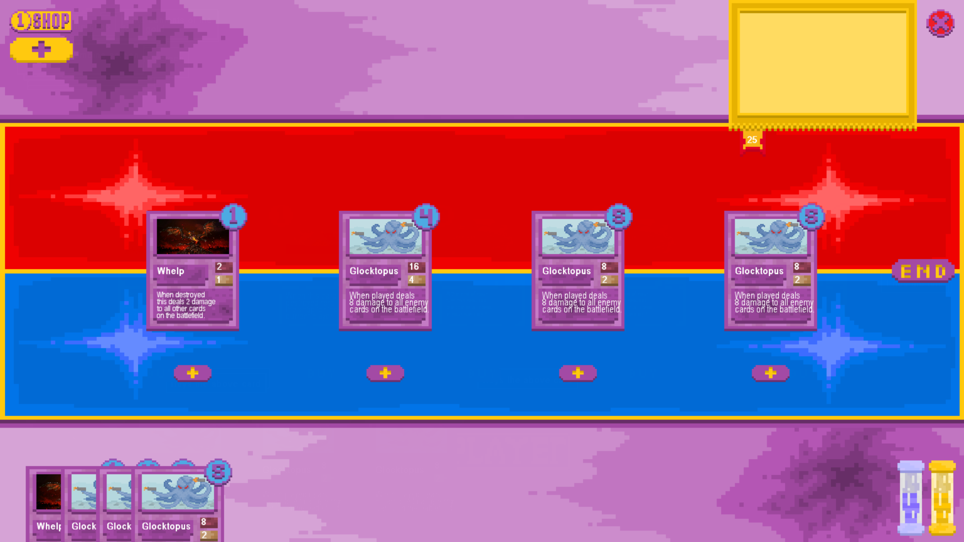

(Upgraded card second from the left)

Combining Screen after attempting to combine cards:



The test was a success as despite having 3 cards of the same type in the player’s hand they were not able to be combined as one was already upgraded. None of the cards were removed from the player’s hand, none of the cards had their stats or mana cost changed from attempting to combine them.

Attempting to combine 3 already upgraded cards

Combining Screen before attempting to combine cards:

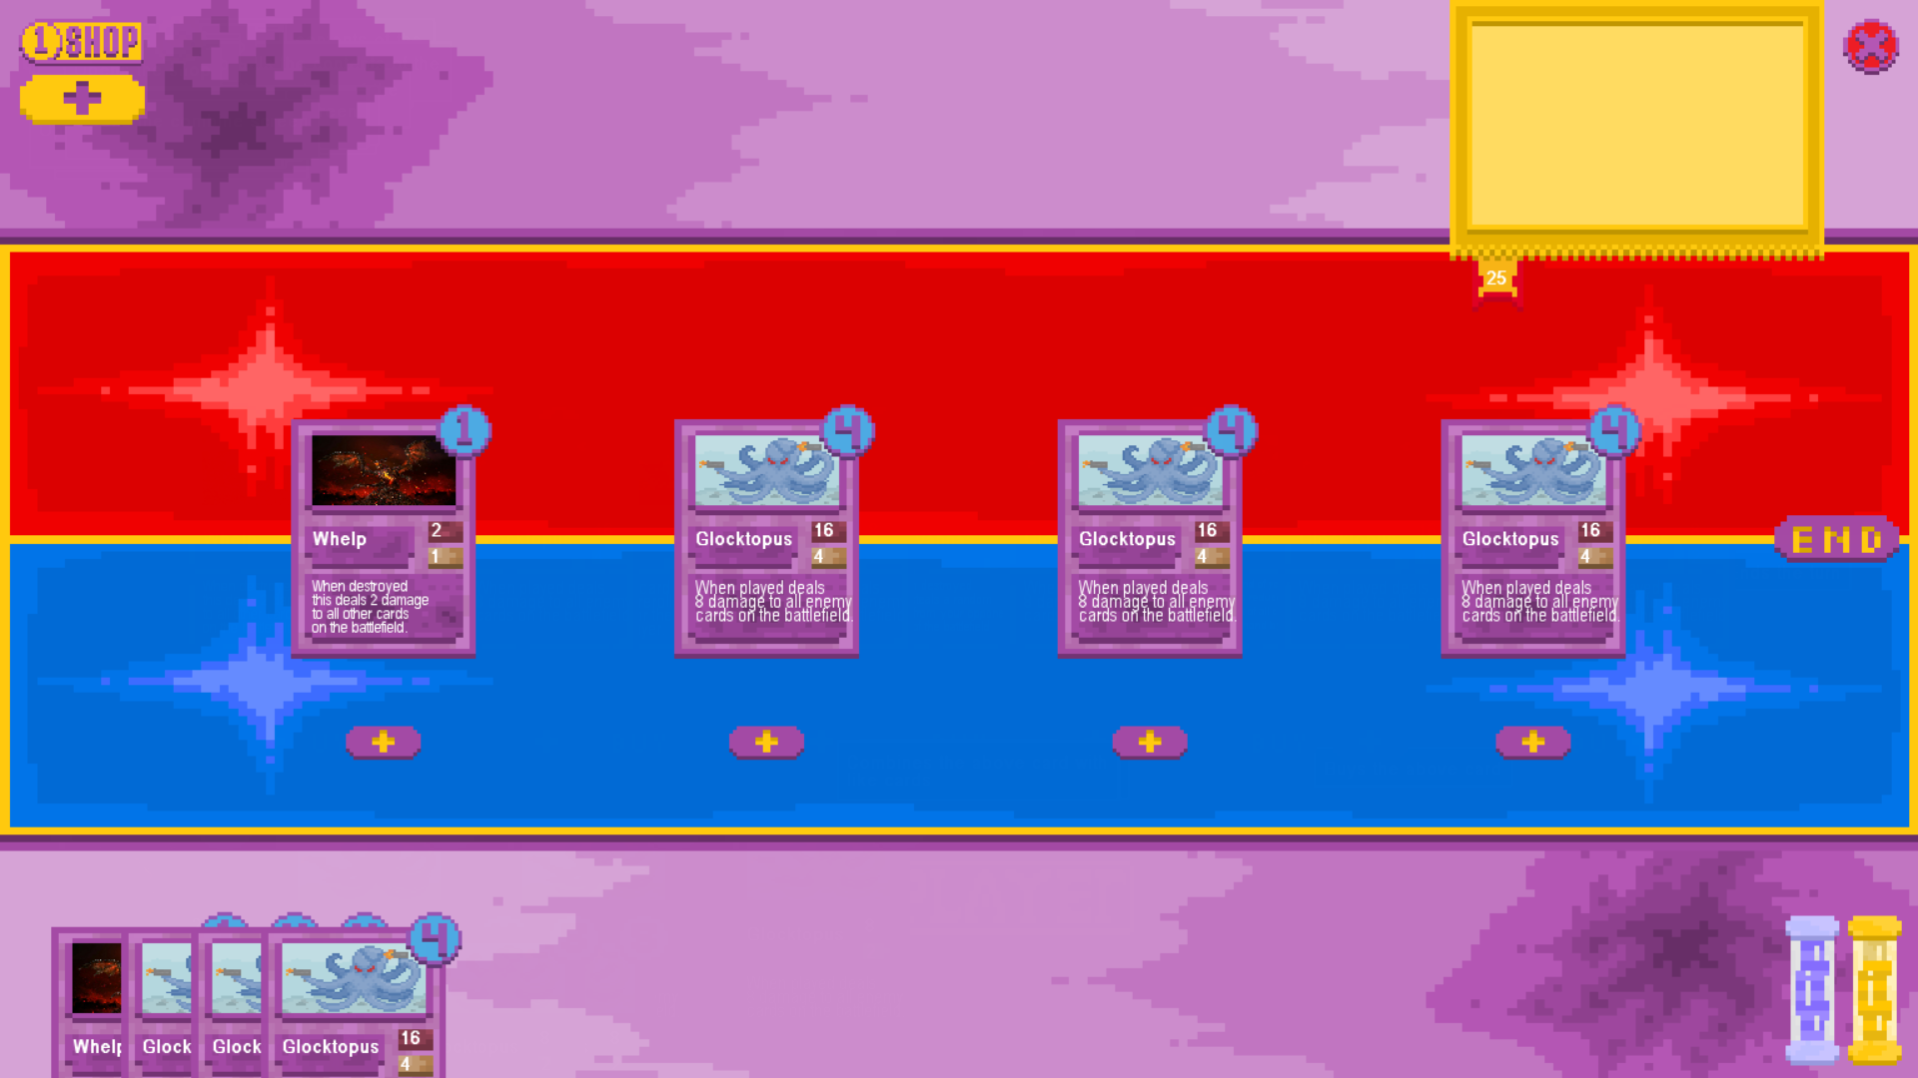

Combining Screen after attempting to combine cards:

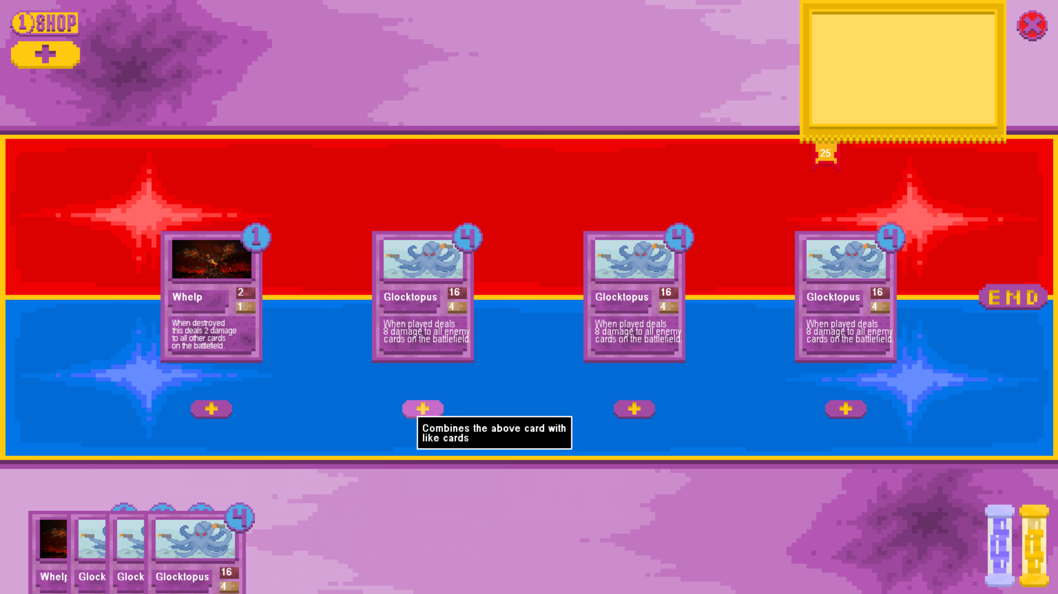

The test was a success as despite having 3 copies of the same card in the player’s hand with the same cost and stats they were unable to be combined as they were marked as upgraded, which is as intended. In previous iterations where there was no “upgraded” flag this would have worked as it only checked the cards’ stats against each other meaning that any 3 cards of the same name and stats would have been able to be upgraded.

Attempt to combine 3 copies of the same un-upgraded card when some have different stats (i.e. one costs less or has more health)

Combining Screen before combining:

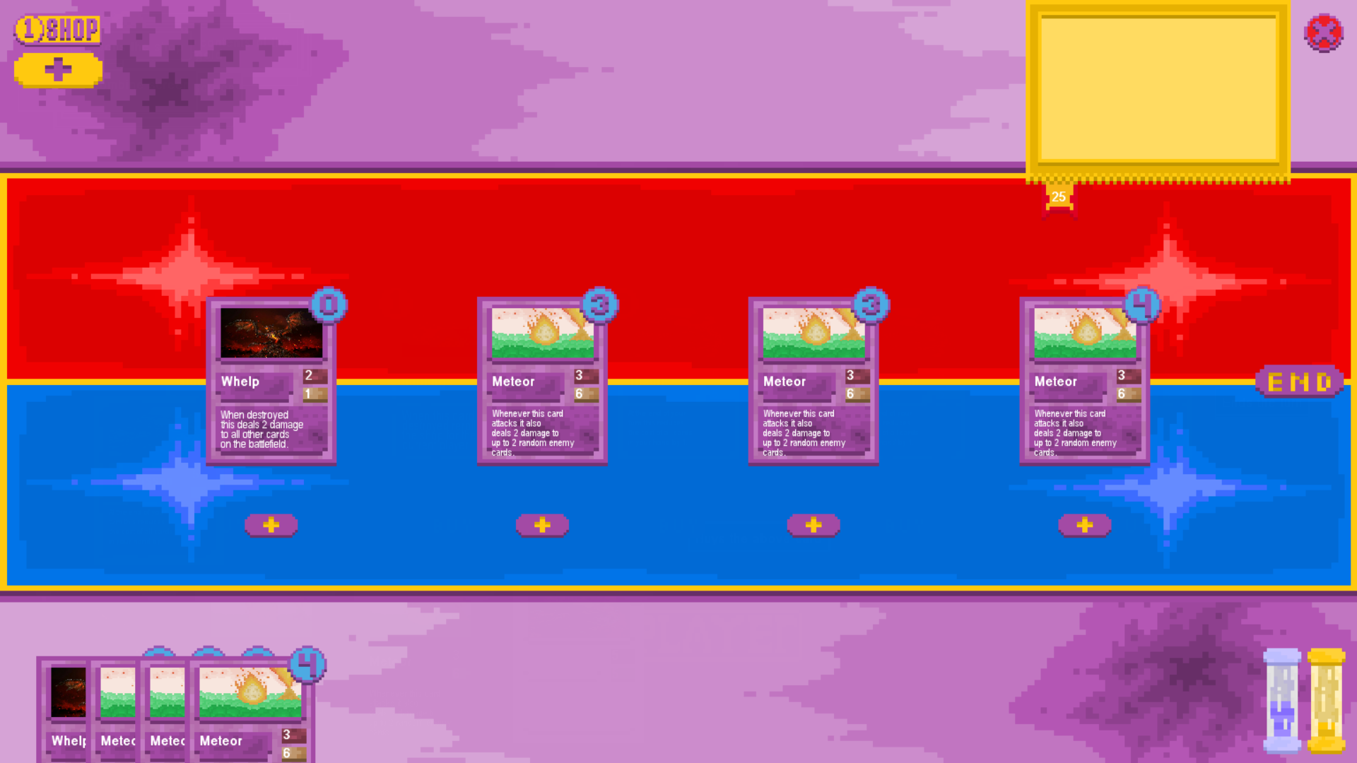

Combining Screen after combining:

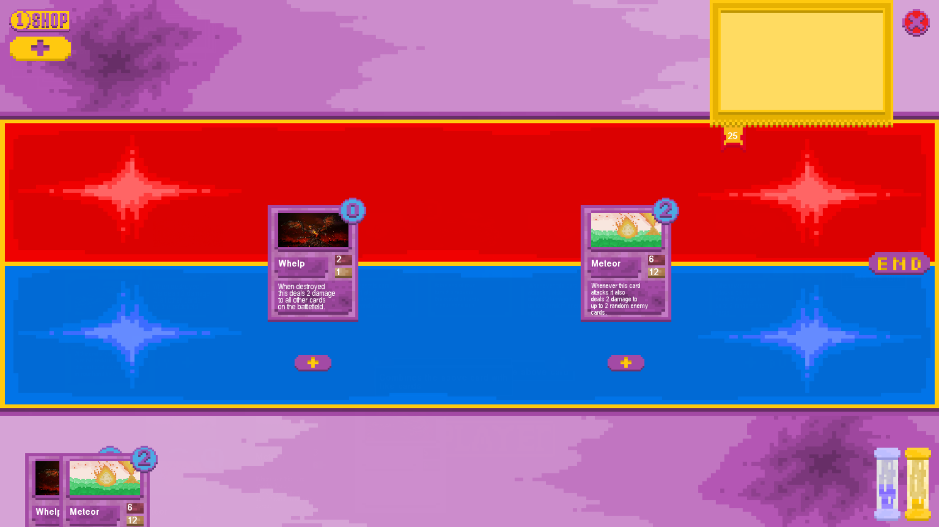

The test was a success as whilst some of the stats of the cards were different (i.e. the rightmost meteor card cost 1 more mana than the other two) they were still able to combine as none of them were combined before, taking the leftmost card in the hand as the benchmark for stat doubling and mana reduction.

Attempt to combine cards when you have more than 3 copies of it in your hand

Combining Screen before attempting to combine cards:

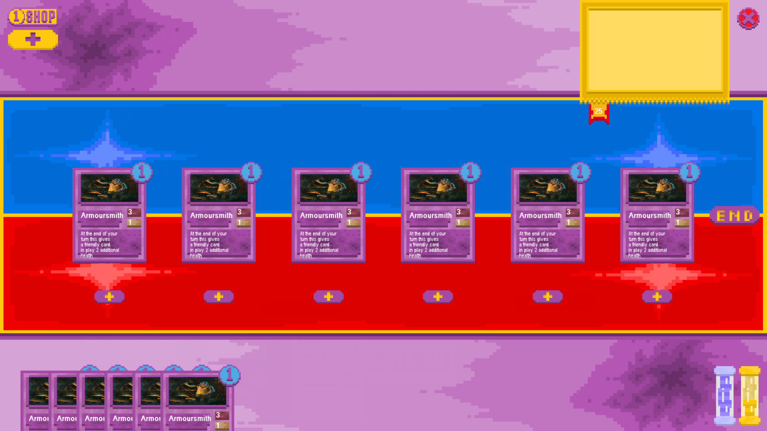

Combining Screen after attempting to combine cards:  
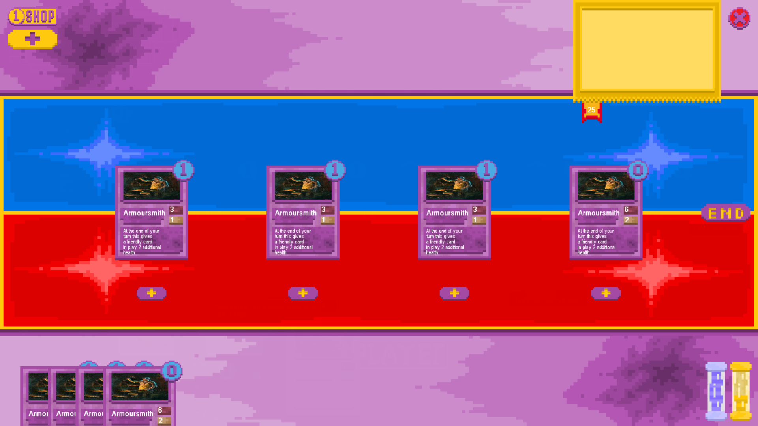

The test was successful as no additional cards were removed from the player’s hand to upgrade the card as they would have been in previous iterations of the upgrade function, additionally whilst there were enough cards to upgrade 2 instances of the card both were not upgraded at the same time which is as intended as the player may not wish to upgrade both.

## Player Switching Testing

1. End the turn with no cards on each player’s board

Board before ending the turn:

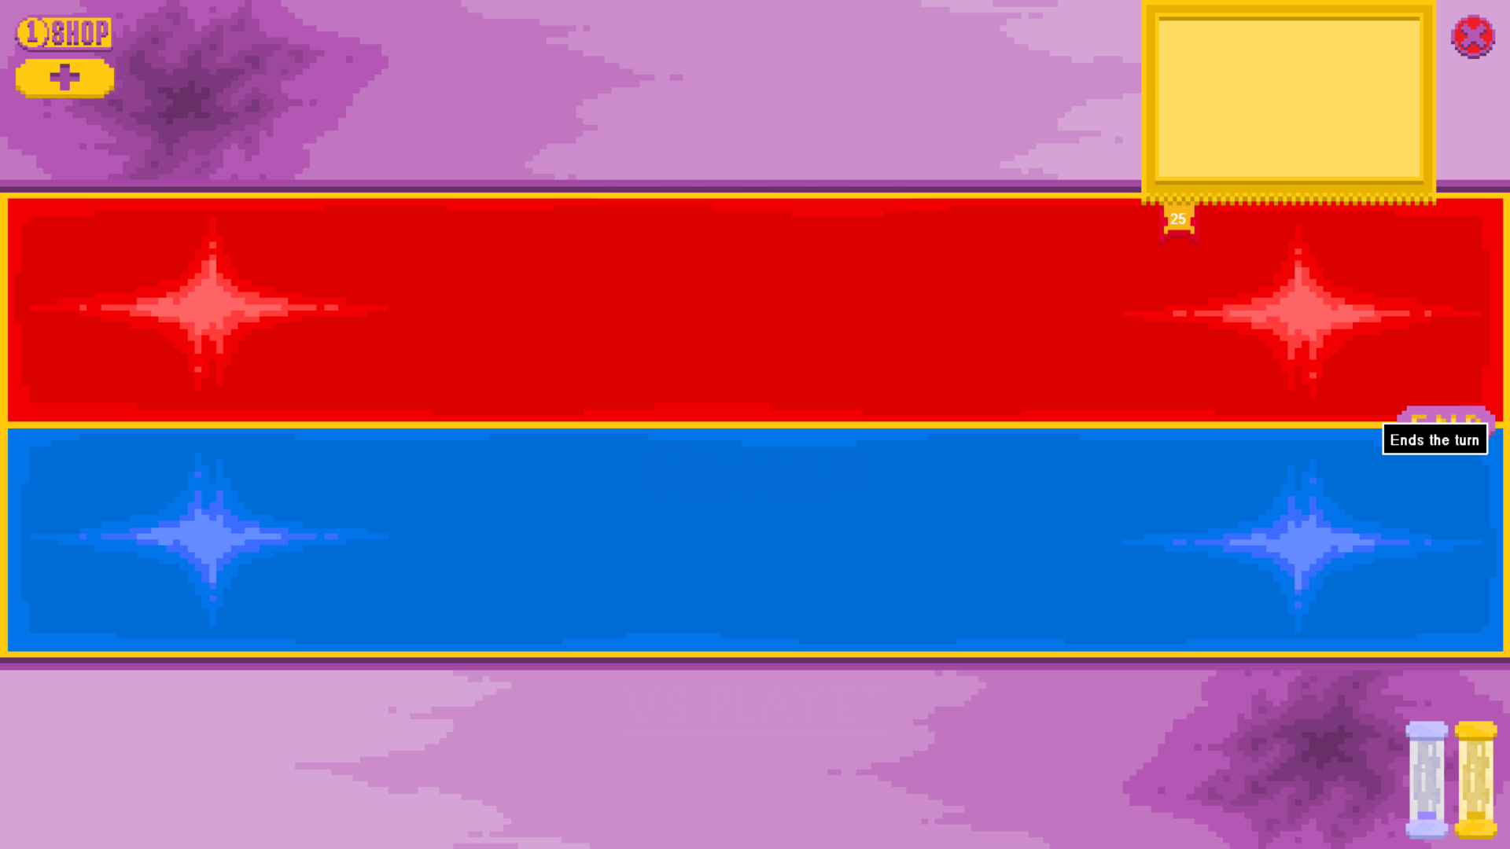

Board after:

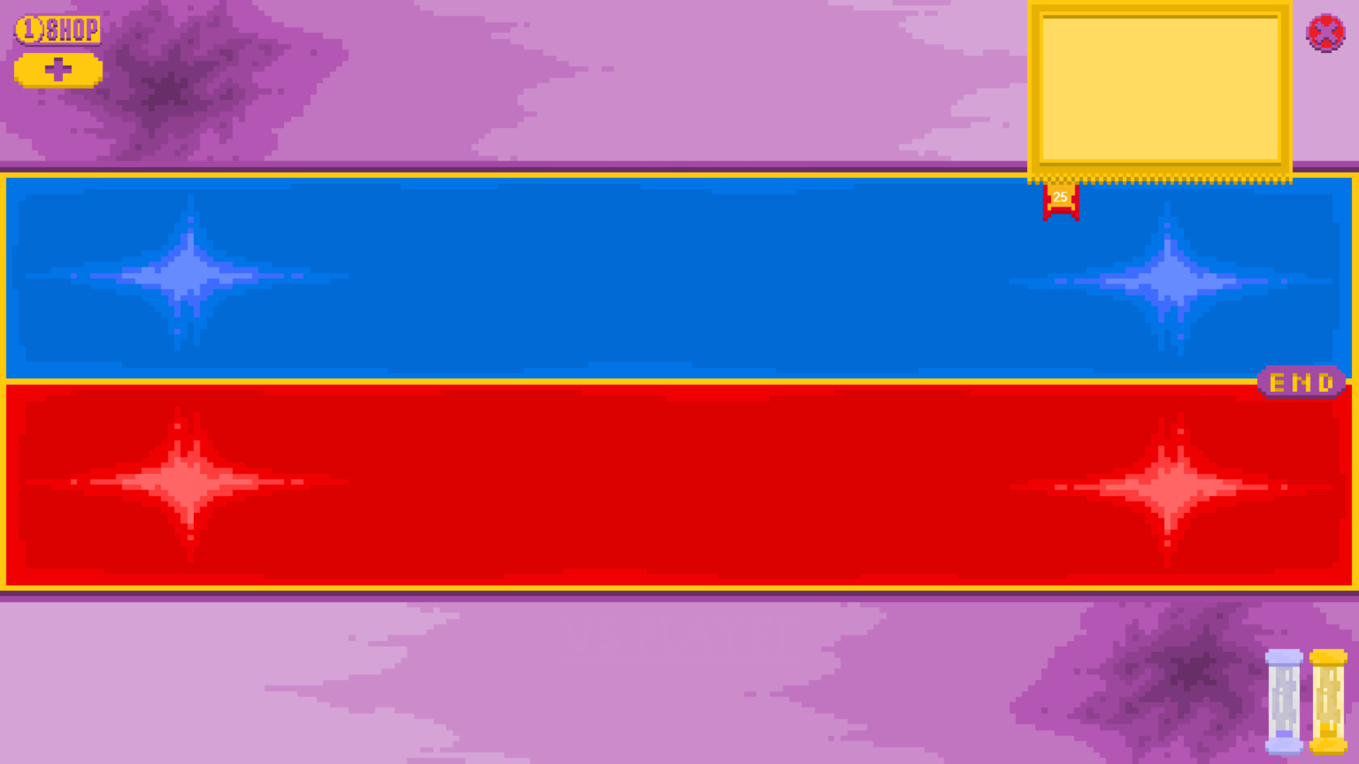

The test was a success as the game did not crash by attempting to swap non-existent cards like it did in the earliest draft, it simply transferred the control of the current turn over to the other player.

1. End the turn with full cards on each player’s board

Board before attempting to end the turn:

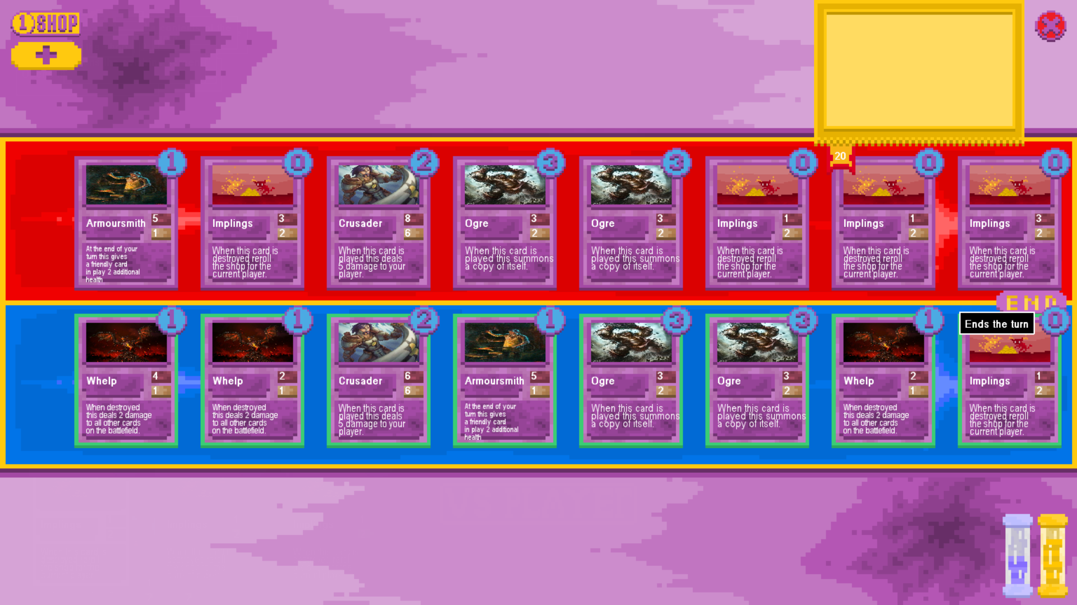

Board after ending the turn:

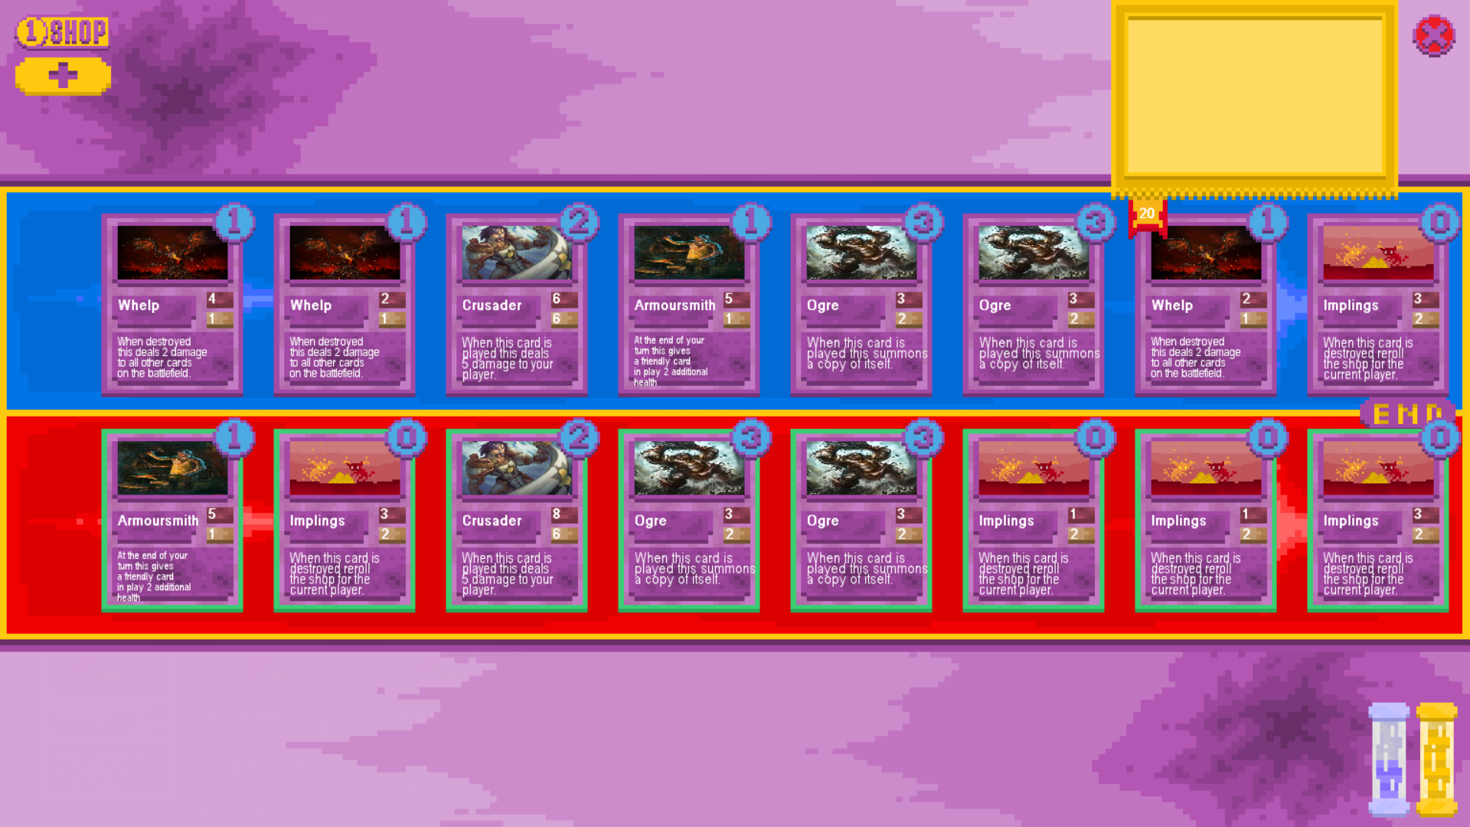

The test was a success as all cards on each player’s board swapped correctly and stayed in the same order upon swapping.

1. End the turn with full cards on one player’s board and the other player’s board empty

Board before attempting to end the turn:

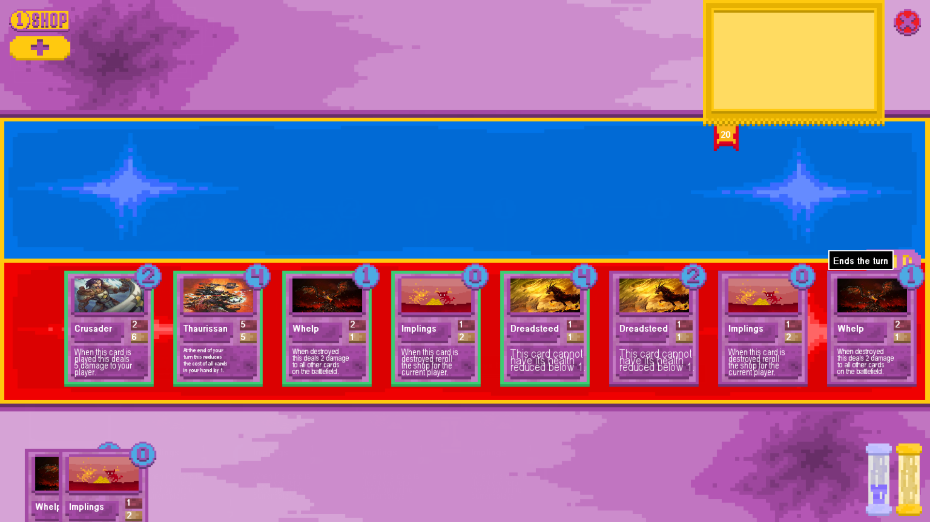

Board after ending the turn:

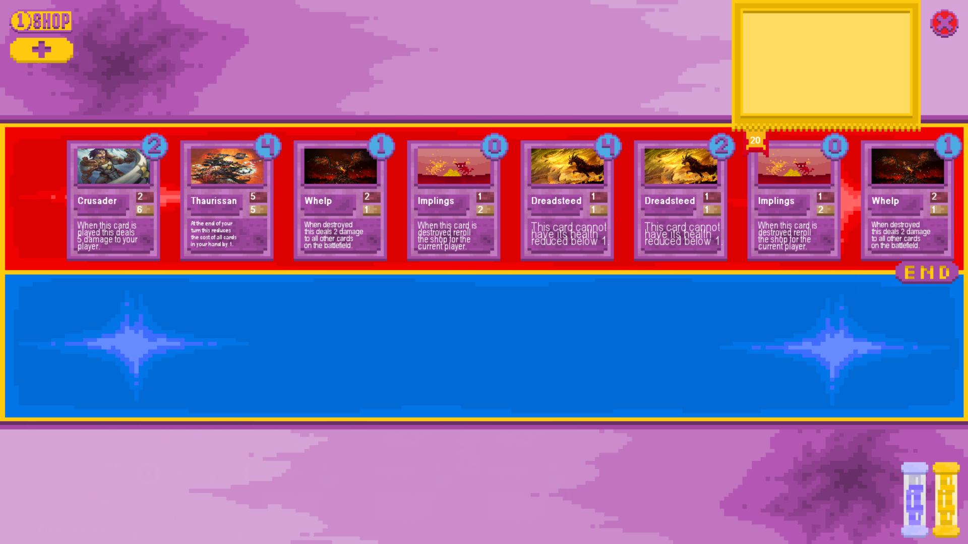

The test was a success as the program had no issue swapping each card for an empty space on the other side of the board.

# Evaluation

Analysis

Design

Implementation

Testing

Evaluation